

**2023 AUDIT REPORT ON THE**

**MINERAL RESOURCES AND MINERAL RESERVES**

**OF HOCHSCHILD’S PRODUCING MINES**

**IN PERU AND ARGENTINA**

**March 31, 2024**

**Effective Date: December 25, 2023**

**Report No.: 2024001**

**INDEX**

[1.0 SUMMARY 10](#_Toc159577719)

[1.1 AUDIT STRATEGY 11](#_Toc159577720)

[1.2 AUDITED MINERAL RESOURCES 12](#_Toc159577721)

[1.3 AUDITED MINERAL RESERVES 13](#_Toc159577722)

[1.4 AUDITED REMAINING MINERAL RESOURCES (EXCLUSIVE OF MINERAL RESERVES) 13](#_Toc159577723)

[2.0 MINERAL RESOURCES 15](#_Toc159577724)

[3.0 PALLANCATA MINERAL RESOURCES 15](#_Toc159577725)

[3.1 DATABASE 16](#_Toc159577726)

[3.2 BULK DENSITY 18](#_Toc159577727)

[3.3 WIREFRAMES 20](#_Toc159577728)

[3.4 COMPOSITING 20](#_Toc159577729)

[3.5 GRADE CAPPING 22](#_Toc159577730)

[3.6 CLASSIFICATION 24](#_Toc159577731)

[3.7 ESTIMATION AND MINERAL RESOURCES 28](#_Toc159577732)

[3.8 MODEL VALIDATION 29](#_Toc159577733)

[3.9 CONCLUSION 30](#_Toc159577734)

[4.0 SAN JOSÉ MINERAL RESOURCES 30](#_Toc159577735)

[4.1 SAN JOSÉ MINERAL RESOURCES 31](#_Toc159577736)

[4.2 DATABASE 31](#_Toc159577737)

[4.3 BULK DENSITY 34](#_Toc159577738)

[4.4 WIREFRAMES 37](#_Toc159577739)

[4.5 COMPOSITING 37](#_Toc159577740)

[4.6 GRADE CAPPING 38](#_Toc159577741)

[4.7 CLASSIFICATION 41](#_Toc159577742)

[4.8 ESTIMATION AND MINERAL RESOURCES 46](#_Toc159577743)

[4.9 MODEL VALIDATION 47](#_Toc159577744)

[4.10 CONCLUSION 50](#_Toc159577745)

[5.0 INMACULADA MINERAL RESOURCES 50](#_Toc159577746)

[5.1 DATABASE 51](#_Toc159577747)

[5.2 BULK DENSITY 53](#_Toc159577748)

[5.3 WIREFRAMES 54](#_Toc159577749)

[5.4 COMPOSITING 55](#_Toc159577750)

[5.5 GRADE CAPPING 56](#_Toc159577751)

[5.6 CLASSIFICATION 58](#_Toc159577752)

[5.7 ESTIMATION AND MINERAL RESOURCES 60](#_Toc159577753)

[5.8 MODEL VALIDATION 60](#_Toc159577754)

[5.9 CONCLUSION 62](#_Toc159577755)

[6.0 MINERAL RESERVES 62](#_Toc159577756)

[6.1 PALLANCATA 62](#_Toc159577757)

[6.1.1 Mineral Resources Considered for Conversion to Mineral Reserves 62](#_Toc159577758)

[6.1.2 Mineral Reserves Estimation 85](#_Toc159577759)

[6.1.3 Mineral Resources Not Considered for Conversion to Mineral Reserves as of December 25, 2022 93](#_Toc159577760)

[6.2 SAN JOSÉ 95](#_Toc159577761)

[6.2.1 Mineral Resources Considered for Conversion to Mineral Reserves 95](#_Toc159577762)

[6.2.2 Mineral Reserves Estimation 121](#_Toc159577763)

[6.2.3 Mineral Resources Not Considered for Conversion to Mineral Reserves as of December 25, 2022 134](#_Toc159577764)

[6.3 INMACULADA 137](#_Toc159577765)

[6.3.1 Mineral Resources Considered for Conversion to Mineral Reserves 137](#_Toc159577766)

[6.3.2 Mineral Reserves Estimation 151](#_Toc159577767)

[6.3.3 Mineral Resources Not Considered for Conversion to Mineral Reserves as of December 25, 2022 159](#_Toc159577768)

[7.0 MINING OPERATIONS 161](#_Toc159577769)

[7.1 PALLANCATA MINE 161](#_Toc159577770)

[7.2 SAN JOSÉ MINE 169](#_Toc159577771)

[7.3 INMACULADA MINE 178](#_Toc159577772)

[8.0 MINERAL PROCESSING 186](#_Toc159577773)

[8.1 SELENE/PALLANCATA PROCESS PLANT 186](#_Toc159577774)

[8.1.1 Recent Selene Plant Performance 191](#_Toc159577775)

[8.1.2 Sampling, Measurement and Accountability 194](#_Toc159577776)

[8.1.3 Selene Laboratory 194](#_Toc159577777)

[8.1.4 Tailings 196](#_Toc159577778)

[8.1.5 Selene/Pallancata Environmental, Permitting and Social 197](#_Toc159577779)

[8.2 SAN JOSÉ PROCESS PLANT 198](#_Toc159577780)

[8.2.1 Mineral Processing at San José 198](#_Toc159577781)

[8.2.2 San José Plant Metallurgy and Performance 206](#_Toc159577782)

[8.2.3 Sampling and Analyses 210](#_Toc159577783)

[8.2.4 Routine Metallurgical Testing and Process Audits 211](#_Toc159577784)

[8.2.5 Tailings Management 211](#_Toc159577785)

[8.2.6 Permitting, Environmental and Social 215](#_Toc159577786)

[8.3 INMACULADA PROCESS PLANT 215](#_Toc159577787)

[8.3.1 Process Description 215](#_Toc159577788)

[8.3.2 Merrill Crowe PLant 221](#_Toc159577789)

[8.3.3 Plant Automation 221](#_Toc159577790)

[8.3.4 Plant Metallurgical and Cost Performance 222](#_Toc159577791)

[8.3.5 Laboratory Operations and Plant Sampling 225](#_Toc159577792)

[8.3.7 Environmental and Social 229](#_Toc159577793)

[8.3.7.1 Wastes 229](#_Toc159577794)

[8.3.7.2 Reporting, Permitting and Social 230](#_Toc159577795)

[9.0 INTERPRETATIONS AND CONCLUSIONS 231](#_Toc159577796)

[10.0 RECOMMENDATIONS (OLD 2021 REPORT) 234](#_Toc159577797)

[11.0 GLOSSARY OF TERMS 234](#_Toc159577798)

**APPENDIXES**

[APPENDIX A PALLANCATA MINE JORC CODE COMMENTS 214](#_Toc159530775)

[APPENDIX B SAN JOSÉ MINE JORC CODE COMMENTS 235](#_Toc159530776)

[APPENDIX C INMACULADA MINE JORC CODE COMMENTS 257](#_Toc159530777)

[APPENDIX D CORE SAMPLE PHOTOGRAPHS 278](#_Toc159530778)

[APPENDIX E MISCELLANEOUS DATA AND DRAWINGS 282](#_Toc159530779)

[APPENDIX F COLLAR LOCATION TABLES 295](#_Toc159530780)

[APPENDIX G SIGNIFICANT INTERSECTIONS 311](#_Toc159530781)

[APPENDIX H DRILL HOLE LOCATIONS 321](#_Toc159530782)

[APPENDIX I FUTURE EXPLORATION PLAN 330](#_Toc159530783)

[APPENDIX J BLOCK MODEL VALIDATION TREND PLOTS 333](#_Toc159530784)

[APPENDIX K CONSENT FORM 334](#_Toc159530785)

**LIST OF TABLES**

[TABLE 1.1 MINERAL RESOURCES AS OF DECEMBER 25, 2022(1-8) 12](#_Toc159531423)

[TABLE 1.2 MINERAL RESERVES AS OF DECEMBER 25, 2022*(1-6)* 13](#_Toc159531424)

[TABLE 1.3 REMAINING MINERAL RESOURCES, EXCLUSIVE OF MINERAL RESERVES, AS OF DECEMBER 25, 2022(1-7) 13](#_Toc159531425)

[TABLE 3.1 TOTAL PALLANCATA MINERAL RESOURCES DECLARED AS OF DECEMBER 31, 2023(1-4) ……………………………………………………………………………………………………………………………15](#_Toc159531426)

[TABLE 3.2 TABLE OF VEIN CODES 16](#_Toc159531427)

[TABLE 3.3 BULK DENSITY TABLE 18](#_Toc159531428)

[TABLE 3.4 PRODUCTION COMPOSITE TABLE 20](#_Toc159531429)

[TABLE 3.5 CAPPING TABLE 21](#_Toc159531430)

[TABLE 3.6 CLASSIFICATION RANGE TABLE 24](#_Toc159531431)

[TABLE 3.7 COMPARISON BETWEEN AVERAGE PRODUCTION BLOCK ESTIMATES AND NEAREST NEIGHBOUR GRADES FOR MEASURED AND INDICATED MINERAL RESOURCES 28](#_Toc159531432)

[TABLE 4.1 TOTAL SAN JOSÉ MINERAL RESOURCES DECLARED AS OF DECEMBER 31, 2022(1-4*)* ……………………………………………………………………………………………………………………………29](#_Toc159531433)

[TABLE 4.2 TABLE OF VEIN CODES 30](#_Toc159531434)

[TABLE 4.3 BULK DENSITY TABLE 33](#_Toc159531435)

[TABLE 4.4 PRODUCTION COMPOSITE TABLE 36](#_Toc159531436)

[TABLE 4.5 CAPPING TABLE 37](#_Toc159531437)

[TABLE 4.6 CLASSIFICATION RANGE TABLE 39](#_Toc159531438)

[TABLE 4.7 COMPARISON BETWEEN AVERAGE PRODUCTION BLOCK ESTIMATE AND NEAREST NEIGHBOUR GRADE FOR MEASURED AND INDICATED MINERAL RESOURCES 45](#_Toc159531439)

[TABLE 5.1 TOTAL INMACULADA MINERAL RESOURCES DECLARED AS OF DECEMBER 31, 2023(1-4) ……………………………………………………………………………………………………………………………48](#_Toc159531440)

[TABLE 5.2 TABLE OF VEIN CODES 49](#_Toc159531441)

[TABLE 5.3 BULK DENSITY TABLE 51](#_Toc159531442)

[TABLE 5.4 PRODUCTION COMPOSITE TABLE 52](#_Toc159531443)

[TABLE 5.5 CAPPING TABLE 53](#_Toc159531444)

[TABLE 5.6 CLASSIFICATION RANGE TABLE 55](#_Toc159531445)

[TABLE 5.7 COMPARISON BETWEEN AVERAGE PRODUCTION BLOCK ESTIMATES AND NEAREST NEIGHBOUR GRADES FOR MEASURED AND INDICATED MINERAL RESOURCES 58](#_Toc159531446)

[TABLE 6.1 PALLANCATA MEASURED AND INDICATED MINERAL RESOURCES INITIALLY CONSIDERED FOR CONVERSION TO MINERAL RESERVE ESTIMATION 59](#_Toc159531447)

[TABLE 6.2 PALLANCATA MEASURED AND INDICATED MINERAL RESOURCES NOT CONSIDERED IN THE MINE PLAN FOR CONVERSION TO MINERAL RESERVES 62](#_Toc159531448)

[TABLE 6.3 PALLANCATA MEASURED AND INDICATED MINERAL RESOURCES INITIALLY CONSIDERDED FOR CONVERSION TO MINERAL RESERVES WITHOUT TOTAL INTERNAL DILUTION ……………………………………………………………………………………………………………………………64](#_Toc159531449)

[TABLE 6.4 PALLANCATA MEASURED AND INDICATED MINERAL RESOURCES TOTAL INTERNAL DILUTION ……………………………………………………………………………………………………………………………67](#_Toc159531450)

[TABLE 6.5 PALLANCATA MEASURED AND INDICATED MINERAL RESOURCES INITIALLY IN THE MINE PLAN FOR CONVERSION TO MINERAL RESERVES WITH TOTAL INTERNAL DILUTION 69](#_Toc159531451)

[TABLE 6.6 PALLANCATA INACCESSIBLE MINERAL RESOURCES NOT RECOVERED 71](#_Toc159531452)

[TABLE 6.7 PALLANCATA MINERAL RESOURCES IN SMALL ISOLATED AREAS NOT RECOVERED ……………………………………………………………………………………………………………………………73](#_Toc159531453)

[TABLE 6.8 PALLANCATA MINERAL RESOURCES IN DEVELOPMENT PILLARS NOT RECOVERED ……………………………………………………………………………………………………………………………76](#_Toc159531454)

[TABLE 6.9 PALLANCATA OPERATIONALLY CONSTRAINED MINERAL RESOURCES NOT RECOVERED ……………………………………………………………………………………………………………………………77](#_Toc159531455)

[TABLE 6.10 PALLANCATA TOTAL UNRECOVERED MINERAL RESOURCES WITH INTERNAL DILUTION …………………………………………………………………………………………………………………………..78](#_Toc159531456)

[TABLE 6.11 PALLANCATA INTERNALLY DILUTED MINERAL RESOURCES RECOVERED……………..81](#_Toc159531457)

[TABLE 6.12 PALLANCATA EXTRACTABLE MEASURED AND INDICATED MINERAL RESOURCES MINERAL RESERVE INTERNAL DILUTION ESTIMATION 82](#_Toc159531458)

[TABLE 6.13 PALLANCATA EXTERNAL DILUTION INCLUDED IN MINERAL RESERVES 83](#_Toc159531459)

[TABLE 6.14 PALLANCATA MINERAL RESERVES AS OF DECEMBER 25, 2022 84](#_Toc159531460)

[TABLE 6.15 PALLANCATA PROVEN AND PROBABLE MINERAL RESERVES AS OF DECEMBER 25, 2022 ……………………………………………………………………………………………………………………………85](#_Toc159531461)

[TABLE 6.16 PALLANCATA ECONOMIC AND MARGINAL MINERAL RESERVES AS OF DECEMBER 25, 2022 …………………………………………………………………………………………………………………………..86](#_Toc159531462)

[TABLE 6.17 PALLANCATA MINERAL RESOURCES NOT CONVERTED TO MINERAL RESERVES AS OF DECEMBER 25, 2022 88](#_Toc159531463)

[TABLE 6.18 SAN JOSÉ MEASURED AND INDICATED MINERAL RESOURCES INITIALLY CONSIDERDED FOR CONVERSION TO MINERAL RESERVES 90](#_Toc159531464)

[TABLE 6.19 SAN JOSÉ MEASURED AND INDICATED MINERAL RESOURCES NOT CONSIDERED IN THE MINE PLAN FOR CONVERSION TO MINERAL RESERVES 93](#_Toc159531465)

[TABLE 6.20 SAN JOSÉ MEASURED AND INDICATED MINERAL RESOURCES INITIALLY CONSIDERDED FOR CONVERSION TO MINERAL RESERVES WITHOUT TOTAL INTERNAL DILUTION ………………………………………………………………………………………………………………………………………………..95](#_Toc159531466)

[TABLE 6.21 SAN JOSÉ MEASURED AND INDICATED MINERAL RESOURCES TOTAL INTERNAL DILUTION ESTIMATION 97](#_Toc159531467)

[TABLE 6.22 SAN JOSÉ MEASURED AND INDICATED MINERAL RESOURCES INITIALLY IN THE MINE PLAN FOR CONVERSION TO MINERAL RESERVES WITH TOTAL INTERNAL DILUTION 100](#_Toc159531468)

[TABLE 6.23 SAN JOSÉ INACCESSIBLE MINERAL RESOURCES NOT RECOVERED 103](#_Toc159531469)

[TABLE 6.24 SAN JOSÉ MINERAL RESOURCES IN MINED OUT / ISOLATED AREAS NOT RECOVERED …………………………………………………………………………………………………………………………105](#_Toc159531470)

[TABLE 6.25 SAN JOSÉ MINERAL RESOURCES TIED UP IN DEVELOPMENT PILLARS NOT RECOVERED …………………………………………………………………………………………………………………………107](#_Toc159531471)

[TABLE 6.26 SAN JOSÉ OPERATIONALLY LOST MINERAL RESOURCES NOT RECOVERED 109](#_Toc159531472)

[TABLE 6.26 SAN JOSÉ OPERATIONALLY LOST MINERAL RESOURCES NOT RECOVERED 110](#_Toc159531473)

[TABLE 6.26 SAN JOSÉ OPERATIONALLY LOST MINERAL RESOURCES NOT RECOVERED 111](#_Toc159531474)

[TABLE 6.27 SAN JOSÉ TOTAL UNRECOVERED MINERAL RESOURCES WITH INTERNAL DILUTION ………………………………………………………………………………………………………………………………………………111](#_Toc159531475)

[TABLE 6.28 SAN JOSÉ INTERNALLY DILUTED MINERAL RESOURCES RECOVERED 114](#_Toc159531476)

[TABLE 6.29 SAN JOSÉ EXTRACTABLE MEASURED AND INDICATED MINERAL RESOURCES MINERAL RESERVE INTERNAL DILUTION ESTIMATION 116](#_Toc159531477)

[TABLE 6.30 SAN JOSÉ EXTERNAL DILUTION INCLUDED IN MINERAL RESERVES 118](#_Toc159531478)

[TABLE 6.31 SAN JOSÉ MINERAL RESERVES AS OF DECEMBER 25, 2022 120](#_Toc159531479)

[TABLE 6.40 INMACULADA UNDEVELOPED MEASURED AND INDICATED MINERAL RESOURCES WITH LOW MINING CONFIDENCE NOT USED IN MINERAL RESERVE ESTIMATION 136](#_Toc159531488)

[TABLE 6.41 INMACULADA MEASURED AND INDICATED MINERAL RESOURCES FURTHER CONSIDERDED FOR CONVERSION TO MINERAL RESERVES WITH TOTAL INTERNAL DILUTION 137](#_Toc159531489)

[TABLE 6.42 INMACULADA INACCESSIBLE MINERAL RESOURCES NOT RECOVERED 139](#_Toc159531490)

[TABLE 6.43 INMACULADA UNECONOMIC MINERAL RESOURCES NOT RECOVERED 139](#_Toc159531491)

[TABLE 6.44 INMACULADA MINERAL RESOURCES IN DEVELOPMENT PILLARS NOT RECOVERED ………………………………………………………………………………………………………………………………………………139](#_Toc159531492)

[TABLE 6.45 INMACULADA OPERATIONALLY CONSTRAINED MINERAL RESOURCES NOT RECOVERED ………………………………………………………………………………………………………………………….140](#_Toc159531493)

[TABLE 6.46 INMACULADA TOTAL UNRECOVERED MINERAL RESOURCES WITH TOTAL INTERNAL DILUTION 141](#_Toc159531494)

[TABLE 6.47 INMACULADA INTERNALLY DILUTED MINERAL RESOURCES RECOVERED 142](#_Toc159531495)

[TABLE 6.48 INMACULADA EXTRACTABLE MEASURED AND INDICATED MINERAL RESOURCES MINERAL RESERVE INTERNAL DILUTION ESTIMATION 143](#_Toc159531496)

[TABLE 6.49 INMACULADA EXTERNAL DILUTION INCLUDED IN MINERAL RESERVES 144](#_Toc159531497)

[TABLE 6.50 INMACULADA MINERAL RESERVES AS OF DECEMBER 25, 2022 146](#_Toc159531498)

[TABLE 6.51 INMACULADA PROVEN AND PROBABLE MINERAL RESERVES AS OF DECEMBER 25, 2022 ………………………………………………………………………………………………………………………….147](#_Toc159531499)

[TABLE 6.52 INMACULADA ECONOMIC AND MARGINAL MINERAL RESERVES AS OF DECEMBER 25, 2022 …………………………………………………………………………………………………………………………149](#_Toc159531500)

[TABLE 6.53 INMACULADA MEASURED AND INDICATED MINERAL RESOURCES EXCLUSIVE OF MINERAL RESERVES 150](#_Toc159531501)

[TABLE 7.1 PALLANCATA UNDERGROUND MINE EQUIPMENT FLEET 153](#_Toc159531502)

[TABLE 7.2 PALLANCATA UNDERGROUND MINE PERSONNEL 154](#_Toc159531503)

[TABLE 7.3 PALLANCATA MINE OPERATING DEVELOPMENT SUMMARY (METRES) 154](#_Toc159531504)

[TABLE 7.4 PALLANCATA MINE CAPITAL DEVELOPMENT SUMMARY (METRES) 155](#_Toc159531505)

[TABLE 7.5 PALLANCATA MINE ORE EXTRACTION SUMMARY AND SCHEDULE 155](#_Toc159531506)

[TABLE 7.6 SAN JOSÉ UNDERGROUND MINE EQUIPMENT FLEET 161](#_Toc159531507)

[TABLE 7.7 SAN JOSÉ UNDERGROUND MINE PERSONNEL 163](#_Toc159531508)

[TABLE 7.8 SAN JOSÉ LOM MINE OPERATING DEVELOPMENT 163](#_Toc159531509)

[TABLE 7.9 SAN JOSÉ LOM MINE CAPITAL DEVELOPMENT 164](#_Toc159531510)

[TABLE 7.10 SCHEDULE FOR SAN JOSÉ LOM ORE DEVELOPMENT AND PRODUCTION 165](#_Toc159531511)

[TABLE 7.11 INMACULADA UNDERGROUND MINE EQUIPMENT FLEET 170](#_Toc159531512)

[TABLE 7.12 INMACULADA UNDERGROUND MINE PERSONNEL 171](#_Toc159531513)

[TABLE 7.13 INMACULADA MINE OPERATING DEVELOPMENT SUMMARY (METRES) 172](#_Toc159531514)

[TABLE 7.14 INMACULADA MINE CAPITAL DEVELOPMENT SUMMARY (METRES) 172](#_Toc159531515)

[TABLE 7.15 INMACULADA MINE ORE EXTRACTION SCHEDULE 173](#_Toc159531516)

[TABLE 8.1 SELENE METALLURGICAL PERFORMANCE 2012-2022 183](#_Toc159531517)

[TABLE 8.2 SELENE PLANT OPERATING STATISTICS 2014-2022 184](#_Toc159531518)

[TABLE 8.3 SELENE PLANT OPERATING COSTS 2013-2022 184](#_Toc159531519)

[TABLE 8.4 SELENE LABORATORY PROTOCOLS 187](#_Toc159531520)

[TABLE 8.5 SAN JOSÉ PLANT INTERRUPTIONS 2022, % OPERATING TIME, DAYS 190](#_Toc159531521)

[TABLE 8.6 SAN JOSÉ METALLURGICAL PERFORMANCE 2012- 2022 198](#_Toc159531522)

[TABLE 8.7 RECENT CONSUMPTIONS AND COSTS, SAN JOSE PLANT 199](#_Toc159531523)

[TABLE 8.8 INMACULADA METALLURGICAL PERFORMANCE 2015 -2022 214](#_Toc159531524)

[TABLE 8.9 INMACULADA PLANT COSTS 2015-2022, $/T PROCESSED 215](#_Toc159531525)

[TABLE 8.10 INMACULADA RETURNING TAILINGS WATER ANALYSES 2021 (MG/L) 220](#_Toc159531526)

[TABLE 11.1 TERMS AND ABBREVIATIONS 225](#_Toc159531527)

**LIST OF FIGURES**

[FIGURE 7.1 LONGITUDINAL PROJECTION VIEW OF JULIET VEIN 141](#_Toc159531748)

[FIGURE 7.2 LONGITUDINAL PROJECTION VIEW OF MIRIAN VEIN 142](#_Toc159531749)

[FIGURE 7.3 LONGITUDINAL PROJECTION VIEW OF PABLO VEIN 143](#_Toc159531750)

[FIGURE 7.4 LONGITUDINAL PROJECTION VIEW OF ODIN VEIN 150](#_Toc159531751)

[FIGURE 7.5 LONGITUDINAL PROJECTION VIEW OF BETANIA VEIN 151](#_Toc159531752)

[FIGURE 7.6 LONGITUDINAL PROJECTION VIEW OF ESCONDIDA VEIN 152](#_Toc159531753)

[FIGURE 7.7 LONGITUDINAL PROJECTION AND PLAN VIEW OF MILLET VEIN 159](#_Toc159531754)

[FIGURE 7.8 LONGITUDINAL PROJECTION AND PLAN VIEW OF ANGELA VEIN 160](#_Toc159531755)

[FIGURE 7.9 LONGITUDINAL PROJECTION VIEW OF ANGELA NE VEIN 161](#_Toc159531756)

[FIGURE 8.1 SELENE PLANT, PHOTOGRAPH BY P&E, JANUARY 2022 162](#_Toc159531757)

[FIGURE 8.2 2022 SELENE PLANT FLOWSHEET 164](#_Toc159531758)

[FIGURE 8.3 TOP OF COLUMN CLEANER CELL AND FROTH WASHING 165](#_Toc159531759)

[FIGURE 8.4 CONCENTRATE PRESSURE FILTER 166](#_Toc159531760)

[FIGURE 8.5 CONCENTRATE ASSEMBLED FOR SHIPMENT, JANUARY 2022 166](#_Toc159531761)

[FIGURE 8.6 SELENE SAMPLE PREPARATION AND ASSAY LABORATORY 171](#_Toc159531762)

[FIGURE 8.7 SELENE NO. 3 TAILINGS FACILITY, JANUARY 2022 173](#_Toc159531763)

[FIGURE 8.8 SAN JOSÉ PROCESS PLANT 174](#_Toc159531764)

[FIGURE 8.9 ORE STOCKPILES AND BLENDING AT SAN JOSÉ (JANUARY 2020 AND 2022) 176](#_Toc159531765)

[FIGURE 8.10 ORE FEED GRIZZLY, SAN JOSÉ PLANT 176](#_Toc159531766)

[FIGURE 8.11 CRUSHER FACILITY, DUST ACCUMULATION, JANUARY 2022 177](#_Toc159531767)

[FIGURE 8.12 SAN JOSE CRUSHING, GRINDING, FLOTATION, CONCENTRATE FILTRATION AND TAILINGS ……………………………………………………………………………………………………………………...178](#_Toc159531768)

[FIGURE 8.13 SAN JOSÉ ILR LEACHING, CCD, EW-FOUNDRY, DETOX AND MC CIRCUITS\* 179](#_Toc159531769)

[FIGURE 8.14 SAN JOSÉ FLOTATION CIRCUIT 180](#_Toc159531770)

[FIGURE 8.15 SAN JOSE INTENSE LEACHING AND CCD CIRCUITS 181](#_Toc159531771)

[FIGURE 8.16 ACTUAL (EFECTIVO) AND BUDGETED (PPTO) PERCENT RECOVERIES, SAN JOSÉ, 2022 ……………………………………………………………………………………………….……………………187](#_Toc159531772)

[FIGURE 8.17 DRY FLOTATION TAILINGS FACILITY NO. 3, JANUARY 2019 189](#_Toc159531773)

[FIGURE 8.18 SAN JOSE TAILINGS WATER BALANCE, 2020 190](#_Toc159531774)

[FIGURE 8.19 TAILINGS CENTRIFUGE DEWATERING PLANT 2022 191](#_Toc159531775)

[FIGURE 8.20 PRA TAILINGS DEWATERING CENTRIFUGES 191](#_Toc159531776)

[FIGURE 8.21 INMACULADA GENERAL FLOWSHEET (2020 -MID 2021) 193](#_Toc159531777)

[FIGURE 8.22 INMACULADA ORE RECEIPT, CONVEYOR FROM CRUSHER TO PLANT 194](#_Toc159531778)

[FIGURE 8.23 BLENDING THE MILL FEED STOCKPILE 194](#_Toc159531779)

[FIGURE 8.24 INMACULADA GRINDING MILLS 195](#_Toc159531780)

[FIGURE 8.25 FOUR TANKS OF THE EIGHT-TANK AGITATED LEACH FACILITY 196](#_Toc159531781)

[FIGURE 8.26 (A) LEACHING PERFORMANCE, JUNE 2022 196](#_Toc159531782)

[FIGURE 8.26 (B) LEACHING PERFORMANCE, NOVEMBER 2021 197](#_Toc159531783)

[FIGURE 8.27 CCD PERFORMANCE, SEPTEMBER 2022 197](#_Toc159531784)

[FIGURE 8.28 MERRIL CROWE - PLS CLARIFIERS AND ZINC PRECIPITATION UNIT 198](#_Toc159531785)

[FIGURE 8.29 PLANT CONTROL PANELS 198](#_Toc159531786)

[FIGURE 8.30 EXAMPLE INMACULADA LABORATORY COMPONENTS 203](#_Toc159531787)

[FIGURE 8.31 TAILINGS (“RELAVE”) AUTOMATIC SAMPLING 204](#_Toc159531788)

[FIGURE 8.32 INMACULADA PLANT WATER BALANCE 205](#_Toc159531789)

[FIGURE 8.33 INMACULADA TAILINGS FACILITY (JANUARY 2021) 206](#_Toc159531790)

# SUMMARY

P&E Mining Consultants Inc. (“P&E”) was engaged by Hochschild Mining PLC (“Hochschild”) to undertake an audit of the Mineral Resources and Mineral Reserves prepared by Hochschild as they pertain to their December 25, 2022 Annual Report. As part of the reporting requirements for a Mineral Company listed under the London Stock Exchange regulations, it is necessary that Mineral Resources and Mineral Reserves be stated in accordance with international reporting standards. To satisfy this requirement, P&E has followed the standards of the Joint Mineral Reserves Committee of the Australian Institute of Mining and Metallurgy (“JORC”), National Instrument NI 43-101 and the Canadian Institute of Mining and Metallurgy (“CIM”) best practices guidelines (2019).

P&E audited the Hochschild Mineral Resource and Mineral Reserve Estimates for the Pallancata, San José and Inmaculada mining properties to confirm that they are in compliance with JORC, NI 43-101 and CIM best practices guidelines and that the employed methodologies have generated reliable estimates of tonnage and grade for the mineral assets stated in the Annual Report. The audit was carried out by James L. Pearson, P.Eng., David Burga, P.Geo., Grant Feasby, P.Eng., and Fred H. Brown, P.Geo., under the direction of P&E President, Eugene Puritch, P.Eng., FEC, CET. All of the persons named herein are independent Qualified Persons as defined by National Instrument 43-101 and Competent Persons as defined by JORC by reason of education, affiliation with a professional association and past relevant work experience.

This report includes Hochschild‟s operating mines in Peru and Argentina. The Peruvian Properties include the Pallancata and Inmuculada Mines located in southern Peru within approximately 100 km of each other. The San José Mine is located in the Santa Cruz Province in southern Argentina. All are operating underground mines in epithermal silver-gold and gold- silver vein deposits. The Pallancata and Inmaculada Properties are 100% owned by Hochschild. Hocschild has a 51% interest in the San José Property.

P&E Qualified Persons have visited all Hochschild operating mines and processing plants since

2009, except for the 2020 Mineral Resource and Reserve Audits due to Covid-19 access restrictions. The last P&E Qualified Persons site visits were in January 2022.

The Hocschild December 25, 2022, Mineral Resource Estimates for Pallancata, Inmaculada and

San José are based on a Gold (Au) price of US$1,800/oz and a Silver (Ag) price of US$24/oz.

The Hocschild Dec 25, 2022, Mineral Reserve Estimates for Inmaculada and San José are based on a Gold (Au) price of US$1,650/oz and a Silver (Ag) price of US$22/oz. The Hocschild Dec 25, 2022, Mineral Reserve Estimate for Pallancata is based on a Gold (Au) price of US$1,650/oz and a Silver (Ag) price of US$25/oz (hedged). P&E determined that these metal prices are suitable to be utilized for Mineral Resource and Mineral Reserve estimation since they are based on recognized consensus forecast metal prices.

All costs in this report are reported in United States dollars (“$”).

## 1.1 AUDIT STRATEGY

All Mineral Resource Estimate and Mineral Reserve Estimate audit data were provided by Hochschild in the form of Excel spreadsheets, text files, AutoCAD, and dxf format files. P&E cannot absolutely verify the authenticity or accuracy of the original source data. The P&E Mineral Resource Estimate audit strategy was based on review and validation checks of the deposits associated with the Pallancata, San José and Inmaculada Properties.

The Mineral Resource Estimates were audited in terms of compliance with generally accepted industry standards and guidelines, the methodology used for estimation, the classification criteria used, and the actual implementation of the methodology in terms of Mineral Resource Estimation and reporting. Mineral Resource Estimates were also checked by running parallel grade, volume and tonnage comparisons from the supplied block models, as well as comparing the statistical distribution of input and output model data. Grade capping, variography and grade estimation parameters were reviewed in detail and their appropriateness was determined. As a final check, composite grades, estimated block grades and Nearest Neighbour block grades, at zero silver equivalent (“AgEq”) value cut-off, were compared.

For the 2022 Mineral Reserve estimate, inaccessible Mineral Resources that contained insufficient tonnages to permit the development of local infrastructure, Mineral Resources in mined out or isolated areas, Mineral Resources located in sill and rib pillars, uneconomic Mineral Resources that did not pass the Mineral Reserve requirements and operationally lost Mineral Resources, were not included in the Mineral Reserve Estimate. P&E has relied on Hochschild for the determination of which Mineral Resources to exclude, and has directly reviewed these Mineral Resources.

The P&E Mineral Reserve Estimate audit strategy was based on a review and check for reasonableness of the dollar value per tonne cut-off utilized at each mining property. Subsequently, the internal dilution, geotechnical dilution, mining dilution, and mine extraction (mining recovery) were thoroughly scrutinized for each mining property to ensure they fell within acceptable limits for Mineral Reserve Estimate reporting. In addition, the remaining Mineral Resource Estimates not converted to a Mineral Reserve Estimate (i.e., Mineral Resources exclusive of Mineral Reserves) were reviewed to ensure they balanced with the mine extraction data.

The preceding Mineral Reserve Estimate reviews were summarized into overall dilution and mine extraction percentile for each mining property for a reasonable value comparison analysis. The Mineral Reserve Estimate overall dilution and mine extraction percentile average is as follows: Internal Dilution = 3%, Mining and Geotechnical Dilution (External Dilution) = 45%

and Mine Extraction = 58%.

In addition to the above mining component of the Mineral Reserve Estimate audit, a review of the metallurgical components of each operation was undertaken to assess the reasonableness of the processing costs, process recoveries and accountability, and operational safety of the facilities. Concentrate and doré sampling methodology, freight handling costs, smelter treatment costs and smelter payables for Pallancata/Selene, Inmaculada and San José, were also reviewed. These components were found to be reasonable and acceptable.

## 1.2 AUDITED MINERAL RESOURCES

The P&E December 25, 2022, audited Mineral Resource Estimates, inclusive of Mineral Reserves, for the Pallancata, Inmaculada and San José properties are summarized in Table 1.1.

TABLE 1.1 MINERAL RESOURCES AS OF DECEMBER 25, 2022(1-8)

|  |  |  |  |  |  |  |
| --- | --- | --- | --- | --- | --- | --- |
| **Property** | **Resource**  **Classification** | **Tonnes (kt)** | **Ag (g/t)** | **Au (g/t)** | **AgEq (g/t)** | **AgEq (Moz)** |
| **Pallancata** | Measured | 1,409 | 296 | 1.36 | 398 | 18 |
| Indicated | 706 | 238 | 1.11 | 321 | 7.3 |
| **Meas & Ind** | **2,115** | **277** | **1.27** | **372** | **25.3** |
| Inferred | 3,702 | 452 | 1.7 | 579 | 69 |
| **San José** | Measured | 1,376 | 483 | 8.07 | 1,088 | 48.2 |
| Indicated | 916 | 386 | 6.66 | 885 | 26 |
| **Meas & Ind** | **2,292** | **444** | **7.5** | **1,007** | **74.2** |
| Inferred | 2,061 | 404 | 5.99 | 854 | 56.6 |
| **Inmaculada** | Measured | 1,942 | 184 | 4.39 | 514 | 32.1 |
| Indicated | 5,651 | 158 | 3.79 | 442 | 80.2 |
| **Meas & Ind** | **7,593** | **164** | **3.94** | **460** | **112.3** |
| Inferred | 11,272 | 96 | 2.49 | 283 | 102.5 |
| **Total / Average** | Measured | 4,727 | 305 | 4.56 | 647 | 98.3 |
| Indicated | 7,273 | 194 | 3.89 | 486 | 113.5 |
| **Meas. & Ind.** | **12,000** | **238** | **4.15** | **549** | **211.8** |
| Inferred | 17,035 | 211 | 2.74 | 416 | 228.1 |

***Notes:*** *Ag = silver, Au = gold, AgEq = silver equivalent.*

*1) Mineral Resources are 100% attributable to each property. Hochschild has a 51 % interest in San José.*

*2) Mineral Resources, which are not Mineral Reserves, do not have demonstrated economic viability. The estimate of Mineral Resources may be materially affected by environmental, permitting, legal, title, taxation, socio-political, marketing, or other relevant issues.*

*3) The quantity and grade of reported Inferred Mineral Resources in this estimation are uncertain in nature and there has been insufficient exploration to define these Inferred Mineral Resources as an Indicated or*

*Measured Mineral Resource and it is uncertain if further exploration will result in upgrading them to an Indicated or Measured Mineral Resource classification.*

*4) Metal prices used for the Mineral Resources calculations: Au: US$1,800/oz, Ag: US$24/oz.*

*5) AgEq = (Au x 75) + Ag.*

*6) Mineral Resources are inclusive of Mineral Reserves.*

*7) AgEq Cut-offs: Pallancata 124 g/t AgEq and 99 g/t AgEq for zone Royropata, Inmaculada 105 g/t, San José 293 g/t AgEq.*

*8) Totals have been rounded to the appropriate number of significant figures.*

## 1.3 AUDITED MINERAL RESERVES

The P&E December 25, 2022, audited Mineral Reserve Estimates for the Pallancata, San José and Inmaculada properties are shown in Table 1.2.

TABLE 1.2 MINERAL RESERVES AS OF DECEMBER 25, 2022*(1-6)*

|  |  |  |  |  |  |  |
| --- | --- | --- | --- | --- | --- | --- |
| **Property** | **Mineral Reserve Classification** | **Tonnes (kt)** | **Ag (g/t)** | **Au (g/t)** | **AgEq (g/t)** | **AgEq (Moz)** |
| **Pallancata** | Proven | 261 | 236 | 1.07 | 316 | 2.6 |
| Probable | 83 | 199 | 1.18 | 288 | 0.8 |
| **Proven & Probable** | **344** | **227** | **1.1** | **309** | **3.4** |
| **San José** | Proven | 513 | 337 | 5.95 | 783 | 12.9 |
| Probable | 427 | 346 | 6.88 | 862 | 11.8 |
| **Proven & Probable** | **940** | **341** | **6.37** | **819** | **24.7** |
| **Inmaculada** | Proven | 1,150 | 178 | 4.12 | 486 | 18 |
| Probable | 4,062 | 149 | 3.5 | 411 | 53.7 |
| **Proven & Probable** | **5,212** | **155** | **3.63** | **428** | **71.7** |
| **Total/Average** | **Proven** | 1,924 | 228 | 4.19 | 542 | 33.5 |
| **Probable** | 4,572 | 168 | 3.77 | 451 | 66.3 |
| **Proven & Probable** | **6,496** | **186** | **3.9** | **478** | **99.8** |

Notes: Ag = silver, Au = gold, AgEq = silver equivalent.

1. Mineral Reserves are 100% attributable to each property. Hochschild has a 51 % interest in San José.
2. Metal prices used for Inmaculada and San José Mineral Reserve calculations: Au: US$1,650/oz, Ag: US$22/oz.
3. Metal prices used for Pallancata Mineral Reserve calculations: Au: US$1,650/oz, Ag: US$25/oz (hedged).
4. AgEq = (Au x 75) + Ag.
5. AgEq Cut-offs: Pallancata (cut & fill 152 g/t AgEq. long hole 128 g/t AgEq.), Inmaculada (cut & fill 135 g/t AgEq., long hole 119 g/t AgEq., San José (cut & fill 311 g/t AgEq. long hole 250 g/t AgEq.).
6. Totals/ averages have been rounded to the appropriate number of significant figures.

## 1.4 AUDITED REMAINING MINERAL RESOURCES (EXCLUSIVE OF MINERAL RESERVES)

The P&E audited the Mineral Resource remaining after conversion of Mineral Resources to Mineral Reserves (i.e., Exclusive of Mineral Reserves) for the Pallancata, San José and Inmaculada properties. The results are summarized in Table 1.3

TABLE 1.3 REMAINING MINERAL RESOURCES, EXCLUSIVE OF MINERAL RESERVES, AS OF DECEMBER 25, 2022(1-7)

|  |  |  |  |  |  |  |
| --- | --- | --- | --- | --- | --- | --- |
| **Property** | **Measured and Indicated** | | | **Inferred** | | |
|
| **Tonnes (kt)** | **Ag (g/t)** | **Au (g/t)** | **Tonnes (kt)** | **Ag (g/t)** | **Au (g/t)** |
| Pallancata | 887 | 226 | 1.05 | 3,702 | 452 | 1.7 |
| San José | 429 | 216 | 3.7 | 2,061 | 404 | 5.99 |
| Inmaculada | 3,312 | 94 | 2.36 | 11,272 | 96 | 2.49 |
| **Total / Average** | **4,628** | **130** | **2.23** | **17,035** | **211** | **2.74** |

1. *Table 1.3 represents 100% of the Mineral Resource on each property. Hochschild has a 51% interest in the San José Property.*
2. *Mineral Resources, which are not Mineral Reserves, do not have demonstrated economic viability. The estimate of Mineral Resources may be materially affected by environmental, permitting, legal, title, taxation, socio-political, marketing, or other relevant issues.*
3. *The quantity and grade of reported Inferred Mineral Resources in this estimation are uncertain in nature and there has been insufficient exploration to define these Inferred Mineral Resources as an Indicated or Measured Mineral Resource and it is uncertain if further exploration will result in upgrading them to an Indicated or Measured Mineral Resource classification.*
4. *The Mineral Resources in this report were estimated using the CIM Standards on Mineral Resources and Mineral Reserves, Definitions and Guidelines prepared by the CIM Standing Committee on Mineral Reserve Definitions and adopted by CIM Council December 11, 2005.*
5. *The Mineral Resources summarized in Table 1.3 are reported additional to the Mineral Reserves.*
6. *Metal prices used for the Mineral Resources calculations: Au: US$1,800/oz, Ag: US$24/oz.*
7. *Mineral Resources are exclusive of Mineral Reserves.*
8. *Totals / averages have been rounded to the appropriate number of significant figures.*

# MINERAL RESOURCES

P&E audited a selected portion of the Hochschild Mineral Resources for the Inmaculada, Pallancata and San José mines. The Mineral Resources were audited in terms of compliance with generally accepted industry standards and guidelines including the methodology used for estimation, the classification criteria used, and the actual implementation of the methodology in terms of Mineral Resource estimation and reporting.

All Mineral Resource estimation work reported here was performed by Fred H. Brown, P.Geo., of P&E of Brampton, Ontario, from data supplied electronically by Hochschild.

The Mineral Resource models were audited by P&E using the commercially available GEOVIA GEMS™ and Snowden Supervisor software programs. P&E has previously audited the Hochschild Mineral Resources in 2021.

Mineral Resources are discussed in separate sections for each mine property.

# PALLANCATA MINERAL RESOURCES

Declared Mineral Resources at Pallancata currently consist of 101 identified deposits. Total Mineral Resources declared by Hochschild for Pallancata, as of December 31, 2022, include 25.3 million Measured and Indicated silver-equivalent ounces and 69.0 million Inferred silver- equivalent ounces (Table 3.1). The cut-off used for reporting is 124 g/t silver equivalent (AgEq). Mineral Resources are inclusive of Mineral Reserves.

TABLE . TOTAL PALLANCATA MINERAL RESOURCES DECLARED AS OF DECEMBER 31, 2023(1-4)

|  |  |  |  |  |  |
| --- | --- | --- | --- | --- | --- |
| **Classification** | **Tonnes (kt)** | **Ag (g/t)** | **Au (g/t)** | **AgEq (g/t)** | **AgEq (Moz)** |
| Measured | 1,196 | 305.94 | 1.39 | 410.38 | 15.78 |
| Indicated | 592 | 235.95 | 1.10 | 318.17 | 6.06 |
| **Meas + Ind** | **1,788** | **282.76** | **1.29** | **379.85** | **21.84** |
| Inferred | 3,372 | 480.58 | 1.81 | 616.65 | 66.85 |

1. Represents 100% of the Mineral Resource. Mineral Resources are inclusive of Mineral Reserves.
2. Mineral Resources, which are not Mineral Reserves, do not have demonstrated economic viability. The estimate of Mineral Resources may be materially affected by environmental, permitting, legal, title, taxation, socio-political, marketing, or other relevant issues.
3. The quantity and grade of reported Inferred Resources are uncertain in nature and there has been insufficient exploration to define these Inferred Mineral Resources as an Indicated or Measured Mineral Resource and it is uncertain if further exploration will result in upgrading them to an Indicated or Measured Mineral Resource classification.
4. The Mineral Resources are reported in compliance with the Australasian Code for Reporting of Exploration Results, Mineral Resources and Ore Reserves (“JORC”).

The audit of the Mineral Resources was carried out by Fred Brown, P.Geo., under the direction of Eugene Puritch, P.Eng. Both persons are considered Qualified Persons under NI 43-101 and Competent Persons under JORC.

For the Mineral Reserve Estimate, inaccessible Mineral Resources that contained insufficient tonnages to permit the development of local infrastructure, Mineral Resources in mined out/ isolated areas, Mineral Resources located in sill and rib pillars and operationally lost Mineral Resources are not included in the Mineral Reserve Estimate. P&E has relied on Hochschild for the determination of which Mineral Resources to include, and has not directly reviewed excluded Mineral Resources.

## 3.1 DATABASE

The information provided for the Pallancata Mineral Resources consists of volumetric summaries, estimation parameters, drilling and sampling databases, block models, and desurveyed composite files. All data were provided electronically in Excel spreadsheets or ASCII coma-separated-value text files. AutoCAD format dxf triangulated wireframes defining deposit shapes, depleted deposits and sub-domains as well as topographic surfaces were also provided. QAQC data were not provided, and no production data nor reconciliation information was made available for this review.

Hochschild uses a naming convention that incorporates an alphanumeric code for each vein

(Table 3.2). Individual block model and de-surveyed composite files were supplied for each vein.

TABLE . TABLE OF VEIN CODES

|  |  |  |  |  |
| --- | --- | --- | --- | --- |
| **Vein** | **Code** |  | **Vein** | **Code** |
| Veta Amelia | aml |  | Veta Huararani 13 | hu13 |
| Veta Anais | ana |  | Veta Huararani 14 | hu14 |
| Veta Andres | and |  | Veta Huararani 15 | hu15 |
| Veta Betty | be |  | Veta Huararani 16 | hu16 |
| Veta Carmen | car |  | Veta Juan 1 | jn1 |
| Veta Central | ce |  | Veta Jonas | jon |
| Veta Charo | cha |  | Veta Juan | juan |
| Veta Cimoide | cm |  | Veta Juliet | jul |
| Veta Cimoide Este | cme |  | Veta Karen | kr |
| Veta Cinthia | cn |  | Veta Laura | lau |
| Veta Cristina | cr |  | Veta Laura | laup |
| Veta Cimoide Yurika 1 | cy1 |  | Veta Lola | lo |
| Veta Cimoide Yurika 2 | cy2 |  | Veta Luisa | lu |
| Veta Demian | dem |  | Veta Marco | marc |
| Veta Demian | demp |  | Veta Mateo | mat |
| Veta Diana | di |  | Veta Melania | mel |
| Veta Delia | dl |  | Veta Mikaela | mik |
| Veta Edith | ed |  | Veta Milagros | mil |
| Veta Edith 2 | ed2 |  | Veta Mirian | mir |
| Veta Edith 3 | ed3 |  | Veta Mishell | mish |
| Veta Elisa 6 | el6 |  | Veta Moises | moi |
| Veta Fanny | fan |  | Veta Marco W | mrcw |
| Veta Huararani 01 | hu01 |  | Veta Mariana | mri |
| Veta Huararani 02 | hu02 |  | Veta Marco W | mrwp |
| Veta Huararani 03 | hu03 |  | Veta Nine | nin |
| Veta Huararani 04 | hu04 |  | Veta Noelia | noe |
| Veta Huararani 05 | hu05 |  | Veta Norka | nrk |
| Veta Huararani 06 | hu06 |  | Veta Pablo Techo | pabt |
| Veta Huararani 07 | hu07 |  | Veta Pallancata Oeste | pal |

**TABLE 3.2 TABLE OF VEIN CODES**

|  |  |  |  |  |
| --- | --- | --- | --- | --- |
| **Vein** | **Code** |  | **Vein** | **Code** |
| Veta Huararani 08 | hu08 |  | Veta Paola | pao |
| Veta Huararani 09 | hu09 |  | Veta Pablo | pbsb |
| Veta Huararani 10 | hu10 |  | Veta Pallancata Este | pe |
| Veta Huararani 11 | hu11 |  | Veta Pedro | ped |
| Veta Huararani 12 | hu12 |  | Veta Paola 1 | po1 |
| Veta Pablo Piso | ppsb |  | Ramal Yurika 2 | ry2 |
| Ramal Andres | rand |  | Ramal Yurika 3 | ry3 |
| Ramal Central | rc |  | Veta Sta Angela | san |
| Ramal Central 2 | rc2 |  | Veta Simon | sim |
| Ramal Delia | rdl |  | Veta San Javier | sj |
| Ramal Este | re |  | Veta Sofia | so |
| Veta Rebeca | reb |  | Veta Sofia 1 | so1 |
| Veta Rina | ri |  | Tensional Delia | tdl |
| Ramal Luisa | rlui |  | Veta Thalia | th |
| Veta Royropata 2 | ro2p |  | Veta Thalia 2 | th2 |
| Veta Rosmery | ros |  | Veta Thalia 4 | th4 |
| Veta Royropata 1 | roy |  | Veta Thalia 5 | th5 |
| Veta Royropata 2 | roy2 |  | Veta Tomas | tom |
| Veta Royropata 1 | royp |  | Tensional Pedro | tped |
| Ramal Pablo | rpab |  | Tensional Yurika Piso | tyrp |
| Ramal Pablo Techo | rpbt |  | Veta Virgen del Carmen | vc |
| Veta Raquel | rq |  | Veta Yanina | yn |
| Ramal Rosmery | rros |  | Veta Yanely | ynl |
| Ramal Ruth | rrth |  | Veta Yurika | yr |
| Veta Ruth | rth |  | Veta Yurika Piso | yrp |
| Veta Rubi | rub |  | Veta Yurika Techo | yrt |
| Ramal Yurika 1 | ry1 |  |  |  |

The supplied database for Pallancata contains 90,741 collar records, 302,442 survey records,

706,551 valid gold assay records and 706,551 valid silver assay records. Industry standard validation checks were completed on the supplied database, which included checking for inconsistencies in naming conventions or analytical units, duplicate entries, interval, length or distance values less than or equal to zero, blank or zero-value assay results, out-of-sequence intervals, intervals or distances greater than the reported drill hole length, inappropriate collar locations, and missing interval and coordinate fields.

P&E noted a total of 241 zero grade Au assay values and 234 zero-grade Ag assay values in the supplied database, and recommends that data entries with a zero grade be re-examined. P&E noted no significant errors in the supplied database. P&E considers that the sample database for Pallancata is suitable for Mineral Resource estimation.

## 3.2 BULK DENSITY

For Pallancata a global bulk density value per deposit has been applied for volumetrics calculations, based on the median measured bulk density (Table 3.3). P&E notes that the bulk density values are consistent with values used in previous Mineral Resource Estimates for Pallancata and have been implemented correctly in the audited block models.

TABLE . BULK DENSITY TABLE

|  |  |  |  |  |
| --- | --- | --- | --- | --- |
| **Vein** | **Density (t/m3)** |  | **Vein** | **Density (t/m3)** |
| Veta Amelia | 2.51 |  | Veta Huararani 09 | 2.46 |
| Veta Anais | 2.51 |  | Veta Huararani 10 | 2.46 |
| Veta Andres | 2.52 |  | Veta Huararani 11 | 2.46 |
| Veta Betty | 2.51 |  | Veta Huararani 12 | 2.46 |
| Veta Carmen | 2.63 |  | Veta Huararani 13 | 2.46 |
| Veta Central | 2.45 |  | Veta Huararani 14 | 2.46 |
| Veta Charo | 2.66 |  | Veta Huararani 15 | 2.46 |
| Veta Cimoide | 2.51 |  | Veta Huararani 16 | 2.46 |
| Veta Cimoide Este | 2.4 |  | Veta Juan 1 | 2.52 |
| Veta Cinthia | 2.5 |  | Veta Jonas | 2.52 |
| Veta Cristina | 2.51 |  | Veta Juan | 2.52 |
| Veta Cimoide Yurika 1 | 2.54 |  | Veta Juliet | 2.66 |
| Veta Cimoide Yurika 2 | 2.54 |  | Veta Karen | 2.54 |
| Veta Demian | 2.55 |  | Veta Laura | 2.52 |
| Veta Demian | 2.6 |  | Veta Laura | 2.59 |
| Veta Diana | 2.5 |  | Veta Lola | 2.45 |
| Veta Delia | 2.4 |  | Veta Luisa | 2.54 |
| Veta Edith | 2.4 |  | Veta Marco | 2.52 |
| Veta Edith 2 | 2.4 |  | Veta Mateo | 2.52 |
| Veta Edith 3 | 2.4 |  | Veta Melania | 2.51 |
| Veta Elisa 6 | 2.51 |  | Veta Mikaela | 2.54 |
| Veta Fanny | 2.66 |  | Veta Milagros | 2.63 |
| Veta Huararani 01 | 2.46 |  | Veta Mirian | 2.45 |
| Veta Huararani 02 | 2.46 |  | Veta Mishell | 2.54 |
| Veta Huararani 03 | 2.46 |  | Veta Moises | 2.52 |
| Veta Huararani 04 | 2.46 |  | Veta Marco W | 2.52 |
| Veta Huararani 05 | 2.46 |  | Veta Mariana | 2.5 |
| Veta Huararani 06 | 2.46 |  | Veta Marco W | 2.58 |
| Veta Huararani 07 | 2.46 |  | Veta Nine | 2.66 |
| Veta Huararani 08 | 2.46 |  | Veta Noelia | 2.54 |

TABLE 3.3 BULK DENSITY TABLE

|  |  |  |  |  |
| --- | --- | --- | --- | --- |
| **Vein** | **Density (t/m3)** |  | **Vein** | **Density (t/m3)** |
| Veta Norka | 2.51 |  | Ramal Pablo | 2.52 |
| Veta Pablo Techo | 2.52 |  | Ramal Pablo Techo | 2.52 |
| Veta Pallancata Oeste | 2.51 |  | Veta Raquel | 2.54 |
| Veta Paola | 2.61 |  | Ramal Rosmery | 2.63 |
| Veta Pablo | 2.55 |  | Ramal Ruth | 2.5 |
| Veta Pallancata Este | 2.4 |  | Veta Ruth | 2.5 |
| Veta Pedro | 2.52 |  | Veta Rubi | 2.5 |
| Veta Paola 1 | 2.54 |  | Ramal Yurika 1 | 2.54 |
| Veta Pablo Piso | 2.53 |  | Ramal Yurika 2 | 2.54 |
| Ramal Andres | 2.52 |  | Ramal Yurika 3 | 2.54 |
| Ramal Central | 2.4 |  | Veta Sta Angela | 2.5 |
| Ramal Central 2 | 2.4 |  | Veta Simon | 2.52 |
| Ramal Delia | 2.4 |  | Veta San Javier | 2.72 |
| Ramal Este | 2.4 |  | Veta Sofia | 2.51 |
| Veta Rebeca | 2.51 |  | Veta Sofia 1 | 2.51 |
| Veta Rina | 2.66 |  | Tensional Delia | 2.4 |
| Ramal Luisa | 2.54 |  | Veta Thalia | 2.51 |
| Veta Royropata 2 | 2.59 |  | Veta Thalia 2 | 2.51 |
| Veta Rosmery | 2.63 |  | Veta Thalia 4 | 2.51 |
| Veta Royropata 1 | 2.52 |  | Veta Thalia 5 | 2.51 |
| Veta Royropata 2 | 2.52 |  | Veta Tomas | 2.52 |
| Veta Royropata 1 | 2.59 |  | Tensional Pedro | 2.52 |
| Veta Yanina | 2.63 |  | Tensional Yurika Piso | 2.52 |
| Veta Yanely | 2.54 |  | Veta Virgen del Carmen | 2.63 |
| Veta Yurika | 2.54 |  | Veta Yurika Techo | 2.54 |
| Veta Yurika Piso | 2.54 |  |  |  |

## 3.3 WIREFRAMES

AutoCAD format wireframes representing the Pallancata deposits were supplied, including unmined and mined deposit models. The wireframe representations of mineralized deposits have been constructed from drillhole intervals, survey data, mining excavations and visual examination of grades in underground chip sample channels. P&E imported the supplied wireframes for several deposits and validated the wireframes. P&E noted small validation errors in several wireframes associated with mined-out volumes due to complex triangulations. No other significant triangulation errors were noted.

## 3.4 COMPOSITING

Hochschild supplied de-surveyed composite files for each deposit (Table 3.4). Each composite record contains midpoint coordinate values and a deposit code, as well as composite length and capped composite Ag and Au grades. Composite grades were imported as points and visually checked for location relative to the appropriate block model. No significant composite errors were observed. P&E notes that the compositing method produces a non-uniform support size. Composite sample lengths range from 0.01 m to 3.00 m, with an average sample length of 1.29 meters. P&E recommends that Hochschild re-examine how it uses smaller residual composite samples during estimation.

TABLE 3.4 PRODUCTION COMPOSITE TABLE

|  |  |  |  |  |  |
| --- | --- | --- | --- | --- | --- |
| **Vein** | **Count** | **Avg Au (g/t)** | **Avg Ag (g/t)** | **Avg Length (m)** | **Min Length (m)** |
| and | 428 | 1.644 | 520.692 | 0.94 | 0.32 |
| car | 254 | 0.681 | 216.329 | 0.95 | 0.4 |
| cha | 1,012 | 1.37 | 330.695 | 0.87 | 0.3 |
| cm | 11,613 | 2.955 | 542.147 | 0.98 | 0.2 |
| cn | 672 | 2.497 | 277.977 | 1.05 | 0.3 |
| dl | 97 | 0.689 | 199.533 | 0.9 | 0.5 |
| fan | 32 | 0.976 | 306.879 | 0.94 | 0.58 |
| juan | 439 | 1.106 | 292.084 | 0.88 | 0.33 |
| jul | 421 | 0.723 | 174.496 | 0.99 | 0.34 |
| lo | 976 | 1.219 | 324.24 | 0.94 | 0.3 |
| lu | 11,407 | 2.516 | 521.795 | 0.99 | 0.3 |
| mir | 795 | 4.325 | 385.75 | 0.98 | 0.34 |
| mish | 106 | 1.548 | 285.989 | 0.92 | 0.4 |
| noe | 645 | 4.669 | 623.593 | 1.01 | 0.4 |
| pab | 12,023 | 1.009 | 272.836 | 0.98 | 0.15 |
| pal | 17,415 | 1.795 | 440.778 | 1.7 | 0 |
| pe | 3,389 | 1.124 | 249.481 | 1.45 | 0.37 |
| re | 427 | 0.831 | 149.075 | 0.95 | 0.4 |
| ri | 4,059 | 1.928 | 544.733 | 0.93 | 0.1 |
| ros | 1,007 | 2.184 | 344.412 | 0.82 | 0.2 |
| rq | 728 | 2.085 | 476.913 | 0.99 | 0.3 |
| sj | 4,006 | 3.028 | 598.59 | 0.87 | 0.1 |
| so1 | 209 | 1.954 | 338.958 | 0.95 | 0.5 |
| th | 516 | 1.652 | 259.648 | 0.96 | 0.3 |
| th2 | 457 | 1.217 | 340.169 | 0.94 | 0.3 |
| th4 | 361 | 1.276 | 239.184 | 0.93 | 0.29 |
| tyrp | 79 | 0.876 | 254.277 | 1.16 | 0.44 |

TABLE 3.4 PRODUCTION COMPOSITE TABLE

|  |  |  |  |  |  |
| --- | --- | --- | --- | --- | --- |
| **Vein** | **Count** | **Avg Au (g/t)** | **Avg Ag (g/t)** | **Avg Length (m)** | **Min Length (m)** |
| vc | 5,445 | 3.73 | 562.753 | 0.96 | 0.2 |
| yr | 8,826 | 4.735 | 745.026 | 0.98 | 0.3 |
| yrp | 1,591 | 1.453 | 322.272 | 0.95 | 0.35 |

## 3.5 GRADE CAPPING

The influence of high-grade outliers has been restricted by capping assay grades above a threshold value prior to compositing (Table 3.5). P&E verified the implementation of the selected capping levels for the composite files and block models. P&E considers that the capping strategy as implemented by Hochschild meets industry standards for linear estimation.

TABLE . CAPPING TABLE

|  |  |  |  |  |  |  |
| --- | --- | --- | --- | --- | --- | --- |
| **Vein** | **Ag (g/t)** | **Au (g/t)** |  | **Vein** | **Ag (g/t)** | **Au (g/t)** |
| Veta Amelia | 1,300 | 11 |  | Veta Huararani 12 | 3,000 | 9 |
| Veta Anais | 2,200 | 9 |  | Veta Huararani 13 | N/A | N/A |
| Veta Andres | 5,600 | 16.5 |  | Veta Huararani 14 | 600 | 2 |
| Veta Betty | 600 | 4 |  | Veta Huararani 15 | 500 | 3 |
| Veta Carmen | 1,100 | 6 |  | Veta Huararani 16 | N/A | N/A |
| Veta Central | 5,000 | 20 |  | Veta Juan 1 | 600 | 2 |
| Veta Charo | 2,000 | 13 |  | Veta Jonas | N/A | N/A |
| Veta Cimoide | 7000 | 55 |  | Veta Juan | 2400 | 9 |
| Veta Cimoide Este | 900 | 10 |  | Veta Juliet | 1,500 | 6 |
| Veta Cinthia | 1,000 | 10 |  | Veta Karen | 4,300 | 11 |
| Veta Cristina | 1,500 | 9 |  | Veta Laura | N/A | N/A |
| Veta Cimoide Yurika 1 | 10,000 | 36 |  | Veta Laura | N/A | N/A |
| Veta Cimoide Yurika 2 | 3,200 | 26 |  | Veta Lola | 1,900 | 11 |
| Veta Demian | 1,100 | 4 |  | Veta Luisa | 13,000 | 55 |
| Veta Demian | 1,100 | 4 |  | Veta Marco | 2,300 | 7 |
| Veta Diana | 2,300 | 10 |  | Veta Mateo | 3,000 | 8 |
| Veta Delia | 1,000 | 3 |  | Veta Melania | 1,500 | 7 |
| Veta Edith | 1,100 | 16.5 |  | Veta Mikaela | 800 | 2.5 |
| Veta Edith 2 | 1100 | 3 |  | Veta Milagros | 2,350 | 13 |
| Veta Edith 3 | 1200 | 3.5 |  | Veta Mirian | 3,500 | 25 |
| Veta Elisa 6 | 170 | 0.45 |  | Veta Mishell | N/A | N/A |

TABLE 3.5 CAPPING TABLE

|  |  |  |  |  |  |  |
| --- | --- | --- | --- | --- | --- | --- |
| **Vein** | **Ag (g/t)** | **Au (g/t)** |  | **Vein** | **Ag (g/t)** | **Au (g/t)** |
| Veta Fanny | N/A | N/A |  | Veta Moises | 600 | 2.1 |
| Veta Huararani 01 | 1500 | 6 |  | Veta Marco W | N/A | N/A |
| Veta Huararani 02 | N/A | N/A |  | Veta Mariana | 2,750 | 9 |
| Veta Huararani 03 | N/A | N/A |  | Veta Marco W | N/A | N/A |
| Veta Huararani 04 | N/A | N/A |  | Veta Nine | 500 | 1.9 |
| Veta Huararani 05 | N/A | N/A |  | Veta Noelia | 3,500 | 22.5 |
| Veta Huararani 06 | 300 | N/A |  | Veta Norka | 1,200 | 15 |
| Veta Huararani 07 | 350 | N/A |  | Veta Pablo Techo | 2,200 | 6.3 |
| Veta Huararani 08 | 1300 | 4 |  | Veta Pallancata Oeste | 6,000 | 20 |
| Veta Huararani 09 | N/A | N/A |  | Veta Paola | 3600 | 22 |
| Veta Huararani 10 | N/A | N/A |  | Veta Pablo | 5,500 | 20 |
| Veta Huararani 11 | N/A | N/A |  | Veta Pallancata Este | 4,200 | 24 |
| Veta Pedro | 550 | 1.5 |  | Ramal Yurika 1 | 770 | 15 |
| Veta Paola 1 | 2,600 | 20 |  | Ramal Yurika 2 | 7,500 | 30 |
| Veta Pablo Piso | 10,500 | 32 |  | Ramal Yurika 3 | 2,000 | 25 |
| Ramal Andres | 210 | 1.3 |  | Veta Sta Angela | 1,000 | 4 |
| Ramal Central | 500 | 20 |  | Veta Simon | 1,900 | 4.8 |
| Ramal Central 2 | 1,600 | 10 |  | Veta San Javier | 7,500 | 30 |
| Ramal Delia | 1,200 | 3.5 |  | Veta Sofia | 1,800 | 12 |
| Ramal Este | 1,000 | 7 |  | Veta Sofia 1 | 4,000 | 16.5 |
| Veta Rebeca | 2100 | 9 |  | Tensional Delia | 700 | 4 |
| Veta Rina | 7100 | 21 |  | Veta Thalia | 2600 | 13 |
| Ramal Luisa | 2,300 | 7.5 |  | Veta Thalia 2 | 3500 | 10.5 |
| Veta Royropata 2 | 2000 | 5 |  | Veta Thalia 4 | 2500 | 12 |
| Veta Rosmery | 2700 | 16.6 |  | Veta Thalia 5 | 1300 | 5.2 |
| Veta Royropata 1 | 1500 | 4 |  | Veta Tomas | 4000 | 11 |
| Veta Royropata 2 | 2000 | 5 |  | Tensional Pedro | 4500 | 14 |
| Veta Royropata 1 | 1500 | 4 |  | Tensional Yurika Piso | 3500 | 15 |
| Ramal Pablo | 3300 | 12 |  | Veta Virgen del Carmen | 10500 | 55 |
| Ramal Pablo Techo | 2000 | 10 |  | Veta Yanina | 6180 | 40 |
| Veta Raquel | 6000 | 37.5 |  | Veta Yanely | 2200 | 14.5 |
| Ramal Rosmery | 1,300 | 6 |  | Veta Yurika | 24000 | 90 |
| Ramal Ruth | 3,300 | 12 |  | Veta Yurika Piso | 2300 | 18 |
| Veta Ruth | 4,500 | 11 |  | Veta Yurika Techo | 3000 | 14 |
| Veta Rubi | 1,750 | 10 |  |  |  |  |

|  |  |  |  |
| --- | --- | --- | --- |
| **Vein** | **Domain** | **Ag (g/t)** | **Au (g/t)** |
| Veta Central | Cortado HG | 1,600 | 10.5 |
| Cortado 1 | 3,200 | 28.0 |
| Cortado 2 | 4,700 | 16.0 |
| Veta Pallancata Oeste | Cortado HG | 5,300 | 17.0 |
| Cortado 1 | 8,000 | 27.0 |
| Cortado 2 | 1,450 | 9.2 |
| Veta Ramal Central | Cortado LG | 7,900 | 44.0 |
| Cortado 1 | 930 | 10.5 |
| Cortado 2 | 1,000 | 7.5 |
| Veta Pablo | Dom1 | 8,800 | 30.0 |
| Dom2 | 950 | 3.5 |
| Veta Pablo Piso | Dom1 | 19,000 | 45.0 |
| Dom2 | 2,200 | 6.0 |
| Dom3 | 2,500 | 9.0 |

## 3.6 CLASSIFICATION

Pallancata Mineral Resources have been classified in accordance with the requirements of the Australasian Code for Reporting of Exploration Results, Mineral Resources and Ore Reserves (“JORC”). Classification is based primarily on the number of drillhole or channel samples within the experimental semi-variogram ranges (Table 3.6). At Pallancata an average of 10.9 composites have been used for Measured Mineral Resources. For Indicated Mineral Resources an average of 8.0 composites have been used, and for Inferred Mineral Resources an average of 4.2 composites have been used. Classification is assigned algorithmically, which generates a small number of locally incongruent blocks.

The Mineral Resources are also confined to areas considered by local mine geologists to have a reasonable degree of geological confidence and to Mineral Resource blocks within the wireframes. Outside of these areas mineralized material is typically downgraded to Inferred Mineral Resources or not reported.

P&E queried the supplied block models in order to verify the classification criteria used and found the results to be consistent with the methodology as described. P&E consider s that the classification scheme as implemented to be compliant with JORC and NI 43-101 standards, but notes that the use of a small number of samples combined with inconsistent compositing intervals may produce a local estimation bias. P&E also notes that in some cases Inferred block grades are derived from a single sample.

TABLE . CLASSIFICATION RANGE TABLE

|  |  |  |  |
| --- | --- | --- | --- |
| **Vein** | **Range Meas\*  (m)** | **Range Meas\*  (m)** | **Range Meas\*  (m)** |
| Veta Amelia | 20 | 40 | 60 |
| Veta Anais | 25 | 50 | 75 |
| Veta Andres | 20 | 40 | 60 |
| Veta Betty | 20 | 40 | 60 |
| Veta Carmen | 20 | 40 | 60 |
| Veta Central | 25 | 50 | 75 |
| Veta Charo | 25 | 50 | 75 |
| Veta Cimoide | 20 | 40 | 60 |
| Veta Cimoide Este | 20 | 40 | 60 |
| Veta Cinthia | 20 | 40 | 60 |
| Veta Cristina | 20 | 40 | 60 |
| Veta Cimoide Yurika 1 | 20 | 40 | 60 |
| Veta Cimoide Yurika 2 | 20 | 40 | 60 |
| Veta Demian | 25 | 50 | 80 |
| Veta Demian | 25 | 50 | 80 |
| Veta Diana | 20 | 40 | 60 |
| Veta Delia | 15 | 30 | 45 |
| Veta Edith | 0 | 40 | 60 |
| Veta Edith 2 | 20 | 40 | 60 |
| Veta Edith 3 | 0 | 0 | 60 |
| Veta Elisa 6 | 0 | 0 | 60 |
| Veta Fanny | 20 | 40 | 60 |
| Veta Huararani 01 | 0 | 0 | 80 |
| Veta Huararani 02 | 0 | 0 | 80 |
| Veta Huararani 03 | 0 | 0 | 80 |
| Veta Huararani 04 | 0 | 0 | 80 |
| Veta Huararani 05 | 0 | 0 | 80 |
| Veta Huararani 06 | 0 | 0 | 80 |
| Veta Huararani 07 | 0 | 0 | 80 |
| Veta Huararani 08 | 0 | 50 | 80 |
| Veta Huararani 09 | 0 | 0 | 80 |
| Veta Huararani 10 | 0 | 50 | 80 |
| Veta Huararani 11 | 0 | 0 | 80 |
| Veta Huararani 12 | 0 | 50 | 80 |
| Veta Huararani 13 | 0 | 0 | 80 |
| Veta Huararani 14 | 0 | 0 | 80 |
| Veta Huararani 15 | 0 | 0 | 80 |

TABLE 3.6 CLASSIFICATION RANGE TABLE

|  |  |  |  |
| --- | --- | --- | --- |
| **Vein** | **Range Meas\*  (m)** | **Range Meas\*  (m)** | **Range Meas\*  (m)** |
| Veta Huararani 16 | 0 | 0 | 80 |
| Veta Juan 1 | 20 | 40 | 60 |
| Veta Jonas | 10 | 20 | 30 |
| Veta Juan | 20 | 40 | 60 |
| Veta Juliet | 25 | 50 | 80 |
| Veta Karen | 20 | 40 | 60 |
| Veta Laura | 25 | 50 | 80 |
| Veta Laura | 25 | 50 | 80 |
| Veta Lola | 20 | 40 | 60 |
| Veta Luisa | 30 | 60 | 90 |
| Veta Marco | 25 | 50 | 80 |
| Veta Mateo | 15 | 30 | 45 |
| Veta Melania | 20 | 40 | 60 |
| Veta Mikaela | 0 | 0 | 80 |
| Veta Milagros | 25 | 50 | 75 |
| Veta Mirian | 20 | 40 | 60 |
| Veta Mishell | 15 | 30 | 45 |
| Veta Moises | 0 | 0 | 80 |
| Veta Marco W | 25 | 50 | 80 |
| Veta Mariana | 30 | 60 | 90 |
| Veta Marco W | 25 | 50 | 80 |
| Veta Nine | 0 | 40 | 60 |
| Veta Noelia | 20 | 40 | 60 |
| Veta Norka | 0 | 0 | 60 |
| Veta Pablo Techo | 25 | 50 | 80 |
| Veta Pallancata Oeste | 26 | 55 | 80 |
| Veta Paola | 20 | 40 | 60 |
| Veta Pablo | 30 | 60 | 90 |
| Veta Pallancata Este | 30 | 60 | 90 |
| Veta Pedro | 0 | 0 | 60 |
| Veta Paola 1 | 0 | 0 | 60 |
| Veta Pablo Piso | 25 | 50 | 75 |
| Ramal Andres | 20 | 40 | 60 |
| Ramal Central | 30 | 60 | 90 |
| Ramal Central 2 | 20 | 40 | 60 |
| Ramal Delia | 0 | 0 | 45 |
| Ramal Este | 30 | 60 | 90 |

**TABLE 3.6 CLASSIFICATION RANGE TABLE**

|  |  |  |  |
| --- | --- | --- | --- |
| **Vein** | **Range Meas\*  (m)** | **Range Meas\*  (m)** | **Range Meas\*  (m)** |
| Veta Rebeca | 15 | 40 | 60 |
| Veta Rina | 25 | 50 | 75 |
| Ramal Luisa | 20 | 40 | 60 |
| Veta Royropata 2 | 25 | 50 | 80 |
| Veta Rosmery | 20 | 40 | 60 |
| Veta Royropata 1 | 25 | 50 | 80 |
| Veta Royropata 2 | 25 | 50 | 80 |
| Veta Royropata 1 | 25 | 50 | 80 |
| Ramal Pablo | 20 | 40 | 60 |
| Ramal Pablo Techo | 13 | 26 | 40 |
| Veta Raquel | 20 | 40 | 60 |
| Ramal Rosmery | 20 | 40 | 60 |
| Ramal Ruth | 20 | 40 | 60 |
| Veta Ruth | 20 | 40 | 60 |
| Veta Rubi | 20 | 40 | 60 |
| Ramal Yurika 1 | 20 | 40 | 60 |
| Ramal Yurika 2 | 20 | 40 | 60 |
| Ramal Yurika 3 | 20 | 40 | 60 |
| Veta Sta Angela | 0 | 0 | 75 |
| Veta Simon | 20 | 40 | 60 |
| Veta San Javier | 20 | 40 | 60 |
| Veta Sofia | 20 | 40 | 60 |
| Veta Sofia 1 | 20 | 40 | 60 |
| Tensional Delia | 0 | 0 | 60 |
| Veta Thalia | 20 | 40 | 60 |
| Veta Thalia 2 | 20 | 40 | 60 |
| Veta Thalia 4 | 20 | 40 | 60 |
| Veta Thalia 5 | 20 | 40 | 60 |
| Veta Tomas | 25 | 50 | 80 |
| Tensional Pedro | 15 | 30 | 40 |
| Tensional Yurika Piso | 20 | 40 | 60 |
| Veta Virgen del Carmen | 25 | 50 | 80 |
| Veta Yanina | 20 | 40 | 60 |
| Veta Yanely | 20 | 45 | 70 |
| Veta Yurika | 25 | 50 | 70 |
| Veta Yurika Piso | 20 | 40 | 60 |
| Veta Yurika Techo | 25 | 40 | 60 |

***Notes:*** *\* Meas = Measured Mineral Resources, Ind = Indicated Mineral Resources, Inf = Inferred Mineral Resources.*

## 3.7 ESTIMATION AND MINERAL RESOURCES

Where there is sufficient information available to construct a variogram, Ordinary Kriging (“OK”) is used for estimation. Where insufficient information is available to establish a variogram, Inverse Distance Cubed estimation is used, applying similar search criteria as that used for OK. Resource block model size and orientation are based on the general size and geometry of the deposit. At Pallancata, the block models are based on a 5 m x 5 m x 5 m or a 10 m x 10 m x 10 m block size. Pallancata Este uses a block size of 2 m x 2 m x 5 m, and Virgen del Carmen uses a block size of 5 m x 10 m x 5 m. An additional three models are sub-blocked, and three models are divided into partial domains. A few selected deposits have also been divided where appropriate into low and high-grade sub-domains for estimation.

The Mineral Resource models consist of separate block models by deposit for Au and Ag estimated grades, diluted Au and Ag estimated grades, average interpolation distance, number of samples used for estimation, ore codes, percentage remaining ore, dilution factors, deposit thickness, estimation variance, classification and geological confidence. A volumetrics check was generated by P&E using the supplied block models, matching the declared Mineral Resource inventory.

Mineral Resources have been accumulated relative to a NSR value, the “valor de punto”. Based on a price of US$24 per ounce Ag and US$1,800 per ounce Au, the cut-off used for the audited Mineral Resources at Pallancata is US$80.60 per tonne. P&E notes that Hochschild declares its Mineral Resources at Pallancata against a global cutoff of 124 g/t silver-equivalent. The silver- equivalent grade and ounces are calculated using a gross metal ratio of 75:1 Au:Ag derived from the metal prices.

## 3.8 MODEL VALIDATION

For each deposit P&E reviewed and compared the summary statistics and distribution of the capped composite data and corresponding block model estimates. P&E notes that in general the estimated grades are conservative in comparison to the composite (see histograms below).

Hochschild generates a Nearest Neighbour (“NN”) model as a check against global estimation bias. P&E compared average Nearest Neighbour grade and the average block model estimate for global bias for Measured and Indicated Mineral Resources (Table 3.7). P&E recommends that the estimation criteria be reviewed for a global Mineral Resource where there is more than a 5% change between the average estimated grade and the average Nearest Neighbour grade.

TABLE 3.7 COMPARISON BETWEEN AVERAGE PRODUCTION BLOCK ESTIMATES AND NEAREST NEIGHBOUR GRADES FOR MEASURED AND INDICATED MINERAL RESOURCES

|  |  |  |  |  |  |  |
| --- | --- | --- | --- | --- | --- | --- |
| **Vein** | **Avg Au (g/t)** | **Avg Ag (g/t)** | **Avg Au NN (g/t)** | **Avg Ag NN (g/t)** | **Au Change** | **Ag Change** |
| and | 1.254 | 385.411 | 1.266 | 384.367 | -1% | 0% |
| car | 0.694 | 249.284 | 0.654 | 234.913 | 6% | 6% |
| cha | 1.037 | 253.749 | 1.064 | 254.497 | -3% | 0% |
| cm | 2.433 | 459.128 | 2.365 | 445.598 | 3% | 3% |

TABLE 3.7 COMPARISON BETWEEN AVERAGE PRODUCTION BLOCK ESTIMATES AND NEAREST NEIGHBOUR GRADES FOR MEASURED AND INDICATED MINERAL RESOURCES

|  |  |  |  |  |  |  |
| --- | --- | --- | --- | --- | --- | --- |
| **Vein** | **Avg Au (g/t)** | **Avg Ag (g/t)** | **Avg Au NN (g/t)** | **Avg Ag NN (g/t)** | **Au Change** | **Ag Change** |
| cn | 1.822 | 217 | 1.862 | 226.849 | -2% | -5% |
| dl | 0.36 | 93.979 | 0.354 | 89.369 | 2% | 5% |
| fan | 0.983 | 304.875 | 0.747 | 229.219 | 24% | 25% |
| juan | 0.94 | 252.233 | 0.948 | 256.969 | -1% | -2% |
| jul | 0.771 | 184.809 | 0.783 | 189.759 | -2% | -3% |
| lo | 0.911 | 233.851 | 0.893 | 225.821 | 2% | 3% |
| lu | 1.713 | 355.455 | 1.7 | 354.819 | 1% | 0% |
| mir | 3.107 | 307.284 | 2.845 | 282.675 | 8% | 8% |
| mish | 1.96 | 364.228 | 1.526 | 313.466 | 22% | 14% |
| noe | 4.043 | 559.998 | 4.117 | 556.753 | -2% | 1% |
| pab | 0.783 | 177.418 | 0.796 | 183.68 | -2% | -4% |
| pal | 1.514 | 374.636 | 1.523 | 375.401 | -1% | 0% |
| pe | 0.798 | 173.415 | 0.816 | 178.091 | -2% | -3% |
| re | 0.613 | 96.183 | 0.625 | 94.501 | -2% | 2% |
| ri | 0.981 | 275.921 | 0.99 | 279.093 | -1% | -1% |
| ros | 1.414 | 248.752 | 1.528 | 266.432 | -8% | -7% |
| rq | 1.307 | 284.697 | 1.371 | 279.241 | -5% | 2% |
| sj | 1.966 | 408.047 | 2.157 | 437.157 | -10% | -7% |
| so1 | 1.328 | 235.861 | 1.513 | 254.915 | -14% | -8% |
| th | 1.032 | 163.443 | 1.054 | 175.985 | -2% | -8% |
| th2 | 1.123 | 273.404 | 1.126 | 279.19 | 0% | -2% |
| th4 | 0.673 | 125.986 | 0.673 | 129.394 | 0% | -3% |
| tyrp | 0.724 | 198.114 | 0.615 | 166.74 | 15% | 16% |
| vc | 2.769 | 419.633 | 2.817 | 430.381 | -2% | -3% |
| yr | 2.778 | 468.522 | 2.796 | 471.28 | -1% | -1% |
| yrp | 1.054 | 241.372 | 1.035 | 242.947 | 2% | -1% |

As an additional check of the Mineral Resource base, P&E has compared the calculated volume of the total Mineral Resource estimated per deposit at a zero-grade cut-off and the theoretical volume of the supplied deposit wireframes. Observed differences in volumes are attributed to the delineation of portions of the deposits as geologically risky, as well as strict restrictions on search ranges used during estimation resulting in a small number of un-estimated blocks within the defined wireframe. P&E notes that the actual wireframe representations are not used directly for the calculation of deposit widths or dilution.

## 3.9 CONCLUSION

P&E considers that the block model Mineral Resource Estimates and Mineral Resource classification reported by Hochschild represent a reasonable estimation of the global Mineral Resources for the Pallancata property with regard to compliance with generally accepted industry standards and guidelines, the methodology used for estimation, the classification criteria used and the actual implementation of the methodology in terms of Mineral Resource estimation and reporting. The Mineral Resources reported by Hochschild have been estimated in conformity with the requirements of the Australasian Code for Reporting of Exploration Results, Mineral Resources and Ore Reserves (“JORC”), as well as generally accepted CIM “Estimation of Mineral Resource and Mineral Reserves Best Practices” guidelines as required by the Canadian Securities Administrators‟ National Instrument 43-101. Mineral Resources are not Mineral Reserves and do not have demonstrated economic viability.

# SAN JOSÉ MINERAL RESOURCES

## 4.1 SAN JOSÉ MINERAL RESOURCES

Declared Mineral Resources at San José currently consist of 151 identified deposits. Total Mineral Resources declared by Hochschild for San José, as of December 31, 2022, include 74.2 million Measured and Indicated silver-equivalent ounces and 56.6 million Inferred silver- equivalent ounces (Table 4.1). The cut-off used for reporting is 293 g/t silver equivalent (AgEq). Mineral Resources are inclusive of Mineral Reserves.

TABLE 4.1 TOTAL SAN JOSÉ MINERAL RESOURCES DECLARED AS OF DECEMBER 31, 2022(1-4*)*

|  |  |  |  |  |  |
| --- | --- | --- | --- | --- | --- |
| **Classification** | **Tonnes (kt)** | **Ag (g/t)** | **Au (g/t)** | **AgEq (g/t)** | **AgEq (Moz)** |
| Measured | 1,409 | 296 | 1.36 | 398 | 18 |
| Indicated | 706 | 238 | 1.11 | 321 | 7.3 |
| **Meas + Ind** | **2,115** | **277** | **1.27** | **372** | **25.3** |
| Inferred | 3,702 | 452 | 1.7 | 579 | 69.0 |

1. *Represents 100 % of the Mineral Resource. Mineral Resources are inclusive of Mineral Reserves. Hochschild has a 51 % interest in San José.*
2. *Mineral Resources, which are not Mineral Reserves, do not have demonstrated economic viability. The estimate of Mineral Resources may be materially affected by environmental, permitting, legal, title, taxation, socio-political, marketing, or other relevant issues.*
3. *An Inferred Mineral Resource has a lower level of confidence than that applying to an Indicated Mineral Resource and must not be converted to a Mineral Reserve. It is reasonably expected that the majority of Inferred Mineral Resources could be upgraded to Indicated Mineral Resources with continued exploration.*
4. *The Mineral Resources are reported in compliance with National Instrument 43-101 (“NI43-101”) and the Australasian Code for Reporting of Exploration Results, Mineral Resources and Ore Reserves (“JORC”).*

The audit of the Mineral Resources was carried out by Fred Brown P.Geo., under the direction of Eugene Puritch, P.Eng. Both persons are considered Qualified Persons under NI 43-101 and Competent Persons under JORC.

For the Mineral Reserve Estimate, inaccessible Mineral Resources that contained insufficient tonnages to permit the development of local infrastructure, Mineral Resources in mined out/ isolated areas, Mineral Resources located in sill and rib pillars and operationally lost Mineral Resources are not included in the Mineral Reserve Estimate. P&E has relied on Hochschild for the determination of which Mineral Resources to include, and has not directly reviewed excluded Mineral Resources.

## 4.2 DATABASE

The information provided for the San José Mineral Resources consists of volumetric summaries, estimation parameters, drilling and sampling databases, block models, and de-surveyed composite files. All data were provided electronically in Excel spreadsheets or ASCII coma - separated-value (csv) files. AutoCAD format dxf triangulated wireframes defining deposit shapes, depleted deposits and sub-domains as well as topographic surfaces were also provided.

QAQC data were not provided, and no production data nor reconciliation information was made available for this review.

Hochschild uses a naming convention that incorporates an alphanumeric code for each vein

(Table 4.2). Individual block model and de-surveyed composite files were supplied for each vein.

TABLE . TABLE OF VEIN CODES

|  |  |  |  |  |
| --- | --- | --- | --- | --- |
| **Vein** | **Code** |  | **Vein** | **Code** |
| Veta 01 | 01 |  | Veta Betania | bet |
| Veta 03 | 03 |  | Bx\_Agostina | bxag |
| Veta 04 | 04 |  | Brecha Saavedra | bxsa |
| Veta 06 | 06 |  | Veta Candela | cand |
| Veta 07 | 07 |  | Veta Canopus | cano |
| Veta 08 | 08 |  | Veta Cata | cat |
| Veta 09 | 09 |  | Veta Celina | cel |
| Veta 425A | 425a |  | Veta Chiara | chi |
| Veta 425B | 425b |  | Veta Chio | chio |
| Veta 480 | 480 |  | Veta Chenque | chnq |
| Ramal 861A | 861a |  | Veta Cindy | cind |
| Ramal 861B | 861b |  | Veta Calandria | clnd |
| Ramal 861C | 861c |  | Veta Candy | cndy |
| Ramal 861G | 861g |  | Veta Dalia | dali |
| Ramal 861I | 861i |  | Veta Delfina | delf |
| Ramal 861M | 861m |  | Veta Extension Ayelen | eayl |
| Ramal 861R | 861r |  | Veta Elisa | eli |
| Ramal 861V | 861v |  | Veta Emilia | emi |
| Ramal 861W | 861w |  | Veta Escondida | esco |
| Veta 870 | 870 |  | Veta Esmeralda | esm |
| Veta 990 | 990 |  | Veta Esperanza | esp |
| Veta 991 | 991 |  | Veta Fatima | fati |
| Sigmoide 290 | S290 |  | Veta Florencia | flor |
| Veta Abril | abr |  | Veta Frea | frea |

**TABLE 4.2 TABLE OF VEIN CODES**

|  |  |  |  |  |
| --- | --- | --- | --- | --- |
| **Vein** | **Code** |  | **Vein** | **Code** |
| Veta Alina | alin |  | Veta Frod | frod |
| Veta Amelia | amel |  | Veta Giulieta | giut |
| Veta Amparo | amp |  | Veta Guadalupe | guad |
| Veta Antonella EW | anew |  | Veta HVC | hvc |
| Veta Antonella SE | anse |  | Veta Huevos Verdes Norte | hvn |
| Veta Antonella | anto |  | Veta HVS | hvs |
| Veta Ayelen | ayl |  | Veta HVS01 | hvs1 |
| Veta Aymara | ayma |  | Veta HVS03 | hvs3 |
| Veta Ayelen SE | ayse |  | Veta HVS04 | hvs4 |
| Veta Isabel | isab |  | Ramal Frea450 | rf45 |
| Veta Julia | jlia |  | Ramal Frea | rfr |
| Veta Kospi | kosp |  | Ramal HVNA | rhna |
| Veta KospiSE | kse |  | Ramal HVNB | rhnb |
| Veta KospiSE01 | kse1 |  | Ramal HVNC | rhnc |
| Veta KospiSE02 | kse2 |  | Ramal HVND | rhnd |
| Veta KospiSE03 | kse3 |  | Ramal HVNE | rhne |
| Veta Luli Sur | lulS |  | Ramal HVNG | rhng |
| Veta Maia | maia |  | Ramal HVNH | rhnh |
| Veta Majo | majo |  | Ramal HVNI | rhni |
| Veta Mara | mara |  | Ramal HVNJ | rhnj |
| Veta Marcia | marc |  | Ramal HVNK | rhnk |
| Veta Martina | mart |  | Ramal HVNL | rhnl |
| Veta Maura Este | maue |  | Ramal HVNM | rhnm |
| Veta Maura | maur |  | Ramal HVNX | rhnx |
| Veta Micaela E | mcle |  | Ramal HVN | rhvn |
| Veta Micaela W | mclw |  | Ramal HVS | rhvs |
| Veta Milagro | mila |  | Ramal Kospi | rksp |
| Veta Micaela NE | mine |  | Ramal Luli | rlu |
| Veta Micaela NW | minw |  | Ramal Molle | rmol |
| Veta Molle | moll |  | Ramal Noel | rnoe |
| Veta Marta | mrt |  | Ramal Norte | rnor |
| Veta Naty | naty |  | Veta Rosario | ros |
| Veta Noel | noel |  | Veta Rosa | rosa |
| Veta Norte | nort |  | Ramal Sanson | rsan |
| Veta NS03 | ns03 |  | Sigmoide 251 | s251 |
| Veta Odin | odi |  | Veta Salma | salm |
| Veta Olivia NW | olnw |  | Veta Sara | sara |
| Veta Patricia | patr |  | Veta Scott1 | sct1 |
| Veta Pacha | pch |  | Sigmoide EW | sew |

TABLE 4.2 TABLE OF VEIN CODES

|  |  |  |  |  |
| --- | --- | --- | --- | --- |
| **Vein** | **Code** |  | **Vein** | **Code** |
| Veta Peke | peke |  | Sigmoide Luli | sglu |
| Veta Perla | perl |  | Sigmoide Odin | sgo |
| Veta Piedad | pied |  | Sigmoide Odin01 | sgo1 |
| Veta Pilar | pil |  | Veta Shanne | shan |
| Ramal 425 | r425 |  | Veta Shala | shl |
| Ramal 483 | r483 |  | Sigmoide Julia | sjul |
| Ramal 581 | r581 |  | Sigmoide Luli03 | slu3 |
| Ramal 595 | r595 |  | Sigmoide Luli04 | slu4 |
| Ramal 793 | r793 |  | Sigmoide Molle | smol |
| Ramal Ayelen | rayl |  | Veta Sanson | snsn |
| Tensional Huevos Verdes Norte | thvn |  | Veta Socorro | soco |
| Tensional Perla | tper |  | Sigmoide Shala | ssha |
| Veta Ula | ula |  | Veta Ester | ster |
| Veta Suspiro | susp |  | Tensional EW | tew |

The supplied database for San José contains 164,768 collar records, 603,463 survey records, 816,606 valid non-zero gold assay records and 816,604 valid non-zero silver assay records. Industry standard validation checks were completed on the supplied database, which included checking for inconsistencies in naming conventions or analytical units, duplicate entries, interval, length or distance values less than or equal to zero, blank or zero-value assay results, out-of- sequence intervals, intervals or distances greater than the reported drill hole length, inappropriate collar locations, and missing interval and coordinate fields.

P&E noted a total of 364 zero grade Au assay values and 387 zero grade Ag assay values in the supplied database, and recommends that data entries with a zero grade be re-examined. P&E noted no significant errors in the supplied database. P&E noted no significant errors in the supplied database. P&E considers that the sample database for San José is suitable for Mineral Resource estimation.

## 4.3 BULK DENSITY

For San José a global bulk density value per deposit has been applied for volumetrics calculations, based on the median measured bulk density (Table 4.3). P&E notes that the bulk density values are consistent with values used in previous Mineral Resource Estimates for San José and have been implemented correctly in the audited block models.

TABLE . BULK DENSITY TABLE

|  |  |  |  |  |
| --- | --- | --- | --- | --- |
| **Vein** | **Density (t/m3)** |  | **Vein** | **Density (t/m3)** |
| Veta 01 | 2.6 |  | Brecha Saavedra | 2.6 |
| Veta 03 | 2.6 |  | Veta Candela | 2.6 |
| Veta 04 | 2.6 |  | Veta Canopus | 2.6 |
| Veta 06 | 2.6 |  | Veta Cata | 2.6 |
| Veta 07 | 2.6 |  | Veta Celina | 2.6 |
| Veta 08 | 2.6 |  | Veta Chiara | 2.5 |
| Veta 09 | 2.6 |  | Veta Chio | 2.6 |
| Veta 425A | 2.64 |  | Veta Chenque | 2.6 |
| Veta 425B | 2.6 |  | Veta Cindy | 2.6 |
| Veta 480 | 2.6 |  | Veta Calandria | 2.6 |
| Ramal 861A | 2.6 |  | Veta Candy | 2.6 |
| Ramal 861B | 2.59 |  | Veta Dalia | 2.6 |
| Ramal 861C | 2.62 |  | Veta Delfina | 2.6 |
| Ramal 861G | 2.61 |  | Veta Extension Ayelen | 2.6 |
| Ramal 861I | 2.56 |  | Veta Elisa | 2.58 |
| Ramal 861M | 2.56 |  | Veta Emilia | 2.6 |
| Ramal 861R | 2.604 |  | Veta Escondida | 2.6 |
| Ramal 861V | 2.6 |  | Veta Esmeralda | 2.6 |
| Ramal 861W | 2.59 |  | Veta Esperanza | 2.7 |
| Veta 870 | 2.73 |  | Veta Fatima | 2.6 |
| Veta 990 | 2.6 |  | Veta Florencia | 2.6 |
| Veta 991 | 2.6 |  | Veta Frea | 2.62 |
| Sigmoide 290 | 2.6 |  | Veta Frod | 2.6 |
| Veta Abril | 2.6 |  | Veta Giulieta | 2.61 |
| Veta Alina | 2.6 |  | Veta Guadalupe | 2.6 |
| Veta Amelia | 2.6 |  | Veta HVC | 2.64 |
| Veta Amparo | 2.6 |  | Veta Huevos Verdes Norte | 2.59 |
| Veta Antonella EW | 2.6 |  | Veta HVS | 2.64 |
| Veta Antonella SE | 2.6 |  | Veta HVS01 | 2.6 |
| Veta Antonella | 2.6 |  | Veta HVS03 | 2.63 |
| Veta Ayelen | 2.6 |  | Veta HVS04 | 2.6 |
| Veta Aymara | 2.6 |  | Veta Isabel | 2.6 |
| Veta Ayelen SE | 2.6 |  | Veta Julia | 2.6 |
| Veta Betania | 2.5 |  | Veta Kospi | 2.6 |
| Bx\_Agostina | 2.6 |  | Veta KospiSE | 2.6 |

TABLE 4.3 BULK DENSITY TABLE

|  |  |  |  |  |
| --- | --- | --- | --- | --- |
| **Vein** | **Density (t/m3)** |  | **Vein** | **Density (t/m3)** |
| Veta KospiSE01 | 2.6 |  | Veta Piedad | 2.6 |
| Veta KospiSE02 | 2.6 |  | Veta Pilar | 2.61 |
| Veta KospiSE03 | 2.6 |  | Ramal 425 | 2.4 |
| Veta Luli Sur | 2.69 |  | Ramal 483 | 2.6 |
| Veta Maia | 2.6 |  | Ramal 581 | 2.6 |
| Veta Majo | 2.6 |  | Ramal 595 | 2.6 |
| Veta Mara | 2.58 |  | Ramal 793 | 2.6 |
| Veta Marcia | 2.62 |  | Ramal Ayelen | 2.5 |
| Veta Martina | 2.6 |  | Ramal Frea450 | 2.6 |
| Veta Maura Este | 2.6 |  | Ramal Frea | 2.6 |
| Veta Maura | 2.6 |  | Ramal HVNA | 2.6 |
| Veta Micaela E | 2.6 |  | Ramal HVNB | 2.6 |
| Veta Micaela W | 2.6 |  | Ramal HVNC | 2.58 |
| Veta Milagro | 2.6 |  | Ramal HVND | 2.6 |
| Veta Micaela NE | 2.6 |  | Ramal HVNE | 2.61 |
| Veta Micaela NW | 2.6 |  | Ramal HVNG | 2.6 |
| Veta Molle | 2.62 |  | Ramal HVNH | 2.6 |
| Veta Marta | 2.6 |  | Ramal HVNI | 2.58 |
| Veta Naty | 2.6 |  | Ramal HVNJ | 2.56 |
| Veta Noel | 2.56 |  | Ramal HVNK | 2.6 |
| Veta Norte | 2.6 |  | Ramal HVNL | 2.75 |
| Veta NS03 | 2.6 |  | Ramal HVNM | 2.6 |
| Veta Odin | 2.6 |  | Ramal HVNX | 2.6 |
| Veta Olivia NW | 2.6 |  | Ramal HVN | 2.59 |
| Veta Patricia | 2.65 |  | Ramal HVS | 2.6 |
| Veta Pacha | 2.6 |  | Ramal Kospi | 2.6 |
| Veta Peke | 2.6 |  | Ramal Luli | 2.55 |
| Veta Perla | 2.6 |  | Ramal Molle | 2.6 |
| Sigmoide EW | 2.6 |  | Ramal Noel | 2.6 |
| Sigmoide Luli | 2.63 |  | Ramal Norte | 2.6 |
| Sigmoide Odin | 2.56 |  | Veta Rosario | 2.604 |
| Sigmoide Odin01 | 2.583 |  | Veta Rosa | 2.6 |
| Veta Shanne | 2.6 |  | Ramal Sanson | 2.6 |
| Veta Shala | 2.62 |  | Sigmoide 251 | 2.6 |
| Sigmoide Julia | 2.6 |  | Veta Salma | 2.6 |
| Sigmoide Luli03 | 2.6 |  | Veta Sara | 2.52 |

TABLE 4.3 BULK DENSITY TABLE

|  |  |  |  |  |
| --- | --- | --- | --- | --- |
| **Vein** | **Density (t/m3)** |  | **Vein** | **Density (t/m3)** |
| Sigmoide Luli04 | 2.6 |  | Veta Scott1 | 2.6 |
| Sigmoide Molle | 2.6 |  | Veta Suspiro | 2.6 |
| Veta Sanson | 2.7 |  | Tensional EW | 2.6 |
| Veta Socorro | 2.6 |  | Tensional Huevos Verdes Norte | 2.6 |
| Sigmoide Shala | 2.6 |  | Tensional Perla | 2.7 |
| Veta Ester | 2.6 |  | Veta Ula | 2.57 |

## 4.4 WIREFRAMES

AutoCAD format wireframes representing the San José deposits were supplied, including unmined and mined deposit models. The wireframe representations of the mineralized deposits have been constructed from drillhole intervals, survey data, mining excavations and visual examination of grades in underground chip sample channels. P&E imported the supplied wireframes for several deposits and validated the wireframes. P&E noted small validation errors in several wireframes associated with mined-out volumes due to complex triangulations. No other significant triangulation errors were noted.

## 4.5 COMPOSITING

Hochschild supplied de-surveyed composite files for each deposit (Table 4.4). Each composite record contains midpoint coordinate values and a deposit code, as well as composite length and capped composite Ag and Au grades. Composite grades were imported as points and visuall y checked for location relative to the appropriate block model. No significant composite errors were observed. P&E notes that the compositing method produces a non-uniform support size, and composite lengths range from 0.10 m to 0.97 m, with an average sample length of 0.99 m.

P&E recommends that Hochschild re-examine how it uses smaller residual composite samples during estimation.

TABLE 4.4 PRODUCTION COMPOSITE TABLE

|  |  |  |  |  |  |
| --- | --- | --- | --- | --- | --- |
| **Vein** | **Count** | **Avg Au (g/t)** | **Avg Ag (g/t)** | **Avg Length (m)** | **Min Length (m)** |
| and | 428 | 1.644 | 520.692 | 0.94 | 0.32 |
| car | 254 | 0.681 | 216.329 | 0.95 | 0.4 |
| cha | 1,012 | 1.37 | 330.695 | 0.87 | 0.3 |
| cm | 11,613 | 2.955 | 542.147 | 0.98 | 0.2 |
| cn | 672 | 2.497 | 277.977 | 1.05 | 0.3 |
| dl | 97 | 0.689 | 199.533 | 0.9 | 0.5 |

TABLE 4.4 PRODUCTION COMPOSITE TABLE

|  |  |  |  |  |  |
| --- | --- | --- | --- | --- | --- |
| **Vein** | **Count** | **Avg Au (g/t)** | **Avg Ag (g/t)** | **Avg Length (m)** | **Min Length (m)** |
| fan | 32 | 0.976 | 306.879 | 0.94 | 0.58 |
| juan | 439 | 1.106 | 292.084 | 0.88 | 0.33 |
| jul | 421 | 0.723 | 174.496 | 0.99 | 0.34 |
| lo | 976 | 1.219 | 324.24 | 0.94 | 0.3 |
| lu | 11,407 | 2.516 | 521.795 | 0.99 | 0.3 |
| mir | 795 | 4.325 | 385.75 | 0.98 | 0.34 |
| mish | 106 | 1.548 | 285.989 | 0.92 | 0.4 |
| noe | 645 | 4.669 | 623.593 | 1.01 | 0.4 |
| pab | 12,023 | 1.009 | 272.836 | 0.98 | 0.15 |
| pal | 17,415 | 1.795 | 440.778 | 1.7 | 0 |
| pe | 3,389 | 1.124 | 249.481 | 1.45 | 0.37 |
| re | 427 | 0.831 | 149.075 | 0.95 | 0.4 |
| ri | 4,059 | 1.928 | 544.733 | 0.93 | 0.1 |
| ros | 1,007 | 2.184 | 344.412 | 0.82 | 0.2 |
| rq | 728 | 2.085 | 476.913 | 0.99 | 0.3 |
| sj | 4,006 | 3.028 | 598.59 | 0.87 | 0.1 |
| so1 | 209 | 1.954 | 338.958 | 0.95 | 0.5 |
| tyrp | 79 | 0.876 | 254.277 | 1.16 | 0.44 |
| vc | 5,445 | 3.73 | 562.753 | 0.96 | 0.2 |
| yr | 8,826 | 4.735 | 745.026 | 0.98 | 0.3 |
| yrp | 1,591 | 1.453 | 322.272 | 0.95 | 0.35 |

## 4.6 GRADE CAPPING

The influence of high-grade outliers has been restricted by capping assay grades above a threshold value prior to compositing (Table 4.5). P&E verified the implementation of the selected capping levels for the composite files and block models. P&E considers that the capping strategy as implemented by Hochschild meets industry standards for linear estimation.

TABLE . CAPPING TABLE

|  |  |  |  |  |  |  |
| --- | --- | --- | --- | --- | --- | --- |
| **Vein** | **Ag (g/t)** | **Au (g/t)** |  | **Vein** | **Ag (g/t)** | **Au (g/t)** |
| Veta 01 | N/A | N/A |  | Veta Antonella EW | N/A | N/A |
| Veta 03 | N/A | N/A |  | Veta Antonella SE | N/A | N/A |
| Veta 04 | N/A | N/A |  | Veta Antonella | 7,200 | 155 |
| Veta 06 | N/A | N/A |  | Veta Ayelen | 8,000 | 194 |
| Veta 07 | N/A | N/A |  | Veta Aymara | N/A | N/A |

**TABLE 4.5 CAPPING TABLE**

|  |  |  |  |  |  |  |
| --- | --- | --- | --- | --- | --- | --- |
| **Vein** | **Ag (g/t)** | **Au (g/t)** |  | **Vein** | **Ag (g/t)** | **Au (g/t)** |
| Veta 08 | N/A | N/A |  | Veta Ayelen SE | 2300 | 35 |
| Veta 09 | N/A | N/A |  | Veta Betania | 200 | 80 |
| Veta 425A | 450 | 8 |  | Bx\_Agostina | 250 | 16 |
| Veta 425B | N/A | N/A |  | Brecha Saavedra | N/A | N/A |
| Veta 480 | 1,300 | 30 |  | Veta Candela | N/A | N/A |
| Ramal 861A | 11,000 | 140 |  | Veta Canopus | N/A | N/A |
| Ramal 861B | 5,000 | 200 |  | Veta Cata | N/A | N/A |
| Ramal 861C | N/A | N/A |  | Veta Celina | 1,500 | 36 |
| Ramal 861G | 2,500 | 31 |  | Veta Chiara | 700 | 65 |
| Ramal 861I | 11,300 | 120 |  | Veta Chio | 900 | 30 |
| Ramal 861M | N/A | N/A |  | Veta Chenque | 1,000 | 12 |
| Ramal 861R | 1,100 | 9 |  | Veta Cindy | 800 | 12 |
| Ramal 861V | 8,000 | 194 |  | Veta Calandria | N/A | N/A |
| Ramal 861W | 21500 | 150 |  | Veta Candy | 1,200 | 6 |
| Veta 870 | 1400 | 15 |  | Veta Dalia | 1,100 | 20 |
| Veta 990 | N/A | N/A |  | Veta Delfina | 5,000 | 80 |
| Veta 991 | N/A | N/A |  | Veta Extension Ayelen | 17,500 | 230 |
| Sigmoide 290 | 1500 | 98 |  | Veta Elisa | N/A | N/A |
| Veta Abril | 6000 | 60 |  | Veta Emilia | 3,200 | 76 |
| Veta Alina | N/A | N/A |  | Veta Escondida | 6,800 | 90 |
| Veta Amelia | 7,700 | 65 |  | Veta Esmeralda | N/A | N/A |
| Veta Amparo | N/A | N/A |  | Veta Esperanza | 4,500 | 85 |
| Veta Fatima | 2150 | 35 |  | Veta Martina | 1,100 | 6 |
| Veta Florencia | 200 | 6 |  | Veta Maura Este | N/A | N/A |
| Veta Frea | 9000 | 395 |  | Veta Maura | 700 | 30 |
| Veta Frod | 670 | 12 |  | Veta Micaela E | 7000 | 140 |
| Veta Giulieta | 16200 | 175 |  | Veta Micaela W | 15,500 | 380 |
| Veta Guadalupe | 750 | 9 |  | Veta Milagro | N/A | N/A |
| Veta HVC | 7,980 | 125 |  | Veta Micaela NE | 1,700 | 40 |
| Veta Huevos Verdes Norte | 10,400 | 145 |  | Veta Micaela NW | 3,200 | 60 |
| Veta HVS | 21,200 | 330 |  | Veta Molle | 22,000 | 297 |
| Veta HVS01 | 5,800 | 60 |  | Veta Marta | 1,600 | 20 |
| Veta HVS03 | 2000 | 50 |  | Veta Naty | 6,500 | 70 |
| Veta HVS04 | N/A | N/A |  | Veta Noel | 700 | 15 |
| Veta Isabel | 3,300 | 24 |  | Veta Norte | N/A | N/A |
| Veta Julia | 2,700 | 25 |  | Veta NS03 | N/A | N/A |
| Veta Kospi | 31000 | 400 |  | Veta Odin | 5,000 | 100 |
| Veta KospiSE | 6170 | 170 |  | Veta Olivia NW | N/A | N/A |
| Veta KospiSE01 | 14,500 | 180 |  | Veta Patricia | 6,800 | 60 |

**TABLE 4.5 CAPPING TABLE**

|  |  |  |  |  |  |  |
| --- | --- | --- | --- | --- | --- | --- |
| **Vein** | **Ag (g/t)** | **Au (g/t)** |  | **Vein** | **Ag (g/t)** | **Au (g/t)** |
| Veta KospiSE02 | 18400 | 165 |  | Veta Pacha | 4,250 | 28 |
| Veta KospiSE03 | 10000 | 50 |  | Veta Peke | N/A | N/A |
| Veta Luli Sur | 28300 | 310 |  | Veta Perla | 6000 | 170 |
| Veta Maia | 1800 | 27 |  | Veta Piedad | 2500 | 50 |
| Veta Majo | 6800 | 19 |  | Veta Pilar | 11400 | 170 |
| Veta Mara | 3300 | 30 |  | Ramal 425 | 20100 | 220 |
| Veta Marcia | 4000 | 80 |  | Ramal 483 | 7000 | 60 |
| Ramal Frea450 | 1200 | 7 |  | Ramal 581 | 8500 | 50 |
| Ramal Frea | 15600 | 300 |  | Ramal 595 | N/A | N/A |
| Ramal HVNA | 12000 | 75 |  | Ramal 793 | 100000 | 100000 |
| Ramal HVNB | 2200 | 50 |  | Ramal Ayelen | 13400 | 240 |
| Ramal HVNC | 3000 | 30 |  | Ramal Sanson | N/A | N/A |
| Ramal HVND | 11000 | 115 |  | Sigmoide 251 | 1000 | 80 |
| Ramal HVNE | 2000 | 40 |  | Veta Salma | N/A | N/A |
| Ramal HVNG | N/A | N/A |  | Veta Sara | 4900 | 50 |
| Ramal HVNH | 800 | 9 |  | Veta Scott1 | N/A | N/A |
| Ramal HVNI | 4500 | 100 |  | Sigmoide EW | N/A | N/A |
| Ramal HVNJ | N/A | N/A |  | Sigmoide Luli | 20460 | 260 |
| Ramal HVNK | 7500 | 60 |  | Sigmoide Odin | 660 | 15 |
| Ramal HVNL | 26000 | 270 |  | Sigmoide Odin01 | 560 | 7 |
| Ramal HVNM | 5000 | 65 |  | Veta Shanne | 4700 | 90 |
| Ramal HVNX | 6500 | 20 |  | Veta Shala | 5600 | 50 |
| Ramal HVN | 12500 | 160 |  | Sigmoide Julia | N/A | N/A |
| Ramal HVS | 2800 | 65 |  | Sigmoide Luli03 | 7600 | 82 |
| Ramal Kospi | 865 | 60 |  | Sigmoide Luli04 | 12000 | 110 |
| Ramal Luli | 10000 | 80 |  | Sigmoide Molle | 15600 | 145 |
| Ramal Molle | N/A | N/A |  | Veta Sanson | 6500 | 30 |
| Ramal Noel | 1900 | 40 |  | Veta Socorro | N/A | N/A |
| Ramal Norte | N/A | N/A |  | Sigmoide Shala | 8000 | 50 |
| Veta Rosario | 300 | 7 |  | Veta Ester | 2200 | 50 |
| Veta Rosa | 650 | 50 |  | Veta Suspiro | N/A | N/A |
| Tensional EW | 2200 | 89 |  | Tensional Perla | 9800 | 162 |
| Tensional Huevos Verdes Norte | 2000 | 23 |  | Veta Ula | N/A | N/A |

## 4.7 CLASSIFICATION

San José Mineral Resources have been classified in accordance with the requirements of the Australasian Code for Reporting of Exploration Results, Mineral Resources and Ore Reserves (“JORC”). Classification is based primarily on the number of drill hole or channel samples within the experimental semi-variogram ranges (Table 4.6). At San José an average of 10.5 composites have been used for Measured Mineral Resources. For Indicated Mineral Resources an average of 6.0 composites have been used, and for Inferred Mineral Resources an average of 3.4 composites have been used. Classification is assigned algorithmically, which generates a small number of locally incongruent blocks.

The Mineral Resources are also confined to areas considered by local mine geologists to have a reasonable degree of geological confidence and Mineral Resource blocks within the wireframes, but outside of these areas the mineralized material is typically downgraded to Inferred Mineral Resources or not reported.

P&E queried the supplied block models in order to verify the classification criteria used and found the results to be consistent with the methodology as described. P&E considers that the classification scheme as implemented to be compliant with JORC and NI 43-101 standards, but notes that the use of a small number of samples combined with inconsistent compositing intervals may produce a local estimation bias. P&E also notes that in some cases Inferred Mineral block grades are derived from a single sample.

TABLE . CLASSIFICATION RANGE TABLE

|  |  |  |  |
| --- | --- | --- | --- |
| **Vein** | **Range Meas\*  (m)** | **Range Meas\*  (m)** | **Range Meas\*  (m)** |
| Veta 01 | 0 | 0 | 60 |
| Veta 03 | 0 | 0 | 60 |
| Veta 04 | 0 | 0 | 60 |
| Veta 06 | 0 | 0 | 60 |
| Veta 07 | 0 | 0 | 60 |
| Veta 08 | 0 | 0 | 60 |
| Veta Micaela NW | 0 | 0 | 90 |
| Veta Molle | 20 | 40 | 70 |
| Veta Marta | 30 | 60 | 90 |
| Veta Naty | 30 | 60 | 90 |
| Veta Noel | 30 | 60 | 90 |
| Veta Norte | 0 | 60 | 90 |
| Veta 09 | 0 | 0 | 60 |
| Veta 425A | 30 | 60 | 90 |
| Veta 425B | 0 | 0 | 90 |
| Veta 480 | 0 | 0 | 90 |
| Ramal 861A | 15 | 30 | 60 |
| Veta NS03 | 0 | 0 | 90 |
| Veta Odin | 30 | 60 | 90 |
| Veta Olivia NW | 0 | 0 | 90 |
| Veta Patricia | 30 | 60 | 90 |

**TABLE 4.6 CLASSIFICATION RANGE TABLE**

|  |  |  |  |
| --- | --- | --- | --- |
| **Vein** | **Range Meas\*  (m)** | **Range Meas\*  (m)** | **Range Meas\*  (m)** |
| Veta Pacha | 30 | 60 | 90 |
| Ramal 861B | 20 | 40 | 60 |
| Ramal 861C | 20 | 35 | 60 |
| Ramal 861G | 0 | 60 | 90 |
| Ramal 861I | 20 | 45 | 60 |
| Ramal 861M | 0 | 60 | 90 |
| Veta Peke | 0 | 0 | 90 |
| Veta Perla | 30 | 50 | 80 |
| Veta Piedad | 20 | 40 | 60 |
| Veta Pilar | 20 | 50 | 80 |
| Ramal 425 | 30 | 60 | 90 |
| Ramal 861R | 0 | 0 | 90 |
| Ramal 861V | 20 | 40 | 60 |
| Ramal 861W | 30 | 60 | 90 |
| Veta 870 | 0 | 0 | 90 |
| Veta 990 | 0 | 0 | 60 |
| Veta 991 | 0 | 0 | 60 |
| Sigmoide 290 | 15 | 30 | 60 |
| Veta Abril | 30 | 50 | 80 |
| Veta Alina | 0 | 0 | 90 |
| Veta Amelia | 25 | 50 | 80 |
| Veta Amparo | 0 | 0 | 90 |
| Veta Antonella EW | 0 | 40 | 60 |
| Veta Antonella SE | 0 | 60 | 90 |
| Veta Antonella | 20 | 50 | 70 |
| Veta Ayelen | 20 | 40 | 70 |
| Veta Aymara | 0 | 0 | 60 |
| Veta Ayelen SE | 0 | 60 | 90 |
| Veta Betania | 0 | 40 | 80 |
| Bx\_Agostina | 0 | 0 | 90 |
| Brecha Saavedra | 25 | 50 | 75 |
| Veta Candela | 20 | 40 | 60 |
| Veta Canopus | 0 | 0 | 90 |
| Veta Cata | 0 | 0 | 60 |
| Veta Celina | 0 | 60 | 90 |
| Veta Chiara | 30 | 60 | 90 |
| Ramal 483 | 30 | 60 | 90 |
| Ramal 581 | 30 | 60 | 90 |

**TABLE 4.6 CLASSIFICATION RANGE TABLE**

|  |  |  |  |
| --- | --- | --- | --- |
| **Vein** | **Range Meas\*  (m)** | **Range Meas\*  (m)** | **Range Meas\*  (m)** |
| Ramal 595 | 0 | 0 | 60 |
| Ramal 793 | 10 | 20 | 30 |
| Ramal Ayelen | 30 | 50 | 80 |
| Ramal Frea450 | 30 | 60 | 90 |
| Ramal Frea | 30 | 60 | 90 |
| Ramal HVNA | 30 | 60 | 90 |
| Ramal HVNB | 0 | 60 | 90 |
| Ramal HVNC | 30 | 50 | 80 |
| Ramal HVND | 15 | 40 | 60 |
| Ramal HVNE | 20 | 35 | 60 |
| Ramal HVNG | 0 | 0 | 60 |
| Ramal HVNH | 0 | 0 | 90 |
| Ramal HVNI | 30 | 50 | 80 |
| Ramal HVNJ | 0 | 35 | 55 |
| Ramal HVNK | 20 | 35 | 50 |
| Ramal HVNL | 20 | 35 | 50 |
| Ramal HVNM | 20 | 40 | 60 |
| Ramal HVNX | 30 | 60 | 90 |
| Ramal Kospi | 30 | 60 | 90 |
| Ramal Luli | 30 | 60 | 80 |
| Ramal Molle | 0 | 40 | 60 |
| Veta Chio | 0 | 0 | 60 |
| Veta Chenque | 0 | 40 | 60 |
| Veta Cindy | 0 | 0 | 90 |
| Veta Calandria | 0 | 50 | 90 |
| Veta Candy | 0 | 60 | 80 |
| Veta Dalia | 0 | 0 | 90 |
| Veta Delfina | 20 | 40 | 80 |
| Veta Extension Ayelen | 20 | 35 | 50 |
| Veta Elisa | 0 | 60 | 90 |
| Veta Emilia | 0 | 0 | 90 |
| Veta Escondida | 30 | 60 | 90 |
| Veta Esmeralda | 0 | 0 | 90 |
| Veta Esperanza | 0 | 0 | 60 |
| Veta Fatima | 20 | 60 | 80 |
| Veta Florencia | 0 | 0 | 60 |
| Veta Frea | 30 | 60 | 90 |
| Veta Frod | 0 | 40 | 60 |

**TABLE 4.6 CLASSIFICATION RANGE TABLE**

|  |  |  |  |
| --- | --- | --- | --- |
| **Vein** | **Range Meas\*  (m)** | **Range Meas\*  (m)** | **Range Meas\*  (m)** |
| Veta Giulieta | 20 | 40 | 60 |
| Veta Guadalupe | 0 | 0 | 90 |
| Veta HVC | 35 | 70 | 105 |
| Veta Huevos Verdes Norte | 35 | 75 | 105 |
| Veta HVS | 30 | 65 | 95 |
| Veta HVS01 | 0 | 0 | 90 |
| Veta HVS03 | 0 | 0 | 90 |
| Veta HVS04 | 0 | 0 | 90 |
| Veta Isabel | 0 | 0 | 90 |
| Veta Julia | 30 | 60 | 80 |
| Veta Kospi | 20 | 50 | 70 |
| Veta KospiSE | 30 | 60 | 90 |
| Veta KospiSE01 | 30 | 60 | 90 |
| Veta KospiSE02 | 30 | 60 | 90 |
| Veta KospiSE03 | 0 | 40 | 80 |
| Veta Luli Sur | 30 | 55 | 80 |
| Veta Maia | 0 | 60 | 80 |
| Veta Majo | 30 | 60 | 90 |
| Veta Mara | 30 | 60 | 90 |
| Veta Marcia | 15 | 24 | 40 |
| Veta Martina | 0 | 0 | 90 |
| Veta Maura Este | 0 | 0 | 90 |
| Veta Maura | 0 | 0 | 90 |
| Veta Micaela E | 15 | 25 | 60 |
| Veta Micaela W | 20 | 40 | 60 |
| Veta Milagro | 0 | 60 | 90 |
| Veta Micaela NE | 0 | 0 | 90 |
| Ramal Noel | 20 | 40 | 60 |
| Ramal Norte | 0 | 0 | 90 |
| Veta Rosario | 0 | 0 | 90 |
| Veta Rosa | 0 | 0 | 90 |
| Ramal Sanson | 0 | 60 | 90 |
| Sigmoide 251 | 20 | 40 | 60 |
| Veta Salma | 0 | 0 | 80 |
| Veta Sara | 30 | 60 | 90 |
| Veta Scott1 | 25 | 60 | 80 |
| Sigmoide EW | 0 | 0 | 90 |
| Sigmoide Luli | 20 | 40 | 60 |

**TABLE 4.6 CLASSIFICATION RANGE TABLE**

|  |  |  |  |
| --- | --- | --- | --- |
| **Vein** | **Range Meas\*  (m)** | **Range Meas\*  (m)** | **Range Meas\*  (m)** |
| Sigmoide Odin | 0 | 0 | 90 |
| Sigmoide Odin01 | 0 | 0 | 90 |
| Veta Shanne | 30 | 50 | 80 |
| Veta Shala | 30 | 60 | 90 |
| Sigmoide Julia | 0 | 0 | 90 |
| Sigmoide Luli03 | 20 | 40 | 60 |
| Sigmoide Luli04 | 15 | 25 | 40 |
| Sigmoide Molle | 30 | 60 | 90 |
| Veta Sanson | 15 | 25 | 40 |
| Veta Socorro | 0 | 60 | 90 |
| Sigmoide Shala | 30 | 60 | 90 |
| Veta Ester | 0 | 0 | 90 |
| Veta Suspiro | 0 | 0 | 90 |
| Tensional EW | 30 | 60 | 90 |
| Tensional Huevos Verdes Norte | 0 | 0 | 80 |
| Tensional Perla | 20 | 47 | 70 |
| Veta Ula | 0 | 60 | 90 |
| Ramal HVN | 30 | 60 | 90 |
| Ramal HVS | 30 | 60 | 90 |

## 4.8 ESTIMATION AND MINERAL RESOURCES

Where there is sufficient information available to construct a variogram, Ordinary Kriging (“OK”) is used for estimation. Where insufficient information is available to establish a variogram, Inverse Distance Cubed estimation is used, applying similar search criteria as that used for OK. Resource block model size and orientation are based on the general size and geometry of the deposit. At San José, the block models are based on a 5 m x 5 m x 5 m or a 10 m x 10 m x 10 m block size. Bx\_Agostino and Veta Micaela use a 2 m x 2 m x 2 m block size. A few selected deposits have also been divided where appropriate into low and high-grade sub- domains for estimation.

The Mineral Resource models consist of separate block models by deposit for Au and Ag estimated grades, diluted Au and Ag estimated grades, average interpolation distance, number of samples used for estimation, ore codes, percentage remaining ore, dilution factors, deposit thickness, estimation variance, classification and geological confidence. A volumetrics check was generated by P&E using the supplied block models, matching the declared Mineral Resource inventory.

Mineral Resources have been accumulated relative to a NSR value, the “valor de punto”. Based on a silver price of US$24.00 per ounce and a gold price of US$1,800.00 per ounce, the cut-off used for the audited Mineral Resources at San José is US$178.50 per tonne. P&E notes that Hochschild declares Mineral Resources at San José against a global cutoff of 293 g/t silver equivalent. The silver-equivalent grades and ounces are calculated using a gross metal ratio of 72:1 derived from the metal prices.

## 4.9 MODEL VALIDATION

For each deposit P&E reviewed and compared the summary statistics and distribution of the capped composite data and corresponding block model estimates. P&E notes that in general the estimated grades are conservative in comparison to the composite grades and typically display an overall reduction in average grade (see histograms below).

Hochschild generates a NN model as a check against global estimation bias. P&E compared the average Nearest Neighbour grade and the average block model estimate for global bias for Measured and Indicated Mineral Resources (Table 4.7). P&E recommends that the estimation criteria be reviewed for a global Mineral Resource where there is more than a 5% change between the average estimated grade and the average Nearest Neighbour grade.

TABLE . COMPARISON BETWEEN AVERAGE PRODUCTION BLOCK ESTIMATE AND NEAREST NEIGHBOUR GRADE FOR MEASURED AND INDICATED MINERAL RESOURCES

|  |  |  |  |  |  |  |
| --- | --- | --- | --- | --- | --- | --- |
| **Vein** | **Avg Au (g/t)** | **Avg Ag (g/t)** | **Avg Au NN (g/t)** | **Avg Ag NN (g/t)** | **Au Change** | **Ag Change** |
| Veta 425A | 3.05 | 118.93 | 4.36 | 170.66 | -30% | -30% |
| Ramal 861A | 6.17 | 499.37 | 6.34 | 452.62 | -3% | 10% |
| Ramal 861B | 8.80 | 276.60 | 9.78 | 284.67 | -10% | -3% |
| Ramal 861C | 7.30 | 383.84 | 7.45 | 338.38 | -2% | 13% |
| Ramal 861G | 4.20 | 407.73 | 4.45 | 434.73 | -5% | -6% |
| Ramal 861I | 6.92 | 669.15 | 6.71 | 606.73 | 3% | 10% |
| Ramal 861M | 7.34 | 1311.30 | 3.65 | 572.07 | 101% | 129% |
| Ramal 861V | 9.44 | 831.75 | 8.63 | 785.91 | 9% | 6% |
| Ramal 861W | 10.15 | 909.96 | 11.18 | 888.68 | -9% | 2% |
| Sigmoide 290 | 11.57 | 253.28 | 10.07 | 247.56 | 15% | 2% |
| Veta Abril | 4.43 | 397.69 | 4.45 | 380.68 | 0% | 4% |
| Veta Amelia | 6.12 | 531.69 | 5.50 | 473.03 | 11% | 12% |
| Veta Antonella SE | 2.33 | 155.40 | 2.94 | 173.00 | -21% | -10% |
| Veta Antonella | 10.34 | 248.76 | 9.79 | 243.94 | 6% | 2% |
| Veta Ayelen | 5.21 | 341.75 | 5.92 | 362.24 | -12% | -6% |
| Veta Ayelen SE | 6.04 | 501.71 | 6.22 | 482.89 | -3% | 4% |
| Veta Betania | 12.54 | 24.16 | 13.30 | 36.26 | -6% | -33% |
| Brecha Saavedra | 2.52 | 536.83 | 3.07 | 631.26 | -18% | -15% |
| Veta Candela | 3.20 | 279.84 | 3.71 | 216.55 | -14% | 29% |
| Veta Celina | 3.75 | 167.41 | 4.69 | 197.63 | -20% | -15% |
| Veta Chiara | 7.01 | 115.67 | 7.58 | 129.31 | -8% | -11% |

TABLE 4.7 COMPARISON BETWEEN AVERAGE PRODUCTION BLOCK ESTIMATE AND NEAREST NEIGHBOUR GRADE FOR MEASURED AND INDICATED MINERAL RESOURCES

|  |  |  |  |  |  |  |
| --- | --- | --- | --- | --- | --- | --- |
| **Vein** | **Avg Au (g/t)** | **Avg Ag (g/t)** | **Avg Au NN (g/t)** | **Avg Ag NN (g/t)** | **Au Change** | **Ag Change** |
| Veta Chenque | 3.22 | 324.16 | 2.93 | 317.66 | 10% | 2% |
| Veta Calandria | 4.22 | 236.47 | 3.70 | 202.42 | 14% | 17% |
| Veta Candy | 2.50 | 346.76 | 2.22 | 302.72 | 13% | 15% |
| Veta Dalia | 5.02 | 244.57 | 5.05 | 249.46 | -1% | -2% |
| Veta Delfina | 6.20 | 442.51 | 5.81 | 400.67 | 7% | 10% |
| Veta Extension Ayelen | 9.15 | 587.57 | 9.08 | 516.48 | 1% | 14% |
| Veta Elisa | 4.28 | 463.79 | 4.11 | 460.67 | 4% | 1% |
| Veta Escondida | 9.43 | 715.18 | 7.97 | 606.08 | 18% | 18% |
| Veta Fatima | 9.05 | 253.45 | 7.74 | 256.85 | 17% | -1% |
| Veta Frea | 9.23 | 246.90 | 11.89 | 316.28 | -22% | -22% |
| Veta Frod | 3.13 | 203.36 | 2.84 | 191.25 | 10% | 6% |
| Veta Giulieta | 9.86 | 1014.99 | 9.32 | 993.66 | 6% | 2% |
| Veta HVC | 8.11 | 644.44 | 7.40 | 679.01 | 10% | -5% |
| Veta Huevos Verdes Norte | 5.24 | 346.23 | 6.43 | 423.50 | -19% | -18% |
| Veta HVS | 9.76 | 594.63 | 9.66 | 580.63 | 1% | 2% |
| Veta Julia | 3.35 | 423.54 | 3.65 | 438.98 | -8% | -4% |
| Veta Kospi | 8.98 | 614.92 | 9.10 | 636.97 | -1% | -3% |
| Veta KospiSE | 20.24 | 862.86 | 15.52 | 742.13 | 30% | 16% |
| Veta KospiSE01 | 16.75 | 815.48 | 15.72 | 814.55 | 7% | 0% |
| Veta KospiSE02 | 8.46 | 770.73 | 7.55 | 693.04 | 12% | 11% |
| Veta KospiSE03 | 8.73 | 1852.35 | 11.23 | 2422.44 | -22% | -24% |
| Veta Luli Sur | 6.05 | 597.40 | 6.01 | 586.40 | 1% | 2% |
| Veta Maia | 6.04 | 193.96 | 5.52 | 170.83 | 9% | 14% |
| Veta Majo | 3.26 | 461.84 | 4.18 | 620.74 | -22% | -26% |
| Veta Mara | 5.09 | 432.33 | 6.42 | 584.06 | -21% | -26% |
| Veta Marcia | 8.02 | 298.94 | 10.19 | 404.48 | -21% | -26% |
| Veta Micaela E | 5.97 | 334.08 | 5.74 | 323.63 | 4% | 3% |
| Veta Micaela W | 11.31 | 427.54 | 10.86 | 430.25 | 4% | -1% |
| Veta Milagro | 4.29 | 458.96 | 3.95 | 357.65 | 9% | 28% |
| Veta Molle | 11.84 | 961.12 | 11.69 | 950.61 | 1% | 1% |
| Veta Marta | 5.50 | 332.85 | 6.24 | 361.88 | -12% | -8% |
| Veta Naty | 7.11 | 386.16 | 6.11 | 328.98 | 16% | 17% |
| Veta Noel | 4.31 | 266.95 | 4.47 | 260.62 | -4% | 2% |
| Veta Norte | 9.45 | 505.95 | 7.76 | 366.89 | 22% | 38% |
| Veta Odin | 6.34 | 204.47 | 6.84 | 229.71 | -7% | -11% |
| Veta Patricia | 2.18 | 244.12 | 1.35 | 164.22 | 61% | 49% |
| Veta Pacha | 4.55 | 429.97 | 3.99 | 288.80 | 14% | 49% |
| Veta Perla | 4.56 | 355.79 | 5.41 | 434.05 | -16% | -18% |

TABLE 4.7 COMPARISON BETWEEN AVERAGE PRODUCTION BLOCK ESTIMATE AND NEAREST NEIGHBOUR GRADE FOR MEASURED AND INDICATED MINERAL RESOURCE**S**

|  |  |  |  |  |  |  |
| --- | --- | --- | --- | --- | --- | --- |
| **Vein** | **Avg Au (g/t)** | **Avg Ag (g/t)** | **Avg Au NN (g/t)** | **Avg Ag NN (g/t)** | **Au Change** | **Ag Change** |
| Veta Piedad | 3.19 | 333.69 | 2.91 | 326.00 | 9% | 2% |
| Veta Pilar | 5.55 | 227.06 | 5.38 | 221.99 | 3% | 2% |
| Ramal 425 | 8.23 | 765.26 | 9.56 | 905.36 | -14% | -15% |
| Ramal 483 | 4.58 | 370.21 | 4.91 | 380.85 | -7% | -3% |
| Ramal 581 | 12.67 | 1740.57 | 13.27 | 1819.99 | -5% | -4% |
| Ramal 793 | 20.91 | 2059.29 | 16.30 | 1659.66 | 28% | 24% |
| Ramal Ayelen | 6.55 | 474.16 | 6.66 | 520.97 | -2% | -9% |
| Ramal Frea | 4.81 | 373.27 | 5.25 | 396.45 | -8% | -6% |
| Ramal HVNA | 6.18 | 496.61 | 5.79 | 486.94 | 7% | 2% |
| Ramal HVNB | 4.59 | 541.95 | 3.72 | 458.56 | 24% | 18% |
| Ramal HVNC | 3.77 | 430.94 | 3.46 | 384.70 | 9% | 12% |
| Ramal HVND | 9.80 | 760.30 | 6.47 | 537.52 | 51% | 41% |
| Ramal HVNE | 3.52 | 243.26 | 4.00 | 276.22 | -12% | -12% |
| Ramal HVNI | 7.06 | 371.92 | 6.02 | 291.73 | 17% | 27% |
| Ramal HVNJ | 3.17 | 202.31 | 3.66 | 236.36 | -13% | -14% |
| Ramal HVNK | 6.51 | 579.27 | 6.98 | 595.79 | -7% | -3% |
| Ramal HVNL | 7.28 | 596.09 | 10.37 | 888.54 | -30% | -33% |
| Ramal HVNM | 6.23 | 500.30 | 4.51 | 352.26 | 38% | 42% |
| Ramal HVNX | 2.99 | 591.20 | 3.37 | 770.74 | -11% | -23% |
| Ramal HVN | 6.42 | 702.53 | 6.74 | 716.46 | -5% | -2% |
| Ramal HVS | 4.68 | 387.43 | 5.40 | 464.57 | -13% | -17% |
| Ramal Kospi | 5.02 | 148.25 | 4.70 | 162.00 | 7% | -8% |
| Ramal Luli | 4.62 | 532.24 | 4.40 | 503.45 | 5% | 6% |
| Ramal Molle | 14.01 | 577.76 | 16.34 | 584.56 | -14% | -1% |
| Ramal Noel | 5.30 | 232.41 | 6.31 | 276.49 | -16% | -16% |
| Ramal Sanson | 6.80 | 1118.21 | 7.89 | 1377.81 | -14% | -19% |
| Sigmoide 251 | 24.45 | 431.79 | 23.63 | 431.90 | 3% | 0% |
| Veta Sara | 3.30 | 517.94 | 3.11 | 535.03 | 6% | -3% |
| Veta Scott1 | 3.12 | 269.86 | 2.61 | 250.47 | 19% | 8% |
| Sigmoide Luli | 8.02 | 753.47 | 8.32 | 767.09 | -4% | -2% |
| Veta Shanne | 7.45 | 572.65 | 7.63 | 582.32 | -2% | -2% |
| Veta Shala | 8.40 | 963.31 | 11.09 | 1287.45 | -24% | -25% |
| Sigmoide Luli03 | 3.76 | 442.72 | 4.13 | 509.21 | -9% | -13% |
| Sigmoide Luli04 | 16.53 | 1747.28 | 14.39 | 1382.97 | 15% | 26% |
| Sigmoide Molle | 11.53 | 1081.34 | 5.48 | 433.29 | 110% | 150% |
| Veta Sanson | 4.46 | 666.82 | 3.88 | 536.84 | 15% | 24% |
| Veta Socorro | 8.00 | 863.57 | 10.41 | 1127.93 | -23% | -23% |
| Sigmoide Shala | 5.69 | 786.78 | 6.81 | 991.22 | -16% | -21% |

TABLE 4.7 COMPARISON BETWEEN AVERAGE PRODUCTION BLOCK ESTIMATE AND NEAREST NEIGHBOUR GRADE FOR MEASURED AND INDICATED MINERAL RESOURCE**S**

|  |  |  |  |  |  |  |
| --- | --- | --- | --- | --- | --- | --- |
| **Vein** | **Avg Au (g/t)** | **Avg Ag (g/t)** | **Avg Au NN (g/t)** | **Avg Ag NN (g/t)** | **Au Change** | **Ag Change** |
| Tensional EW | 9.05 | 141.58 | 9.30 | 144.70 | -3% | -2% |
| Tensional Perla | 6.06 | 431.05 | 7.59 | 546.31 | -20% | -21% |
| Veta Ula | 2.25 | 232.27 | 2.53 | 262.63 | -11% | -12% |
|  |  |  |  |  |  |  |

As an additional check of the Mineral Resource base P&E has compared the calculated volume of the total Mineral Resource estimated per deposit at a zero-grade cut-off and the theoretical volume of the supplied deposit wireframes. Observed differences in volumes are attributed to the delineation of portions of the deposits as geologically risky, as well as strict rest rictions on search ranges used during estimation resulting in a small number of unestimated blocks within the defined wireframe. P&E notes that the actual wireframe representations are not used directly for the calculation of deposit widths or dilution.

## 4.10 CONCLUSION

P&E considers that the block model Mineral Resource Estimates and Mineral Resource classification reported by Hochschild represent a reasonable estimation of the global Mineral Resources for the San José property with regard to compliance with generally accepted industry standards and guidelines, the methodology used for estimation, the classification criteria used and the actual implementation of the methodology in terms of Mineral Resource estimation and reporting. The Mineral Resources reported by Hochschild have been estimated in conformity with the requirements of the Australasian Code for Reporting of Exploration Results, Mineral Resources and Ore Reserves (“JORC”), as well as generally accepted CIM “Estimation of Mineral Resource and Mineral Reserves Best Practices” guidelines as required by the Canadian Securities Administrators‟ National Instrument 43-101. Mineral Resources are not Mineral Reserves and do not have demonstrated economic viability.

# INMACULADA MINERAL RESOURCES

Declared Mineral Resources at Inmaculada currently consist of 73 identified deposits. Total

Mineral Resources declared by Hochschild for Inmaculada as of December 31, 2022 include 112.3 million Measured and Indicated silver-equivalent ounces and 102.5 million Inferred silver- equivalent ounces (Table 5.1). Mineral Resources are inclusive of Mineral Reserves. The cut-off grade used for reporting is 105 g/t silver equivalent (AgEq).

TABLE . TOTAL INMACULADA MINERAL RESOURCES DECLARED AS OF DECEMBER 31, 2023(1-4)

|  |  |  |  |  |  |
| --- | --- | --- | --- | --- | --- |
| **Classification** | **Tonnes (kt)** | **Ag (g/t)** | **Au (g/t)** | **AgEq (g/t)** | **AgEq (Moz)** |
| Measured | 2,455 | 186.62 | 4.45 | 520.42 | 41.08 |
| Indicated | 5,236 | 132.04 | 3.22 | 373.68 | 62.91 |
| **Meas + Ind** | **7,692** | **149.46** | **3.61** | **420.52** | **103.99** |
| Inferred | 8,533 | 106.95 | 2.78 | 315.75 | 86.63 |

1. Represents 100% of the Mineral Resource. Mineral Resources are inclusive of Mineral Reserves.
2. Mineral Resources, which are not Mineral Reserves, do not have demonstrated economic viability. The estimate of Mineral Resources may be materially affected by environmental, permitting, legal, title, taxation, socio-political, marketing, or other relevant issues.
3. The quantity and grade of reported Inferred Mineral Resources are uncertain in nature and there has been insufficient exploration to define these Inferred Mineral Resources as an Indicated or Measured Mineral Resource and it is uncertain if further exploration will result in upgrading them to an Indicated or Measured Mineral Resource classification.
4. The Mineral Resources are reported in compliance with the Australasian Code for Reporting of Exploration Results, Mineral Resources and Ore Reserves (“JORC”).

The audit of the Mineral Resources was carried out by Fred Brown P.Geo., under the direction of Eugene Puritch, P.Eng. Both persons are considered Qualified Persons under NI 43-101 and Competent Persons under JORC.

For the Mineral Reserve Estimate, inaccessible Mineral Resources that contained insufficient tonnages to permit the development of local infrastructure, Mineral Resources in mined out/ isolated areas, Mineral Resources located in sill and rib pillars and operationally lost Mineral Resources are not included in the Mineral Reserve Estimate. P&E has relied on Hochschild for the determination of which Mineral Resources to include, and has not directly reviewed excluded Mineral Resources.

## 5.1 DATABASE

The information provided for the Inmaculada Mineral Resources consists of volumetric summaries, estimation parameters, drilling and sampling databases, block models, and de - surveyed composite files. All data were provided electronically in Excel spreadsheets or ASCII coma-separated-value text files. AutoCAD format dxf triangulated wireframes defining deposit shapes, depleted deposits and sub-domains as well as topographic surfaces were also provided. QAQC data were not provided, and no production data nor reconciliation information was made available for this review.

Hochschild uses a naming convention that incorporates an alphanumeric code for each vein (Table 5.2). Individual block model and de-surveyed composite files were supplied for each vein.

TABLE . TABLE OF VEIN CODES

|  |  |  |  |  |
| --- | --- | --- | --- | --- |
| **Vein** | **Code** |  | **Vein** | **Code** |
| Veta Angela SB | imsb |  | Veta Rosy | rsy |
| Ramal 1 - Angela | anr1 |  | Veta Gera | ger |
| Veta Splay Angela | spl |  | Veta Thalia | tha |
| Ramal 2 - Angela | anr2 |  | Veta Bety | bet |
| Ramal 3 - Angela | anr3 |  | Veta Juliana NE | jne |
| Ramal 4 - Angela | anr4 |  | Veta Angela NE\_Split2 | ans2 |
| Veta Tensional Lourdes II | tlo2 |  | Veta Split Salvador | ssal |
| Veta Martha | mar |  | Veta Naty | nat |
| Veta Lourdes | lou |  | Veta Nora | nor |
| Veta Tensional Lourdes | tlou |  | Veta Pilar | pil |
| Veta Cimoide Angela SW | csw |  | Veta Ross | rss |
| Veta Tensional | ten |  | Veta Salvador | sal |
| Veta Rosario | ros |  | Veta Susana-Beatriz | sub |
| Veta Lucy | lcy |  | Veta Thalia Techo | tht |
| Veta Lucy II | lcy2 |  | Veta Dora | do |
| Veta Mirella | mir |  | Veta Jose | jos |
| Ramal 5 - Angela | anr5 |  | Veta Sandra | san |
| Ramal 6 - Angela | anr6 |  | Veta Lady Sur | lads |
| Ramal 7- Angela | anr7 |  | Veta Brenda | bre |
| Veta Xiomara | xio |  | Veta Tula | tul |
| Veta Barbara | bar |  | Veta Perla | per |
| Veta Keyla | ke |  | Veta Noelia | noe |
| Veta Sheyla | she |  | Veta Lucrecia | lcr |
| Veta Rubi | ru |  | Veta Luciana | lci |
| Veta Millet SB | misb |  | Veta Lupe | lup |
| Veta Alessandra | ale |  | Veta Diana | dia |
| Veta Veronica | ver |  | Veta Lady Norte | ladn |
| Veta Divina SB | disb |  | Veta Peta | pet |
| Veta Lizina | liz |  | Veta Extension Millet | exm |
| Veta Lola | lol |  | Sigmoide Susana Beatriz | ssb |
| Veta Olga | olg |  | Veta Shakira Este | shke |
| Veta Lady | lad |  | Veta Shakira Oeste | shko |
| Veta Juliana | jul |  | Veta Juliana NE Piso | jnep |
| Veta Angela NE SB | ane |  | Veta Juliana NE Split | jnes |
| Ramal Piso Angela NE | ran |  | Veta Juliana NE Techo | jnet |
| Veta Angela Conexion | ann |  | Veta Angela NE\_Split1 | ans1 |
| Veta Juliana Sur | juls |  |  |  |

The supplied database for Inmaculada contains 33,062 collar records, 583,223 valid gold assay records and 583,182 valid silver assay records. Industry standard validation checks were completed on the supplied database, which included checking for inconsistencies in naming conventions or analytical units, duplicate entries, interval, length or distance values less than or equal to zero, blank or zero-value assay results, out-of-sequence intervals, intervals or distances greater than the reported drill hole length, inappropriate collar locations, and missing interval and coordinate fields.

P&E noted 40 gold assays records with zero grade values and 39 silver assay records with zero grade values, and recommends that data entries with a zero value be re-examined. P&E noted no significant errors in the supplied database. P&E considers that the sample database for Inmaculada is suitable for Mineral Resource estimation.

## 5.2 BULK DENSITY

For Inmaculada a global bulk density value per deposit has been applied for volum etrics calculations, based on the median measured bulk density (Table 5.3). P&E notes that the bulk density values are consistent with values used in previous Mineral Resource Estimates for Inmaculada and have been implemented correctly in the audited block models.

TABLE . BULK DENSITY TABLE

|  |  |  |  |  |
| --- | --- | --- | --- | --- |
| **Vein** | **Density (t/m3)** |  | **Vein** | **Density (t/m3)** |
| Veta Alessandra | 2.68 |  | Veta Lizina | 2.65 |
| Veta Angela NE\_SB | 2.55 |  | Veta Lola | 2.65 |
| Veta Angela Conexion | 2.55 |  | Veta Lourdes | 2.6 |
| Ramal 1 - Angela | 2.51 |  | Veta Lupe | 2.55 |
| Ramal 2 - Angela | 2.51 |  | Veta Martha | 2.49 |
| Ramal 3 - Angela | 2.51 |  | Veta Mirella | 2.58 |
| Ramal 4 - Angela | 2.51 |  | Veta Millet SB | 2.65 |
| Ramal 5 - Angela | 2.51 |  | Veta Naty | 2.66 |
| Ramal 6 - Angela | 2.51 |  | Veta Noelia | 2.55 |
| Ramal 7- Angela | 2.51 |  | Veta Nora | 2.62 |
| Veta Angela NE\_Split1 | 2.55 |  | Veta Olga | 2.65 |
| Veta Angela NE\_Split2 | 2.55 |  | Veta Perla | 2.55 |
| Veta Barbara | 2.64 |  | Veta Peta | 2.65 |
| Veta Bety | 2.64 |  | Veta Pilar | 2.65 |
| Veta Brenda | 2.64 |  | Ramal Piso Angela NE | 2.55 |
| Veta Cimoide Angela SW | 2.51 |  | Veta Rosario | 2.51 |
| Veta Diana | 2.66 |  | Veta Ross | 2.62 |
| Veta Divina SB | 2.62 |  | Veta Rosy | 2.64 |
| Veta Dora | 2.55 |  | Veta Rubi | 2.51 |
| Veta Extension Millet | 2.6 |  | Veta Salvador | 2.55 |

TABLE 5.3 BULK DENSITY TABLE

|  |  |  |  |  |
| --- | --- | --- | --- | --- |
| **Vein** | **Density (t/m3)** |  | **Vein** | **Density (t/m3)** |
| Veta Gera | 2.58 |  | Veta Sandra | 2.65 |
| Veta Angela SB | 2.55 |  | Veta Sheyla | 2.51 |
| Veta Juliana NE | 2.55 |  | Veta Shakira Este | 2.55 |
| Veta Juliana NE Piso | 2.55 |  | Veta Shakira Oeste | 2.55 |
| Veta Juliana NE Split | 2.55 |  | Veta Splay Angela | 2.51 |
| Veta Juliana NE Techo | 2.55 |  | Veta Split Salvador | 2.55 |
| Veta Jose | 2.65 |  | Sigmoide Susana Beatriz | 2.55 |
| Veta Juliana | 2.55 |  | Veta Susana-Beatriz | 2.55 |
| Veta Juliana Sur | 2.55 |  | Veta Tensional | 2.51 |
| Veta Keyla | 2.64 |  | Veta Thalia | 2.57 |
| Veta Lady | 2.58 |  | Veta Thalia Techo | 2.57 |
| Veta Lady Norte | 2.58 |  | Veta Tensional Lourdes II | 2.51 |
| Veta Lady Sur | 2.58 |  | Veta Tensional Lourdes | 2.58 |
| Veta Luciana | 2.55 |  | Veta Tula | 2.58 |
| Veta Lucrecia | 2.55 |  | Veta Veronica | 2.6 |
| Veta Lucy | 2.5 |  | Veta Xiomara | 2.51 |
| Veta Lucy II | 2.51 |  |  |  |

## 5.3 WIREFRAMES

AutoCAD format wireframes representing the Inmaculada deposits were supplied, including unmined and mined deposit models. The wireframe representations of mineralized deposits have been constructed from drillhole intervals, survey data, mining excavations and visual examination of grades in underground chip sample channels. P&E imported the supplied wireframes for several deposits and validated the wireframes. P&E noted small validation errors in several wireframes associated with mined-out volumes due to complex triangulations. No other significant triangulation errors were noted.

## 5.4 COMPOSITING

Hochschild supplied de-surveyed composite files for each deposit (Table 5.4). Each composite record contains midpoint coordinate values and a deposit code, as well as composite length and capped composite Ag and Au grades. Composite grades were imported as points and visually checked for location relative to the appropriate block model. No significant composite erro rs were observed. P&E notes that the compositing method produces a non-uniform support size, and composite lengths range from 0.10 m to 1.50 m, with an average length of 0.99 m. P&E recommends that Hochschild re-examine how it uses smaller residual composite samples during estimation.

TABLE 5.4 PRODUCTION COMPOSITE TABLE

|  |  |  |  |  |  |
| --- | --- | --- | --- | --- | --- |
| **Vein** | **Count** | **Avg Au (g/t)** | **Avg Ag (g/t)** | **Avg Length (m)** | **Min Length (m)** |
| ane | 742 | 8.986 | 461.722 | 0.98 | 0.20 |
| ann | 819 | 7.102 | 269.435 | 1.00 | 0.30 |
| anr1 | 261 | 3.657 | 100.364 | 0.98 | 0.34 |
| bar | 3,524 | 5.061 | 335.978 | 1.01 | 0.30 |
| imsb | 43,386 | 4.981 | 178.327 | 1.00 | 0.20 |
| juls | 48 | 2.03 | 116.398 | 0.98 | 0.52 |
| ke | 2,770 | 4.155 | 222.414 | 1.00 | 0.38 |
| misb | 8,832 | 3.934 | 190.834 | 0.95 | 0.10 |
| noe | 119 | 2.231 | 114.376 | 1.01 | 0.60 |
| pil | 429 | 3.627 | 252.512 | 1.01 | 0.50 |
| ru | 583 | 8.934 | 314.908 | 1.00 | 0.49 |
| sal | 372 | 2.369 | 102.72 | 1.01 | 0.50 |
| san | 48 | 3.142 | 147.319 | 0.96 | 0.50 |
| she | 288 | 2.157 | 167.574 | 1.04 | 0.35 |
| spl | 398 | 3.316 | 139.146 | 1.04 | 0.33 |
| sub | 425 | 2.711 | 147.078 | 1.00 | 0.48 |
| tha | 1,723 | 4.551 | 107.01 | 1.02 | 0.50 |
| tlou | 144 | 1.847 | 91.729 | 1.03 | 0.50 |
| tul | 623 | 2.996 | 83.578 | 1.01 | 0.30 |

## 5.5 GRADE CAPPING

The influence of high-grade outliers has been restricted by capping assay grades above a threshold value prior to compositing (Table 5.5). P&E verified the implementation of the selected capping levels for the composite files and block models. P&E considers that the capping strategy as implemented by Hochschild meets industry standards for linear estimation.

TABLE . CAPPING TABLE

|  |  |  |  |  |  |  |
| --- | --- | --- | --- | --- | --- | --- |
| **Vein** | **Ag (g/t)** | **Au (g/t)** |  | **Vein** | **Ag (g/t)** | **Au (g/t)** |
| Veta Alessandra | 462 | 20 |  | Veta Lizina | 300 | 9 |
| Veta Angela NE\_SB | N/A | N/A |  | Veta Lola | 250 | 14 |
| Veta Angela Conexion | 1886 | 61 |  | Veta Lourdes | 800 | 15 |
| Ramal 1 - Angela | 570 | 20 |  | Veta Lupe | 270 | 25 |
| Ramal 2 - Angela | 340 | 10 |  | Veta Martha | 700 | 28 |
| Ramal 3 - Angela | 320 | 4 |  | Veta Mirella | 220 | 3.2 |
| Ramal 4 - Angela | 900 | 20 |  | Veta Millet SB | N/A | N/A |

**TABLE 5.5 CAPPING TABLE**

|  |  |  |  |  |  |  |
| --- | --- | --- | --- | --- | --- | --- |
| **Vein** | **Ag (g/t)** | **Au (g/t)** |  | **Vein** | **Ag (g/t)** | **Au (g/t)** |
| Ramal 5 - Angela | 820 | 16 |  | Veta Naty | 680 | 17 |
| Ramal 6 - Angela | 230 | 7 |  | Veta Noelia | 1900 | 34 |
| Ramal 7- Angela | 500 | 6 |  | Veta Nora | 400 | 12 |
| Veta Angela NE\_Split1 | 650 | 15 |  | Veta Olga | 390 | 14 |
| Veta Angela NE\_Split2 | 700 | 12 |  | Veta Perla | 1600 | 30 |
| Veta Barbara | 3,110 | 42 |  | Veta Peta | 300 | 14 |
| Veta Bety | 1,850 | 35 |  | Veta Pilar | 2800 | 60 |
| Veta Brenda | 1000 | 19 |  | Ramal Piso Angela NE | 300 | 3 |
| Veta Cimoide Angela SW | 388 | 23 | Veta Rosario | 205 | 17 |
| Veta Diana | 600 | 9 |  | Veta Ross | 490 | 8 |
| Veta Divina SB | 1,100 | 40 |  | Veta Rosy | 1000 | 8 |
| Veta Dora | 1500 | 40 |  | Veta Rubi | 1,500 | 47 |
| Veta Extension Millet | 150 | 7 |  | Veta Salvador | 1,150 | 35 |
| Veta Gera | 250 | 10 |  | Veta Sandra | 600 | 13 |
| Veta Angela SB | 2225 | 60 |  | Veta Sheyla | 2050 | 20.5 |
| Veta Juliana NE | 2000 | 50 |  | Veta Shakira Este | 865 | 999 |
| Veta Juliana NE Piso | 320 | 18 |  | Veta Shakira Oeste | 619 | 15 |
| Veta Juliana NE Split | 300 | 4 |  | Veta Splay Angela | 1600 | 26 |
| Veta Juliana NE Techo | 260 | 10 |  | Veta Split Salvador | N/A | N/A |
| Veta Jose | 310 | 12 |  | Sigmoide Susana Beatriz | 290 | 7 |
| Veta Juliana | 250 | 15 |  | Veta Susana-Beatriz | 1,806 | 45 |
| Veta Juliana Sur | 3200 | 32 |  | Veta Tensional | 300 | 11 |
| Veta Keyla | 1300 | 29 |  | Veta Thalia | 500 | 50 |
| Veta Lady | 620 | 30 |  | Veta Thalia Techo | 500 | 20 |
| Veta Lady Norte | 110 | 8 |  | Veta Tensional Lourdes II | 223 | 4.4 |
| Veta Lady Sur | 220 | 10 |  | Veta Tensional Lourdes | 875 | 13 |
| Veta Luciana | 400 | 14 |  | Veta Tula | 421 | 23 |
| Veta Lucrecia | 450 | 7 |  | Veta Veronica | 630 | 25 |
| Veta Lucy | 360 | 26 |  | Veta Xiomara | 275 | 3.75 |
| Veta Lucy II | 200 | 11 |  |  |  |  |

|  |  |  |  |  |  |  |  |  |
| --- | --- | --- | --- | --- | --- | --- | --- | --- |
| **Vein** | **Domain** | **Au  (g/t)** | **Ag  (g/t)** |  | **Vein** | **Domain** | **Au  (g/t)** | **Ag  (g/t)** |
| Veta Angela SB | 1.0 | 137.0 | 4200.0 |  | Veta Olga | 480100.0 | 4.0 | 260.0 |
| 2.0 | 27.0 | 500.0 |  | 480101.0 | N/A | N/A |
| Veta Angela NE\_SB | 910100.0 | 2.0 | 135.0 |  | 480102.0 | 16.9 | N/A |
| 910101.0 | 67.0 | 3500.0 |  | 480103.0 | N/A | N/A |
| 910102.0 | 850.0 | 8330.0 |  | 480104.0 | N/A | N/A |
| 910103.0 | 237.0 | 5220.0 |  | 480105.0 | N/A | N/A |
| 910104.0 | 190.0 | 8990.0 |  | 480106.0 | N/A | N/A |
| 910105.0 | 80.0 | 2320.0 |  | 480107.0 | 8.0 | N/A |
| 910200.0 | 8.0 | 725.0 |  | 480108.0 | N/A | N/A |
| 910206.0 | 13.0 | 797.0 |  | Veta Lady | 490100.0 | 20.0 | 485.0 |
| Veta Divina SB | 450100.0 | 3.9 | 130.0 |  | Veta Rosy | 510100.0 | 1.5 | 304.0 |
| 450101.0 | 11.0 | 470.0 |  | 510101.0 | N/A | N/A |
| 450102.0 | N/A | 750.0 |  | 510102.0 | N/A | N/A |
| 450103.0 | 28.0 | 445.0 |  | 510103.0 | 12.0 | N/A |
| 450104.0 | 12.0 | 370.0 |  | Veta Gera | 530100.0 | 15.0 | 407.0 |
| 450105.0 | 10.0 | 170.0 |  | Veta Naty | 590100.0 | 3.5 | 120.0 |
| 450106.0 | 6.0 | 200.0 |  | 590101.0 | 6.5 | 435.0 |
| Veta Millet SB | 420100.0 | 20.0 | 1200.0 |  | 590102.0 | 15.0 | 850.0 |
| 420101.0 | 70.0 | 9045.0 |  | 590103.0 | 19.0 | 720.0 |
| 420200.0 | 18.0 | 670.0 |  | 590104.0 | 32.0 | 695.0 |
| 420201.0 | 75.0 | 3720.0 |  | 590105.0 | N/A | N/A |
| 420202.0 | 31.0 | 1940.0 |  | Veta Lady Norte | 840100.0 | N/A | N/A |
| Veta Lizina | 460100.0 | 5.8 | 310.0 |  | Veta Nora | 600100.0 | 4.0 | 113.0 |
| 460101.0 | 9.0 | 590.0 |  | 600101.0 | N/A | N/A |
| 460102.0 | N/A | 400.0 |  | 600102.0 | 10.0 | N/A |
| Veta Lola | 470100.0 | 4.7 | 140.0 |  | Veta Ross | 630100.0 | 5.0 | 98.0 |
| 470101.0 | 9.7 | 117.0 |  | 630101.0 | N/A | N/A |
| 470102.0 | N/A | N/A |  | 630102.0 | N/A | N/A |
| 470103.0 | 18.5 | 700.0 |  | 630103.0 | N/A | N/A |
| 470104.0 | 10.5 | N/A |  | Veta Diana | 830100.0 | 1.7 | 160.0 |
| 470105.0 | 8.6 | 710.0 |  | 830101.0 | N/A | N/A |
| 470106.0 | N/A | N/A |  | 830102.0 | N/A | N/A |
| Veta Jose | - | 14.0 | 705.0 |  | Veta Peta | 850100.0 | 11.0 | N/A |
| Veta Veronica | - | 20.0 | 710.0 |  |  |  |  |  |

## 5.6 CLASSIFICATION

Inmaculada Mineral Resources have been classified in accordance with the requirements of the Australasian Code for Reporting of Exploration Results, Mineral Resources and Ore Reserves (“JORC”). Classification is based primarily on the number of drill hole or channel samples within the defined search ranges (Table 5.6). At Inmaculada an average of 8.5 composites per block have been used for Measured Mineral Resources. For Indicated Mineral Resources an average of 7.8 composites per block have been used, and for Inferred Mineral Resources an average of 3.8 composites have been used. Classification is assigned algorithmically, which generates a small number of locally incongruent blocks.

TABLE . CLASSIFICATION RANGE TABLE

|  |  |  |  |  |  |  |  |  |
| --- | --- | --- | --- | --- | --- | --- | --- | --- |
| **Vein** | **Range Meas\*  (m)** | **Range Meas\*  (m)** | **Range Meas\*  (m)** |  | **Vein** | **Range Meas\*  (m)** | **Range Meas\*  (m)** | **Range Meas\*  (m)** |
| Veta Alessandra | 15 | 45 | 80 |  | Ramal 1 - Angela | 18 | 50 | 75 |
| Ramal 3 - Angela | 0 | 50 | 75 |  | Ramal 6 - Angela | 20 | 50 | 75 |
| Veta Angela NE\_Split1 | 0 | 0 | 75 |  | Veta Bety | 30 | 60 | 90 |
| Veta Cimoide Angela SW | 0 | 0 | 75 |  | Veta Dora | 25 | 55 | 90 |
| Veta Gera | 0 | 0 | 80 |  | Veta Juliana NE Piso | 0 | 0 | 80 |
| Veta Juliana NE Techo | 0 | 0 | 80 |  | Veta Juliana Sur | 20 | 60 | 80 |
| Veta Lady | 30 | 60 | 90 |  | Veta Luciana | 20 | 50 | 75 |
| Veta Lucy | 0 | 45 | 75 |  | Veta Lola | 30 | 60 | 90 |
| Veta Lupe | 20 | 50 | 80 |  | Veta Millet SB | 30 | 90 | 155 |
| Veta Noelia | 25 | 50 | 80 |  | Veta Perla | 0 | 0 | 90 |
| Veta Pilar | 25 | 60 | 90 |  | Veta Ross | 0 | 0 | 80 |
| Veta Rubi | 25 | 50 | 75 |  | Veta Sheyla | 23 | 50 | 75 |
| Veta Shakira Oeste | 0 | 50 | 75 |  | Sigmoide Susana Beatriz | 0 | 0 | 80 |
| Veta Tensional | 0 | 50 | 75 |  | Veta Tensional Lourdes II | 0 | 45 | 75 |
| Veta Tula | 25 | 50 | 80 |  | Ramal 2 - Angela | 0 | 0 | 75 |
| Veta Angela NE\_SB | 25 | 50 | 80 |  | Ramal 7- Angela | 0 | 0 | 75 |
| Ramal 4 - Angela | 0 | 50 | 75 |  | Veta Brenda | 30 | 60 | 90 |
| Veta Angela NE\_Split2 | 0 | 0 | 75 |  | Veta Extension Millet | 0 | 0 | 80 |
| Veta Diana | 0 | 0 | 80 |  | Veta Juliana NE Split | 0 | 0 | 80 |
| Veta Angela SB | 35 | 70 | 120 |  | Veta Keyla | 25 | 60 | 90 |
| Veta Jose | 0 | 0 | 80 |  | Veta Lucrecia | 0 | 0 | 80 |
| Veta Lady Norte | 0 | 0 | 75 |  | Veta Lourdes | 0 | 0 | 75 |
| Veta Lucy II | 0 | 50 | 75 |  | Veta Naty | 30 | 60 | 90 |
| Veta Martha | 0 | 0 | 90 |  | Veta Peta | 0 | 0 | 75 |
| Veta Nora | 30 | 60 | 90 |  | Veta Rosy | 0 | 60 | 90 |
| Ramal Piso Angela NE | 0 | 0 | 75 |  | Veta Shakira Este | 0 | 0 | 75 |
| Veta Salvador | 30 | 60 | 90 |  | Veta Susana-Beatriz | 30 | 60 | 90 |
| Veta Splay Angela | 25 | 50 | 75 |  | Veta Tensional Lourdes | 25 | 50 | 75 |
| Veta Thalia | 24 | 53 | 80 |  | Veta Lizina | 0 | 50 | 80 |
| Veta Veronica | 0 | 45 | 80 |  | Veta Mirella | 0 | 0 | 80 |

**TABLE 5.6 CLASSIFICATION RANGE TABLE**

|  |  |  |  |  |  |  |  |  |
| --- | --- | --- | --- | --- | --- | --- | --- | --- |
| **Vein** | **Range Meas\*  (m)** | **Range Meas\*  (m)** | **Range Meas\*  (m)** |  | **Vein** | **Range Meas\*  (m)** | **Range Meas\*  (m)** | **Range Meas\*  (m)** |
| Veta Angela Conexion | 20 | 50 | 75 |  | Veta Olga | 30 | 60 | 90 |
| Ramal 5 - Angela | 20 | 50 | 75 |  | Veta Rosario | 0 | 0 | 75 |
| Veta Barbara | 25 | 50 | 80 |  | Veta Sandra | 25 | 50 | 80 |
| Veta Divina SB | 30 | 60 | 90 |  | Veta Split Salvador | 0 | 0 | 75 |
| Veta Juliana NE | 0 | 0 | 80 |  | Veta Thalia Techo | 0 | 0 | 70 |
| Veta Juliana | 0 | 55 | 80 |  | Veta Xiomara | 0 | 50 | 75 |
| Veta Lady Sur | 0 | 0 | 80 |  |  |  |  |  |

**Notes:** \* Meas = Measured Mineral Resources, Ind = Indicated Mineral Resources, Inf = Inferred Mineral Resources.

The Mineral Resources are also confined to areas considered by local mine geologists to have a reasonable degree of geological confidence and Mineral Resource blocks within the wireframes. Outside of these areas the mineralized material is typically downgraded to Inferred Mineral Resources or not reported.

P&E queried the supplied block models in order to verify the classification criteria used and found the results to be consistent with the methodology as described. P&E considers that the classification scheme as implemented to be compliant with JORC and NI 43-101 standards, but notes that the use of a small number of samples combined with inconsistent compositing intervals may produce a local estimation bias.

## 5.7 ESTIMATION AND MINERAL RESOURCES

Where there is sufficient information available to construct a reliable variogram, Ordinary Kriging (“OK”) is used for estimation. Where insufficient information is available to establish a variogram, Inverse Distance estimation is used, applying similar search criteria as that used fo r OK. Resource block model size and orientation are based on the general size and geometry of the deposit. At Inmaculada, the block models are based on a 5 m x 5 m x 5 m block size. A few selected deposits have also been divided where appropriate into low and high-grade sub-domains for estimation.

The Mineral Resource models consist of separate block models by deposit for Au and Ag estimated grades, diluted Au and Ag estimated grades, average interpolation distance, number of samples used for estimation, ore codes, percentage remaining ore, dilution factors, deposit thickness, estimation variance, classification and geological confidence. A volumetrics check was generated by P&E using the supplied block models, matching the declared Mineral Resource inventory.

Mineral Resources have been accumulated relative to a NSR value, the “valor de punto”. Based on a price of US$24 per ounce Ag and US$1,800 per ounce Au, the cut-off used for the audited Mineral Resources at Inmaculada is US$73.40 per tonne. P&E notes that Hochschild declares its Mineral Resources at Inmaculada against a global cutoff of 105 g/t silver-equivalent. The silver- equivalent grade and ounces are calculated using a gross metal ratio of 75:1 Au:Ag derived from the metal prices.

## 5.8 MODEL VALIDATION

For each deposit P&E reviewed and compared the summary statistics and distribution of the capped composite data and corresponding block model estimates. P&E notes that in general the estimated grades are conservative in comparison to the composite (see histograms below).

Hochschild generates a NN model as a check against global estimation bias. P&E compared average Nearest Neighbour grade and the average block model estimate for global bias for Measured and Indicated Mineral Resources (Table 5.7). P&E recommends that the estimation criteria be reviewed for a global Mineral Resource where there is more than a 5% change between the average estimated grade and the average Nearest Neighbour grade.

TABLE 5.7 COMPARISON BETWEEN AVERAGE PRODUCTION BLOCK ESTIMATES AND NEAREST NEIGHBOUR GRADES FOR MEASURED AND INDICATED MINERAL RESOURCES

|  |  |  |  |  |  |  |
| --- | --- | --- | --- | --- | --- | --- |
| **Vein** | **Avg Au (g/t)** | **Avg Ag (g/t)** | **Avg Au NN (g/t)** | **Avg Ag NN (g/t)** | **Au Change** | **Ag Change** |
| and | 1.254 | 385.411 | 1.266 | 384.367 | -1% | 0% |
| car | 0.694 | 249.284 | 0.654 | 234.913 | 6% | 6% |
| cha | 1.037 | 253.749 | 1.064 | 254.497 | -3% | 0% |
| cm | 2.433 | 459.128 | 2.365 | 445.598 | 3% | 3% |
| cn | 1.822 | 217 | 1.862 | 226.849 | -2% | -5% |
| dl | 0.36 | 93.979 | 0.354 | 89.369 | 2% | 5% |
| fan | 0.983 | 304.875 | 0.747 | 229.219 | 24% | 25% |
| juan | 0.94 | 252.233 | 0.948 | 256.969 | -1% | -2% |
| jul | 0.771 | 184.809 | 0.783 | 189.759 | -2% | -3% |
| lo | 0.911 | 233.851 | 0.893 | 225.821 | 2% | 3% |
| lu | 1.713 | 355.455 | 1.7 | 354.819 | 1% | 0% |
| mir | 3.107 | 307.284 | 2.845 | 282.675 | 8% | 8% |
| lu | 1.713 | 355.455 | 1.7 | 354.819 | 1% | 0% |
| mir | 3.107 | 307.284 | 2.845 | 282.675 | 8% | 8% |
| mish | 1.96 | 364.228 | 1.526 | 313.466 | 22% | 14% |
| noe | 4.043 | 559.998 | 4.117 | 556.753 | -2% | 1% |
| pab | 0.783 | 177.418 | 0.796 | 183.68 | -2% | -4% |
| noe | 4.043 | 559.998 | 4.117 | 556.753 | -2% | 1% |
| pab | 0.783 | 177.418 | 0.796 | 183.68 | -2% | -4% |

As an additional check of the Mineral Resource base P&E has compared the calculated volume of the total Mineral Resource estimated for selected deposits at a zero-grade cut-off and the theoretical volume of the corresponding deposit wireframes. Observed differences in volumes are attributed to the delineation of portions of the deposits as geologically risky, as well as strict restrictions on search ranges used during estimation resulting in a small number of un-estimated blocks within the defined wireframe. P&E notes that the actual wireframe representations are not used directly for the calculation of deposit widths or dilution.

## 5.9 CONCLUSION

P&E considers that the block model Mineral Resource Estimates and classification reported by Hochschild represent a reasonable estimation of the global Mineral Resources for the Inmaculada property with regard to compliance with generally accepted industry standards and guidelines, the methodology used for estimation, the classification criteria used and the actual implementation of the methodology in terms of Mineral Resource estimation and reporting. The Mineral Resources reported by Hochschild have been estimated in conformity with the requirements of the Australasian Code for Reporting of Exploration Results, Mineral Resources and Ore Reserves (“JORC”), as well as generally accepted CIM “Estimation of Mineral Resource and Mineral Reserves Best Practices” guidelines as required by the Canadian Securities Administrators‟ National Instrument 43-101. Mineral Resources are not Mineral Reserves and do not have demonstrated economic viability.

# MINERAL RESERVES

The P&E Mineral Reserve Estimate audit strategy was based on a review and check for reasonableness of the dollar value per tonne cut-off utilized at each mining property. Subsequently, the internal dilution, geotechnical dilution, mining dilution, mine extraction (mining recovery) and mine losses were thoroughly scrutinized for each mining property to ensure they fell within acceptable limits for Mineral Reserve Estimate reporting.

Measured and Indicated Mineral Resource blocks were converted to Proven and Probable Mineral Reserves, respectively. The remaining Mineral Resource Estimates not converted to Mineral Reserve Estimates (i.e., exclusive of Mineral Reserves) were reviewed to ensure they balanced with the mine extraction data. All Mineral Reserve Estimate audit data were provided by Hochschild in the form of Excel spreadsheets.

**Note:** Table data and text numbers have been subject to rounding. Tonnages are generally rounded to the nearest hundred tonnes in the text while the tables display lower amounts of rounding.

## 6.1 PALLANCATA

### 6.1.1 Mineral Resources Considered for Conversion to Mineral Reserves

A total of 2,115,100 t of Measured and Indicated Mineral Resources, grading at 277 g/t Ag and 1.27 g/t Au, were considered for conversion to Pallancata Mineral Reserves, before dilution. These Mineral Resources were estimated to a minimum 0.8 m width. A summary of this estimate by vein is presented in Table 6.1.

TABLE 6.1 PALLANCATA MEASURED AND INDICATED MINERAL RESOURCES INITIALLY CONSIDERED FOR CONVERSION TO MINERAL RESERVE ESTIMATION

|  |  |  |  |
| --- | --- | --- | --- |
| **Vein** | **Tonnes (t)** | **Ag (g/t)** | **Au (g/t)** |
| Amelia | 5,956 | 232 | 0.91 |
| Anais | 10,170 | 328 | 1.34 |
| Andres | 11,815 | 722 | 2.25 |
| Betty | 6,195 | 144 | 1.03 |
| Carmen | 8,390 | 302 | 0.74 |
| Central | 92,888 | 194 | 0.91 |
| Charo | 57,066 | 247 | 0.99 |
| Cimoide | 57,505 | 286 | 1.31 |
| Cimoide Este | 6,922 | 178 | 0.52 |
| Cinthia | 34,627 | 210 | 1.76 |
| Cristina | 17,037 | 223 | 0.92 |
| Cimoide Yurika 1 | 2,441 | 325 | 3.52 |

TABLE 6.1 PALLANCATA MEASURED AND INDICATED MINERAL RESOURCES INITIALLY CONSIDERED FOR CONVERSION TO MINERAL RESERVE ESTIMATION

|  |  |  |  |
| --- | --- | --- | --- |
| **Vein** | **Tonnes (t)** | **Ag (g/t)** | **Au (g/t)** |
| Cimoide Yurika 2 | 2,998 | 538 | 5.43 |
| Diana | 45,885 | 217 | 0.93 |
| Delia | 5,343 | 172 | 0.59 |
| Edith | 18,613 | 220 | 1.81 |
| Edith 2 | 8,204 | 229 | 0.78 |
| Fanny | 3,322 | 449 | 1.42 |
| Huararani 08 | 18,034 | 403 | 1.1 |
| Huararani 10 | 4,557 | 164 | 0.44 |
| Huararani 12 | 10,327 | 424 | 1.23 |
| Juan 1 | 3,946 | 203 | 0.75 |
| Jonas | 3,338 | 290 | 1.12 |
| Juan | 13,338 | 384 | 1.34 |
| Juliet | 49,339 | 203 | 0.85 |
| Karen | 1,708 | 489 | 1.41 |
| Lola | 18,991 | 234 | 0.87 |
| Luisa | 100,698 | 363 | 1.7 |
| Marco | 11,945 | 275 | 0.79 |
| Mateo | 4,343 | 274 | 0.97 |
| Melania | 9,925 | 207 | 0.91 |
| Milagros | 34,869 | 197 | 1.53 |
| Mirian | 63,663 | 391 | 3.64 |
| Mishell | 7,448 | 361 | 1.93 |
| Mariana | 22,005 | 308 | 1.08 |
| Nine | 10,489 | 165 | 0.63 |
| Noelia | 9,321 | 534 | 3.43 |
| Pablo Techo | 2,140 | 210 | 0.74 |
| Pallancata Oeste | 117,179 | 269 | 1.07 |
| Paola | 16,396 | 218 | 1.2 |
| Pablo | 164,650 | 253 | 1.04 |
| Pallancata Este | 162,221 | 197 | 0.8 |
| Pablo Piso | 35,969 | 550 | 1.84 |
| Ramal Andres | 2,111 | 117 | 0.68 |
| Ramal Central | 81,999 | 214 | 0.85 |
| Ramal Central 2 | 25,413 | 228 | 0.82 |
| Ramal Este | 73,559 | 170 | 0.89 |
| Rebeca | 21,965 | 384 | 1.48 |

TABLE 6.1 PALLANCATA MEASURED AND INDICATED MINERAL RESOURCES INITIALLY CONSIDERED FOR CONVERSION TO MINERAL RESERVE ESTIMATION

|  |  |  |  |
| --- | --- | --- | --- |
| **Vein** | **Tonnes (t)** | **Ag (g/t)** | **Au (g/t)** |
| Rina | 65,022 | 385 | 1.26 |
| Ramal Luisa | 968 | 383 | 1.43 |
| Rosmery | 44,704 | 265 | 1.38 |
| Ramal Pablo | 6,556 | 342 | 1.25 |
| Ramal Pablo Techo | 3,005 | 257 | 0.82 |
| Raquel | 18,018 | 279 | 1.4 |
| Ramal Rosmery | 614 | 257 | 1.05 |
| Ramal Ruth | 634 | 548 | 2.34 |
| Ruth | 28,856 | 267 | 1.15 |
| Rubi | 14,192 | 393 | 1.51 |
| Ramal Yurika 1 | 1,250 | 231 | 2.47 |
| Ramal Yurika 2 | 664 | 222 | 1.02 |
| Ramal Yurika 3 | 915 | 280 | 1.93 |
| Simon | 14,271 | 202 | 0.68 |
| San Javier | 46,017 | 330 | 1.33 |
| Sofia | 24,141 | 215 | 0.98 |
| Sofia 1 | 6,930 | 272 | 1.51 |
| Thalia | 18,102 | 169 | 1.13 |
| Thalia 2 | 14,234 | 298 | 1.33 |
| Thalia 4 | 27,211 | 231 | 1.11 |
| Thalia 5 | 5,407 | 236 | 1.2 |
| Tomas | 8,097 | 631 | 2.16 |
| Tensional Pedro | 2,679 | 263 | 0.87 |
| Tensional Yurika Piso | 5,491 | 417 | 1.43 |
| Virgen del Carmen | 41,337 | 333 | 1.69 |
| Yanina | 9,063 | 215 | 1.33 |
| Yanely | 56,475 | 211 | 1.18 |
| Yurika | 89,649 | 381 | 1.86 |
| Yurika Piso | 56,441 | 285 | 1.19 |
| Yurika Techo | 6,909 | 271 | 1.45 |
| **Total / Average** | **2,115,116** | **277** | **1.27** |

Of these 2,115,100 t, a total of 887,300 t of Measured and Indicated Mineral Resources grading 226 g/t Ag and 1.05 g/t Au were not in the mine plan, thus were excluded from further consideration for conversion to Pallancata Mineral Reserves, before dilution. A summary of this estimate, by vein, is presented in Table 6.2.

TABLE 6.2 PALLANCATA MEASURED AND INDICATED MINERAL RESOURCES NOT CONSIDERED IN THE MINE PLAN FOR CONVERSION TO MINERAL RESERVES

|  |  |  |  |
| --- | --- | --- | --- |
| **Vein** | **Tonnes (t)** | **Ag (g/t)** | **Au (g/t)** |
| Amelia | 1,477 | 186 | 0.69 |
| Anais | 7,705 | 234 | 0.94 |
| Andres | 3,599 | 361 | 0.99 |
| Betty | 2,731 | 123 | 0.97 |
| Carmen | 1,371 | 161 | 0.63 |
| Central | 67,458 | 184 | 0.93 |
| Charo | 8,280 | 165 | 0.76 |
| Cimoide | 22,293 | 223 | 1.06 |
| Cimoide Este | 1,543 | 153 | 0.43 |
| Cinthia | 11,089 | 189 | 1.67 |
| Cristina | 6,308 | 247 | 1.11 |
| Cimoide Yurika 1 | 920 | 270 | 3.13 |
| Cimoide Yurika 2 | 612 | 467 | 4.84 |
| Diana | 16,891 | 213 | 0.92 |
| Delia | 2,434 | 144 | 0.52 |
| Edith | 5,824 | 185 | 0.99 |
| Edith 2 | 907 | 236 | 0.69 |
| Fanny | 177 | 301 | 0.95 |
| Huararani 08 | 1,983 | 203 | 0.52 |
| Huararani 10 | 2,904 | 142 | 0.38 |
| Huararani 12 | 353 | 340 | 1.02 |
| Juan 1 | 1,095 | 183 | 0.69 |
| Jonas | 483 | 250 | 0.93 |
| Juan | 2,751 | 226 | 0.83 |
| Juliet | 5,820 | 165 | 0.69 |
| Karen | 882 | 426 | 1.32 |
| Lola | 1,852 | 1 | 0.58 |
| Luisa | 45,283 | 231 | 1.27 |
| Marco | 6,471 | 195 | 0.58 |
| Mateo | 1,933 | 183 | 0.71 |
| Melania | 3,637 | 186 | 0.81 |
| Milagros | 16,130 | 186 | 1.49 |
| Mirian | 11,342 | 164 | 1.92 |
| Mishell | 1,507 | 190 | 0.97 |
| Mariana | 5,246 | 221 | 0.75 |
| Nine | 6,909 | 144 | 0.56 |

TABLE 6.2 PALLANCATA MEASURED AND INDICATED MINERAL RESOURCES NOT CONSIDERED IN THE MINE PLAN FOR CONVERSION TO MINERAL RESERVES

|  |  |  |  |
| --- | --- | --- | --- |
| **Vein** | **Tonnes (t)** | **Ag (g/t)** | **Au (g/t)** |
| Noelia | 4,336 | 473 | 2.82 |
| Pablo Techo | 1,449 | 154 | 0.57 |
| Pallancata Oeste | 44,673 | 219 | 0.85 |
| Paola | 7,598 | 182 | 0.94 |
| Pablo | 161,340 | 246 | 1.02 |
| Pallancata Este | 40,816 | 189 | 0.67 |
| Pablo Piso | 21,463 | 471 | 1.61 |
| Ramal Andres | 904 | 111 | 0.67 |
| Ramal Central | 39,637 | 198 | 0.9 |
| Ramal Central 2 | 12,731 | 183 | 0.71 |
| Ramal Este | 30,659 | 85 | 0.59 |
| Rebeca | 5,555 | 289 | 1.16 |
| Rina | 21,655 | 280 | 0.91 |
| Ramal Luisa | 968 | 383 | 1.43 |
| Rosmery | 7,371 | 130 | 0.91 |
| Ramal Pablo | 3,284 | 257 | 0.94 |
| Ramal Pablo Techo | 869 | 180 | 0.52 |
| Raquel | 7,793 | 195 | 0.94 |
| Ramal Rosmery | 290 | 182 | 0.8 |
| Ramal Ruth | 194 | 529 | 1.95 |
| Ruth | 5,677 | 281 | 1.19 |
| Rubi | 1,957 | 251 | 0.92 |
| Ramal Yurika 1 | 275 | 200 | 1.92 |
| Ramal Yurika 2 | 109 | 209 | 0.87 |
| Ramal Yurika 3 | 801 | 271 | 1.88 |
| Simon | 7,357 | 160 | 0.52 |
| San Javier | 24,229 | 256 | 1.01 |
| Sofia | 12,435 | 220 | 1.09 |
| Sofia 1 | 1,260 | 202 | 1.3 |
| Thalia | 4,921 | 149 | 0.99 |
| Thalia 2 | 3,624 | 157 | 0.89 |
| Thalia 4 | 5,210 | 195 | 0.94 |
| Thalia 5 | 1,017 | 221 | 1.11 |
| Tomas | 277 | 3,171 | 11.12 |
| Tensional Pedro | 297 | 320 | 1.08 |
| Tensional Yurika Piso | 1,161 | 270 | 0.93 |
| Virgen del Carmen | 10,471 | 342 | 1.63 |

TABLE 6.2 PALLANCATA MEASURED AND INDICATED MINERAL RESOURCES NOT CONSIDERED IN THE MINE PLAN FOR CONVERSION TO MINERAL RESERVES

|  |  |  |  |
| --- | --- | --- | --- |
| **Vein** | **Tonnes (t)** | **Ag (g/t)** | **Au (g/t)** |
| Yanina | 3,967 | 174 | 1.04 |
| Yanely | 17,121 | 175 | 0.92 |
| Yurika | 65,564 | 305 | 1.63 |
| Yurika Piso | 23,950 | 195 | 0.86 |
| Yurika Techo | 3,838 | 198 | 1.08 |
| **Total / Average** | **887,305** | **226** | **1.05** |

Thus 1,227,800 t of Measured and Indicated Mineral Resources grading 313 g/t Ag and 1.44 g/t Au, without total internal dilution, were considered in the mine plan (Table 6.1 minus Table 6.2). A summary of this estimate, by vein, is presented in Table 6.3.

TABLE 6.3 PALLANCATA MEASURED AND INDICATED MINERAL RESOURCES INITIALLY CONSIDERDED FOR CONVERSION TO MINERAL RESERVES WITHOUT TOTAL INTERNAL DILUTION

|  |  |  |  |
| --- | --- | --- | --- |
| **Vein** | **Tonnes (t)** | **Ag (g/t)** | **Au (g/t)** |
| Amelia | 4,479 | 247 | 0.99 |
| Anais | 2,465 | 621 | 2.57 |
| Andres | 8,216 | 880 | 2.8 |
| Betty | 3,464 | 161 | 1.09 |
| Carmen | 7,019 | 329 | 0.76 |
| Central | 25,430 | 220 | 0.87 |
| Charo | 48,786 | 261 | 1.03 |
| Cimoide | 35,211 | 327 | 1.47 |
| Cimoide Este | 5,378 | 185 | 0.55 |
| Cinthia | 23,538 | 220 | 1.81 |
| Cristina | 10,729 | 209 | 0.81 |
| Cimoide Yurika 1 | 1,521 | 358 | 3.76 |
| Cimoide Yurika 2 | 2,387 | 557 | 5.58 |
| Diana | 28,994 | 218 | 0.94 |
| Delia | 2,908 | 195 | 0.65 |
| Edith | 12,789 | 236 | 2.19 |
| Edith 2 | 7,297 | 228 | 0.79 |
| Fanny | 3,145 | 457 | 1.45 |
| Huararani 08 | 16,051 | 428 | 1.17 |
| Huararani 10 | 1,653 | 203 | 0.56 |

TABLE 6.3 PALLANCATA MEASURED AND INDICATED MINERAL RESOURCES INITIALLY CONSIDERDED FOR CONVERSION TO MINERAL RESERVES WITHOUT TOTAL INTERNAL DILUTION

|  |  |  |  |
| --- | --- | --- | --- |
| **Vein** | **Tonnes (t)** | **Ag (g/t)** | **Au (g/t)** |
| Huararani 12 | 9,974 | 427 | 1.24 |
| Juan 1 | 2,850 | 211 | 0.77 |
| Jonas | 2,855 | 297 | 1.15 |
| Juan | 10,588 | 425 | 1.47 |
| Juliet | 43,519 | 208 | 0.87 |
| Karen | 826 | 556 | 1.51 |
| Lola | 17,139 | 259 | 0.9 |
| Luisa | 55,416 | 472 | 2.05 |
| Marco | 5,474 | 370 | 1.04 |
| Mateo | 2,409 | 347 | 1.19 |
| Melania | 6,287 | 218 | 0.96 |
| Milagros | 18,739 | 207 | 1.56 |
| Mirian | 52,321 | 440 | 4.02 |
| Mishell | 5,941 | 404 | 2.17 |
| Mariana | 16,759 | 335 | 1.19 |
| Nine | 3,580 | 204 | 0.76 |
| Noelia | 4,985 | 587 | 3.96 |
| Pablo Techo | 691 | 327 | 1.08 |
| Pallancata Oeste | 72,506 | 300 | 1.2 |
| Paola | 8,798 | 249 | 1.44 |
| Pablo | 3,310 | 616 | 2.14 |
| Pallancata Este | 121,405 | 199 | 0.84 |
| Pablo Piso | 14,506 | 668 | 2.17 |
| Ramal Andres | 1,207 | 121 | 0.68 |
| Ramal Central | 42,362 | 229 | 0.81 |
| Ramal Central 2 | 12,681 | 273 | 0.92 |
| Ramal Este | 42,899 | 231 | 1.11 |
| Rebeca | 16,410 | 416 | 1.58 |
| Rina | 43,367 | 438 | 1.44 |
| Rosmery | 37,333 | 292 | 1.47 |
| Ramal Pablo | 3,272 | 428 | 1.56 |
| Ramal Pablo Techo | 2,136 | 288 | 0.94 |
| Raquel | 10,225 | 343 | 1.75 |
| Ramal Rosmery | 324 | 325 | 1.28 |
| Ramal Ruth | 440 | 556 | 2.51 |
| Ruth | 23,179 | 263 | 1.14 |
| Rubi | 12,235 | 416 | 1.6 |

TABLE 6.3 PALLANCATA MEASURED AND INDICATED MINERAL RESOURCES INITIALLY CONSIDERDED FOR CONVERSION TO MINERAL RESERVES WITHOUT TOTAL INTERNAL DILUTION

|  |  |  |  |
| --- | --- | --- | --- |
| **Vein** | **Tonnes (t)** | **Ag (g/t)** | **Au (g/t)** |
| Ramal Yurika 1 | 975 | 240 | 2.62 |
| Ramal Yurika 2 | 555 | 225 | 1.05 |
| Ramal Yurika 3 | 114 | 347 | 2.29 |
| Simon | 6,915 | 247 | 0.84 |
| San Javier | 21,788 | 412 | 1.7 |
| Sofia | 11,707 | 211 | 0.86 |
| Sofia 1 | 5,671 | 288 | 1.56 |
| Thalia | 13,181 | 176 | 1.19 |
| Thalia 2 | 10,610 | 346 | 1.48 |
| Thalia 4 | 22,001 | 240 | 1.15 |
| Thalia 5 | 4,390 | 239 | 1.22 |
| Tomas | 7,820 | 541 | 1.85 |
| Tensional Pedro | 2,381 | 256 | 0.85 |
| Tensional Yurika Piso | 4,330 | 456 | 1.57 |
| Virgen del Carmen | 30,866 | 330 | 1.71 |
| Yanina | 5,096 | 247 | 1.55 |
| Yanely | 39,354 | 227 | 1.29 |
| Yurika | 24,085 | 588 | 2.5 |
| Yurika Piso | 32,490 | 351 | 1.44 |
| Yurika Techo | 3,070 | 362 | 1.92 |
| **Total / Average** | **1,227,811** | **313** | **1.44** |

Within the area of the 1,227,800 t of Measured and Indicated Mineral Resources used in the Mineral Reserve estimation, there is an estimated 245,400 t of total internal dilution grading 117 g/t Ag and 0.54 g/t Au. This represents a total internal dilution of 20.0% by tonnes, and 7.4% and 7.5% of contained silver and gold, respectively. A summary of this estimate by vein is presented in Table 6.4.

TABLE 6.4 PALLANCATA MEASURED AND INDICATED MINERAL RESOURCES TOTAL INTERNAL DILUTION

|  |  |  |  |  |  |  |
| --- | --- | --- | --- | --- | --- | --- |
| **Vein** | **Tonnes (t)** | **Ag (g/t)** | **Au (g/t)** | **Tonnes (%)** | **Contained Ag (%)** | **Contained Au (%)** |
| Amelia | 858 | 64.4 | 0.26 | 19.10% | 5.00% | 5.00% |
| Anais | 73 | 64.98 | 0.25 | 3.00% | 0.30% | 0.30% |
| Andres | 1,309 | 55.56 | 0.24 | 15.90% | 1.00% | 1.40% |
| Betty | 836 | 43.48 | 0.44 | 24.10% | 6.50% | 9.90% |
| Carmen | 292 | 69.39 | 0.28 | 4.20% | 0.90% | 1.50% |

TABLE 6.4 PALLANCATA MEASURED AND INDICATED MINERAL RESOURCES

TOTAL INTERNAL DILUTION

|  |  |  |  |  |  |  |
| --- | --- | --- | --- | --- | --- | --- |
| **Vein** | **Tonnes (t)** | **Ag (g/t)** | **Au (g/t)** | **Tonnes (%)** | **Contained Ag (%)** | **Contained Au (%)** |
| Central | 5,154 | 68.39 | 0.24 | 20.30% | 6.30% | 5.50% |
| Charo | 8,442 | 59.77 | 0.25 | 17.30% | 4.00% | 4.30% |
| Cimoide | 5,148 | 48.57 | 0.24 | 14.60% | 2.20% | 2.40% |
| Cimoide Este | 826 | 82.82 | 0.21 | 15.40% | 6.90% | 5.80% |
| Cinthia | 1,544 | 58.29 | 0.37 | 6.60% | 1.70% | 1.40% |
| Cristina | 605 | 58.79 | 0.32 | 5.60% | 1.60% | 2.20% |
| Diana | 5,052 | 62.89 | 0.32 | 17.40% | 5.00% | 6.00% |
| Delia | 940 | 81.94 | 0.31 | 32.30% | 13.60% | 15.20% |
| Edith | 2,012 | 62.75 | 0.27 | 15.70% | 4.20% | 1.90% |
| Edith 2 | 1,439 | 73.06 | 0.29 | 19.70% | 6.30% | 7.20% |
| Fanny | 238 | 44.63 | 0.16 | 7.60% | 0.70% | 0.80% |
| Huararani 08 | 181 | 79.42 | 0.3 | 1.10% | 0.20% | 0.30% |
| Huararani 10 | 242 | 45.89 | 0.2 | 14.70% | 3.30% | 5.30% |
| Huararani 12 | 496 | 73.24 | 0.36 | 5.00% | 0.90% | 1.40% |
| Juan 1 | 421 | 64.57 | 0.3 | 14.80% | 4.50% | 5.80% |
| Jonas | 481 | 32.53 | 0.22 | 16.80% | 1.80% | 3.20% |
| Juan | 2,001 | 51.65 | 0.23 | 18.90% | 2.30% | 3.00% |
| Juliet | 7,913 | 66.18 | 0.31 | 18.20% | 5.80% | 6.50% |
| Lola | 2,288 | 53.34 | 0.25 | 13.40% | 2.80% | 3.70% |
| Luisa | 4,361 | 42.38 | 0.23 | 7.90% | 0.70% | 0.90% |
| Marco | 795 | 30.36 | 0.18 | 14.50% | 1.20% | 2.60% |
| Mateo | 1,381 | 56.98 | 0.29 | 57.30% | 9.40% | 14.00% |
| Melania | 279 | 70.12 | 0.3 | 4.40% | 1.40% | 1.40% |
| Milagros | 2,297 | 53.01 | 0.41 | 12.30% | 3.10% | 3.20% |
| Mirian | 1,345 | 15.31 | 0.53 | 2.60% | 0.10% | 0.30% |
| Mishell | 279 | 63.99 | 0.35 | 4.70% | 0.70% | 0.80% |
| Mariana | 2,653 | 48.07 | 0.21 | 15.80% | 2.30% | 2.80% |
| Pablo Techo | 106 | 57.76 | 0.36 | 15.30% | 2.70% | 5.10% |
| Pallancata Oeste | 12,107 | 65.86 | 0.27 | 16.70% | 3.70% | 3.70% |
| Paola | 81 | 50.91 | 0.29 | 0.90% | 0.20% | 0.20% |
| Pablo | 68,061 | 284.8 | 1.16 | 2056.00% | 950.80% | 1118.20% |
| Pallancata Este | 15,492 | 43.11 | 0.29 | 12.80% | 2.80% | 4.30% |
| Pablo Piso | 2,219 | 43.21 | 0.26 | 15.30% | 1.00% | 1.80% |
| Ramal Andres | 250 | 64.82 | 0.44 | 20.70% | 11.10% | 13.40% |
| Ramal Central | 4,897 | 75.02 | 0.27 | 11.60% | 3.80% | 3.90% |

TABLE 6.4 PALLANCATA MEASURED AND INDICATED MINERAL RESOURCES

TOTAL INTERNAL DILUTION

|  |  |  |  |  |  |  |
| --- | --- | --- | --- | --- | --- | --- |
| **Vein** | **Tonnes (t)** | **Ag (g/t)** | **Au (g/t)** | **Tonnes (%)** | **Contained Ag (%)** | **Contained Au (%)** |
| Ramal Central 2 | 321 | 65.86 | 0.23 | 2.50% | 0.60% | 0.60% |
| Ramal Este | 25,732 | 43.78 | 0.37 | 60.00% | 11.40% | 20.10% |
| Rebeca | 4,715 | 45.06 | 0.18 | 28.70% | 3.10% | 3.30% |
| Rina | 5,011 | 38.49 | 0.23 | 11.60% | 1.00% | 1.80% |
| Rosmery | 2,134 | 58.7 | 0.26 | 5.70% | 1.10% | 1.00% |
| Ramal Pablo | 22 | 73.26 | 0.41 | 0.70% | 0.10% | 0.20% |
| Ramal Pablo Techo | 320 | 12.71 | 0.57 | 15.00% | 0.70% | 9.10% |
| Raquel | 77 | 82.14 | 0.37 | 0.80% | 0.20% | 0.20% |
| Ramal Rosmery | 18 | 40.36 | 0.21 | 5.60% | 0.70% | 0.90% |
| Ruth | 2,995 | 56.48 | 0.28 | 12.90% | 2.80% | 3.20% |
| Rubi | 1,154 | 29.75 | 0.2 | 9.40% | 0.70% | 1.20% |
| Simon | 3,906 | 48.09 | 0.24 | 56.50% | 11.00% | 15.90% |
| San Javier | 2,874 | 35.08 | 0.32 | 13.20% | 1.10% | 2.50% |
| Sofia | 3,305 | 38.3 | 0.31 | 28.20% | 5.10% | 10.30% |
| Sofia 1 | 397 | 46.1 | 0.43 | 7.00% | 1.10% | 1.90% |
| Thalia | 2,800 | 58.14 | 0.38 | 21.20% | 7.00% | 6.70% |
| Thalia 2 | 2,096 | 54.15 | 0.36 | 19.80% | 3.10% | 4.90% |
| Thalia 4 | 5,449 | 59.1 | 0.34 | 24.80% | 6.10% | 7.30% |
| Thalia 5 | 117 | 43.09 | 0.23 | 2.70% | 0.50% | 0.50% |
| Tomas | 1,424 | 31.26 | 0.17 | 18.20% | 1.10% | 1.70% |
| Tensional Pedro | 210 | 67.63 | 0.28 | 8.80% | 2.30% | 2.90% |
| Tensional Yurika Piso | 271 | 37.09 | 0.19 | 6.30% | 0.50% | 0.80% |
| Virgen del Carmen | 3,169 | 46.75 | 0.32 | 10.30% | 1.50% | 1.90% |
| Yanina | 207 | 54.85 | 0.46 | 4.10% | 0.90% | 1.20% |
| Yanely | 10,587 | 47.79 | 0.31 | 26.90% | 5.70% | 6.50% |
| Yurika | 583 | 27.16 | 0.58 | 2.40% | 0.10% | 0.60% |
| Yurika Piso | 101 | 60.24 | 0.26 | 0.30% | 0.10% | 0.10% |
| **Total / Average** | **245,387** | **116.56** | **0.54** | **20.00%** | **7.40%** | **7.50%** |

Thus 1,473,200 t of Measured and Indicated Mineral Resources grading 280 g/t Ag and 1.29 g/t Au, with total internal dilution, were initially considered in the mine plan (Table 6.3 plus Table

6.4). A summary of this estimate, by vein, is presented in Table 6.5.

TABLE 6.5 PALLANCATA MEASURED AND INDICATED MINERAL RESOURCES INITIALLY IN THE MINE PLAN FOR CONVERSION TO MINERAL RESERVES WITH TOTAL INTERNAL DILUTION

|  |  |  |  |
| --- | --- | --- | --- |
| **Vein** | **Tonnes (t)** | **Ag (g/t)** | **Au (g/t)** |
| Amelia | 5,336 | 217 | 0.87 |
| Anais | 2,538 | 605 | 2.5 |
| Andres | 9,525 | 766 | 2.45 |
| Betty | 4,300 | 138 | 0.96 |
| Carmen | 7,311 | 319 | 0.74 |
| Central | 30,583 | 194 | 0.77 |
| Charo | 57,228 | 231 | 0.92 |
| Cimoide | 40,360 | 291 | 1.32 |
| Cimoide Este | 6,205 | 172 | 0.5 |
| Cinthia | 25,082 | 210 | 1.72 |
| Cristina | 11,334 | 201 | 0.79 |
| Cimoide Yurika 1 | 1,521 | 358 | 3.76 |
| Cimoide Yurika 2 | 2,387 | 557 | 5.58 |
| Diana | 34,046 | 195 | 0.85 |
| Delia | 3,848 | 167 | 0.57 |
| Edith | 14,801 | 212 | 1.92 |
| Edith 2 | 8,736 | 202 | 0.71 |
| Fanny | 3,383 | 428 | 1.36 |
| Huararani 08 | 16,231 | 424 | 1.16 |
| Huararani 10 | 1,895 | 183 | 0.51 |
| Huararani 12 | 10,470 | 410 | 1.2 |
| Juan 1 | 3,272 | 192 | 0.71 |
| Jonas | 3,336 | 259 | 1.02 |
| Juan | 12,589 | 365 | 1.27 |
| Juliet | 51,432 | 186 | 0.78 |
| Karen | 826 | 556 | 1.51 |
| Lola | 19,428 | 235 | 0.83 |
| Luisa | 59,777 | 441 | 1.92 |
| Marco | 6,269 | 327 | 0.93 |
| Mateo | 3,790 | 242 | 0.86 |
| Melania | 6,566 | 212 | 0.93 |
| Milagros | 21,036 | 190 | 1.44 |
| Mirian | 53,667 | 429 | 3.93 |
| Mishell | 6,220 | 389 | 2.09 |
| Mariana | 19,412 | 296 | 1.05 |
| Nine | 3,580 | 204 | 0.76 |

TABLE 6.5 PALLANCATA MEASURED AND INDICATED MINERAL RESOURCES INITIALLY IN THE MINE PLAN FOR CONVERSION TO MINERAL RESERVES WITH TOTAL INTERNAL DILUTION

|  |  |  |  |
| --- | --- | --- | --- |
| **Vein** | **Tonnes (t)** | **Ag (g/t)** | **Au (g/t)** |
| Noelia | 4,985 | 587 | 3.96 |
| Pablo Techo | 797 | 291 | 0.98 |
| Pallancata Oeste | 84,613 | 266 | 1.06 |
| Paola | 8,879 | 248 | 1.43 |
| Pablo | 71,371 | 300 | 1.21 |
| Pallancata Este | 136,897 | 181 | 0.78 |
| Pablo Piso | 16,725 | 585 | 1.92 |
| Ramal Andres | 1,457 | 112 | 0.64 |
| Ramal Central | 47,259 | 213 | 0.75 |
| Ramal Central 2 | 13,003 | 268 | 0.91 |
| Ramal Este | 68,631 | 161 | 0.83 |
| Rebeca | 21,125 | 333 | 1.27 |
| Rina | 48,378 | 396 | 1.31 |
| Rosmery | 39,467 | 279 | 1.4 |
| Ramal Pablo | 3,294 | 426 | 1.55 |
| Ramal Pablo Techo | 2,456 | 253 | 0.89 |
| Raquel | 10,302 | 341 | 1.74 |
| Ramal Rosmery | 342 | 310 | 1.22 |
| Ramal Ruth | 440 | 556 | 2.51 |
| Ruth | 26,173 | 239 | 1.04 |
| Rubi | 13,389 | 383 | 1.48 |
| Ramal Yurika 1 | 975 | 240 | 2.62 |
| Ramal Yurika 2 | 555 | 225 | 1.05 |
| Ramal Yurika 3 | 114 | 347 | 2.29 |
| Simon | 10,820 | 175 | 0.62 |
| San Javier | 24,663 | 368 | 1.54 |
| Sofia | 15,012 | 173 | 0.74 |
| Sofia 1 | 6,068 | 272 | 1.49 |
| Thalia | 15,981 | 156 | 1.05 |
| Thalia 2 | 12,706 | 298 | 1.29 |
| Thalia 4 | 27,451 | 204 | 0.99 |
| Thalia 5 | 4,507 | 234 | 1.2 |
| Tomas | 9,244 | 462 | 1.59 |
| Tensional Pedro | 2,592 | 240 | 0.8 |
| Tensional Yurika Piso | 4,602 | 432 | 1.49 |
| Virgen del Carmen | 34,035 | 304 | 1.58 |

TABLE 6.5 PALLANCATA MEASURED AND INDICATED MINERAL RESOURCES INITIALLY IN THE MINE PLAN FOR CONVERSION TO MINERAL RESERVES WITH TOTAL INTERNAL DILUTION

|  |  |  |  |
| --- | --- | --- | --- |
| **Vein** | **Tonnes (t)** | **Ag (g/t)** | **Au (g/t)** |
| Yanina | 5,303 | 239 | 1.51 |
| Yanely | 49,941 | 189 | 1.08 |
| Yurika | 24,668 | 575 | 2.45 |
| Yurika Piso | 32,591 | 350 | 1.43 |
| Yurika Techo | 3,070 | 362 | 1.92 |
| **Total / Average** | **1,473,197** | **280** | **1.29** |

Mine recovery losses at the Pallancata Mine include inaccessible Mineral Resources, mined out / isolated Mineral Resources, Mineral Resources tied up in pillars, and operationally constrained Mineral Resources. Mineral Resources that will not be recovered are:

* 890,500 t of inaccessible Mineral Resources grading 241 g/t Ag and 1.09 g/t Au

(Table 6.6);

* 130,900 t of Mineral Resources in small, isolated areas grading 233 g/t Ag and 1.14 g/t Au (Table 6.7);
* 215,200 t of Mineral Resources lost in pillars grading 401 g/t Ag and 1.76 g/t Au

(Table 6.8); and

* 10,000 t of operationally lost Mineral Resources grading 332 g/t Ag and 1.61 g/t Au

(Table 6.9); and

This results in a total 1,246,600 t Mineral Resources grading 269 g/t Ag and 1.22 g/t Au not recovered. Summaries of initial Mineral Resources not recovered are presented in Tables 6.6 to 6.9.

TABLE 6.6 PALLANCATA INACCESSIBLE MINERAL RESOURCES NOT RECOVERED

|  |  |  |  |
| --- | --- | --- | --- |
| **Vein** | **Tonnes (t)** | **Ag (g/t)** | **Au (g/t)** |
| Amelia | 4,748 | 210 | 0.83 |
| Anais | 66 | 328 | 1.09 |
| Andres | 2,837 | 616 | 2.19 |
| Betty | 1,319 | 146 | 1.14 |
| Carmen | 3,925 | 240 | 0.59 |
| Central | 19,352 | 181 | 0.61 |
| Charo | 46,710 | 222 | 0.90 |

TABLE 6.6 PALLANCATA INACCESSIBLE MINERAL RESOURCES NOT RECOVERED

|  |  |  |  |
| --- | --- | --- | --- |
| **Vein** | **Tonnes (t)** | **Ag (g/t)** | **Au (g/t)** |
| Cimoide | 13,691 | 173 | 0.75 |
| Cimoide Este | 5,930 | 175 | 0.52 |
| Cinthia | 23,756 | 210 | 1.71 |
| Cristina | 9,543 | 180 | 0.75 |
| Cimoide Yurika 1 | 1,163 | 354 | 3.83 |
| Cimoide Yurika 2 | 800 | 398 | 4.61 |
| Diana | 22,864 | 170 | 0.74 |
| Delia | 2,570 | 112 | 0.39 |
| Edith | 13,408 | 182 | 1.93 |
| Edith 2 | 8,055 | 197 | 0.72 |
| Fanny | 2,160 | 391 | 1.25 |
| Huararani 08 | 16,231 | 424 | 1.16 |
| Huararani 10 | 1,895 | 183 | 0.51 |
| Huararani 12 | 10,306 | 415 | 1.21 |
| Juan 1 | 2,697 | 182 | 0.68 |
| Jonas | 2,301 | 116 | 0.52 |
| Juan | 4,581 | 272 | 0.91 |
| Juliet | 10,844 | 148 | 0.62 |
| Lola | 13,649 | 227 | 0.83 |
| Luisa | 12,932 | 440 | 2.04 |
| Marco | 3,094 | 335 | 0.97 |
| Mateo | 2,846 | 266 | 0.90 |
| Melania | 1,503 | 286 | 1.20 |
| Milagros | 12,239 | 188 | 1.38 |
| Mirian | 12,357 | 382 | 4.40 |
| Mishell | 2,526 | 343 | 1.84 |
| Mariana | 17,679 | 287 | 1.01 |
| Nine | 3,401 | 206 | 0.77 |
| Noelia | 1,830 | 496 | 3.96 |
| Pallancata Oeste | 56,118 | 252 | 0.99 |
| Paola | 5,303 | 248 | 1.14 |
| Pablo | 19,400 | 239 | 0.95 |
| Pallancata Este | 100,425 | 181 | 0.80 |
| Pablo Piso | 7,316 | 510 | 1.65 |
| Ramal Andres | 592 | 127 | 0.55 |
| Ramal Central | 36,041 | 200 | 0.71 |
| Ramal Central 2 | 10,793 | 264 | 0.92 |

TABLE 6.6 PALLANCATA INACCESSIBLE MINERAL RESOURCES NOT RECOVERED

|  |  |  |  |
| --- | --- | --- | --- |
| **Vein** | **Tonnes (t)** | **Ag (g/t)** | **Au (g/t)** |
| Ramal Este | 46,632 | 144 | 0.81 |
| Rebeca | 18,627 | 323 | 1.20 |
| Rina | 24,402 | 368 | 1.17 |
| Rosmery | 25,572 | 275 | 1.36 |
| Ramal Pablo | 480 | 281 | 1.03 |
| Ramal Pablo Techo | 1,752 | 226 | 0.81 |
| Raquel | 7,865 | 360 | 1.87 |
| Ramal Ruth | 14 | 1,010 | 3.23 |
| Ruth | 22,427 | 232 | 1.01 |
| Rubi | 9,932 | 347 | 1.32 |
| Simon | 8,515 | 175 | 0.62 |
| San Javier | 11,307 | 274 | 1.13 |
| Sofia | 11,530 | 160 | 0.65 |
| Sofia 1 | 1,669 | 139 | 0.84 |
| Thalia | 5,724 | 163 | 1.02 |
| Thalia 2 | 7,674 | 235 | 1.10 |
| Thalia 4 | 18,873 | 174 | 0.88 |
| Thalia 5 | 3,353 | 192 | 1.08 |
| Tomas | 6,713 | 330 | 1.15 |
| Tensional Pedro | 2,001 | 179 | 0.59 |
| Tensional Yurika Piso | 4,235 | 444 | 1.53 |
| Virgen del Carmen | 25,002 | 279 | 1.43 |
| Yanina | 2,464 | 213 | 1.48 |
| Yanely | 40,061 | 168 | 0.97 |
| Yurika | 8,511 | 431 | 1.83 |
| Yurika Piso | 22,295 | 345 | 1.49 |
| Yurika Techo | 1,059 | 271 | 1.32 |
| **Total / Average** | **890,486** | **241** | **1.09** |

TABLE 6.7 PALLANCATA MINERAL RESOURCES IN SMALL ISOLATED AREAS NOT RECOVERED

|  |  |  |  |
| --- | --- | --- | --- |
| **Vein** | **Tonnes (t)** | **Ag (g/t)** | **Au (g/t)** |
| Amelia | 128 | 92 | 0.28 |
| Anais | 237 | 188 | 0.58 |
| Andres | 177 | 1,590 | 4.79 |
| Betty | 1,830 | 96 | 0.76 |

TABLE 6.7 PALLANCATA MINERAL RESOURCES IN SMALL ISOLATED AREAS

NOT RECOVERED

|  |  |  |  |
| --- | --- | --- | --- |
| **Vein** | **Tonnes (t)** | **Ag (g/t)** | **Au (g/t)** |
| Carmen | 133 | 309 | 1.15 |
| Central | 2,531 | 184 | 0.96 |
| Charo | 1,876 | 145 | 0.69 |
| Cimoide | 3,138 | 193 | 0.83 |
| Cimoide Este | 258 | 90 | 0.20 |
| Cinthia | 280 | 130 | 1.42 |
| Cristina | 1,014 | 279 | 0.86 |
| Cimoide Yurika 1 | 282 | 259 | 2.84 |
| Cimoide Yurika 2 | 524 | 710 | 6.68 |
| Diana | 1,180 | 142 | 0.60 |
| Delia | 591 | 211 | 0.71 |
| Edith | 631 | 481 | 1.79 |
| Edith 2 | 681 | 268 | 0.51 |
| Huararani 12 | 163 | 81 | 0.38 |
| Juan 1 | 78 | 275 | 1.01 |
| Juan | 2,028 | 173 | 0.61 |
| Juliet | 896 | 256 | 0.96 |
| Lola | 653 | 191 | 0.77 |
| Luisa | 15,044 | 236 | 1.20 |
| Marco | 1,304 | 232 | 0.62 |
| Mateo | 184 | 111 | 0.49 |
| Melania | 4,846 | 183 | 0.82 |
| Milagros | 6,414 | 174 | 1.29 |
| Mirian | 1,282 | 203 | 2.64 |
| Mishell | 356 | 222 | 1.26 |
| Mariana | 1,192 | 370 | 1.37 |
| Noelia | 1,910 | 654 | 3.71 |
| Pablo Techo | 251 | 340 | 1.10 |
| Pallancata Oeste | 8,796 | 198 | 0.81 |
| Paola | 722 | 189 | 1.30 |
| Pablo | 2,671 | 218 | 0.76 |
| Pallancata Este | 7,009 | 206 | 0.87 |
| Pablo Piso | 286 | 480 | 1.49 |
| Ramal Andres | 73 | 117 | 0.74 |
| Ramal Central | 4,445 | 215 | 0.75 |
| Ramal Central 2 | 333 | 209 | 0.71 |

TABLE 6.7 PALLANCATA MINERAL RESOURCES IN SMALL ISOLATED AREAS

NOT RECOVERED

|  |  |  |  |
| --- | --- | --- | --- |
| **Vein** | **Tonnes (t)** | **Ag (g/t)** | **Au (g/t)** |
| Ramal Este | 1,157 | 87 | 1.24 |
| Rebeca | 124 | 428 | 1.97 |
| Rina | 4,096 | 284 | 0.87 |
| Rosmery | 3,358 | 188 | 1.05 |
| Ramal Pablo | 277 | 326 | 1.10 |
| Ramal Pablo Techo | 96 | 188 | 0.42 |
| Raquel | 1,926 | 281 | 1.35 |
| Ramal Rosmery | 103 | 352 | 1.59 |
| Ramal Ruth | 25 | 644 | 2.06 |
| Ruth | 1,741 | 241 | 1.19 |
| Rubi | 207 | 237 | 0.74 |
| Ramal Yurika 1 | 833 | 228 | 2.44 |
| Ramal Yurika 2 | 555 | 225 | 1.05 |
| Ramal Yurika 3 | 114 | 347 | 2.29 |
| Simon | 1,264 | 164 | 0.58 |
| San Javier | 2,039 | 246 | 1.04 |
| Sofia | 1,592 | 166 | 0.79 |
| Sofia 1 | 1,866 | 307 | 1.70 |
| Thalia | 8,863 | 137 | 0.99 |
| Thalia 2 | 1,348 | 128 | 1.02 |
| Thalia 4 | 3,575 | 161 | 0.88 |
| Thalia 5 | 304 | 398 | 1.76 |
| Tomas | 74 | 69 | 0.34 |
| Tensional Pedro | 226 | 217 | 0.85 |
| Tensional Yurika Piso | 367 | 290 | 0.99 |
| Virgen del Carmen | 2,302 | 257 | 1.79 |
| Yanely | 5,283 | 132 | 0.71 |
| Yurika | 6,649 | 501 | 1.98 |
| Yurika Piso | 2,665 | 266 | 0.99 |
| Yurika Techo | 1,475 | 412 | 2.26 |
| **Total / Average** | **130,931** | **233** | **1.14** |

TABLE 6.8 PALLANCATA MINERAL RESOURCES IN DEVELOPMENT PILLARS NOT RECOVERED

|  |  |  |  |
| --- | --- | --- | --- |
| **Vein** | **Tonnes (t)** | **Ag (g/t)** | **Au (g/t)** |
| Amelia | 461 | 329 | 1.41 |
| Anais | 418 | 433 | 1.40 |
| Andres | 6,510 | 809 | 2.50 |
| Betty | 609 | 183 | 0.86 |
| Carmen | 174 | 315 | 0.93 |
| Central | 4,009 | 262 | 1.38 |
| Charo | 126 | 236 | 0.71 |
| Cimoide | 11,246 | 359 | 1.54 |
| Cimoide Este | 17 | 181 | 0.63 |
| Cinthia | 1,045 | 241 | 1.95 |
| Cristina | 206 | 264 | 1.27 |
| Cimoide Yurika 1 | 76 | 776 | 6.04 |
| Cimoide Yurika 2 | 1,063 | 600 | 5.77 |
| Diana | 7,473 | 248 | 1.06 |
| Delia | 687 | 337 | 1.09 |
| Edith | 762 | 533 | 1.97 |
| Juan 1 | 496 | 234 | 0.83 |
| Jonas | 462 | 253 | 0.96 |
| Juan | 3,457 | 442 | 1.54 |
| Karen | 826 | 556 | 1.51 |
| Lola | 2,071 | 238 | 0.63 |
| Luisa | 20,310 | 487 | 2.22 |
| Marco | 1,871 | 380 | 1.10 |
| Mateo | 760 | 183 | 0.78 |
| Melania | 217 | 347 | 1.49 |
| Milagros | 2,383 | 248 | 2.12 |
| Mirian | 4,601 | 429 | 5.36 |
| Mishell | 555 | 407 | 2.51 |
| Mariana | 540 | 439 | 1.60 |
| Nine | 179 | 178 | 0.62 |
| Noelia | 1,245 | 617 | 4.36 |
| Pablo Techo | 546 | 269 | 0.93 |
| Pallancata Oeste | 14,572 | 292 | 1.17 |
| Paola | 1,386 | 312 | 1.64 |
| Pablo | 23,670 | 404 | 1.68 |
| Pallancata Este | 13,369 | 206 | 0.81 |
| Pablo Piso | 6,690 | 781 | 2.55 |

TABLE 6.8 PALLANCATA MINERAL RESOURCES IN DEVELOPMENT PILLARS NOT RECOVERED

|  |  |  |  |
| --- | --- | --- | --- |
| **Vein** | **Tonnes (t)** | **Ag (g/t)** | **Au (g/t)** |
| Ramal Andres | 791 | 100 | 0.70 |
| Ramal Central | 6,773 | 280 | 0.96 |
| Ramal Central 2 | 1,876 | 298 | 0.86 |
| Ramal Este | 235 | 197 | 0.66 |
| Rebeca | 729 | 400 | 1.62 |
| Rina | 11,241 | 484 | 1.67 |
| Rosmery | 5,076 | 274 | 1.51 |
| Ramal Pablo | 2,537 | 464 | 1.70 |
| Ramal Pablo Techo | 608 | 339 | 1.20 |
| Raquel | 511 | 272 | 1.18 |
| Ramal Rosmery | 239 | 291 | 1.06 |
| Ramal Ruth | 117 | 655 | 2.20 |
| Ruth | 2,005 | 316 | 1.27 |
| Rubi | 97 | 576 | 1.58 |
| Ramal Yurika 1 | 142 | 311 | 3.72 |
| Simon | 1,041 | 189 | 0.65 |
| San Javier | 7,954 | 455 | 2.03 |
| Sofia | 1,890 | 254 | 1.24 |
| Sofia 1 | 2,533 | 334 | 1.76 |
| Thalia | 1,394 | 245 | 1.48 |
| Thalia 2 | 3,684 | 491 | 1.79 |
| Thalia 4 | 5,003 | 349 | 1.47 |
| Thalia 5 | 850 | 340 | 1.46 |
| Tomas | 2,457 | 838 | 2.82 |
| Tensional Pedro | 366 | 592 | 1.91 |
| Virgen del Carmen | 6,732 | 412 | 2.10 |
| Yanina | 2,839 | 262 | 1.53 |
| Yanely | 2,580 | 400 | 2.19 |
| Yurika | 3,012 | 602 | 2.99 |
| Yurika Piso | 4,262 | 455 | 1.69 |
| Yurika Techo | 535 | 404 | 2.18 |
| **Total / Average** | **215,195** | **401** | **1.76** |

TABLE 6.9 PALLANCATA OPERATIONALLY CONSTRAINED MINERAL RESOURCES NOT RECOVERED

|  |  |  |  |
| --- | --- | --- | --- |
| **Vein** | **Tonnes (t)** | **Ag (g/t)** | **Au (g/t)** |
| Anais | 82 | 699 | 3.04 |
| Betty | 27 | 215 | 1.32 |
| Carmen | 133 | 415 | 0.90 |
| Central | 219 | 197 | 0.79 |
| Charo | 363 | 295 | 1.05 |
| Cimoide | 556 | 389 | 1.87 |
| Cristina | 29 | 390 | 1.08 |
| Diana | 127 | 299 | 1.32 |
| Fanny | 61 | 494 | 1.54 |
| Jonas | 29 | 838 | 3.05 |
| Juan | 124 | 582 | 2.08 |
| Juliet | 1,872 | 196 | 0.83 |
| Lola | 153 | 277 | 0.94 |
| Luisa | 396 | 645 | 2.03 |
| Mirian | 1,558 | 457 | 3.65 |
| Mishell | 50 | 449 | 2.35 |
| Pallancata Oeste | 221 | 449 | 1.90 |
| Paola | 59 | 215 | 2.31 |
| Pablo | 1,025 | 259 | 1.01 |
| Pallancata Este | 683 | 153 | 0.59 |
| Pablo Piso | 122 | 285 | 1.02 |
| Ramal Este | 1,001 | 203 | 0.86 |
| Rebeca | 80 | 411 | 1.82 |
| Rina | 376 | 420 | 1.45 |
| Rosmery | 106 | 374 | 1.95 |
| Ramal Ruth | 5 | 485 | 2.65 |
| Rubi | 156 | 500 | 2.02 |
| San Javier | 161 | 532 | 1.95 |
| Yanely | 81 | 479 | 2.89 |
| Yurika | 117 | 828 | 3.51 |
| Yurika Piso | 61 | 319 | 1.11 |
| **Total / Average** | **10,032** | **332** | **1.61** |

As shown in Tables 6.6 through to 6.9, a total of 1,246,600 t grading 269 g/t Ag and 1.22 g/t Au will not be recovered. These Measured and Indicated Mineral Resources include internal dilution. A summary of this estimate, by vein, is presented in Table 6.10.

TABLE 6.10 PALLANCATA TOTAL UNRECOVERED MINERAL RESOURCES WITH INTERNAL DILUTION

|  |  |  |  |
| --- | --- | --- | --- |
| **Vein** | **Tonnes (t)** | **Ag (g/t)** | **Au (g/t)** |
| Amelia | 5,336 | 217 | 0.87 |
| Anais | 803 | 379 | 1.30 |
| Andres | 9,525 | 766 | 2.45 |
| Betty | 3,785 | 128 | 0.91 |
| Carmen | 4,365 | 250 | 0.63 |
| Central | 26,110 | 194 | 0.76 |
| Charo | 49,074 | 220 | 0.89 |
| Cimoide | 28,630 | 253 | 1.09 |
| Cimoide Este | 6,205 | 172 | 0.50 |
| Cinthia | 25,082 | 210 | 1.72 |
| Cristina | 10,792 | 192 | 0.77 |
| Cimoide Yurika 1 | 1,521 | 358 | 3.76 |
| Cimoide Yurika 2 | 2,387 | 557 | 5.58 |
| Diana | 31,643 | 187 | 0.81 |
| Delia | 3,848 | 167 | 0.57 |
| Edith | 14,801 | 212 | 1.92 |
| Edith 2 | 8,736 | 202 | 0.71 |
| Fanny | 2,221 | 393 | 1.26 |
| Huararani 08 | 16,231 | 424 | 1.16 |
| Huararani 10 | 1,895 | 183 | 0.51 |
| Huararani 12 | 10,470 | 410 | 1.20 |
| Juan 1 | 3,272 | 192 | 0.71 |
| Jonas | 2,791 | 146 | 0.62 |
| Juan | 10,190 | 314 | 1.08 |
| Juliet | 13,612 | 162 | 0.67 |
| Karen | 826 | 556 | 1.51 |
| Lola | 16,526 | 227 | 0.81 |
| Luisa | 48,681 | 398 | 1.85 |
| Marco | 6,269 | 327 | 0.93 |
| Mateo | 3,790 | 242 | 0.86 |
| Melania | 6,566 | 212 | 0.93 |
| Milagros | 21,036 | 190 | 1.44 |
| Mirian | 19,799 | 387 | 4.45 |

TABLE 6.10 PALLANCATA TOTAL UNRECOVERED MINERAL RESOURCES WITH

INTERNAL DILUTION

|  |  |  |  |
| --- | --- | --- | --- |
| **Vein** | **Tonnes (t)** | **Ag (g/t)** | **Au (g/t)** |
| Mishell | 3,487 | 342 | 1.89 |
| Mariana | 19,412 | 296 | 1.05 |
| Nine | 3,580 | 204 | 0.76 |
| Noelia | 4,985 | 587 | 3.96 |
| Pablo Techo | 797 | 291 | 0.98 |
| Pallancata Oeste | 79,706 | 254 | 1.01 |
| Paola | 7,469 | 254 | 1.26 |
| Pablo | 46,767 | 322 | 1.31 |
| Pallancata Este | 121,486 | 185 | 0.81 |
| Pablo Piso | 14,413 | 633 | 2.06 |
| Ramal Andres | 1,457 | 112 | 0.64 |
| Ramal Central | 47,259 | 213 | 0.75 |
| Ramal Central 2 | 13,003 | 268 | 0.91 |
| Ramal Este | 49,026 | 144 | 0.82 |
| Rebeca | 19,560 | 327 | 1.23 |
| Rina | 40,115 | 392 | 1.28 |
| Rosmery | 34,111 | 267 | 1.35 |
| Ramal Pablo | 3,294 | 426 | 1.55 |
| Ramal Pablo Techo | 2,456 | 253 | 0.89 |
| Raquel | 10,302 | 341 | 1.74 |
| Ramal Rosmery | 342 | 310 | 1.22 |
| Ramal Ruth | 161 | 678 | 2.28 |
| Ruth | 26,173 | 239 | 1.04 |
| Rubi | 10,392 | 349 | 1.32 |
| Ramal Yurika 1 | 975 | 240 | 2.62 |
| Ramal Yurika 2 | 555 | 225 | 1.05 |
| Ramal Yurika 3 | 114 | 347 | 2.29 |
| Simon | 10,820 | 175 | 0.62 |
| San Javier | 21,462 | 340 | 1.46 |
| Sofia | 15,012 | 173 | 0.74 |
| Sofia 1 | 6,068 | 272 | 1.49 |
| Thalia | 15,981 | 156 | 1.05 |
| Thalia 2 | 12,706 | 298 | 1.29 |
| Thalia 4 | 27,451 | 204 | 0.99 |
| Thalia 5 | 4,507 | 234 | 1.20 |
| Tomas | 9,244 | 462 | 1.59 |

TABLE 6.10 PALLANCATA TOTAL UNRECOVERED MINERAL RESOURCES WITH

INTERNAL DILUTION

|  |  |  |  |
| --- | --- | --- | --- |
| **Vein** | **Tonnes (t)** | **Ag (g/t)** | **Au (g/t)** |
| Tensional Pedro | 2,592 | 240 | 0.80 |
| Tensional Yurika Piso | 4,602 | 432 | 1.49 |
| Virgen del Carmen | 34,035 | 304 | 1.58 |
| Yanina | 5,303 | 239 | 1.51 |
| Yanely | 48,004 | 177 | 1.01 |
| Yurika | 18,288 | 487 | 2.09 |
| Yurika Piso | 29,282 | 354 | 1.47 |
| Yurika Techo | 3,070 | 362 | 1.92 |
| **Total / Average** | **1,246,643** | **269** | **1.22** |

### 6.1.2 Mineral Reserves Estimation

A total of 226,600 t of internally diluted Measured and Indicated Mineral Resources, grading 345 g/t Ag and 1.67 g/t Au, will be recovered (extracted) (Table 6.5 minus Table 6.10). This represents a total of 15% of internally diluted Mineral Resources, containing 19% and 20% of the internally diluted contained silver and gold, respectively. A summary of mine recovery (extraction) is presented in Table 6.11.

TABLE 6.11 PALLANCATA INTERNALLY DILUTED MINERAL RESOURCES RECOVERED

|  |  |  |  |  |  |  |
| --- | --- | --- | --- | --- | --- | --- |
| **Vein** | **Total Recovered** | | | **Recovery Contained** | | |
| **Tonnes (t)** | **Ag (g/t)** | **Au (g/t)** | **Tonnes (%)** | **Ag (%)** | **Au (%)** |
| Anais | 1,734 | 709 | 3.06 | 68.30% | 80.20% | 83.60% |
| Betty | 515 | 215 | 1.32 | 12.00% | 18.60% | 16.50% |
| Carmen | 2,946 | 421 | 0.91 | 40.30% | 53.10% | 49.40% |
| Central | 4,473 | 196 | 0.79 | 14.60% | 14.80% | 15.00% |
| Charo | 8,154 | 298 | 1.06 | 14.20% | 18.40% | 16.50% |
| Cimoide | 11,729 | 385 | 1.87 | 29.10% | 38.40% | 41.20% |
| Cristina | 542 | 390 | 1.08 | 4.80% | 9.30% | 6.60% |
| Diana | 2,404 | 299 | 1.32 | 7.10% | 10.80% | 11.00% |
| Fanny | 1,162 | 494 | 1.54 | 34.40% | 39.60% | 39.00% |
| Jonas | 545 | 838 | 3.05 | 16.30% | 52.80% | 49.10% |
| Juan | 2,399 | 583 | 2.09 | 19.10% | 30.40% | 31.30% |
| Juliet | 37,820 | 195 | 0.82 | 73.50% | 77.00% | 77.30% |
| Lola | 2,901 | 277 | 0.94 | 14.90% | 17.70% | 17.00% |
| Luisa | 11,096 | 627 | 2.19 | 18.60% | 26.40% | 21.20% |

TABLE 6.11 PALLANCATA INTERNALLY DILUTED MINERAL RESOURCES RECOVERED

|  |  |  |  |  |  |  |
| --- | --- | --- | --- | --- | --- | --- |
| **Vein** | **Total Recovered** | | | **Recovery Contained** | | |
| **Tonnes (t)** | **Ag (g/t)** | **Au (g/t)** | **Tonnes (%)** | **Ag (%)** | **Au (%)** |
| Mirian | 33,868 | 454 | 3.63 | 63.10% | 66.70% | 58.20% |
| Mishell | 2,732 | 449 | 2.35 | 43.90% | 50.70% | 49.30% |
| Pallancata Oeste | 4,906 | 470 | 1.99 | 5.80% | 10.20% | 10.80% |
| Paola | 1,410 | 215 | 2.31 | 15.90% | 13.80% | 25.70% |
| Pablo | 24,604 | 259 | 1.01 | 34.50% | 29.80% | 28.90% |
| Pallancata Este | 15,411 | 150 | 0.58 | 11.30% | 9.30% | 8.40% |
| Pablo Piso | 2,312 | 285 | 1.02 | 13.80% | 6.70% | 7.30% |
| Ramal Este | 19,605 | 203 | 0.86 | 28.60% | 36.00% | 29.50% |
| Rebeca | 1,565 | 416 | 1.84 | 7.40% | 9.20% | 10.70% |
| Rina | 8,262 | 415 | 1.45 | 17.10% | 17.90% | 18.80% |
| Rosmery | 5,356 | 359 | 1.75 | 13.60% | 17.50% | 16.90% |
| Ramal Ruth | 279 | 485 | 2.65 | 63.40% | 55.30% | 66.70% |
| Rubi | 2,996 | 501 | 2.02 | 22.40% | 29.30% | 30.60% |
| San Javier | 3,201 | 555 | 2.07 | 13.00% | 19.60% | 17.40% |
| Yanely | 1,937 | 479 | 2.89 | 3.90% | 9.80% | 10.40% |
| Yurika | 6,380 | 828 | 3.51 | 25.90% | 37.20% | 36.90% |
| Yurika Piso | 3,309 | 319 | 1.11 | 10.20% | 9.20% | 7.90% |
| **Total / Average** | **226,555** | **345** | **1.67** | **15.40%** | **18.90%** | **19.90%** |

Within the area of the 226,600 t extractable, externally undiluted, Measured and Indicated Mineral Resources used in the Mineral Reserve estimation, there is an estimated 15,700 t of Mineral Reserve internal dilution grading 104 g/t Ag and 0.53 g/t Au. This represents a total Mineral Reserve internal dilution of 7.5%, 2.1% and 2.3% by tonnes of contained silver and contained gold, respectively. A summary of this estimate, by vein is presented in Table 6.12.

TABLE 6.12 PALLANCATA EXTRACTABLE MEASURED AND INDICATED MINERAL RESOURCES MINERAL RESERVE INTERNAL DILUTION ESTIMATION

|  |  |  |  |  |  |  |
| --- | --- | --- | --- | --- | --- | --- |
| **Vein** | **Tonnes (t)** | **Ag (g/t)** | **Au (g/t)** | **Tonnes (%)** | **Contained Ag (%)** | **Contained Au (%)** |
| Anais | 3 | 39.19 | 0.21 | 0.17% | 0.01% | 0.01% |
| Carmen | 3 | 35.18 | 0.15 | 0.11% | 0.01% | 0.02% |
| Central | 57 | 75.60 | 0.23 | 1.29% | 0.49% | 0.37% |
| Charo | 487 | 49.68 | 0.23 | 6.35% | 1.00% | 1.31% |
| Cimoide | 151 | 19.06 | 0.42 | 1.31% | 0.06% | 0.29% |
| Fanny | 156 | 30.52 | 0.11 | 15.47% | 0.84% | 1.00% |
| Jonas | 4 | 43.58 | 0.19 | 0.80% | 0.04% | 0.05% |
| Juan | 343 | 42.39 | 0.21 | 16.68% | 1.05% | 1.45% |
| Juliet | 2,509 | 60.80 | 0.29 | 7.11% | 2.11% | 2.35% |
| Lola | 58 | 43.34 | 0.19 | 2.05% | 0.31% | 0.40% |
| Luisa | 238 | 30.21 | 0.26 | 2.19% | 0.10% | 0.26% |
| Mirian | 343 | 9.79 | 0.43 | 1.02% | 0.02% | 0.12% |
| Mishell | 39 | 54.73 | 0.32 | 1.45% | 0.17% | 0.19% |
| Pallancata Oeste | 98 | 52.70 | 0.29 | 2.03% | 0.22% | 0.29% |
| Paola | 2 | 34.03 | 0.40 | 0.12% | 0.02% | 0.02% |
| Pablo | 7,484 | 167.28 | 0.77 | 43.71% | 24.41% | 30.19% |
| Pallancata Este | 1,134 | 51.96 | 0.28 | 7.94% | 2.62% | 3.70% |
| Pablo Piso | 92 | 49.38 | 0.33 | 4.13% | 0.69% | 1.29% |
| Ramal Este | 1,213 | 41.68 | 0.38 | 6.60% | 1.29% | 2.83% |
| Rina | 521 | 29.73 | 0.28 | 6.73% | 0.45% | 1.23% |
| San Javier | 490 | 36.97 | 0.45 | 18.07% | 1.03% | 3.45% |
| Yanely | 245 | 53.84 | 0.55 | 14.46% | 1.44% | 2.47% |
| Yurika | 63 | 11.75 | 0.22 | 1.00% | 0.01% | 0.06% |
| Yurika Piso | 16 | 79.25 | 0.35 | 0.49% | 0.12% | 0.15% |
| **Total / Average** | **15,749** | **104.06** | **0.53** | **7.47%** | **2.14%** | **2.26%** |

The 226,600 t of extracted Mineral Resources (Table 6.11) will be externally diluted by 117,500 t of material at zero grade, averaging 52% external dilution. This external dilution includes slough and blasted waste rock from both the hanging and footwalls, mined backfill, and development waste sent to the mill. A summary of this external dilution is presented in Table 6.13.

TABLE 6.13 PALLANCATA EXTERNAL DILUTION INCLUDED IN MINERAL RESERVES

|  |  |  |
| --- | --- | --- |
| **Vein** | **Tonnes (t)** | **Percentage of Extracted Mineral Resources** |
| Anais | 839 | 48.40% |
| Betty | 403 | 78.30% |
| Carmen | 5,456 | 185.20% |
| Central | 937 | 21.00% |
| Charo | 10,126 | 124.20% |
| Cimoide | 10,627 | 90.60% |
| Cristina | 563 | 103.90% |
| Diana | 1,763 | 73.30% |
| Fanny | 1,984 | 170.60% |
| Jonas | 341 | 62.50% |
| Juan | 2,756 | 114.90% |
| Juliet | 8,082 | 21.40% |
| Lola | 2,444 | 84.20% |
| Luisa | 9,458 | 85.20% |
| Mirian | 24,875 | 73.40% |
| Mishell | 2,313 | 84.70% |
| Pallancata Oeste | 2,716 | 55.40% |
| Paola | 288 | 20.40% |
| Pablo | 4,766 | 19.40% |
| Pallancata Este | 1,136 | 7.40% |
| Pablo Piso | 116 | 5.00% |
| Ramal Este | 945 | 4.80% |
| Rebeca | 2,142 | 136.80% |
| Rina | 5,907 | 71.50% |
| Rosmery | 2,444 | 45.60% |
| Ramal Ruth | 105 | 37.70% |
| Rubi | 2,636 | 88.00% |
| San Javier | 4,008 | 125.20% |
| Yanely | 1,123 | 58.00% |
| Yurika | 3,846 | 60.30% |
| Yurika Piso | 2,315 | 70.00% |
| **Total / Average** | **117,462** | **51.80%** |

Mineral Reserves, which include extracted Mineral Resources of 226,600 t and external dilution of 117,500 t (Table 6.11 plus Table 6.13), total 344,000 t grading 227 g/t Ag and 1.10 g/t Au which are summarized by vein in Table 6.14.

TABLE 6.14 PALLANCATA MINERAL RESERVES AS OF DECEMBER 25, 2022

|  |  |  |  |
| --- | --- | --- | --- |
| **Vein** | **Tonnes (t)** | **Ag (g/t)** | **Au (g/t)** |
| Anais | 2,573 | 478 | 2.06 |
| Betty | 918 | 121 | 0.74 |
| Carmen | 8,402 | 147 | 0.32 |
| Central | 5,410 | 162 | 0.65 |
| Charo | 18,280 | 133 | 0.47 |
| Cimoide | 22,356 | 202 | 0.98 |
| Cristina | 1,105 | 191 | 0.53 |
| Diana | 4,167 | 172 | 0.76 |
| Fanny | 3,146 | 182 | 0.57 |
| Jonas | 885 | 515 | 1.88 |
| Juan | 5,154 | 271 | 0.97 |
| Juliet | 45,903 | 161 | 0.68 |
| Lola | 5,345 | 151 | 0.51 |
| Luisa | 20,554 | 339 | 1.18 |
| Mirian | 58,743 | 262 | 2.09 |
| Mishell | 5,045 | 243 | 1.27 |
| Pallancata Oeste | 7,622 | 302 | 1.28 |
| Paola | 1,698 | 178 | 1.92 |
| Pablo | 29,370 | 217 | 0.85 |
| Pallancata Este | 16,547 | 139 | 0.54 |
| Pablo Piso | 2,428 | 272 | 0.97 |
| Ramal Este | 20,551 | 193 | 0.82 |
| Rebeca | 3,707 | 175 | 0.78 |
| Rina | 14,169 | 242 | 0.84 |
| Rosmery | 7,800 | 247 | 1.20 |
| Ramal Ruth | 384 | 352 | 1.92 |
| Rubi | 5,632 | 266 | 1.08 |
| San Javier | 7,209 | 246 | 0.92 |
| Yanely | 3,060 | 303 | 1.83 |
| Yurika | 10,227 | 516 | 2.19 |
| Yurika Piso | 5,625 | 188 | 0.65 |
| **Total / Average** | **344,017** | **227** | **1.10** |

The Mineral Reserves of 344,000 t grading 227 g/t Ag and 1.10 g/t Au are further classified into Proven Mineral Reserves totalling 260,900 t grading 236 g/t Ag and 1.07 g/t Au, and Probable Mineral Reserves totalling 83,100 t grading 199 g/t Ag and 1.18 g/t Au. A summary of Proven and Probable Mineral Reserves is presented in Table 6.15.

TABLE 6.15 PALLANCATA PROVEN AND PROBABLE MINERAL RESERVES AS OF DECEMBER 25, 2022

|  |  |  |  |  |  |  |
| --- | --- | --- | --- | --- | --- | --- |
| **Vein** | **Proven Mineral Reserves** | | | **Probable Mineral Reserves** | | |
| **Tonnes (t)** | **Ag (g/t)** | **Au (g/t)** | **Tonnes (t)** | **Ag (g/t)** | **Au (g/t)** |
| Anais | 2,549 | 482 | 2.08 | 25 | 52 | 0.23 |
| Betty | 527 | 107 | 0.63 | 391 | 139 | 0.89 |
| Carmen | 3,121 | 154 | 0.34 | 5,280 | 144 | 0.31 |
| Central | 5,257 | 163 | 0.66 | 153 | 128 | 0.53 |
| Charo | 17,414 | 135 | 0.48 | 865 | 84 | 0.30 |
| Cimoide | 7,473 | 200 | 0.96 | 14,883 | 203 | 0.99 |
| Cristina | 789 | 242 | 0.67 | 316 | 66 | 0.18 |
| Diana | 4,167 | 172 | 0.76 | 0 |  |  |
| Fanny | 3,055 | 180 | 0.56 | 91 | 246 | 0.77 |
| Jonas | 400 | 585 | 2.11 | 486 | 458 | 1.69 |
| Juan | 2,858 | 414 | 1.46 | 2,296 | 94 | 0.36 |
| Juliet | 44,546 | 163 | 0.69 | 1,356 | 72 | 0.30 |
| Lola | 5,345 | 151 | 0.51 | 0 | 95 | 0.25 |
| Luisa | 18,311 | 360 | 1.18 | 2,243 | 168 | 1.23 |
| Mirian | 26,100 | 294 | 2.46 | 32,644 | 236 | 1.80 |
| Mishell | 1,242 | 283 | 1.75 | 3,803 | 230 | 1.11 |
| Pallancata Oeste | 7,622 | 302 | 1.28 | 0 |  |  |
| Paola | 1,656 | 179 | 1.95 | 42 | 163 | 0.74 |
| Pablo | 25,421 | 226 | 0.86 | 3,949 | 162 | 0.77 |
| Pallancata Este | 12,066 | 144 | 0.57 | 4,481 | 128 | 0.48 |
| Pablo Piso | 2,428 | 272 | 0.97 | 0 | 7 | 0.15 |
| Ramal Este | 20,510 | 193 | 0.82 | 41 | 211 | 1.21 |
| Rebeca | 2,946 | 198 | 0.9 | 761 | 88 | 0.31 |
| Rina | 12,657 | 258 | 0.87 | 1,512 | 109 | 0.64 |
| Rosmery | 5,108 | 209 | 1.17 | 2,692 | 318 | 1.26 |
| Ramal Ruth | 384 | 352 | 1.92 | 0 |  |  |
| Rubi | 4,110 | 261 | 1.04 | 1,523 | 280 | 1.16 |
| San Javier | 5,506 | 306 | 1.14 | 1,703 | 55 | 0.21 |
| Yanely | 2,997 | 308 | 1.86 | 63 | 63 | 0.42 |
| Yurika | 8,946 | 564 | 2.34 | 1,281 | 183 | 1.11 |
| Yurika Piso | 5,357 | 190 | 0.66 | 268 | 143 | 0.56 |
| **Total / Average** | **260,868** | **236** | **1.07** | **83,149** | **199.26** | **1.18** |

At Pallancata, the Proven and Probable Mineral Reserves are based on an economic cut-off value (“ECOV”) of US$119.20/t and a marginal cut-off value (“MCOV”) of US$83.10, using a price of US$1,650/oz for gold and US$25.00/oz (hedged) for silver. The Mineral Reserves take into account marginal blocks of ore located within or on the periphery of higher-grade zones. The marginal cut-off was defined by the value of ore that meets the variable costs, but not the fixed costs. The Mineral Reserve cut-off value (“COV”) is based on historical October 2021 to September 2022 geologic, mining, plant and mine administration variable and fixed costs. The ECOV was estimated using both variable and fixed costs.

The Mineral Reserve Estimate is primarily based on the ECOV. Ore with a grade above the MCOV and less than the ECOV are included in the Mineral Reserve Estimate, where it is necessary to develop through these areas in order to access ore grades above the ECOV. A total of 71% of Mineral Reserves are at or above the ECOV and 29% of Mineral Reserves are between the ECOV and the MCOV. The economic and marginal cut-offs used to estimate Pallancata‟s Mineral Reserves are ECOV 183 g/t AgEq (silver equivalent) and MCOV 128 g/t AgEq (silver equivalent). A summary of economic and marginal Mineral Reserves is presented in Table 6.16. Economic Mineral Reserves are 242,900 t, grading 274 g/t Ag and 1.35 g/t Au, and marginal Mineral Reserves are 101,100 t, 114 g/t Ag and 0.49 g/t Au, for the Pallancata Mine.

TABLE 6.16 PALLANCATA ECONOMIC AND MARGINAL MINERAL RESERVES AS OF DECEMBER 25, 2022

|  |  |  |  |  |  |  |
| --- | --- | --- | --- | --- | --- | --- |
| **Vein** | **Economic Mineral Reserves** | | | **Marginal Mineral Reserves** | | |
| **Tonnes (t)** | **Ag (g/t)** | **Au (g/t)** | **Tonnes (t)** | **Ag (g/t)** | **Au (g/t)** |
| Anais | 2,180 | 550.08 | 2.39 | 394 | 80.03 | 0.27 |
| Betty | 475 | 147.79 | 0.89 | 443 | 91.67 | 0.59 |
| Carmen | 5,384 | 164.39 | 0.34 | 3,017 | 117.27 | 0.28 |
| Central | 4,635 | 170.75 | 0.7 | 775 | 110.37 | 0.34 |
| Charo | 11,241 | 169.37 | 0.6 | 7,038 | 75.11 | 0.26 |
| Cimoide | 17,136 | 230.05 | 1.14 | 5,220 | 109.98 | 0.45 |
| Cristina | 432 | 356.59 | 0.99 | 673 | 85.23 | 0.24 |
| Diana | 2,893 | 196.43 | 0.9 | 1,274 | 117.76 | 0.45 |
| Fanny | 1,651 | 301.51 | 0.91 | 1,495 | 50.72 | 0.19 |
| Jonas | 544 | 712.21 | 2.6 | 342 | 202.36 | 0.73 |
| Juan | 2,366 | 489.65 | 1.73 | 2,789 | 86.35 | 0.33 |
| Juliet | 33,773 | 177.9 | 0.76 | 12,130 | 112.08 | 0.45 |
| Lola | 2,042 | 220.79 | 0.72 | 3,303 | 107.16 | 0.38 |
| Luisa | 16,875 | 392.22 | 1.36 | 3,679 | 92.96 | 0.37 |
| Mirian | 54,712 | 271.88 | 2.19 | 4,031 | 122.63 | 0.69 |
| Mishell | 1,920 | 418.84 | 2.29 | 3,125 | 135.01 | 0.64 |
| Pallancata Oeste | 5,599 | 370.68 | 1.59 | 2,024 | 112.79 | 0.44 |
| Paola | 1,358 | 197.26 | 2.13 | 340 | 102.21 | 1.05 |
| Pablo | 20,050 | 257.48 | 0.96 | 9,320 | 130.63 | 0.60 |
| Pallancata Este | 3,816 | 193.92 | 0.72 | 12,731 | 123.11 | 0.49 |
| Pablo Piso | 2,227 | 286.5 | 1.01 | 201 | 108.66 | 0.47 |
| Ramal Este | 16,712 | 214.09 | 0.9 | 3,838 | 103.43 | 0.46 |
| Rebeca | 1,905 | 256.62 | 1.14 | 1,802 | 89.64 | 0.40 |

TABLE 6.16 PALLANCATA ECONOMIC AND MARGINAL MINERAL RESERVES AS OF DECEMBER 25, 2022

|  |  |  |  |  |  |  |
| --- | --- | --- | --- | --- | --- | --- |
| **Vein** | **Economic Mineral Reserves** | | | **Marginal Mineral Reserves** | | |
| **Tonnes (t)** | **Ag (g/t)** | **Au (g/t)** | **Tonnes (t)** | **Ag (g/t)** | **Au (g/t)** |
| Rina | 9,415 | 305.49 | 1.04 | 4,754 | 115.72 | 0.46 |
| Rosmery | 3,767 | 353.4 | 1.59 | 4,033 | 147.20 | 0.83 |
| Ramal Ruth | 384 | 352.26 | 1.92 | 0 |  |  |
| Rubi | 5,450 | 271.57 | 1.09 | 182 | 107.09 | 0.58 |
| San Javier | 4,732 | 329.14 | 1.24 | 2,477 | 88.28 | 0.31 |
| Yanely | 1,677 | 475.63 | 2.77 | 1,383 | 93.74 | 0.69 |
| Yurika | 6,444 | 727.49 | 2.94 | 3,783 | 156.56 | 0.91 |
| Yurika Piso | 1,087 | 363.61 | 1.29 | 4,537 | 145.43 | 0.50 |
| **Total / Average** | **242,886** | **274** | **1.35** | **101,131** | **114.41** | **0.49** |

In summary, for the Pallancata Mine there is an average 8% Mineral Reserve internal dilution on Mineral Resources that are converted to Mineral Reserves, an average 15% mine recovery extraction factor is applied to internally diluted Mineral Resources, and a 52% external dilution is added to these Mineral Resources, at zero grade.

### 6.1.3 Mineral Resources Not Considered for Conversion to Mineral Reserves as of December 25, 2022

In addition to the 1,246,600 t of Measured and Indicated Mineral Resources not recovered (Table 6.10), a total of 887,300 t of Measured and Indicated Mineral Resources grading 226 g/t Ag and 1.05 g/t Au remain to be considered for conversion to Mineral Reserves and are not in the December 25, 2022 mine plan. A summary of Mineral Resources not converted to Mineral Reserves is presented in Table 6.17.

TABLE 6.17 PALLANCATA MINERAL RESOURCES NOT CONVERTED TO MINERAL RESERVES AS OF DECEMBER 25, 2022

|  |  |  |  |
| --- | --- | --- | --- |
| **Vein** | **Tonnes (t)** | **Ag (g/t)** | **Au (g/t)** |
| Amelia | 1,477 | 186 | 0.69 |
| Anais | 7,705 | 234 | 0.94 |
| Andres | 3,599 | 361 | 0.99 |
| Betty | 2,731 | 123 | 0.97 |
| Carmen | 1,371 | 161 | 0.63 |
| Central | 67,458 | 184 | 0.93 |
| Charo | 8,280 | 165 | 0.76 |

TABLE 6.17 PALLANCATA MINERAL RESOURCES NOT CONVERTED TO

MINERAL RESERVES AS OF DECEMBER 25, 2022

|  |  |  |  |
| --- | --- | --- | --- |
| Vein | Tonnes (t) | Ag (g/t) | Au (g/t) |
| Cimoide | 22,293 | 223 | 1.06 |
| Cimoide Este | 1,543 | 153 | 0.43 |
| Cinthia | 11,089 | 189 | 1.67 |
| Cristina | 6,308 | 247 | 1.11 |
| Cimoide Yurika 1 | 920 | 270 | 3.13 |
| Cimoide Yurika 2 | 612 | 467 | 4.84 |
| Diana | 16,891 | 213 | 0.92 |
| Delia | 2,434 | 144 | 0.52 |
| Edith | 5,824 | 185 | 0.99 |
| Edith 2 | 907 | 236 | 0.69 |
| Fanny | 177 | 301 | 0.95 |
| Huararani 08 | 1,983 | 203 | 0.52 |
| Huararani 10 | 2,904 | 142 | 0.38 |
| Huararani 12 | 353 | 340 | 1.02 |
| Juan 1 | 1,095 | 183 | 0.69 |
| Jonas | 483 | 250 | 0.93 |
| Juan | 2,751 | 226 | 0.83 |
| Juliet | 5,820 | 165 | 0.69 |
| Karen | 882 | 426 | 1.32 |
| Lola | 1,852 | 1 | 0.58 |
| Luisa | 45,283 | 231 | 1.27 |
| Marco | 6,471 | 195 | 0.58 |
| Mateo | 1,933 | 183 | 0.71 |
| Melania | 3,637 | 186 | 0.81 |
| Milagros | 16,130 | 186 | 1.49 |
| Mirian | 11,342 | 164 | 1.92 |
| Mishell | 1,507 | 190 | 0.97 |
| Mariana | 5,246 | 221 | 0.75 |
| Nine | 6,909 | 144 | 0.56 |
| Noelia | 4,336 | 473 | 2.82 |
| Pablo Techo | 1,449 | 154 | 0.57 |
| Pallancata Oeste | 44,673 | 219 | 0.85 |
| Paola | 7,598 | 182 | 0.94 |
| Pablo | 161,340 | 246 | 1.02 |
| Pallancata Este | 40,816 | 189 | 0.67 |
| Pablo Piso | 21,463 | 471 | 1.61 |

TABLE 6.17 PALLANCATA MINERAL RESOURCES NOT CONVERTED TO

MINERAL RESERVES AS OF DECEMBER 25, 2022

|  |  |  |  |
| --- | --- | --- | --- |
| **Vein** | **Tonnes (t)** | **Ag (g/t)** | **Au (g/t)** |
| Ramal Andres | 904 | 111 | 0.67 |
| Ramal Central | 39,637 | 198 | 0.9 |
| Ramal Central 2 | 12,731 | 183 | 0.71 |
| Ramal Este | 30,659 | 85 | 0.59 |
| Rebeca | 5,555 | 289 | 1.16 |
| Rina | 21,655 | 280 | 0.91 |
| Ramal Luisa | 968 | 383 | 1.43 |
| Rosmery | 7,371 | 130 | 0.91 |
| Ramal Pablo | 3,284 | 257 | 0.94 |
| Ramal Pablo Techo | 869 | 180 | 0.52 |
| Raquel | 7,793 | 195 | 0.94 |
| Ramal Rosmery | 290 | 182 | 0.8 |
| Ramal Ruth | 194 | 529 | 1.95 |
| Ruth | 5,677 | 281 | 1.19 |
| Rubi | 1,957 | 251 | 0.92 |
| Ramal Yurika 1 | 275 | 200 | 1.92 |
| Ramal Yurika 2 | 109 | 209 | 0.87 |
| Ramal Yurika 3 | 801 | 271 | 1.88 |
| Simon | 7,357 | 160 | 0.52 |
| San Javier | 24,229 | 256 | 1.01 |
| Sofia | 12,435 | 220 | 1.09 |
| Sofia 1 | 1,260 | 202 | 1.3 |
| Thalia | 4,921 | 149 | 0.99 |
| Thalia 2 | 3,624 | 157 | 0.89 |
| Thalia 4 | 5,210 | 195 | 0.94 |
| Thalia 5 | 1,017 | 221 | 1.11 |
| Tomas | 277 | 3,171 | 11.12 |
| Tensional Pedro | 297 | 320 | 1.08 |
| Tensional Yurika Piso | 1,161 | 270 | 0.93 |
| Virgen del Carmen | 10,471 | 342 | 1.63 |
| Yanina | 3,967 | 174 | 1.04 |
| Yanely | 17,121 | 175 | 0.92 |
| Yurika | 65,564 | 305 | 1.63 |
| Yurika Piso | 23,950 | 195 | 0.86 |
| Yurika Techo | 3,838 | 198 | 1.08 |
| **Total / Average** | **887,305** | **226** | **1.05** |

**Note:** The Mineral Resources summarized in Table 6.17 are reported exclusive of Mineral Reserves.

## 6.2 SAN JOSÉ

### 6.2.1 Mineral Resources Considered for Conversion to Mineral Reserves

A total of 2,292,200 t of Measured and Indicated Mineral Resources, grading 444 g/t Ag and 7.50 g/t Au were considered for conversion to San José Mineral Reserves, before internal dilution. These Mineral Resources were estimated to a minimum 0.8 m width. A summary of this estimate by vein is presented in Table 6.18.

TABLE 6.18 SAN JOSÉ MEASURED AND INDICATED MINERAL RESOURCES INITIALLY CONSIDERDED FOR CONVERSION TO MINERAL RESERVES

|  |  |  |  |
| --- | --- | --- | --- |
| **Vein** | **Tonnes (t)** | **Ag (g/t)** | **Au (g/t)** |
| Amelia | 5,956 | 232 | 0.91 |
| Anais | 10,170 | 328 | 1.34 |
| Andres | 11,815 | 722 | 2.25 |
| Betty | 6,195 | 144 | 1.03 |
| Carmen | 8,390 | 302 | 0.74 |
| Central | 92,888 | 194 | 0.91 |
| Charo | 57,066 | 247 | 0.99 |
| Cimoide | 57,505 | 286 | 1.31 |
| Cimoide Este | 6,922 | 178 | 0.52 |
| Cinthia | 34,627 | 210 | 1.76 |
| Cristina | 17,037 | 223 | 0.92 |
| Cimoide Yurika 1 | 2,441 | 325 | 3.52 |
| Cimoide Yurika 2 | 2,998 | 538 | 5.43 |
| Diana | 45,885 | 217 | 0.93 |
| Delia | 5,343 | 172 | 0.59 |
| Edith | 18,613 | 220 | 1.81 |
| Edith 2 | 8,204 | 229 | 0.78 |
| Fanny | 3,322 | 449 | 1.42 |
| Huararani 08 | 18,034 | 403 | 1.1 |
| Huararani 10 | 4,557 | 164 | 0.44 |
| Huararani 12 | 10,327 | 424 | 1.23 |
| Juan 1 | 3,946 | 203 | 0.75 |
| Jonas | 3,338 | 290 | 1.12 |
| Juan | 13,338 | 384 | 1.34 |
| Juliet | 49,339 | 203 | 0.85 |
| Karen | 1,708 | 489 | 1.41 |
| Lola | 18,991 | 234 | 0.87 |
| Luisa | 100,698 | 363 | 1.7 |
| Marco | 11,945 | 275 | 0.79 |

TABLE 6.18 SAN JOSÉ MEASURED AND INDICATED MINERAL RESOURCES INITIALLY CONSIDERDED FOR CONVERSION TO MINERAL RESERVES

|  |  |  |  |
| --- | --- | --- | --- |
| **Vein** | **Tonnes (t)** | **Ag (g/t)** | **Au (g/t)** |
| Mateo | 4,343 | 274 | 0.97 |
| Melania | 9,925 | 207 | 0.91 |
| Milagros | 34,869 | 197 | 1.53 |
| Mirian | 63,663 | 391 | 3.64 |
| Mishell | 7,448 | 361 | 1.93 |
| Mariana | 22,005 | 308 | 1.08 |
| Nine | 10,489 | 165 | 0.63 |
| Noelia | 9,321 | 534 | 3.43 |
| Pablo Techo | 2,140 | 210 | 0.74 |
| Pallancata Oeste | 117,179 | 269 | 1.07 |
| Paola | 16,396 | 218 | 1.2 |
| Pablo | 164,650 | 253 | 1.04 |
| Pallancata Este | 162,221 | 197 | 0.8 |
| Pablo Piso | 35,969 | 550 | 1.84 |
| Ramal Andres | 2,111 | 117 | 0.68 |
| Ramal Central | 81,999 | 214 | 0.85 |
| Ramal Central 2 | 25,413 | 228 | 0.82 |
| Ramal Este | 73,559 | 170 | 0.89 |
| Rebeca | 21,965 | 384 | 1.48 |
| Rina | 65,022 | 385 | 1.26 |
| Ramal Luisa | 968 | 383 | 1.43 |
| Rosmery | 44,704 | 265 | 1.38 |
| Ramal Pablo | 6,556 | 342 | 1.25 |
| Ramal Pablo Techo | 3,005 | 257 | 0.82 |
| Raquel | 18,018 | 279 | 1.4 |
| Ramal Rosmery | 614 | 257 | 1.05 |
| Ramal Ruth | 634 | 548 | 2.34 |
| Ruth | 28,856 | 267 | 1.15 |
| Rubi | 14,192 | 393 | 1.51 |
| Ramal Yurika 1 | 1,250 | 231 | 2.47 |
| Ramal Yurika 2 | 664 | 222 | 1.02 |
| Ramal Yurika 3 | 915 | 280 | 1.93 |
| Simon | 14,271 | 202 | 0.68 |
| San Javier | 46,017 | 330 | 1.33 |
| Sofia | 24,141 | 215 | 0.98 |
| Sofia 1 | 6,930 | 272 | 1.51 |
| Thalia | 18,102 | 169 | 1.13 |

TABLE 6.18 SAN JOSÉ MEASURED AND INDICATED MINERAL RESOURCES INITIALLY

CONSIDERDED FOR CONVERSION TO MINERAL RESERVES

|  |  |  |  |
| --- | --- | --- | --- |
| **Vein** | **Tonnes (t)** | **Ag (g/t)** | **Au (g/t)** |
| Thalia 2 | 14,234 | 298 | 1.33 |
| Thalia 4 | 27,211 | 231 | 1.11 |
| Thalia 5 | 5,407 | 236 | 1.2 |
| Tomas | 8,097 | 631 | 2.16 |
| Tensional Pedro | 2,679 | 263 | 0.87 |
| Tensional Yurika Piso | 5,491 | 417 | 1.43 |
| Virgen del Carmen | 41,337 | 333 | 1.69 |
| Yanina | 9,063 | 215 | 1.33 |
| Yanely | 56,475 | 211 | 1.18 |
| Yurika | 89,649 | 381 | 1.86 |
| Yurika Piso | 56,441 | 285 | 1.19 |
| Yurika Techo | 6,909 | 271 | 1.45 |
| Total / Average | 2,115,116 | 277 | 1.27 |

**Note:** Table 6.18 represents 100% of the San José Property. Hochschild has a 51% attributable interest in the SanJosé Property.

Of these 2,292,200 t, a total of 428,500 t of Measured and Indicated Mineral Resources (exclusive of Mineral Reserves) grading 216 g/t Ag and 3.70 g/t Au were not in the mine plan, thus were excluded from further consideration for conversion to San José Mineral Reserves, before dilution. A summary of this estimate, by vein, is presented in Table 6.19.

TABLE 6.19 SAN JOSÉ MEASURED AND INDICATED MINERAL RESOURCES NOT CONSIDERED IN THE MINE PLAN FOR CONVERSION TO MINERAL RESERVES

|  |  |  |  |
| --- | --- | --- | --- |
| **Vein** | **Tonnes (t)** | **Ag (g/t)** | **Au (g/t)** |
| Amelia | 1,477 | 186 | 0.69 |
| Anais | 7,705 | 234 | 0.94 |
| Andres | 3,599 | 361 | 0.99 |
| Betty | 2,731 | 123 | 0.97 |
| Carmen | 1,371 | 161 | 0.63 |
| Central | 67,458 | 184 | 0.93 |
| Charo | 8,280 | 165 | 0.76 |
| Cimoide | 22,293 | 223 | 1.06 |
| Cimoide Este | 1,543 | 153 | 0.43 |
| Cinthia | 11,089 | 189 | 1.67 |
| Cristina | 6,308 | 247 | 1.11 |
| Cimoide Yurika 1 | 920 | 270 | 3.13 |
| Cimoide Yurika 2 | 612 | 467 | 4.84 |

TABLE 6.19 SAN JOSÉ MEASURED AND INDICATED MINERAL RESOURCES NOT CONSIDERED IN THE MINE PLAN FOR CONVERSION TO MINERAL RESERVES

|  |  |  |  |
| --- | --- | --- | --- |
| **Vein** | **Tonnes (t)** | **Ag (g/t)** | **Au (g/t)** |
| Diana | 16,891 | 213 | 0.92 |
| Delia | 2,434 | 144 | 0.52 |
| Edith | 5,824 | 185 | 0.99 |
| Edith 2 | 907 | 236 | 0.69 |
| Fanny | 177 | 301 | 0.95 |
| Huararani 08 | 1,983 | 203 | 0.52 |
| Huararani 10 | 2,904 | 142 | 0.38 |
| Huararani 12 | 353 | 340 | 1.02 |
| Juan 1 | 1,095 | 183 | 0.69 |
| Jonas | 483 | 250 | 0.93 |
| Juan | 2,751 | 226 | 0.83 |
| Juliet | 5,820 | 165 | 0.69 |
| Karen | 882 | 426 | 1.32 |
| Lola | 1,852 | 1 | 0.58 |
| Luisa | 45,283 | 231 | 1.27 |
| Marco | 6,471 | 195 | 0.58 |
| Mateo | 1,933 | 183 | 0.71 |
| Melania | 3,637 | 186 | 0.81 |
| Milagros | 16,130 | 186 | 1.49 |
| Mirian | 11,342 | 164 | 1.92 |
| Mishell | 1,507 | 190 | 0.97 |
| Mariana | 5,246 | 221 | 0.75 |
| Nine | 6,909 | 144 | 0.56 |
| Noelia | 4,336 | 473 | 2.82 |
| Pablo Techo | 1,449 | 154 | 0.57 |
| Pallancata Oeste | 44,673 | 219 | 0.85 |
| Paola | 7,598 | 182 | 0.94 |
| Pablo | 161,340 | 246 | 1.02 |
| Pallancata Este | 40,816 | 189 | 0.67 |
| Pablo Piso | 21,463 | 471 | 1.61 |
| Ramal Andres | 904 | 111 | 0.67 |
| Ramal Central | 39,637 | 198 | 0.9 |
| Ramal Central 2 | 12,731 | 183 | 0.71 |
| Ramal Este | 30,659 | 85 | 0.59 |
| Rebeca | 5,555 | 289 | 1.16 |
| Rina | 21,655 | 280 | 0.91 |

TABLE 6.19 SAN JOSÉ MEASURED AND INDICATED MINERAL RESOURCES NOT CONSIDERED IN THE MINE PLAN FOR CONVERSION TO MINERAL RESERVES

|  |  |  |  |
| --- | --- | --- | --- |
| **Vein** | **Tonnes (t)** | **Ag (g/t)** | **Au (g/t)** |
| Ramal Luisa | 968 | 383 | 1.43 |
| Rosmery | 7,371 | 130 | 0.91 |
| Ramal Pablo | 3,284 | 257 | 0.94 |
| Ramal Pablo Techo | 869 | 180 | 0.52 |
| Raquel | 7,793 | 195 | 0.94 |
| Ramal Rosmery | 290 | 182 | 0.8 |
| Ramal Ruth | 194 | 529 | 1.95 |
| Ruth | 5,677 | 281 | 1.19 |
| Rubi | 1,957 | 251 | 0.92 |
| Ramal Yurika 1 | 275 | 200 | 1.92 |
| Ramal Yurika 2 | 109 | 209 | 0.87 |
| Ramal Yurika 3 | 801 | 271 | 1.88 |
| Simon | 7,357 | 160 | 0.52 |
| San Javier | 24,229 | 256 | 1.01 |
| Sofia | 12,435 | 220 | 1.09 |
| Sofia 1 | 1,260 | 202 | 1.3 |
| Thalia | 4,921 | 149 | 0.99 |
| Thalia 2 | 3,624 | 157 | 0.89 |
| Thalia 4 | 5,210 | 195 | 0.94 |
| Thalia 5 | 1,017 | 221 | 1.11 |
| Tomas | 277 | 3,171 | 11.12 |
| Tensional Pedro | 297 | 320 | 1.08 |
| Tensional Yurika Piso | 1,161 | 270 | 0.93 |
| Virgen del Carmen | 10,471 | 342 | 1.63 |
| Yanina | 3,967 | 174 | 1.04 |
| Yanely | 17,121 | 175 | 0.92 |
| Yurika | 65,564 | 305 | 1.63 |
| Yurika Piso | 23,950 | 195 | 0.86 |
| Yurika Techo | 3,838 | 198 | 1.08 |
| **Total / Average** | **887,305** | **226** | **1.05** |

**Note:** Table 6.19 represents 100% of the San José Property. Hochschild has a 51% attributable interest in the San José Property.

Thus 1,863,600 t of Measured and Indicated Mineral Resources grading 497 g/t Ag and 8.38 g/t Au, without total internal dilution, were considered in the mine plan (Table 6.18 minus Table 6.19). A summary of this estimate, by vein, is presented in Table 6.20.

TABLE 6.20 SAN JOSÉ MEASURED AND INDICATED MINERAL RESOURCES INITIALLY CONSIDERDED FOR CONVERSION TO MINERAL RESERVES WITHOUT TOTAL INTERNAL DILUTION

|  |  |  |  |
| --- | --- | --- | --- |
| **Vein** | **Tonnes (t)** | **Ag (g/t)** | **Au (g/t)** |
| Amelia | 4,479 | 247 | 0.99 |
| Anais | 2,465 | 621 | 2.57 |
| Andres | 8,216 | 880 | 2.8 |
| Betty | 3,464 | 161 | 1.09 |
| Carmen | 7,019 | 329 | 0.76 |
| Central | 25,430 | 220 | 0.87 |
| Charo | 48,786 | 261 | 1.03 |
| Cimoide | 35,211 | 327 | 1.47 |
| Cimoide Este | 5,378 | 185 | 0.55 |
| Cinthia | 23,538 | 220 | 1.81 |
| Cristina | 10,729 | 209 | 0.81 |
| Cimoide Yurika 1 | 1,521 | 358 | 3.76 |
| Cimoide Yurika 2 | 2,387 | 557 | 5.58 |
| Diana | 28,994 | 218 | 0.94 |
| Delia | 2,908 | 195 | 0.65 |
| Edith | 12,789 | 236 | 2.19 |
| Edith 2 | 7,297 | 228 | 0.79 |
| Fanny | 3,145 | 457 | 1.45 |
| Huararani 08 | 16,051 | 428 | 1.17 |
| Huararani 10 | 1,653 | 203 | 0.56 |
| Huararani 12 | 9,974 | 427 | 1.24 |
| Juan 1 | 2,850 | 211 | 0.77 |
| Jonas | 2,855 | 297 | 1.15 |
| Juan | 10,588 | 425 | 1.47 |
| Juliet | 43,519 | 208 | 0.87 |
| Karen | 826 | 556 | 1.51 |
| Lola | 17,139 | 259 | 0.9 |
| Luisa | 55,416 | 472 | 2.05 |
| Marco | 5,474 | 370 | 1.04 |
| Mateo | 2,409 | 347 | 1.19 |
| Melania | 6,287 | 218 | 0.96 |
| Milagros | 18,739 | 207 | 1.56 |
| Mirian | 52,321 | 440 | 4.02 |

TABLE 6.20 SAN JOSÉ MEASURED AND INDICATED MINERAL RESOURCES INITIALLY CONSIDERDED FOR CONVERSION TO MINERAL RESERVES WITHOUT TOTAL INTERNAL DILUTION

|  |  |  |  |
| --- | --- | --- | --- |
| **Vein** | **Tonnes (t)** | **Ag (g/t)** | **Au (g/t)** |
| Mishell | 5,941 | 404 | 2.17 |
| Mariana | 16,759 | 335 | 1.19 |
| Nine | 3,580 | 204 | 0.76 |
| Noelia | 4,985 | 587 | 3.96 |
| Pablo Techo | 691 | 327 | 1.08 |
| Pallancata Oeste | 72,506 | 300 | 1.2 |
| Paola | 8,798 | 249 | 1.44 |
| Pablo | 3,310 | 616 | 2.14 |
| Pallancata Este | 121,405 | 199 | 0.84 |
| Pablo Piso | 14,506 | 668 | 2.17 |
| Ramal Andres | 1,207 | 121 | 0.68 |
| Ramal Central | 42,362 | 229 | 0.81 |
| Ramal Central 2 | 12,681 | 273 | 0.92 |
| Ramal Este | 42,899 | 231 | 1.11 |
| Rebeca | 16,410 | 416 | 1.58 |
| Rina | 43,367 | 438 | 1.44 |
| Rosmery | 37,333 | 292 | 1.47 |
| Ramal Pablo | 3,272 | 428 | 1.56 |
| Ramal Pablo Techo | 2,136 | 288 | 0.94 |
| Raquel | 10,225 | 343 | 1.75 |
| Ramal Rosmery | 324 | 325 | 1.28 |
| Ramal Ruth | 440 | 556 | 2.51 |
| Ruth | 23,179 | 263 | 1.14 |
| Rubi | 12,235 | 416 | 1.6 |
| Ramal Yurika 1 | 975 | 240 | 2.62 |
| Ramal Yurika 2 | 555 | 225 | 1.05 |
| Ramal Yurika 3 | 114 | 347 | 2.29 |
| Simon | 6,915 | 247 | 0.84 |
| San Javier | 21,788 | 412 | 1.7 |
| Sofia | 11,707 | 211 | 0.86 |
| Sofia 1 | 5,671 | 288 | 1.56 |
| Thalia | 13,181 | 176 | 1.19 |
| Thalia 2 | 10,610 | 346 | 1.48 |
| Thalia 4 | 22,001 | 240 | 1.15 |
| Thalia 5 | 4,390 | 239 | 1.22 |
| Tomas | 7,820 | 541 | 1.85 |

TABLE 6.20 SAN JOSÉ MEASURED AND INDICATED MINERAL RESOURCES INITIALLY CONSIDERDED FOR CONVERSION TO MINERAL RESERVES WITHOUT TOTAL INTERNAL DILUTION

|  |  |  |  |
| --- | --- | --- | --- |
| **Vein** | **Tonnes (t)** | **Ag (g/t)** | **Au (g/t)** |
| Tensional Pedro | 2,381 | 256 | 0.85 |
| Tensional Yurika Piso | 4,330 | 456 | 1.57 |
| Virgen del Carmen | 30,866 | 330 | 1.71 |
| Yanina | 5,096 | 247 | 1.55 |
| Yanely | 39,354 | 227 | 1.29 |
| Yurika | 24,085 | 588 | 2.5 |
| Yurika Piso | 32,490 | 351 | 1.44 |
| Yurika Techo | 3,070 | 362 | 1.92 |
| **Total / Average** | **1,227,811** | **313** | **1.44** |

**Note:** Table 6.20 represents 100% of the San José Property. Hochschild has a 51% attributable interest in the San José Property.

Within the area of the 1,863,600 t of Measured and Indicated Mineral Resources, used in the Mineral Reserve estimation, there is an estimated 262,500 t of total internal dilution grading 83 g/t Ag and 1.59 g/t Au. This represents a total internal dilution of 14.1%, 2.4% and 2.7% by tonnes of contained silver and contained gold, respectively. A summary of this estimate, by vein , is presented in Table 6.21.

TABLE 6.21 SAN JOSÉ MEASURED AND INDICATED MINERAL RESOURCES TOTAL INTERNAL DILUTION ESTIMATION

|  |  |  |  |  |  |  |
| --- | --- | --- | --- | --- | --- | --- |
| **Vein** | **Tonnes (t)** | **Ag (g/t)** | **Au (g/t)** | **Tonnes (%)** | **Contained Ag (%)** | **Contained Au (%)** |
| Amelia | 858 | 64.4 | 0.26 | 19.10% | 5.00% | 5.00% |
| Anais | 73 | 64.98 | 0.25 | 3.00% | 0.30% | 0.30% |
| Andres | 1,309 | 55.56 | 0.24 | 15.90% | 1.00% | 1.40% |
| Betty | 836 | 43.48 | 0.44 | 24.10% | 6.50% | 9.90% |
| Carmen | 292 | 69.39 | 0.28 | 4.20% | 0.90% | 1.50% |
| Central | 5,154 | 68.39 | 0.24 | 20.30% | 6.30% | 5.50% |
| Charo | 8,442 | 59.77 | 0.25 | 17.30% | 4.00% | 4.30% |
| Cimoide | 5,148 | 48.57 | 0.24 | 14.60% | 2.20% | 2.40% |
| Cimoide Este | 826 | 82.82 | 0.21 | 15.40% | 6.90% | 5.80% |
| Cinthia | 1,544 | 58.29 | 0.37 | 6.60% | 1.70% | 1.40% |
| Cristina | 605 | 58.79 | 0.32 | 5.60% | 1.60% | 2.20% |
| Diana | 5,052 | 62.89 | 0.32 | 17.40% | 5.00% | 6.00% |

TABLE 6.21 SAN JOSÉ MEASURED AND INDICATED MINERAL RESOURCES

TOTAL INTERNAL DILUTION ESTIMATION

|  |  |  |  |  |  |  |
| --- | --- | --- | --- | --- | --- | --- |
| **Vein** | **Tonnes (t)** | **Ag (g/t)** | **Au (g/t)** | **Tonnes (%)** | **Contained Ag (%)** | **Contained Au (%)** |
| Delia | 940 | 81.94 | 0.31 | 32.30% | 13.60% | 15.20% |
| Edith | 2,012 | 62.75 | 0.27 | 15.70% | 4.20% | 1.90% |
| Edith 2 | 1,439 | 73.06 | 0.29 | 19.70% | 6.30% | 7.20% |
| Fanny | 238 | 44.63 | 0.16 | 7.60% | 0.70% | 0.80% |
| Huararani 08 | 181 | 79.42 | 0.3 | 1.10% | 0.20% | 0.30% |
| Huararani 10 | 242 | 45.89 | 0.2 | 14.70% | 3.30% | 5.30% |
| Huararani 12 | 496 | 73.24 | 0.36 | 5.00% | 0.90% | 1.40% |
| Juan 1 | 421 | 64.57 | 0.3 | 14.80% | 4.50% | 5.80% |
| Jonas | 481 | 32.53 | 0.22 | 16.80% | 1.80% | 3.20% |
| Juan | 2,001 | 51.65 | 0.23 | 18.90% | 2.30% | 3.00% |
| Juliet | 7,913 | 66.18 | 0.31 | 18.20% | 5.80% | 6.50% |
| Lola | 2,288 | 53.34 | 0.25 | 13.40% | 2.80% | 3.70% |
| Luisa | 4,361 | 42.38 | 0.23 | 7.90% | 0.70% | 0.90% |
| Marco | 795 | 30.36 | 0.18 | 14.50% | 1.20% | 2.60% |
| Mateo | 1,381 | 56.98 | 0.29 | 57.30% | 9.40% | 14.00% |
| Melania | 279 | 70.12 | 0.3 | 4.40% | 1.40% | 1.40% |
| Milagros | 2,297 | 53.01 | 0.41 | 12.30% | 3.10% | 3.20% |
| Mirian | 1,345 | 15.31 | 0.53 | 2.60% | 0.10% | 0.30% |
| Mishell | 279 | 63.99 | 0.35 | 4.70% | 0.70% | 0.80% |
| Mariana | 2,653 | 48.07 | 0.21 | 15.80% | 2.30% | 2.80% |
| Pablo Techo | 106 | 57.76 | 0.36 | 15.30% | 2.70% | 5.10% |
| Pallancata Oeste | 12,107 | 65.86 | 0.27 | 16.70% | 3.70% | 3.70% |
| Paola | 81 | 50.91 | 0.29 | 0.90% | 0.20% | 0.20% |
| Pablo | 68,061 | 284.8 | 1.16 | 2056.00% | 950.80% | 1118.20% |
| Pallancata Este | 15,492 | 43.11 | 0.29 | 12.80% | 2.80% | 4.30% |
| Pablo Piso | 2,219 | 43.21 | 0.26 | 15.30% | 1.00% | 1.80% |
| Ramal Andres | 250 | 64.82 | 0.44 | 20.70% | 11.10% | 13.40% |
| Ramal Central | 4,897 | 75.02 | 0.27 | 11.60% | 3.80% | 3.90% |
| Ramal Central 2 | 321 | 65.86 | 0.23 | 2.50% | 0.60% | 0.60% |
| Ramal Este | 25,732 | 43.78 | 0.37 | 60.00% | 11.40% | 20.10% |
| Rebeca | 4,715 | 45.06 | 0.18 | 28.70% | 3.10% | 3.30% |
| Rina | 5,011 | 38.49 | 0.23 | 11.60% | 1.00% | 1.80% |
| Rosmery | 2,134 | 58.7 | 0.26 | 5.70% | 1.10% | 1.00% |
| Ramal Pablo | 22 | 73.26 | 0.41 | 0.70% | 0.10% | 0.20% |
| Ramal Pablo Techo | 320 | 12.71 | 0.57 | 15.00% | 0.70% | 9.10% |
| Raquel | 77 | 82.14 | 0.37 | 0.80% | 0.20% | 0.20% |

TABLE 6.21 SAN JOSÉ MEASURED AND INDICATED MINERAL RESOURCES

TOTAL INTERNAL DILUTION ESTIMATION

|  |  |  |  |  |  |  |
| --- | --- | --- | --- | --- | --- | --- |
| **Vein** | **Tonnes (t)** | **Ag (g/t)** | **Au (g/t)** | **Tonnes (%)** | **Contained Ag (%)** | **Contained Au (%)** |
| Ramal Rosmery | 18 | 40.36 | 0.21 | 5.60% | 0.70% | 0.90% |
| Ruth | 2,995 | 56.48 | 0.28 | 12.90% | 2.80% | 3.20% |
| Rubi | 1,154 | 29.75 | 0.2 | 9.40% | 0.70% | 1.20% |
| Simon | 3,906 | 48.09 | 0.24 | 56.50% | 11.00% | 15.90% |
| San Javier | 2,874 | 35.08 | 0.32 | 13.20% | 1.10% | 2.50% |
| Sofia | 3,305 | 38.3 | 0.31 | 28.20% | 5.10% | 10.30% |
| Sofia 1 | 397 | 46.1 | 0.43 | 7.00% | 1.10% | 1.90% |
| Thalia | 2,800 | 58.14 | 0.38 | 21.20% | 7.00% | 6.70% |
| Thalia 2 | 2,096 | 54.15 | 0.36 | 19.80% | 3.10% | 4.90% |
| Thalia 4 | 5,449 | 59.1 | 0.34 | 24.80% | 6.10% | 7.30% |
| Thalia 5 | 117 | 43.09 | 0.23 | 2.70% | 0.50% | 0.50% |
| Tomas | 1,424 | 31.26 | 0.17 | 18.20% | 1.10% | 1.70% |
| Tensional Pedro | 210 | 67.63 | 0.28 | 8.80% | 2.30% | 2.90% |
| Tensional Yurika Piso | 271 | 37.09 | 0.19 | 6.30% | 0.50% | 0.80% |
| Virgen del Carmen | 3,169 | 46.75 | 0.32 | 10.30% | 1.50% | 1.90% |
| Yanina | 207 | 54.85 | 0.46 | 4.10% | 0.90% | 1.20% |
| Yanely | 10,587 | 47.79 | 0.31 | 26.90% | 5.70% | 6.50% |
| Yurika | 583 | 27.16 | 0.58 | 2.40% | 0.10% | 0.60% |
| Yurika Piso | 101 | 60.24 | 0.26 | 0.30% | 0.10% | 0.10% |
| **Total / Average** | **245,387** | **116.56** | **0.54** | **20.00%** | **7.40%** | **7.50%** |

**Note:** Table 6.21 represents 100% of the San José Property. Hochschild has a 51% attributable interest in the San José Property.

Thus 2,126,200 t of Measured and Indicated Mineral Resources grading 446 g/t Ag and 7.54 g/t Au, with total internal dilution, were initially considered in the mine plan (Table 6.20 plus Table 6.21). A summary of this estimate, by vein, is presented in Table 6.22.

TABLE 6.22 SAN JOSÉ MEASURED AND INDICATED MINERAL RESOURCES INITIALLY IN THE MINE PLAN FOR CONVERSION TO MINERAL RESERVES WITH TOTAL INTERNAL DILUTION

|  |  |  |  |
| --- | --- | --- | --- |
| **Vein** | **Tonnes (t)** | **Ag (g/t)** | **Au (g/t)** |
| Veta 290 | 45,137 | 231 | 14.08 |
| Veta 425A | 6,247 | 119 | 3.78 |
| Ramal 861A | 13,654 | 526 | 6.22 |
| Ramal 861B | 7,621 | 301 | 9.58 |
| Ramal 861C | 2,618 | 464 | 8.8 |
| Ramal 861I | 5,804 | 698 | 7.02 |
| Ramal 861V | 7,286 | 684 | 9.23 |
| Ramal 861W | 14,654 | 1,160 | 10.53 |
| Sigmoide 290 | 1,012 | 265 | 12.76 |
| Veta Abril | 13,816 | 392 | 4.6 |
| Veta Amelia | 9,061 | 576 | 5.55 |
| Veta Antonella EW | 11,064 | 217 | 7.93 |
| Veta Antonella SE | 4,389 | 146 | 2.66 |
| Veta Antonella | 39,750 | 232 | 9.11 |
| Veta Ayelen | 51,854 | 355 | 5.27 |
| Veta Betania | 41,269 | 24 | 12.21 |
| Veta Candy | 3,009 | 363 | 2.6 |
| Veta Delfina | 23,859 | 420 | 5.93 |
| Veta Extension Ayelen | 33,029 | 701 | 8.26 |
| Veta Elisa | 3,856 | 593 | 6.16 |
| Veta Escondida | 46,403 | 1,396 | 15.15 |
| Veta Fatima | 5,302 | 218 | 8.41 |
| Veta Frea | 56,250 | 260 | 7.81 |
| Veta Frod | 6,011 | 223 | 4.02 |
| Veta Giulieta | 18,018 | 922 | 8.32 |
| Veta HVC | 11,453 | 624 | 8.05 |
| Veta Huevos Verdes Norte | 61,723 | 448 | 4.98 |
| Veta HVS | 36,229 | 640 | 10.92 |
| Veta Julia | 21,295 | 504 | 4.44 |
| Veta Kospi | 125,495 | 692 | 11.59 |
| Veta Kospi SE | 10,065 | 326 | 9.91 |
| Veta Kospi SE01 | 8,326 | 288 | 5.85 |
| Veta Kospi SE02 | 4,428 | 771 | 9.74 |
| Veta Kospi SE03 | 238 | 1,440 | 5.81 |
| Veta Luli Sur | 34,456 | 659 | 6.7 |
| Veta Mara | 2,527 | 561 | 6.4 |
| Veta Marcia | 5,102 | 315 | 8.29 |

TABLE 6.22 SAN JOSÉ MEASURED AND INDICATED MINERAL RESOURCES INITIALLY IN THE MINE PLAN FOR CONVERSION TO MINERAL RESERVES WITH TOTAL INTERNAL DILUTION

|  |  |  |  |
| --- | --- | --- | --- |
| **Vein** | **Tonnes (t)** | **Ag (g/t)** | **Au (g/t)** |
| Veta Micaela E | 59,296 | 305 | 5.22 |
| Veta Micaela W | 39,116 | 439 | 10.88 |
| Veta Milagro | 10,439 | 445 | 4.71 |
| Veta Molle | 51,676 | 777 | 10.08 |
| Veta Marta | 20,821 | 317 | 5.44 |
| Veta Noel | 5,621 | 311 | 5.12 |
| Veta Norte | 28,908 | 484 | 9.89 |
| Veta Odin | 330,466 | 329 | 7.61 |
| Veta Patricia | 256 | 328 | 2.91 |
| Veta Pacha | 1,666 | 317 | 4.61 |
| Veta Perla | 9,370 | 437 | 6.47 |
| Veta Piedad | 15,174 | 265 | 2.93 |
| Veta Pilar | 120,751 | 209 | 5.06 |
| Ramal 425 | 9,399 | 697 | 7.23 |
| Ramal 483 | 8,345 | 370 | 4.2 |
| Ramal 581 | 1,807 | 1,649 | 12.11 |
| Ramal 793 | 1,836 | 2,007 | 20.39 |
| Ramal Ayelen | 38,820 | 506 | 6.59 |
| Ramal Frea450 | 2,757 | 616 | 3.84 |
| Ramal Frea | 113,387 | 410 | 4.63 |
| Ramal HVNA | 16,478 | 403 | 4.21 |
| Ramal HVNB | 13,444 | 600 | 7.99 |
| Ramal HVNC | 31,192 | 314 | 3.3 |
| Ramal HVND | 15,153 | 793 | 9.31 |
| Ramal HVNE | 6,087 | 258 | 3.72 |
| Ramal HVNI | 2,502 | 589 | 11.84 |
| Ramal HVNJ | 2,171 | 228 | 3.53 |
| Ramal HVNK | 3,176 | 430 | 5 |
| Ramal HVNL | 8,457 | 776 | 11.28 |
| Ramal HVNM | 4,910 | 641 | 10.21 |
| Ramal HVN | 12,695 | 541 | 5.55 |
| Ramal HVS | 34,813 | 346 | 4.25 |
| Ramal Kospi | 64,222 | 145 | 5.61 |
| Ramal Luli | 12,119 | 476 | 4.1 |
| Ramal Molle | 3,548 | 784 | 19.89 |
| Ramal Noel | 6,214 | 247 | 5.69 |
| Ramal Sanson | 5,488 | 722 | 4.15 |

TABLE 6.22 SAN JOSÉ MEASURED AND INDICATED MINERAL RESOURCES INITIALLY IN THE MINE PLAN FOR CONVERSION TO MINERAL RESERVES WITH TOTAL INTERNAL DILUTION

|  |  |  |  |
| --- | --- | --- | --- |
| **Vein** | **Tonnes (t)** | **Ag (g/t)** | **Au (g/t)** |
| Sigmoide 251 | 2,206 | 524 | 29.6 |
| Veta Sara | 5,332 | 574 | 5.17 |
| Veta Scott1 | 5,684 | 271 | 3.16 |
| Sigmoide Luli | 30,586 | 676 | 7.18 |
| Veta Shala | 6,509 | 863 | 7.04 |
| Sigmoide Luli03 | 12,444 | 489 | 3.8 |
| Sigmoide Luli04 | 4,245 | 1,887 | 17.96 |
| Veta Sanson | 6,267 | 677 | 4.39 |
| Veta Socorro | 9,302 | 1,588 | 14.78 |
| Sigmoide Shala | 236 | 843 | 6 |
| Tensional EW | 48,111 | 165 | 10.15 |
| Tensional Perla | 25,137 | 521 | 8.52 |
| Veta Ula | 2,628 | 221 | 2.78 |
| **Total / Average** | **2,126,170** | **446** | **7.54** |

Note: Table 6.22 represents 100% of the San José Property. Hochschild has a 51% attributable interest in the San José Property.

Mine recovery losses at the San José Mine include inaccessible Mineral Resources, mined out / isolated Mineral Resources, Mineral Resources tied up in development pillars and operationally lost Mineral Resources. Mineral Resources that will not be recovered are:

* 233,500 t of inaccessible Mineral Resources grading 273 g/t Ag and 4.22 g/t Au (Table 6.23);
* 730,000 t of Mineral Resources in mined out / isolated areas grading 298 g/t Ag and

4.87 g/t Au (Table 6.24);

* 528,400 t of Mineral Resources tied up in development pillars grading 643 g/t Ag and

10.20 g/t Au (Table 6.25); and

* 10,700 t of operationally lost Mineral Resources, grading 511 g/t Ag and 9.61 g/t Au (Table 6.26).

This results in a total of 1,502,600 t Mineral Resources grading 417 g/t Ag and 6.68 g/t Au not recovered. Details of these Mineral Resources not recovered are presented in Tables 6.23 to 6.26.

TABLE 6.23 SAN JOSÉ INACCESSIBLE MINERAL RESOURCES NOT RECOVERED

|  |  |  |  |
| --- | --- | --- | --- |
| **Vein** | **Tonnes (t)** | **Ag (g/t)** | **Au (g/t)** |
| Amelia | 4,748 | 210 | 0.83 |
| Anais | 66 | 328 | 1.09 |
| Andres | 2,837 | 616 | 2.19 |
| Betty | 1,319 | 146 | 1.14 |
| Carmen | 3,925 | 240 | 0.59 |
| Central | 19,352 | 181 | 0.61 |
| Charo | 46,710 | 222 | 0.90 |
| Cimoide | 13,691 | 173 | 0.75 |
| Cimoide Este | 5,930 | 175 | 0.52 |
| Cinthia | 23,756 | 210 | 1.71 |
| Cristina | 9,543 | 180 | 0.75 |
| Cimoide Yurika 1 | 1,163 | 354 | 3.83 |
| Cimoide Yurika 2 | 800 | 398 | 4.61 |
| Diana | 22,864 | 170 | 0.74 |
| Delia | 2,570 | 112 | 0.39 |
| Edith | 13,408 | 182 | 1.93 |
| Edith 2 | 8,055 | 197 | 0.72 |
| Fanny | 2,160 | 391 | 1.25 |
| Huararani 08 | 16,231 | 424 | 1.16 |
| Huararani 10 | 1,895 | 183 | 0.51 |
| Huararani 12 | 10,306 | 415 | 1.21 |
| Juan 1 | 2,697 | 182 | 0.68 |
| Jonas | 2,301 | 116 | 0.52 |
| Juan | 4,581 | 272 | 0.91 |
| Juliet | 10,844 | 148 | 0.62 |
| Lola | 13,649 | 227 | 0.83 |
| Luisa | 12,932 | 440 | 2.04 |
| Marco | 3,094 | 335 | 0.97 |
| Mateo | 2,846 | 266 | 0.90 |
| Melania | 1,503 | 286 | 1.20 |
| Milagros | 12,239 | 188 | 1.38 |
| Mirian | 12,357 | 382 | 4.40 |
| Mishell | 2,526 | 343 | 1.84 |
| Mariana | 17,679 | 287 | 1.01 |
| Nine | 3,401 | 206 | 0.77 |
| Noelia | 1,830 | 496 | 3.96 |

TABLE 6.23 SAN JOSÉ INACCESSIBLE MINERAL RESOURCES NOT RECOVERED

|  |  |  |  |
| --- | --- | --- | --- |
| **Vein** | **Tonnes (t)** | **Ag (g/t)** | **Au (g/t)** |
| Pallancata Oeste | 56,118 | 252 | 0.99 |
| Paola | 5,303 | 248 | 1.14 |
| Pablo | 19,400 | 239 | 0.95 |
| Pallancata Este | 100,425 | 181 | 0.80 |
| Pablo Piso | 7,316 | 510 | 1.65 |
| Ramal Andres | 592 | 127 | 0.55 |
| Ramal Central | 36,041 | 200 | 0.71 |
| Ramal Central 2 | 10,793 | 264 | 0.92 |
| Ramal Este | 46,632 | 144 | 0.81 |
| Rebeca | 18,627 | 323 | 1.20 |
| Rina | 24,402 | 368 | 1.17 |
| Rosmery | 25,572 | 275 | 1.36 |
| Ramal Pablo | 480 | 281 | 1.03 |
| Ramal Pablo Techo | 1,752 | 226 | 0.81 |
| Raquel | 7,865 | 360 | 1.87 |
| Ramal Ruth | 14 | 1,010 | 3.23 |
| Ruth | 22,427 | 232 | 1.01 |
| Rubi | 9,932 | 347 | 1.32 |
| Simon | 8,515 | 175 | 0.62 |
| San Javier | 11,307 | 274 | 1.13 |
| Sofia | 11,530 | 160 | 0.65 |
| Sofia 1 | 1,669 | 139 | 0.84 |
| Thalia | 5,724 | 163 | 1.02 |
| Thalia 2 | 7,674 | 235 | 1.10 |
| Thalia 4 | 18,873 | 174 | 0.88 |
| Thalia 5 | 3,353 | 192 | 1.08 |
| Tomas | 6,713 | 330 | 1.15 |
| Tensional Pedro | 2,001 | 179 | 0.59 |
| Tensional Yurika Piso | 4,235 | 444 | 1.53 |
| Virgen del Carmen | 25,002 | 279 | 1.43 |
| Yanina | 2,464 | 213 | 1.48 |
| Yanely | 40,061 | 168 | 0.97 |
| Yurika | 8,511 | 431 | 1.83 |
| Yurika Piso | 22,295 | 345 | 1.49 |
| Yurika Techo | 1,059 | 271 | 1.32 |
| **Total / Average** | **890,486** | **241** | **1.09** |

**Note:** Table 6.23 represents 100% of the San José Property. Hochschild has a 51% attributable interest in the SanJosé Property.

TABLE 6.24 SAN JOSÉ MINERAL RESOURCES IN MINED OUT / ISOLATED AREAS NOT RECOVERED

|  |  |  |  |
| --- | --- | --- | --- |
| **Vein** | **Tonnes (t)** | **Ag (g/t)** | **Au (g/t)** |
| Veta 290 | 10,996 | 133 | 7.08 |
| Veta 425A | 6,247 | 119 | 3.78 |
| Ramal 861A | 1,626 | 219 | 3.11 |
| Ramal 861B | 4,082 | 253 | 8.86 |
| Ramal 861C | 2,618 | 464 | 8.80 |
| Ramal 861I | 3,926 | 596 | 5.28 |
| Ramal 861V | 3,893 | 730 | 9.28 |
| Ramal 861W | 8,271 | 1,273 | 10.08 |
| Veta Abril | 3,126 | 313 | 3.48 |
| Veta Amelia | 691 | 218 | 3.50 |
| Veta Antonella EW | 2,166 | 181 | 4.71 |
| Veta Antonella SE | 4,389 | 146 | 2.66 |
| Veta Antonella | 14,655 | 159 | 6.74 |
| Veta Ayelen | 16,630 | 347 | 5.75 |
| Veta Betania | 2,502 | 20 | 7.39 |
| Brecha Saavedra | 7,157 | 190 | 0.73 |
| Veta Candela | 291 | 150 | 1.69 |
| Veta Chiara | 5,838 | 142 | 4.55 |
| Veta Chenque | 7,691 | 431 | 4.42 |
| Veta Calandria | 696 | 327 | 2.18 |
| Veta Candy | 1,166 | 310 | 2.30 |
| Veta Delfina | 5,969 | 161 | 4.97 |
| Veta Extension Ayelen | 9,235 | 508 | 6.05 |
| Veta Elisa | 3,856 | 593 | 6.16 |
| Veta Escondida | 12,805 | 431 | 4.46 |
| Veta Fatima | 2,003 | 120 | 5.46 |
| Veta Frea | 39,697 | 210 | 5.32 |
| Veta Frod | 4,699 | 244 | 2.95 |
| Veta Giulieta | 6,918 | 911 | 8.18 |
| Veta HVC | 2,595 | 270 | 4.18 |
| Veta Huevos Verdes Norte | 26,702 | 279 | 3.94 |
| Veta HVS | 15,927 | 365 | 6.47 |
| Veta Julia | 10,752 | 279 | 3.17 |
| Veta Kospi | 39,253 | 409 | 6.58 |
| Veta Kospi SE | 4,775 | 156 | 7.29 |
| Veta Kospi SE01 | 4,124 | 255 | 4.75 |
| Veta Kospi SE02 | 866 | 278 | 4.07 |

TABLE 6.24 SAN JOSÉ MINERAL RESOURCES IN MINED OUT / ISOLATED AREAS NOT RECOVERED

|  |  |  |  |
| --- | --- | --- | --- |
| **Vein** | **Tonnes (t)** | **Ag (g/t)** | **Au (g/t)** |
| Veta Luli Sur | 12,707 | 456 | 4.93 |
| Veta Mara | 474 | 329 | 4.02 |
| Veta Marcia | 4,631 | 323 | 8.53 |
| Veta Micaela E | 31,001 | 292 | 4.40 |
| Veta Micaela W | 9,115 | 384 | 8.48 |
| Veta Milagro | 10,439 | 445 | 4.71 |
| Veta Molle | 18,153 | 313 | 4.07 |
| Veta Marta | 3,003 | 112 | 6.91 |
| Veta Norte | 1,019 | 256 | 4.47 |
| Veta Odin | 51,891 | 208 | 4.49 |
| Veta Patricia | 256 | 328 | 2.91 |
| Veta Pacha | 358 | 252 | 3.89 |
| Veta Perla | 3,579 | 205 | 2.90 |
| Veta Piedad | 4,066 | 236 | 2.25 |
| Veta Pilar | 65,292 | 186 | 4.13 |
| Ramal 425 | 2,262 | 398 | 3.43 |
| Ramal 483 | 6,319 | 321 | 3.50 |
| Ramal 581 | 190 | 483 | 3.89 |
| Ramal 793 | 298 | 1,029 | 10.71 |
| Ramal Ayelen | 14,162 | 325 | 3.57 |
| Ramal Frea450 | 650 | 256 | 1.56 |
| Ramal Frea | 35,707 | 296 | 3.78 |
| Ramal HVNA | 3,929 | 447 | 3.85 |
| Ramal HVNB | 4,411 | 386 | 3.44 |
| Ramal HVNC | 9,038 | 349 | 2.85 |
| Ramal HVND | 2,806 | 457 | 5.93 |
| Ramal HVNE | 4,364 | 248 | 3.51 |
| Ramal HVNI | 1,994 | 615 | 12.59 |
| Ramal HVNJ | 1,736 | 168 | 3.47 |
| Ramal HVNK | 1,195 | 379 | 5.17 |
| Ramal HVNL | 1,814 | 186 | 2.81 |
| Ramal HVNM | 121 | 223 | 2.68 |
| Ramal HVN | 4,721 | 358 | 4.72 |
| Ramal HVS | 21,344 | 305 | 3.16 |
| Ramal Kospi | 41,205 | 129 | 5.81 |
| Ramal Luli | 5,834 | 263 | 2.84 |
| Ramal Molle | 1,951 | 569 | 9.28 |

TABLE 6.24 SAN JOSÉ MINERAL RESOURCES IN MINED OUT / ISOLATED AREAS NOT RECOVERED

|  |  |  |  |
| --- | --- | --- | --- |
| **Vein** | **Tonnes (t)** | **Ag (g/t)** | **Au (g/t)** |
| Ramal Noel | 1,255 | 140 | 3.09 |
| Ramal Sanson | 2,722 | 484 | 3.03 |
| Sigmoide 251 | 103 | 108 | 1.59 |
| Veta Sara | 1,128 | 489 | 4.55 |
| Veta Scott1 | 2,283 | 251 | 3.08 |
| Sigmoide Luli | 13,050 | 349 | 3.63 |
| Veta Shala | 3,683 | 446 | 3.97 |
| Sigmoide Luli03 | 3,116 | 272 | 3.19 |
| Veta Sanson | 2,255 | 700 | 4.98 |
| Veta Socorro | 919 | 161 | 2.13 |
| Sigmoide Shala | 236 | 843 | 6.00 |
| Tensional EW | 12,477 | 61 | 5.52 |
| Tensional Perla | 3,250 | 276 | 3.33 |
| Veta Ula | 2,628 | 221 | 2.78 |
| **Total / Average** | **729,976** | **298** | **4.87** |

**Note:** Table 6.24 represents 100% of the San José Property. Hochschild has a 51% attributable interest in the San *José Property.*

TABLE 6.25 SAN JOSÉ MINERAL RESOURCES TIED UP IN DEVELOPMENT PILLARS NOT RECOVERED

|  |  |  |  |
| --- | --- | --- | --- |
| Vein | Tonnes (t) | Ag (g/t) | Au (g/t) |
| Amelia | 461 | 329 | 1.41 |
| Anais | 418 | 433 | 1.40 |
| Andres | 6,510 | 809 | 2.50 |
| Betty | 609 | 183 | 0.86 |
| Carmen | 174 | 315 | 0.93 |
| Central | 4,009 | 262 | 1.38 |
| Charo | 126 | 236 | 0.71 |
| Cimoide | 11,246 | 359 | 1.54 |
| Cimoide Este | 17 | 181 | 0.63 |
| Cinthia | 1,045 | 241 | 1.95 |
| Cristina | 206 | 264 | 1.27 |
| Cimoide Yurika 1 | 76 | 776 | 6.04 |
| Cimoide Yurika 2 | 1,063 | 600 | 5.77 |
| Diana | 7,473 | 248 | 1.06 |
| Delia | 687 | 337 | 1.09 |

TABLE 6.25 SAN JOSÉ MINERAL RESOURCES TIED UP IN DEVELOPMENT PILLARS

NOT RECOVERED

|  |  |  |  |
| --- | --- | --- | --- |
| **Vein** | **Tonnes (t)** | **Ag (g/t)** | **Au (g/t)** |
| Edith | 762 | 533 | 1.97 |
| Juan 1 | 496 | 234 | 0.83 |
| Jonas | 462 | 253 | 0.96 |
| Juan | 3,457 | 442 | 1.54 |
| Karen | 826 | 556 | 1.51 |
| Lola | 2,071 | 238 | 0.63 |
| Luisa | 20,310 | 487 | 2.22 |
| Marco | 1,871 | 380 | 1.10 |
| Mateo | 760 | 183 | 0.78 |
| Melania | 217 | 347 | 1.49 |
| Milagros | 2,383 | 248 | 2.12 |
| Mirian | 4,601 | 429 | 5.36 |
| Mishell | 555 | 407 | 2.51 |
| Mariana | 540 | 439 | 1.60 |
| Nine | 179 | 178 | 0.62 |
| Noelia | 1,245 | 617 | 4.36 |
| Pablo Techo | 546 | 269 | 0.93 |
| Pallancata Oeste | 14,572 | 292 | 1.17 |
| Paola | 1,386 | 312 | 1.64 |
| Pablo | 23,670 | 404 | 1.68 |
| Pallancata Este | 13,369 | 206 | 0.81 |
| Pablo Piso | 6,690 | 781 | 2.55 |
| Ramal Andres | 791 | 100 | 0.70 |
| Ramal Central | 6,773 | 280 | 0.96 |
| Ramal Central 2 | 1,876 | 298 | 0.86 |
| Ramal Este | 235 | 197 | 0.66 |
| Rebeca | 729 | 400 | 1.62 |
| Rina | 11,241 | 484 | 1.67 |
| Rosmery | 5,076 | 274 | 1.51 |
| Ramal Pablo | 2,537 | 464 | 1.70 |
| Ramal Pablo Techo | 608 | 339 | 1.20 |
| Raquel | 511 | 272 | 1.18 |
| Ramal Rosmery | 239 | 291 | 1.06 |
| Ramal Ruth | 117 | 655 | 2.20 |
| Ruth | 2,005 | 316 | 1.27 |
| Rubi | 97 | 576 | 1.58 |
| Ramal Yurika 1 | 142 | 311 | 3.72 |

TABLE 6.25 SAN JOSÉ MINERAL RESOURCES TIED UP IN DEVELOPMENT PILLARS

NOT RECOVERED

|  |  |  |  |
| --- | --- | --- | --- |
| Vein | Tonnes (t) | Ag (g/t) | Au (g/t) |
| Simon | 1,041 | 189 | 0.65 |
| San Javier | 7,954 | 455 | 2.03 |
| Sofia | 1,890 | 254 | 1.24 |
| Sofia 1 | 2,533 | 334 | 1.76 |
| Thalia | 1,394 | 245 | 1.48 |
| Thalia 2 | 3,684 | 491 | 1.79 |
| Thalia 4 | 5,003 | 349 | 1.47 |
| Thalia 5 | 850 | 340 | 1.46 |
| Tomas | 2,457 | 838 | 2.82 |
| Tensional Pedro | 366 | 592 | 1.91 |
| Virgen del Carmen | 6,732 | 412 | 2.10 |
| Yanina | 2,839 | 262 | 1.53 |
| Yanely | 2,580 | 400 | 2.19 |
| Yurika | 3,012 | 602 | 2.99 |
| Yurika Piso | 4,262 | 455 | 1.69 |
| Yurika Techo | 535 | 404 | 2.18 |
| Total / Average | 215,195 | 401 | 1.76 |

**Note:** Table 6.25 represents 100% of the San José Property. Hochschild has a 51% attributable interest in the San José Property.

TABLE 6.26 SAN JOSÉ OPERATIONALLY LOST MINERAL RESOURCES NOT RECOVERED

|  |  |  |  |
| --- | --- | --- | --- |
| **Vein** | **Tonnes (t)** | **Ag (g/t)** | **Au (g/t)** |
| Veta 290 | 228 | 122 | 11.98 |
| Ramal 861A | 64 | 413 | 4.61 |
| Veta Abril | 137 | 445 | 4.88 |
| Veta Amelia | 101 | 654 | 6.05 |
| Veta Antonella EW | 136 | 236 | 9.20 |
| Veta Antonella | 159 | 318 | 7.78 |
| Veta Ayelen | 367 | 339 | 5.23 |
| Veta Betania | 663 | 24 | 12.52 |
| Veta Delfina | 25 | 557 | 5.34 |
| Veta Extension Ayelen | 130 | 915 | 9.69 |
| Veta Escondida | 548 | 1,785 | 19.32 |
| Veta Fatima | 39 | 262 | 10.63 |
| Veta Frea | 112 | 385 | 16.20 |

TABLE 6.26 SAN JOSÉ OPERATIONALLY LOST MINERAL RESOURCES NOT RECOVERED

|  |  |  |  |
| --- | --- | --- | --- |
| **Vein** | **Tonnes (t)** | **Ag (g/t)** | **Au (g/t)** |
| Veta Giulieta | 61 | 1,159 | 11.71 |
| Veta HVC | 110 | 727 | 9.16 |
| Veta Huevos Verdes Norte | 280 | 604 | 6.16 |
| Veta HVS | 179 | 979 | 16.87 |
| Veta Julia | 89 | 876 | 6.89 |
| Veta Kospi | 245 | 767 | 13.39 |
| Veta Kospi SE | 78 | 473 | 12.32 |
| Veta Kospi SE01 | 72 | 321 | 6.93 |
| Veta Kospi SE02 | 61 | 891 | 11.12 |
| Veta Kospi SE03 | 4 | 1,440 | 5.81 |
| Veta Mara | 35 | 614 | 6.95 |
| Veta Micaela E | 39 | 192 | 7.25 |
| Veta Micaela W | 367 | 456 | 11.77 |
| Veta Molle | 129 | 471 | 9.26 |
| Veta Noel | 59 | 389 | 6.30 |
| Veta Norte | 459 | 508 | 10.41 |
| Veta Odin | 2,887 | 398 | 9.40 |
| Veta Perla | 33 | 434 | 6.49 |
| Veta Piedad | 90 | 296 | 3.27 |
| Veta Pilar | 312 | 142 | 5.14 |
| Ramal 425 | 47 | 684 | 7.79 |
| Ramal 581 | 27 | 1,819 | 13.31 |
| Ramal Ayelen | 94 | 386 | 5.69 |
| Ramal Frea450 | 31 | 779 | 4.86 |
| Ramal Frea | 490 | 430 | 4.41 |
| Ramal HVNA | 164 | 413 | 4.53 |
| Ramal HVNB | 147 | 724 | 10.55 |
| Ramal HVND | 108 | 840 | 9.73 |
| Ramal HVNI | 5 | 738 | 14.00 |
| Ramal HVNJ | 4 | 503 | 4.00 |
| Ramal HVNK | 7 | 463 | 6.14 |
| Ramal HVNL | 32 | 829 | 9.98 |
| Ramal HVN | 50 | 730 | 6.25 |
| Ramal HVS | 26 | 394 | 9.77 |
| Ramal Kospi | 19 | 150 | 20.04 |
| Ramal Luli | 38 | 1,030 | 7.33 |
| Ramal Noel | 59 | 250 | 5.53 |
| Ramal Sanson | 34 | 1,216 | 6.57 |

TABLE 6.26 SAN JOSÉ OPERATIONALLY LOST MINERAL RESOURCES NOT RECOVERED

|  |  |  |  |
| --- | --- | --- | --- |
| **Vein** | **Tonnes (t)** | **Ag (g/t)** | **Au (g/t)** |
| Sigmoide 251 | 13 | 655 | 34.87 |
| Veta Sara | 13 | 838 | 8.91 |
| Veta Scott1 | 58 | 284 | 3.22 |
| Sigmoide Luli | 84 | 715 | 7.33 |
| Veta Shala | 48 | 1,406 | 11.05 |
| Sigmoide Luli03 | 148 | 560 | 3.93 |
| Veta Sanson | 30 | 536 | 3.63 |
| Tensional EW | 371 | 201 | 12.14 |
| Tensional Perla | 258 | 547 | 9.55 |
| **Total / Average** | **10,707** | **511** | **9.61** |

**Note:** Table 6.26 represents 100% of the San José Property. Hochschild has a 51% attributable interest in the San José Property.

As shown in Tables 6.23 through to 6.26, a total of 1,502,600 t grading 417 g/t Ag and 6.68 g/t Au will not be recovered. These Measured and Indicated Mineral Resources include internal dilution. A summary of this estimate, by vein, is presented in Table 6.27.

TABLE 6.27 SAN JOSÉ TOTAL UNRECOVERED MINERAL RESOURCES WITH INTERNAL DILUTION

|  |  |  |  |
| --- | --- | --- | --- |
| Vein | Tonnes (t) | Ag (g/t) | Au (g/t) |
| Veta 290 | 32,001 | 275 | 14.94 |
| Veta 425A | 6,247 | 119 | 3.78 |
| Ramal 861A | 9,950 | 568 | 6.82 |
| Ramal 861B | 7,621 | 301 | 9.58 |
| Ramal 861C | 2,618 | 464 | 8.80 |
| Ramal 861I | 5,804 | 698 | 7.02 |
| Ramal 861V | 7,286 | 684 | 9.23 |
| Ramal 861W | 14,654 | 1,160 | 10.53 |
| Sigmoide 290 | 1,012 | 265 | 12.76 |
| Veta Abril | 5,944 | 322 | 4.24 |
| Veta Amelia | 3,254 | 438 | 4.66 |
| Veta Antonella EW | 3,227 | 170 | 4.85 |
| Veta Antonella SE | 4,389 | 146 | 2.66 |
| Veta Antonella | 30,604 | 206 | 9.51 |
| Veta Ayelen | 30,733 | 365 | 5.30 |
| Veta Betania | 3,165 | 21 | 8.47 |
| Brecha Saavedra | 33,000 | 440 | 2.07 |

TABLE 6.27 SAN JOSÉ TOTAL UNRECOVERED MINERAL RESOURCES WITH

INTERNAL DILUTION

|  |  |  |  |
| --- | --- | --- | --- |
| **Vein** | **Tonnes (t)** | **Ag (g/t)** | **Au (g/t)** |
| Veta Candela | 1,700 | 219 | 2.98 |
| Veta Chiara | 11,120 | 124 | 7.47 |
| Veta Chenque | 7,691 | 431 | 4.42 |
| Veta Calandria | 9,080 | 290 | 4.13 |
| Veta Candy | 3,009 | 363 | 2.60 |
| Veta Delfina | 22,426 | 412 | 5.97 |
| Veta Extension Ayelen | 25,527 | 638 | 7.84 |
| Veta Elisa | 3,856 | 593 | 6.16 |
| Veta Escondida | 14,886 | 574 | 6.31 |
| Veta Fatima | 3,047 | 185 | 6.76 |
| Veta Frea | 49,812 | 244 | 6.73 |
| Veta Frod | 6,011 | 223 | 4.02 |
| Veta Giulieta | 14,516 | 865 | 7.51 |
| Veta HVC | 5,099 | 497 | 6.65 |
| Veta Huevos Verdes Norte | 41,594 | 335 | 4.39 |
| Veta HVS | 25,951 | 505 | 8.56 |
| Veta Julia | 16,191 | 387 | 3.67 |
| Veta Kospi | 111,387 | 683 | 11.36 |
| Veta Kospi SE | 5,568 | 206 | 7.96 |
| Veta Kospi SE01 | 4,195 | 256 | 4.79 |
| Veta Kospi SE02 | 927 | 318 | 4.54 |
| Veta Kospi SE03 | 4 | 1,440 | 5.81 |
| Veta Luli Sur | 34,456 | 659 | 6.70 |
| Veta Mara | 509 | 349 | 4.23 |
| Veta Marcia | 5,102 | 315 | 8.29 |
| Veta Micaela E | 57,057 | 309 | 5.14 |
| Veta Micaela W | 17,991 | 419 | 9.84 |
| Veta Milagro | 10,439 | 445 | 4.71 |
| Veta Molle | 44,263 | 828 | 10.22 |
| Veta Marta | 20,821 | 317 | 5.44 |
| Veta Noel | 2,221 | 192 | 3.31 |
| Veta Norte | 2,511 | 227 | 4.47 |
| Veta Odin | 164,414 | 259 | 5.80 |
| Veta Patricia | 256 | 328 | 2.91 |
| Veta Pacha | 1,666 | 317 | 4.61 |
| Veta Perla | 7,476 | 438 | 6.46 |
| Veta Piedad | 10,026 | 249 | 2.76 |

TABLE 6.27 SAN JOSÉ TOTAL UNRECOVERED MINERAL RESOURCES WITH

INTERNAL DILUTION

|  |  |  |  |
| --- | --- | --- | --- |
| **Vein** | **Tonnes (t)** | **Ag (g/t)** | **Au (g/t)** |
| Veta Pilar | 102,797 | 220 | 5.05 |
| Ramal 425 | 6,681 | 702 | 7.00 |
| Ramal 483 | 8,345 | 370 | 4.20 |
| Ramal 581 | 264 | 657 | 5.09 |
| Ramal 793 | 1,836 | 2,007 | 20.39 |
| Ramal Ayelen | 33,391 | 526 | 6.74 |
| Ramal Frea450 | 974 | 318 | 1.97 |
| Ramal Frea | 85,204 | 404 | 4.70 |
| Ramal HVNA | 7,068 | 389 | 3.79 |
| Ramal HVNB | 4,976 | 388 | 3.63 |
| Ramal HVNC | 31,192 | 314 | 3.30 |
| Ramal HVND | 8,583 | 760 | 9.09 |
| Ramal HVNE | 6,087 | 258 | 3.72 |
| Ramal HVNI | 2,213 | 570 | 11.55 |
| Ramal HVNJ | 1,929 | 194 | 3.48 |
| Ramal HVNK | 2,750 | 425 | 4.83 |
| Ramal HVNL | 6,312 | 714 | 11.26 |
| Ramal HVNM | 4,910 | 641 | 10.21 |
| Ramal HVN | 9,801 | 486 | 5.35 |
| Ramal HVS | 33,336 | 344 | 4.00 |
| Ramal Kospi | 63,135 | 145 | 5.36 |
| Ramal Luli | 9,912 | 352 | 3.38 |
| Ramal Molle | 3,548 | 784 | 19.89 |
| Ramal Noel | 2,814 | 244 | 5.88 |
| Ramal Sanson | 3,554 | 453 | 2.83 |
| Sigmoide 251 | 1,458 | 457 | 26.90 |
| Veta Sara | 3,570 | 444 | 3.32 |
| Veta Scott1 | 2,341 | 252 | 3.08 |
| Sigmoide Luli | 25,741 | 669 | 7.16 |
| Veta Shala | 3,731 | 459 | 4.06 |
| Sigmoide Luli03 | 3,905 | 333 | 3.51 |
| Sigmoide Luli04 | 4,245 | 1,887 | 17.96 |
| Veta Sanson | 4,544 | 730 | 4.67 |
| Veta Socorro | 9,302 | 1,588 | 14.78 |
| Sigmoide Shala | 236 | 843 | 6.00 |
| Tensional EW | 24,727 | 130 | 8.16 |
| Tensional Perla | 10,272 | 483 | 7.03 |

TABLE 6.27 SAN JOSÉ TOTAL UNRECOVERED MINERAL RESOURCES WITH

INTERNAL DILUTION

|  |  |  |  |
| --- | --- | --- | --- |
| Vein | Tonnes (t) | Ag (g/t) | Au (g/t) |
| Veta Ula | 2,628 | 221 | 2.78 |
| Total / Average | 1,502,630 | 417 | 6.68 |

**Note:** Table 6.27 represents 100% of the San José Property. Hochschild has a 51% attributable interest in the San José Property.

### 6.2.2 Mineral Reserves Estimation

A total of 623,500 t of internally diluted Measured and Indicated Mineral Resources grading 515 g/t Ag and 9.61 g/t Au will be recovered (extracted) (Table 6.22 minus Table 6.27). This represents a total of 29% of internally diluted Mineral Resources, containing 34% and 37% of the internally diluted contained silver and gold, respectively. A summary of mine recovery (extraction) is presented in Table 6.28.

TABLE 6.28 SAN JOSÉ INTERNALLY DILUTED MINERAL RESOURCES RECOVERED

|  |  |  |  |  |  |  |
| --- | --- | --- | --- | --- | --- | --- |
| **Vein** | **Total Recovered** | | | **Recovery Contained** | | |
| **Tonnes (t)** | **Ag (g/t)** | **Au (g/t)** | **Tonnes (%)** | **Ag (%)** | **Au (%)** |
| Veta 290 | 13,136 | 122 | 11.98 | 29.10% | 15.40% | 24.80% |
| Ramal 861A | 3,704 | 413 | 4.61 | 27.10% | 21.30% | 20.10% |
| Veta Abril | 7,872 | 445 | 4.88 | 57.00% | 64.60% | 60.40% |
| Veta Amelia | 5,807 | 654 | 6.05 | 64.10% | 72.70% | 69.90% |
| Veta Antonella EW | 7,838 | 236 | 9.20 | 70.80% | 77.20% | 82.20% |
| Veta Antonella | 9,146 | 318 | 7.78 | 23.00% | 31.50% | 19.60% |
| Veta Ayelen | 21,121 | 339 | 5.23 | 40.70% | 39.00% | 40.40% |
| Veta Betania | 38,104 | 24 | 12.52 | 92.30% | 93.30% | 94.70% |
| Veta Delfina | 1,432 | 557 | 5.34 | 6.00% | 7.90% | 5.40% |
| Veta Ext. Ayelen | 7,502 | 915 | 9.69 | 22.70% | 29.60% | 26.60% |
| Veta Escondida | 31,517 | 1,785 | 19.32 | 67.90% | 86.80% | 86.60% |
| Veta Fatima | 2,255 | 262 | 10.63 | 42.50% | 51.20% | 53.80% |
| Veta Frea | 6,438 | 385 | 16.20 | 11.40% | 16.90% | 23.70% |
| Veta Giulieta | 3,502 | 1,159 | 11.71 | 19.40% | 24.40% | 27.30% |
| Veta HVC | 6,354 | 727 | 9.16 | 55.50% | 64.60% | 63.20% |
| Veta HVN | 20,130 | 681 | 6.19 | 32.60% | 49.60% | 40.60% |
| Veta HVS | 10,278 | 979 | 16.87 | 28.40% | 43.40% | 43.90% |
| Veta Julia | 5,104 | 876 | 6.89 | 24.00% | 41.70% | 37.20% |

TABLE 6.28 SAN JOSÉ INTERNALLY DILUTED MINERAL RESOURCES RECOVERED

|  |  |  |  |  |  |  |
| --- | --- | --- | --- | --- | --- | --- |
| **Vein** | **Total Recovered** | | | **Recovery Contained** | | |
| **Tonnes (t)** | **Ag (g/t)** | **Au (g/t)** | **Tonnes (%)** | **Ag (%)** | **Au (%)** |
| Veta Kospi | 14,109 | 767 | 13.39 | 11.20% | 12.50% | 13.00% |
| Veta Kospi SE | 4,497 | 473 | 12.32 | 44.70% | 64.90% | 55.60% |
| Veta Kospi SE01 | 4,131 | 321 | 6.93 | 49.60% | 55.20% | 58.80% |
| Veta Kospi SE02 | 3,502 | 891 | 11.12 | 79.10% | 91.40% | 90.30% |
| Veta Kospi SE03 | 234 | 1,440 | 5.81 | 98.30% | 98.30% | 98.30% |
| Veta Mara | 2,018 | 614 | 6.95 | 79.80% | 87.50% | 86.70% |
| Veta Micaela E | 2,239 | 192 | 7.25 | 3.80% | 2.40% | 5.20% |
| Veta Micaela W | 21,125 | 456 | 11.77 | 54.00% | 56.10% | 58.40% |
| Veta Molle | 7,413 | 471 | 9.26 | 14.30% | 8.70% | 13.20% |
| Veta Noel | 3,400 | 389 | 6.30 | 60.50% | 75.60% | 74.40% |
| Veta Norte | 26,397 | 508 | 10.41 | 91.30% | 95.90% | 96.10% |
| Veta Odin | 166,052 | 398 | 9.40 | 50.20% | 60.80% | 62.10% |
| Veta Perla | 1,894 | 434 | 6.49 | 20.20% | 20.10% | 20.30% |
| Veta Piedad | 5,148 | 296 | 3.27 | 33.90% | 37.90% | 37.80% |
| Veta Pilar | 17,953 | 142 | 5.14 | 14.90% | 10.10% | 15.10% |
| Ramal 425 | 2,717 | 684 | 7.79 | 28.90% | 28.40% | 31.10% |
| Ramal 581 | 1,543 | 1,819 | 13.31 | 85.40% | 94.20% | 93.90% |
| Ramal Ayelen | 5,429 | 386 | 5.69 | 14.00% | 10.70% | 12.10% |
| Ramal Frea450 | 1,783 | 779 | 4.86 | 64.70% | 81.80% | 81.90% |
| Ramal Frea | 28,183 | 430 | 4.41 | 24.90% | 26.00% | 23.70% |
| Ramal HVNA | 9,410 | 413 | 4.53 | 57.10% | 58.60% | 61.40% |
| Ramal HVNB | 8,469 | 724 | 10.55 | 63.00% | 76.10% | 83.20% |
| Ramal HVND | 6,570 | 836 | 9.60 | 43.40% | 45.70% | 44.70% |
| Ramal HVNI | 289 | 738 | 14.00 | 11.60% | 14.50% | 13.70% |
| Ramal HVNJ | 242 | 503 | 4.00 | 11.10% | 24.50% | 12.60% |
| Ramal HVNK | 427 | 463 | 6.14 | 13.40% | 14.50% | 16.50% |
| Ramal HVNL | 2,145 | 958 | 11.32 | 25.40% | 31.30% | 25.50% |
| Ramal HVN | 2,894 | 730 | 6.25 | 22.80% | 30.70% | 25.70% |
| Ramal HVS | 1,477 | 394 | 9.77 | 4.20% | 4.80% | 9.80% |
| Ramal Kospi | 1,086 | 150 | 20.04 | 1.70% | 1.70% | 6.00% |
| Ramal Luli | 2,207 | 1,030 | 7.33 | 18.20% | 39.40% | 32.60% |
| Ramal Noel | 3,400 | 250 | 5.53 | 54.70% | 55.30% | 53.20% |
| Ramal Sanson | 1,934 | 1,216 | 6.57 | 35.20% | 59.30% | 55.80% |
| Sigmoide 251 | 748 | 655 | 34.87 | 33.90% | 42.30% | 39.90% |
| Veta Sara | 1,761 | 838 | 8.91 | 33.00% | 48.20% | 57.00% |

TABLE 6.28 SAN JOSÉ INTERNALLY DILUTED MINERAL RESOURCES RECOVERED

|  |  |  |  |  |  |  |
| --- | --- | --- | --- | --- | --- | --- |
| **Vein** | **Total Recovered** | | | **Recovery Contained** | | |
| **Tonnes (t)** | **Ag (g/t)** | **Au (g/t)** | **Tonnes (%)** | **Ag (%)** | **Au (%)** |
| Veta Scott1 | 3,344 | 284 | 3.22 | 58.80% | 61.70% | 59.90% |
| Sigmoide Luli | 4,845 | 715 | 7.33 | 15.80% | 16.80% | 16.20% |
| Veta Shala | 2,778 | 1,406 | 11.05 | 42.70% | 69.50% | 66.90% |
| Sigmoide Luli03 | 8,538 | 560 | 3.93 | 68.60% | 78.60% | 71.00% |
| Veta Sanson | 1,723 | 536 | 3.63 | 27.50% | 21.80% | 22.80% |
| Tensional EW | 23,384 | 201 | 12.26 | 48.60% | 59.40% | 58.70% |
| Tensional Perla | 14,865 | 547 | 9.55 | 59.10% | 62.10% | 66.30% |
| **Total / Average** | **623,541** | **515** | **9.61** | **29.30%** | **33.90%** | **37.40%** |

**Note:** Table 6.28 represents 100% of the San José Property. Hochschild has a 51% attributable interest in the San José Property.

Within the area of the extractable, externally undiluted, Measured and Indicated Mineral Resources used in the Mineral Reserve estimation, there is an estimated 32,700 t of Mineral Reserve internal dilution grading 81 g/t Ag and 2.04 g/t Au. This represents an internal dilution of 5.5%, 0.8% and 1.1% by tonnes, contained silver and contained gold, respectively. A summary of this estimate by vein is presented in Table 6.29.

TABLE 6.29 SAN JOSÉ EXTRACTABLE MEASURED AND INDICATED MINERAL RESOURCES MINERAL RESERVE INTERNAL DILUTION ESTIMATION

|  |  |  |  |  |  |  |
| --- | --- | --- | --- | --- | --- | --- |
| **Vein** | **Tonnes (t)** | **Ag (g/t)** | **Au (g/t)** | **Tonnes (%)** | **Contained Ag (%)** | **Contained Au (%)** |
| Veta 290 | 1,200 | 24 | 2.59 | 10.10% | 1.80% | 2.00% |
| Ramal 861A | 464 | 96 | 1.3 | 14.30% | 3.00% | 3.70% |
| Veta Abril | 702 | 128 | 1.4 | 9.80% | 2.60% | 2.60% |
| Veta Amelia | 287 | 96 | 1.44 | 5.20% | 0.70% | 1.20% |
| Veta Antonella | 1,531 | 63 | 1.66 | 20.10% | 3.40% | 3.70% |
| Veta Ayelen | 3,301 | 156 | 1.4 | 18.50% | 7.80% | 4.40% |
| Veta Betania | 4,873 | 9 | 3.38 | 14.70% | 4.80% | 3.60% |
| Veta Ext. Ayelen | 186 | 80 | 0.85 | 2.50% | 0.20% | 0.20% |
| Veta Escondida | 51 | 21 | 0.56 | 0.20% | 0.00% | 0.00% |
| Veta Fatima | 259 | 78 | 2.25 | 13.00% | 3.50% | 2.50% |
| Veta Frea | 60 | 200 | 0.5 | 0.90% | 0.50% | 0.00% |
| Veta Giulieta | 146 | 36 | 0.53 | 4.30% | 0.10% | 0.20% |

TABLE 6.29 SAN JOSÉ EXTRACTABLE MEASURED AND INDICATED MINERAL RESOURCES

MINERAL RESERVE INTERNAL DILUTION ESTIMATION

|  |  |  |  |  |  |  |
| --- | --- | --- | --- | --- | --- | --- |
| **Vein** | **Tonnes (t)** | **Ag (g/t)** | **Au (g/t)** | **Tonnes (%)** | **Contained Ag (%)** | **Contained Au (%)** |
| Veta HVC | 212 | 80 | 0.96 | 3.50% | 0.40% | 0.40% |
| Veta HVN | 1,739 | 110 | 1.65 | 9.50% | 1.40% | 2.40% |
| Veta HVS | 566 | 50 | 2.54 | 5.80% | 0.30% | 0.80% |
| Veta Julia | 2 | 10 | 0.06 | 0.03% | 0.00% | 0.00% |
| Veta Kospi | 489 | 93 | 1.49 | 3.60% | 0.40% | 0.40% |
| Veta Kospi SE | 447 | 41 | 1.14 | 11.00% | 0.90% | 0.90% |
| Veta Kospi SE01 | 884 | 32 | 1.81 | 27.20% | 2.20% | 5.90% |
| Veta Kospi SE02 | 226 | 104 | 0.81 | 6.90% | 0.80% | 0.50% |
| Veta Mara | 160 | 94 | 0.98 | 8.60% | 1.20% | 1.10% |
| Veta Micaela W | 95 | 101 | 1.98 | 0.50% | 0.10% | 0.10% |
| Veta Molle | 939 | 70 | 2.48 | 14.50% | 1.90% | 3.50% |
| Veta Norte | 619 | 70 | 2.85 | 2.40% | 0.30% | 0.60% |
| Veta Odin | 5,460 | 88 | 1.82 | 3.40% | 0.70% | 0.60% |
| Veta Perla | 137 | 175 | 0.9 | 7.80% | 3.00% | 1.00% |
| Veta Piedad | 55 | 195 | 0.91 | 1.10% | 0.70% | 0.30% |
| Veta Pilar | 2,295 | 63 | 2.98 | 14.70% | 6.00% | 8.00% |
| Ramal 425 | 179 | 85 | 1.65 | 7.10% | 0.80% | 1.40% |
| Ramal Ayelen | 559 | 121 | 1.85 | 11.50% | 3.30% | 3.50% |
| Ramal Frea | 200 | 116 | 1.86 | 0.70% | 0.20% | 0.30% |
| Ramal HVNA | 598 | 147 | 1.57 | 6.80% | 2.30% | 2.30% |
| Ramal HVNB | 53 | 103 | 1.33 | 0.60% | 0.10% | 0.10% |
| Ramal HVND | 321 | 116 | 2.26 | 5.10% | 0.70% | 1.20% |
| Ramal HVNJ | 2 | 129 | 1.5 | 0.80% | 0.20% | 0.30% |
| Ramal HVNK | 209 | 102 | 1.98 | 96.20% | 12.10% | 18.80% |
| Ramal HVNL | 11 | 90 | 1.06 | 0.50% | 0.00% | 0.00% |
| Ramal HVN | 123 | 152 | 1.36 | 4.50% | 0.90% | 0.90% |
| Ramal HVS | 94 | 103 | 2.01 | 6.80% | 1.70% | 1.30% |
| Ramal Kospi | 97 | 18 | 1.88 | 9.90% | 1.10% | 0.80% |
| Ramal Luli | 104 | 98 | 0.79 | 4.90% | 0.40% | 0.50% |
| Ramal Noel | 252 | 111 | 2.37 | 8.00% | 3.40% | 3.30% |
| Ramal Sanson | 49 | 194 | 1.03 | 2.60% | 0.40% | 0.40% |
| Veta Sara | 116 | 61 | 0.81 | 7.00% | 0.50% | 0.60% |
| Veta Scott1 | 524 | 149 | 1.15 | 18.60% | 8.90% | 5.90% |
| Sigmoide Luli | 320 | 87 | 0.92 | 7.10% | 0.80% | 0.80% |
| Veta Shala | 106 | 58 | 0.48 | 4.00% | 0.20% | 0.20% |
| Sigmoide Luli03 | 471 | 98 | 0.8 | 5.80% | 1.00% | 1.10% |

TABLE 6.29 SAN JOSÉ EXTRACTABLE MEASURED AND INDICATED MINERAL RESOURCES

MINERAL RESERVE INTERNAL DILUTION ESTIMATION

|  |  |  |  |  |  |  |
| --- | --- | --- | --- | --- | --- | --- |
| Vein | Tonnes (t) | Ag (g/t) | Au (g/t) | Tonnes (%) | Contained Ag (%) | Contained Au (%) |
| Veta Sanson | 453 | 125 | 0.91 | 35.70% | 6.50% | 7.10% |
| Tensional EW | 243 | 46 | 2.55 | 1.10% | 0.20% | 0.20% |
| Tensional Perla | 240 | 134 | 1.93 | 1.60% | 0.40% | 0.30% |
| Total / Average | 32,709 | 81 | 2.04 | 5.50% | 0.80% | 1.10% |

**Note:** Table 6.29 represents 100% of the San José Property. Hochschild has a 51% attributable interest in the San José Property.

The 623,500 t of internally diluted extractable Mineral Resources (Table 6.28) will be externally diluted by 316,800 t of material at zero grade, averaging 51% external dilution. This external dilution includes slough and blasted waste rock from both the hanging and footwalls and mined backfill, and development waste sent to the mill. A summary of this external dilution is presented in Table 6.30.

TABLE 6.30 SAN JOSÉ EXTERNAL DILUTION INCLUDED IN MINERAL RESERVES

|  |  |  |
| --- | --- | --- |
| **Vein** | **Tonnes (t)** | **Percentage of Extracted Mineral Resources** |
| Anais | 839 | 48.40% |
| Betty | 403 | 78.30% |
| Betty | 403 | 78.30% |
| Carmen | 5,456 | 185.20% |
| Central | 937 | 21.00% |
| Charo | 10,126 | 124.20% |
| Cimoide | 10,627 | 90.60% |
| Cristina | 563 | 103.90% |
| Diana | 1,763 | 73.30% |
| Fanny | 1,984 | 170.60% |
| Jonas | 341 | 62.50% |
| Juan | 2,756 | 114.90% |
| Juliet | 8,082 | 21.40% |
| Lola | 2,444 | 84.20% |
| Luisa | 9,458 | 85.20% |
| Mirian | 24,875 | 73.40% |
| Mishell | 2,313 | 84.70% |
| Pallancata Oeste | 2,716 | 55.40% |
| Paola | 288 | 20.40% |
| Pablo | 4,766 | 19.40% |

TABLE 6.30 SAN JOSÉ EXTERNAL DILUTION INCLUDED IN MINERAL RESERVES

|  |  |  |
| --- | --- | --- |
| Vein | Tonnes (t) | Percentage of Extracted Mineral Resources |
| Pallancata Este | 1,136 | 7.40% |
| Pablo Piso | 116 | 5.00% |
| Ramal Este | 945 | 4.80% |
| Rebeca | 2,142 | 136.80% |
| Rina | 5,907 | 71.50% |
| Rosmery | 2,444 | 45.60% |
| Ramal Ruth | 105 | 37.70% |
| Rubi | 2,636 | 88.00% |
| San Javier | 4,008 | 125.20% |
| Yanely | 1,123 | 58.00% |
| Yurika | 3,846 | 60.30% |
| Yurika Piso | 2,315 | 70.00% |
| Pallancata Oeste | 2,716 | 55.40% |
| Paola | 288 | 20.40% |
| Pablo | 4,766 | 19.40% |
| Pallancata Este | 1,136 | 7.40% |
| Pablo Piso | 116 | 5.00% |
| Ramal Este | 945 | 4.80% |
| Rebeca | 2,142 | 136.80% |
| Rina | 5,907 | 71.50% |
| Rosmery | 2,444 | 45.60% |
| Ramal Ruth | 105 | 37.70% |
| Rubi | 2,636 | 88.00% |
| San Javier | 4,008 | 125.20% |
| Yanely | 1,123 | 58.00% |
| Yurika | 3,846 | 60.30% |
| Yurika Piso | 2,315 | 70.00% |
| Carmen | 5,456 | 185.20% |
| Central | 937 | 21.00% |
| Charo | 10,126 | 124.20% |
| Cimoide | 10,627 | 90.60% |
| Cristina | 563 | 103.90% |
| Diana | 1,763 | 73.30% |
| Fanny | 1,984 | 170.60% |
| Jonas | 341 | 62.50% |
| Juan | 2,756 | 114.90% |

TABLE 6.30 SAN JOSÉ EXTERNAL DILUTION INCLUDED IN MINERAL RESERVES

|  |  |  |
| --- | --- | --- |
| **Vein** | **Tonnes (t)** | **Percentage of Extracted Mineral Resources** |
| Juliet | 8,082 | 21.40% |
| Lola | 2,444 | 84.20% |
| Luisa | 9,458 | 85.20% |
| Mirian | 24,875 | 73.40% |
| Mishell | 2,313 | 84.70% |
| Pallancata Oeste | 2,716 | 55.40% |
| Paola | 288 | 20.40% |
| Pablo | 4,766 | 19.40% |
| Pallancata Este | 1,136 | 7.40% |
| Pablo Piso | 116 | 5.00% |
| Ramal Este | 945 | 4.80% |
| Rebeca | 2,142 | 136.80% |
| Rina | 5,907 | 71.50% |
| Rosmery | 2,444 | 45.60% |
| Ramal Ruth | 105 | 37.70% |
| Rubi | 2,636 | 88.00% |
| San Javier | 4,008 | 125.20% |
| Yanely | 1,123 | 58.00% |
| Yurika | 3,846 | 60.30% |
| Yurika Piso | 2,315 | 70.00% |
| **Total / Average** | **117,462** | **51.80%** |

**Note:** Table 6.30 represents 100% of the San José Property. Hochschild has a 51% attributable interest in the San José Property.

Mineral Reserves, which include extractable internally diluted Mineral Resources of 623,500 t (Table 6.28) and external dilution of 316,800 t (Table 6.30) total 940,300 t grading 341 g/t Ag and 6.37 g/t Au and are summarized by vein in Table 6.31. Note that these total tonnes may not add due to rounding to the nearest one hundred tonnes.

TABLE 6.31 SAN JOSÉ MINERAL RESERVES AS OF DECEMBER 25, 2022

|  |  |  |  |
| --- | --- | --- | --- |
| **Vein** | **Tonnes (t)** | **Ag (g/t)** | **Au (g/t)** |
| Veta 290 | 19,042 | 84 | 8.27 |
| Ramal 861A | 5,085 | 301 | 3.36 |
| Veta Abril | 10,903 | 321 | 3.52 |
| Veta Amelia | 8,625 | 440 | 4.08 |
| Veta Antonella EW | 12,116 | 153 | 5.95 |
| Veta Antonella | 12,788 | 227 | 5.57 |
| Veta Ayelen | 32,106 | 223 | 3.44 |
| Veta Betania | 51,896 | 18 | 9.20 |
| Veta Delfina | 1,948 | 409 | 3.93 |
| Veta Extension Ayelen | 13,273 | 517 | 5.48 |
| Veta Escondida | 49,332 | 1,140 | 12.34 |
| Veta Fatima | 3,308 | 179 | 7.24 |
| Veta Frea | 10,927 | 227 | 9.55 |
| Veta Giulieta | 6,187 | 656 | 6.63 |
| Veta HVC | 9,903 | 466 | 5.88 |
| Veta Huevos Verdes Norte | 28,118 | 487 | 4.43 |
| Veta HVS | 16,067 | 626 | 10.79 |
| Veta Julia | 12,675 | 353 | 2.78 |
| Veta Kospi | 19,957 | 542 | 9.47 |
| Veta Kospi SE | 6,599 | 323 | 8.39 |
| Veta Kospi SE01 | 5,883 | 225 | 4.87 |
| Veta Kospi SE02 | 4,789 | 652 | 8.13 |
| Veta Kospi SE03 | 556 | 605 | 2.44 |
| Veta Mara | 3,293 | 376 | 4.26 |
| Veta Micaela E | 3,045 | 141 | 5.33 |
| Veta Micaela W | 36,585 | 263 | 6.80 |
| Veta Molle | 10,320 | 338 | 6.65 |
| Veta Noel | 7,232 | 183 | 2.96 |
| Veta Norte | 37,902 | 354 | 7.25 |
| Veta Odin | 242,044 | 273 | 6.45 |
| Veta Perla | 3,073 | 267 | 4.00 |
| Veta Piedad | 7,110 | 214 | 2.37 |
| Veta Pilar | 26,507 | 96 | 3.48 |
| Ramal 425 | 4,695 | 396 | 4.51 |
| Ramal 581 | 2,222 | 1,263 | 9.25 |
| Ramal Ayelen | 7,384 | 284 | 4.18 |
| Ramal Frea450 | 3,788 | 367 | 2.29 |

TABLE 6.31 SAN JOSÉ MINERAL RESERVES AS OF DECEMBER 25, 2022

|  |  |  |  |
| --- | --- | --- | --- |
| Vein | Tonnes (t) | Ag (g/t) | Au (g/t) |
| Ramal Frea | 38,375 | 316 | 3.24 |
| Ramal HVNA | 14,569 | 267 | 2.93 |
| Ramal HVNB | 17,765 | 345 | 5.03 |
| Ramal HVND | 9,177 | 599 | 6.87 |
| Ramal HVNI | 464 | 460 | 8.71 |
| Ramal HVNJ | 439 | 277 | 2.20 |
| Ramal HVNK | 581 | 340 | 4.51 |
| Ramal HVNL | 3,312 | 620 | 7.33 |
| Ramal HVN | 4,324 | 488 | 4.18 |
| Ramal HVS | 2,974 | 196 | 4.85 |
| Ramal Kospi | 2,274 | 72 | 9.57 |
| Ramal Luli | 3,805 | 597 | 4.25 |
| Ramal Noel | 5,715 | 149 | 3.29 |
| Ramal Sanson | 4,351 | 541 | 2.92 |
| Sigmoide 251 | 1,529 | 320 | 17.05 |
| Veta Sara | 2,844 | 519 | 5.52 |
| Veta Scott1 | 5,439 | 175 | 1.98 |
| Sigmoide Luli | 8,330 | 416 | 4.26 |
| Veta Shala | 5,547 | 704 | 5.53 |
| Sigmoide Luli03 | 12,571 | 380 | 2.67 |
| Veta Sanson | 2,762 | 335 | 2.27 |
| Tensional EW | 35,340 | 133 | 8.11 |
| Tensional Perla | 20,528 | 396 | 6.91 |
| Total / Average | 940,300 | 341 | 6.37 |

**Note:** Table 6.31 represents 100% of the San José Property. Hochschild has a 51% attributable interest in the San José Property.

The Mineral Reserves of 940,300 t grading 341 g/t Ag and 6.37 g/t Au are further classified into Proven Mineral Reserves totalling 512,600 t grading 337 g/t Ag and 5.95 g/t Au, and Probable Mineral Reserves totalling 427,700 t grading 346 g/t Ag and 6.88 g/t Au. A summary of Proven and Probable Mineral Reserves is presented in Table 6.32.

TABLE 6.32 SAN JOSÉ PROVEN AND PROBABLE MINERAL RESERVES AS OF DECEMBER 25, 2022

|  |  |  |  |  |  |  |
| --- | --- | --- | --- | --- | --- | --- |
| **Vein** | **Proven Mineral Reserves** | | | **Probable Mineral Reserves** | | |
| **Tonnes (t)** | **Ag (g/t)** | **Au (g/t)** | **Tonnes (t)** | **Ag (g/t)** | **Au (g/t)** |
| Veta 290 | 16,748 | 87 | 7.79 | 2,294 | 59 | 11.77 |
| Ramal 861A | 3,880 | 318 | 3.66 | 1,205 | 247 | 2.38 |
| Veta Abril | 10,035 | 320 | 3.66 | 867 | 329 | 1.92 |
| Veta Amelia | 7,824 | 451 | 4.16 | 801 | 335 | 3.25 |
| Veta Antonella EW | 0 |  |  | 12,116 | 153 | 5.95 |
| Veta Antonella | 12,581 | 230 | 5.57 | 207 | 80 | 5.06 |
| Veta Ayelen | 18,893 | 237 | 3.31 | 13,213 | 204 | 3.62 |
| Veta Betania | 0 |  |  | 51,896 | 18 | 9.20 |
| Veta Delfina | 1,948 | 409 | 3.93 | 0 |  |  |
| Veta Ext. Ayelen | 13,242 | 518 | 5.49 | 31 | 38 | 0.40 |
| Veta Escondida | 0 |  |  | 49,332 | 1,140 | 12.34 |
| Veta Fatima | 2,345 | 172 | 6.63 | 963 | 196 | 8.73 |
| Veta Frea | 3,804 | 273 | 10.95 | 7,123 | 202 | 8.79 |
| Veta Giulieta | 6,103 | 665 | 6.72 | 83 | 16 | 0.31 |
| Veta HVC | 9,831 | 469 | 5.92 | 71 | 34 | 0.47 |
| Veta HVN | 23,802 | 432 | 4.93 | 4,316 | 790 | 1.70 |
| Veta HVS | 15,458 | 642 | 10.99 | 609 | 237 | 5.76 |
| Veta Julia | 0 |  |  | 12,675 | 353 | 2.78 |
| Veta Kospi | 16,274 | 597 | 10.30 | 3,683 | 300 | 5.77 |
| Veta Kospi SE | 5,404 | 337 | 9.05 | 1,194 | 256 | 5.42 |
| Veta Kospi SE01 | 5,565 | 238 | 5.12 | 318 | 7 | 0.38 |
| Veta Kospi SE02 | 0 |  |  | 4,789 | 652 | 8.13 |
| Veta Kospi SE03 | 0 |  |  | 556 | 605 | 2.44 |
| Veta Mara | 1,710 | 252 | 2.31 | 1,583 | 511 | 6.36 |
| Veta Micaela E | 3,045 | 141 | 5.33 | 0 |  |  |
| Veta Micaela W | 36,122 | 262 | 6.83 | 463 | 341 | 4.04 |
| Veta Molle | 8,834 | 355 | 7.09 | 1,486 | 241 | 4.06 |
| Veta Noel | 4,170 | 185 | 2.87 | 3,062 | 180 | 3.09 |
| Veta Norte | 0 |  |  | 37,902 | 354 | 7.25 |
| Veta Odin | 107,105 | 347 | 6.88 | 134,939 | 215 | 6.11 |
| Veta Perla | 3,073 | 267 | 4.00 | 0 |  |  |
| Veta Piedad | 5,194 | 217 | 2.34 | 1,917 | 206 | 2.43 |
| Veta Pilar | 13,675 | 128 | 3.72 | 12,832 | 63 | 3.23 |
| Ramal 425 | 4,289 | 393 | 4.55 | 406 | 429 | 4.03 |
| Ramal 581 | 1,464 | 1,067 | 7.98 | 758 | 1,643 | 11.70 |
| Ramal Ayelen | 5,506 | 268 | 3.98 | 1,878 | 330 | 4.78 |
| Ramal Frea450 | 268 | 273 | 1.70 | 3,520 | 374 | 2.33 |

TABLE 6.32 SAN JOSÉ PROVEN AND PROBABLE MINERAL RESERVES AS OF DECEMBER 25, 2022

|  |  |  |  |  |  |  |
| --- | --- | --- | --- | --- | --- | --- |
| **Vein** | **Proven Mineral Reserves** | | | **Probable Mineral Reserves** | | |
| **Tonnes (t)** | **Ag (g/t)** | **Au (g/t)** | **Tonnes (t)** | **Ag (g/t)** | **Au (g/t)** |
| Ramal Frea | 34,838 | 317 | 3.27 | 3,537 | 298 | 2.87 |
| Ramal HVNA | 12,733 | 258 | 2.85 | 1,836 | 325 | 3.45 |
| Ramal HVNB | 0 |  |  | 17,765 | 345 | 5.03 |
| Ramal HVND | 7,975 | 640 | 7.25 | 1,202 | 324 | 4.40 |
| Ramal HVNI | 464 | 460 | 8.71 | 0 |  |  |
| Ramal HVNJ | 0 |  |  | 439 | 277 | 2.20 |
| Ramal HVNK | 569 | 332 | 4.27 | 12 | 720 | 15.86 |
| Ramal HVNL | 3,312 | 620 | 7.33 | 0 |  |  |
| Ramal HVN | 3,952 | 493 | 4.14 | 372 | 436 | 4.62 |
| Ramal HVS | 2,803 | 197 | 4.80 | 171 | 178 | 5.75 |
| Ramal Kospi | 2,153 | 72 | 9.57 | 121 | 71 | 9.54 |
| Ramal Luli | 3,730 | 593 | 4.23 | 76 | 829 | 5.07 |
| Ramal Noel | 5,704 | 149 | 3.29 | 11 | 67 | 0.66 |
| Ramal Sanson | 0 |  |  | 4,351 | 541 | 2.92 |
| Sigmoide 251 | 0 |  |  | 1,529 | 320 | 17.05 |
| Veta Sara | 0 |  |  | 2,844 | 519 | 5.52 |
| Veta Scott1 | 5,439 | 175 | 1.98 | 0 |  |  |
| Sigmoide Luli | 4,991 | 430 | 4.49 | 3,339 | 395 | 3.92 |
| Veta Shala | 4,166 | 805 | 6.92 | 1,381 | 402 | 1.34 |
| Sigmoide Luli03 | 7,892 | 349 | 2.58 | 4,679 | 433 | 2.82 |
| Veta Sanson | 2,760 | 334 | 2.27 | 2 | 605 | 4.56 |
| Tensional EW | 30,955 | 134 | 8.26 | 4,385 | 128 | 7.09 |
| Tensional Perla | 9,943 | 356 | 5.72 | 10,585 | 434 | 8.04 |
| **Total / Average** | **512,573** | **337** | **5.95** | **427,727** | **346.09** | **6.88** |

**Note:** Table 6.32 represents 100% of the San José Property. Hochschild has a 51% attributable interest in the San José Property.

At San José, the Proven and Probable Mineral Reserves are based on an Economic Cut-off Value (ECOV) of $257.60/t and a Marginal Cut-off Value (MCOV) of $138.70/t, using a price of $1,650/oz for gold and $22.00/oz for silver. The Mineral Reserves take into account marginal blocks of ore located within or on the periphery of higher-grade zones. The marginal cut-off was defined by the value of ore that meets the variable costs, but not the fixed costs. The Mineral Reserve cut-off value (COV) is based on historical October 2021 to September 2022 geologic, mining, plant and mine administration variable and fixed costs.

The ECOV was estimated using both variable and fixed costs and the MCOV was estimated using variable costs only. The Mineral Reserve Estimate is primarily based on the ECOV.Ore with a grade above the MCOV and less than the ECOV are included in the Mineral Reserve Estimate, where it is necessary to develop through these areas in order to access ore grades above the ECOV. A total of 74% of Mineral Reserves are at or above the ECOV and 26% of Mineral Reserves are between the ECOV and the MCOV. The economic and marginal cut-offs used to estimate San José‟s Mineral Reserves are 464 g/t AgEq (silver equivalent) and 250 g/t AgEq (silver equivalent), respectively.

A summary of the 940,300 t of economic and marginal Mineral Reserves is presented in Table 6.33. Economic Mineral Reserves are 697,500 t grading 406 g/t Ag and 7.44 g/t Au and marginal Mineral Reserves are 242,800 t grading 157 g/t Ag and 3.30 g/t Au for the San José Mine.

TABLE 6.33 SAN JOSÉ ECONOMIC AND MARGINAL MINERAL RESERVES AS OF DECEMBER 25, 2022

|  |  |  |  |  |  |  |
| --- | --- | --- | --- | --- | --- | --- |
| **Vein** | **Economic Mineral Reserves** | | | **Marginal Mineral Reserves** | | |
| **Tonnes (t)** | **Ag (g/t)** | **Au (g/t)** | **Tonnes (t)** | **Ag (g/t)** | **Au (g/t)** |
| Veta 290 | 11,976 | 81 | 10.17 | 7,066 | 88.37 | 5.04 |
| Ramal 861A | 4,615 | 323 | 3.33 | 470 | 82.44 | 3.68 |
| Veta Abril | 7,585 | 360 | 3.4 | 3,318 | 231.48 | 3.80 |
| Veta Amelia | 8,625 | 440 | 4.08 | 0 |  |  |
| Veta Antonella EW | 10,022 | 165 | 6.45 | 2,095 | 93.25 | 3.53 |
| Veta Antonella | 8,417 | 305 | 6.24 | 4,372 | 76.94 | 4.26 |
| Veta Ayelen | 16,256 | 265 | 4.73 | 15,851 | 180.77 | 2.11 |
| Veta Betania | 51,896 | 18 | 9.2 | 0 |  |  |
| Veta Delfina | 1,948 | 409 | 3.93 | 0 |  |  |
| Veta Ext. Ayelen | 12,114 | 541 | 5.78 | 1,159 | 268.55 | 2.25 |
| Veta Escondida | 49,332 | 1,140 | 12.34 | 0 |  |  |
| Veta Fatima | 2,492 | 205 | 8.72 | 816 | 98.30 | 2.73 |
| Veta Frea | 10,927 | 227 | 9.55 | 0 |  |  |
| Veta Giulieta | 4,700 | 788 | 7.76 | 1,487 | 239.11 | 3.06 |
| Veta HVC | 9,903 | 466 | 5.88 | 0 |  |  |
| Veta HVN | 28,118 | 487 | 4.43 | 0 |  |  |
| Veta HVS | 14,382 | 689 | 11.7 | 1,685 | 92.05 | 3.08 |
| Veta Julia | 10,233 | 384 | 3 | 2,443 | 222.17 | 1.82 |
| Veta Kospi | 19,089 | 556 | 9.75 | 867 | 235.76 | 3.23 |
| Veta Kospi SE | 6,599 | 323 | 8.39 | 0 |  |  |
| Veta Kospi SE01 | 5,883 | 225 | 4.87 | 0 |  |  |
| Veta Kospi SE02 | 4,789 | 652 | 8.13 | 0 |  |  |
| Veta Kospi SE03 | 556 | 605 | 2.44 | 0 |  |  |
| Veta Mara | 3,293 | 376 | 4.26 | 0 |  |  |
| Veta Micaela E | 2,125 | 156 | 5.32 | 921 | 108.19 | 5.37 |
| Veta Micaela W | 30,902 | 285 | 7.37 | 5,683 | 142.58 | 3.65 |
| Veta Molle | 10,320 | 338 | 6.65 | 0 |  |  |
| Veta Noel | 0 |  |  | 7,232 | 182.79 | 2.96 |

TABLE 6.33 SAN JOSÉ ECONOMIC AND MARGINAL MINERAL RESERVES AS OF DECEMBER 25, 2022

|  |  |  |  |  |  |  |
| --- | --- | --- | --- | --- | --- | --- |
| **Vein** | **Economic Mineral Reserves** | | | **Marginal Mineral Reserves** | | |
| **Tonnes (t)** | **Ag (g/t)** | **Au (g/t)** | **Tonnes (t)** | **Ag (g/t)** | **Au (g/t)** |
| Veta Norte | 37,902 | 354 | 7.25 | 0 |  |  |
| Veta Odin | 149,286 | 362 | 8.1 | 92,758 | 130.81 | 3.80 |
| Veta Perla | 3,073 | 267 | 4 | 0 |  |  |
| Veta Piedad | 830 | 296 | 3.77 | 6,280 | 203.64 | 2.18 |
| Veta Pilar | 4,818 | 225 | 4.05 | 21,689 | 67.57 | 3.35 |
| Ramal 425 | 3,059 | 514 | 5.84 | 1,636 | 173.91 | 2.02 |
| Ramal 581 | 2,222 | 1,263 | 9.25 | 0 |  |  |
| Ramal Ayelen | 7,384 | 284 | 4.18 | 0 |  |  |
| Ramal Frea450 | 2,604 | 450 | 2.81 | 1,184 | 183.59 | 1.14 |
| Ramal Frea | 12,675 | 391 | 4.05 | 25,700 | 278.45 | 2.83 |
| Ramal HVNA | 6,092 | 356 | 3.48 | 8,476 | 202.44 | 2.53 |
| Ramal HVNB | 14,010 | 386 | 5.79 | 3,755 | 191.69 | 2.19 |
| Ramal HVND | 9,177 | 599 | 6.87 | 0 |  |  |
| Ramal HVNI | 464 | 460 | 8.71 | 0 |  |  |
| Ramal HVNJ | 0 |  |  | 439 | 277.16 | 2.20 |
| Ramal HVNK | 581 | 340 | 4.51 | 0 |  |  |
| Ramal HVNL | 2,177 | 836 | 9.78 | 1,135 | 205.98 | 2.64 |
| Ramal HVN | 4,324 | 488 | 4.18 | 0 |  |  |
| Ramal HVS | 2,974 | 196 | 4.85 | 0 |  |  |
| Ramal Kospi | 1,887 | 81 | 10.89 | 387 | 27.20 | 3.15 |
| Ramal Luli | 3,805 | 597 | 4.25 | 0 |  |  |
| Ramal Noel | 0 |  |  | 5,715 | 148.51 | 3.29 |
| Ramal Sanson | 3,165 | 635 | 3.38 | 1,186 | 288.00 | 1.68 |
| Sigmoide 251 | 1,529 | 320 | 17.05 | 0 |  |  |
| Veta Sara | 2,844 | 519 | 5.52 | 0 |  |  |
| Veta Scott1 | 0 |  |  | 5,439 | 174.63 | 1.98 |
| Sigmoide Luli | 6,958 | 450 | 4.53 | 1,372 | 242.43 | 2.88 |
| Veta Shala | 5,547 | 704 | 5.53 | 0 |  |  |
| Sigmoide Luli03 | 10,475 | 420 | 2.91 | 2,096 | 184.50 | 1.46 |
| Veta Sanson | 1,673 | 328 | 2.38 | 1,089 | 345.02 | 2.09 |
| Tensional EW | 28,708 | 140 | 8.98 | 6,632 | 103.04 | 4.38 |
| Tensional Perla | 20,182 | 401 | 6.98 | 347 | 122.42 | 3.03 |
| **Total / Average** | **697,522** | **406** | **7.44** | **242,778** | **156.55** | **3.30** |

**Note:** Table 6.33 represents 100% of the San José Property. Hochschild has a 51% attributable interest in the San José Property.

In summary, for the San José Mine there is an average 6% Mineral Reserve internal dilution on Mineral Resources that are converted to Mineral Reserves. Of the internally diluted Mineral Resources, 29% are recovered extractable, and a 51% external dilution was added to these Mineral Resources, at zero grade.

### 6.2.3 Mineral Resources Not Considered for Conversion to Mineral Reserves as of December 25, 2022

In addition to the 1,502,600 t of internally diluted Measured and Indicated Mineral Resources not recovered (Table 6.27), a total of 428,500 t of internally undiluted Measured and Indicated Mineral Resources grading 216 g/t Ag and 3.70 g/t Au remain to be considered for conversion to Mineral Reserves and are not in the December 25, 2022 mine plan. A summary of Mineral Resources not converted to Mineral Reserves is presented in Table 6.34.

TABLE 6.34 SAN JOSÉ MINERAL RESOURCES NOT CONVERTED TO MINERAL RESERVES AS OF DECEMBER 25, 2022

|  |  |  |  |
| --- | --- | --- | --- |
| Vein | Tonnes (t) | Ag (g/t) | Au (g/t) |
| Veta 290 | 6,159 | 122 | 6.71 |
| Veta 425A | 1,990 | 134 | 0.95 |
| Ramal 861A | 1,105 | 201 | 3.36 |
| Ramal 861B | 760 | 146 | 4.67 |
| Ramal 861C | 372 | 199 | 2.90 |
| Ramal 861I | 957 | 415 | 5.42 |
| Ramal 861V | 2,382 | 182 | 2.49 |
| Ramal 861W | 2,660 | 336 | 4.84 |
| Sigmoide 290 | 85 | 209 | 8.43 |
| Veta Abril | 3,799 | 247 | 2.75 |
| Veta Amelia | 1,585 | 418 | 4.12 |
| Veta Antonella EW | 1,715 | 166 | 3.68 |
| Veta Antonella SE | 773 | 199 | 1.40 |
| Veta Antonella | 6,468 | 165 | 5.82 |
| Veta Ayelen | 9,754 | 210 | 2.54 |
| Veta Betania | 1,639 | 13 | 5.76 |
| Brecha Saavedra | 33,882 | 153 | 1.15 |
| Veta Candela | 468 | 223 | 1.78 |
| Veta Chiara | 2,664 | 79 | 4.16 |
| Veta Chenque | 5,015 | 197 | 1.81 |
| Veta Calandria | 2,190 | 133 | 2.76 |
| Veta Candy | 525 | 261 | 2.02 |
| Veta Delfina | 3,679 | 208 | 3.07 |
| Veta Extension Ayelen | 8,467 | 289 | 3.46 |

TABLE 6.34 SAN JOSÉ MINERAL RESOURCES NOT CONVERTED TO MINERAL RESERVES AS OF DECEMBER 25, 2022

|  |  |  |  |
| --- | --- | --- | --- |
| Vein | Tonnes (t) | Ag (g/t) | Au (g/t) |
| Veta Elisa | 682 | 435 | 1.91 |
| Veta Escondida | 8,569 | 291 | 4.19 |
| Veta Fatima | 1,052 | 261 | 7.25 |
| Veta Frea | 9,135 | 174 | 4.56 |
| Veta Frod | 1,330 | 169 | 2.48 |
| Veta Giulieta | 2,196 | 498 | 4.52 |
| Veta HVC | 938 | 397 | 5.28 |
| Veta Huevos Verdes Norte | 10,440 | 232 | 3.05 |
| Veta HVS | 5,230 | 246 | 4.00 |
| Veta Julia | 8,960 | 174 | 1.82 |
| Veta Kospi | 21,291 | 264 | 4.61 |
| Veta Kospi SE | 2,175 | 372 | 9.87 |
| Veta Kospi SE01 | 737 | 121 | 3.79 |
| Veta Kospi SE02 | 1,380 | 238 | 3.47 |
| Veta Kospi SE03 | 44 | 14 | 0.06 |
| Veta Luli Sur | 7,355 | 334 | 3.22 |
| Veta Mara | 117 | 413 | 4.37 |
| Veta Marcia | 1,111 | 163 | 5.02 |
| Veta Micaela E | 18,411 | 180 | 3.16 |
| Veta Micaela W | 6,251 | 368 | 8.97 |
| Veta Milagro | 8,364 | 103 | 1.33 |
| Veta Molle | 9,057 | 248 | 4.09 |
| Veta Marta | 6,954 | 155 | 3.43 |
| Veta Noel | 1,378 | 199 | 2.58 |
| Veta Norte | 995 | 257 | 5.27 |
| Veta Odin | 52,952 | 246 | 5.02 |
| Veta Patricia | 163 | 219 | 1.97 |
| Veta Pacha | 94 | 226 | 4.69 |
| Veta Perla | 1,874 | 228 | 3.46 |
| Veta Piedad | 2,204 | 230 | 2.45 |
| Veta Pilar | 27,413 | 143 | 3.50 |
| Ramal 425 | 391 | 244 | 3.51 |
| Ramal 483 | 2,075 | 198 | 2.56 |
| Ramal 581 | 100 | 1,200 | 8.93 |
| Ramal 793 | 73 | 1 | 0.00 |
| Ramal Ayelen | 5,235 | 253 | 2.77 |
| Ramal Frea450 | 1 | 4,753 | 27.85 |

TABLE 6.34 SAN JOSÉ MINERAL RESOURCES NOT CONVERTED TO MINERAL RESERVES AS OF DECEMBER 25, 2022

|  |  |  |  |
| --- | --- | --- | --- |
| **Vein** | **Tonnes (t)** | **Ag (g/t)** | **Au (g/t)** |
| Ramal Frea | 19,511 | 293 | 3.04 |
| Ramal HVNA | 2,611 | 238 | 2.74 |
| Ramal HVNB | 1,932 | 179 | 1.75 |
| Ramal HVNC | 5,686 | 225 | 1.96 |
| Ramal HVND | 1,800 | 362 | 4.44 |
| Ramal HVNE | 1,399 | 207 | 2.25 |
| Ramal HVNI | 373 | 273 | 4.13 |
| Ramal HVNJ | 869 | 158 | 3.19 |
| Ramal HVNK | 770 | 240 | 3.64 |
| Ramal HVNL | 2,374 | 353 | 5.19 |
| Ramal HVNM | 671 | 474 | 6.60 |
| Ramal HVN | 1,601 | 363 | 3.61 |
| Ramal HVS | 7,500 | 201 | 1.92 |
| Ramal Kospi | 18,342 | 85 | 3.63 |
| Ramal Luli | 1,880 | 219 | 2.53 |
| Ramal Molle | 727 | 65 | 1.21 |
| Ramal Noel | 826 | 172 | 3.87 |
| Ramal Sanson | 800 | 216 | 1.33 |
| Sigmoide 251 | 78 | 623 | 31.19 |
| Veta Sara | 2,107 | 348 | 2.88 |
| Veta Scott1 | 1,135 | 186 | 2.27 |
| Sigmoide Luli | 6,119 | 362 | 4.05 |
| Veta Shala | 1,102 | 357 | 3.20 |
| Sigmoide Luli03 | 1,157 | 327 | 2.98 |
| Sigmoide Luli04 | 198 | 743 | 7.49 |
| Veta Sanson | 1,238 | 422 | 2.96 |
| Veta Socorro | 1,537 | 229 | 1.77 |
| Sigmoide Shala | 40 | 63 | 1.11 |
| Tensional EW | 14,985 | 91 | 6.90 |
| Tensional Perla | 2,767 | 385 | 6.17 |
| Veta Ula | 578 | 399 | 1.35 |
| **Total / Average** | **428,531** | **216** | **3.70** |

**Notes:** Table 6.34 represents 100% of the San José Property. Hochschild has a 51% attributable interest in the San José Property.

The Mineral Resources summarized in Table 6.34 are reported as exclusive of Mineral Reserves.

## 6.3 INMACULADA

### 6.3.1 Mineral Resources Considered for Conversion to Mineral Reserves

A total 7,593,200 t of Measured and Indicated Mineral Resources grading 164 g/t Ag and 3.94 g/t Au were initially considered for conversion to Inmaculada Mineral Reserves, before dilution. These Mineral Resources were estimated to a minimum 0.8 m width. A summary of this estimate, by vein, is presented in Table 6.35.

TABLE 6.35 INMACULADA MEASURED AND INDICATED MINERAL RESOURCES INITIALLY CONSIDERDED FOR CONVERSION TO MINERAL RESERVES

|  |  |  |  |
| --- | --- | --- | --- |
| **Vein** | **Tonnes (t)** | **Ag (g/t)** | **Au (g/t)** |
| Amelia | 5,956 | 232 | 0.91 |
| Anais | 10,170 | 328 | 1.34 |
| Andres | 11,815 | 722 | 2.25 |
| Betty | 6,195 | 144 | 1.03 |
| Carmen | 8,390 | 302 | 0.74 |
| Central | 92,888 | 194 | 0.91 |
| Charo | 57,066 | 247 | 0.99 |
| Cimoide | 57,505 | 286 | 1.31 |
| Cimoide Este | 6,922 | 178 | 0.52 |
| Cinthia | 34,627 | 210 | 1.76 |
| Cristina | 17,037 | 223 | 0.92 |
| Cimoide Yurika 1 | 2,441 | 325 | 3.52 |
| Cimoide Yurika 2 | 2,998 | 538 | 5.43 |
| Diana | 45,885 | 217 | 0.93 |
| Delia | 5,343 | 172 | 0.59 |
| Edith | 18,613 | 220 | 1.81 |
| Edith 2 | 8,204 | 229 | 0.78 |
| Fanny | 3,322 | 449 | 1.42 |
| Huararani 08 | 18,034 | 403 | 1.1 |
| Huararani 10 | 4,557 | 164 | 0.44 |
| Huararani 12 | 10,327 | 424 | 1.23 |
| Juan 1 | 3,946 | 203 | 0.75 |
| Jonas | 3,338 | 290 | 1.12 |
| Juan | 13,338 | 384 | 1.34 |
| Juliet | 49,339 | 203 | 0.85 |
| Karen | 1,708 | 489 | 1.41 |
| Lola | 18,991 | 234 | 0.87 |
| Luisa | 100,698 | 363 | 1.7 |

TABLE 6.35 INMACULADA MEASURED AND INDICATED MINERAL RESOURCES

INITIALLY CONSIDERDED FOR CONVERSION TO MINERAL RESERVES

|  |  |  |  |
| --- | --- | --- | --- |
| **Vein** | **Tonnes (t)** | **Ag (g/t)** | **Au (g/t)** |
| Marco | 11,945 | 275 | 0.79 |
| Mateo | 4,343 | 274 | 0.97 |
| Melania | 9,925 | 207 | 0.91 |
| Milagros | 34,869 | 197 | 1.53 |
| Mirian | 63,663 | 391 | 3.64 |
| Mishell | 7,448 | 361 | 1.93 |
| Mariana | 22,005 | 308 | 1.08 |
| Nine | 10,489 | 165 | 0.63 |
| Noelia | 9,321 | 534 | 3.43 |
| Pablo Techo | 2,140 | 210 | 0.74 |
| Mariana | -4,202 | 323 | 1.915 |
| Nine | -10,278 | 330.5 | 2.093 |
| Noelia | -16,355 | 338 | 2.271 |
| Pablo Techo | -22,431 | 345.5 | 2.449 |
| Pallancata Oeste | 117,179 | 269 | 1.07 |
| Paola | 16,396 | 218 | 1.2 |
| Pablo | 164,650 | 253 | 1.04 |
| Pallancata Este | 162,221 | 197 | 0.8 |
| Pablo Piso | 35,969 | 550 | 1.84 |
| Ramal Andres | 2,111 | 117 | 0.68 |
| Ramal Central | 81,999 | 214 | 0.85 |
| Ramal Central 2 | 25,413 | 228 | 0.82 |
| Ramal Este | 73,559 | 170 | 0.89 |
| Rebeca | 21,965 | 384 | 1.48 |
| Rina | 65,022 | 385 | 1.26 |
| **Total / Average** | **2,115,116** | **277** | **1.27** |

Of these 7,593,200 t, a total of 3,312,400 t of Measured and Indicated Mineral Resources grading

94 g/t Ag and 2.36 g/t Au were not in the mine plan, thus were excluded from further consideration for conversion to Inmaculada Mineral Reserves, before dilution. A summary of this estimate, by vein, is presented in Table 6.36.

TABLE 6.36 INMACULADA MEASURED AND INDICATED MINERAL RESOURCES NOT CONSIDERED IN THE MINE PLAN FOR CONVERSION TO MINERAL RESERVES

|  |  |  |  |
| --- | --- | --- | --- |
| **Vein** | **Tonnes (t)** | **Ag (g/t)** | **Au (g/t)** |
| Amelia | 1,477 | 186 | 0.69 |
| Anais | 7,705 | 234 | 0.94 |
| Andres | 3,599 | 361 | 0.99 |
| Betty | 2,731 | 123 | 0.97 |
| Carmen | 1,371 | 161 | 0.63 |
| Central | 67,458 | 184 | 0.93 |
| Charo | 8,280 | 165 | 0.76 |
| Cimoide | 22,293 | 223 | 1.06 |
| Cimoide Este | 1,543 | 153 | 0.43 |
| Cinthia | 11,089 | 189 | 1.67 |
| Cristina | 6,308 | 247 | 1.11 |
| Cimoide Yurika 1 | 920 | 270 | 3.13 |
| Cimoide Yurika 2 | 612 | 467 | 4.84 |
| Diana | 16,891 | 213 | 0.92 |
| Delia | 2,434 | 144 | 0.52 |
| Edith | 5,824 | 185 | 0.99 |
| Edith 2 | 907 | 236 | 0.69 |
| Fanny | 177 | 301 | 0.95 |
| Huararani 08 | 1,983 | 203 | 0.52 |
| Huararani 10 | 2,904 | 142 | 0.38 |
| Huararani 12 | 353 | 340 | 1.02 |
| Juan 1 | 1,095 | 183 | 0.69 |
| Jonas | 483 | 250 | 0.93 |
| Juan | 2,751 | 226 | 0.83 |
| Juliet | 5,820 | 165 | 0.69 |
| Karen | 882 | 426 | 1.32 |
| Lola | 1,852 | 1 | 0.58 |
| Luisa | 45,283 | 231 | 1.27 |
| Marco | 6,471 | 195 | 0.58 |
| Mateo | 1,933 | 183 | 0.71 |
| Melania | 3,637 | 186 | 0.81 |
| Milagros | 16,130 | 186 | 1.49 |
| Mirian | 11,342 | 164 | 1.92 |
| Mishell | 1,507 | 190 | 0.97 |
| Mariana | 5,246 | 221 | 0.75 |

TABLE 6.36 INMACULADA MEASURED AND INDICATED MINERAL RESOURCES NOT CONSIDERED IN THE MINE PLAN FOR CONVERSION TO MINERAL RESERVES

|  |  |  |  |
| --- | --- | --- | --- |
| **Vein** | **Tonnes (t)** | **Ag (g/t)** | **Au (g/t)** |
| Nine | 6,909 | 144 | 0.56 |
| Noelia | 4,336 | 473 | 2.82 |
| Pablo Techo | 1,449 | 154 | 0.57 |
| Pallancata Oeste | 44,673 | 219 | 0.85 |
| Paola | 7,598 | 182 | 0.94 |
| Pablo | 161,340 | 246 | 1.02 |
| Pallancata Este | 40,816 | 189 | 0.67 |
| Pablo Piso | 21,463 | 471 | 1.61 |
| Ramal Andres | 904 | 111 | 0.67 |
| Ramal Central | 39,637 | 198 | 0.9 |
| Ramal Central 2 | 12,731 | 183 | 0.71 |
| Ramal Este | 30,659 | 85 | 0.59 |
| Rebeca | 5,555 | 289 | 1.16 |
| Rina | 21,655 | 280 | 0.91 |
| Ramal Luisa | 968 | 383 | 1.43 |
| Rosmery | 7,371 | 130 | 0.91 |
| Ramal Pablo | 3,284 | 257 | 0.94 |
| Yurika Techo | 3,838 | 198 | 1.08 |
| **Total / Average** | **887,305** | **226** | **1.05** |

Thus 4,280,800 t of internally undiluted Measured and Indicated Mineral Resources grading 219 g/t Ag and 5.17 g/t Au, without total internal dilution, were considered in the mine plan (Table

6.35 minus Table 6.36). A summary of this estimate, by vein, is presented in Table 6.37.

TABLE 6.37 INMACULADA MEASURED AND INDICATED MINERAL RESOURCES FURTHER CONSIDERDED FOR CONVERSION TO MINERAL RESERVES WITHOUT TOTAL INTERNAL DILUTION

|  |  |  |  |
| --- | --- | --- | --- |
| **Vein** | **Tonnes (t)** | **Ag (g/t)** | **Au (g/t)** |
| Amelia | 4,479 | 247 | 0.99 |
| Anais | 2,465 | 621 | 2.57 |
| Andres | 8,216 | 880 | 2.8 |
| Betty | 3,464 | 161 | 1.09 |
| Carmen | 7,019 | 329 | 0.76 |
| Central | 25,430 | 220 | 0.87 |
| Charo | 48,786 | 261 | 1.03 |

TABLE 6.37 INMACULADA MEASURED AND INDICATED MINERAL RESOURCES FURTHER CONSIDERDED FOR CONVERSION TO MINERAL RESERVES WITHOUT TOTAL INTERNAL DILUTION

|  |  |  |  |
| --- | --- | --- | --- |
| **Vein** | **Tonnes (t)** | **Ag (g/t)** | **Au (g/t)** |
| Cimoide | 35,211 | 327 | 1.47 |
| Cimoide Este | 5,378 | 185 | 0.55 |
| Cinthia | 23,538 | 220 | 1.81 |
| Cristina | 10,729 | 209 | 0.81 |
| Cimoide Yurika 1 | 1,521 | 358 | 3.76 |
| Cimoide Yurika 2 | 2,387 | 557 | 5.58 |
| Diana | 28,994 | 218 | 0.94 |
| Delia | 2,908 | 195 | 0.65 |
| Edith | 12,789 | 236 | 2.19 |
| Edith 2 | 7,297 | 228 | 0.79 |
| Fanny | 3,145 | 457 | 1.45 |
| Huararani 08 | 16,051 | 428 | 1.17 |
| Huararani 10 | 1,653 | 203 | 0.56 |
| Huararani 12 | 9,974 | 427 | 1.24 |
| Juan 1 | 2,850 | 211 | 0.77 |
| Jonas | 2,855 | 297 | 1.15 |
| Juan | 10,588 | 425 | 1.47 |
| Juliet | 43,519 | 208 | 0.87 |
| Karen | 826 | 556 | 1.51 |
| Lola | 17,139 | 259 | 0.9 |
| Luisa | 55,416 | 472 | 2.05 |
| Marco | 5,474 | 370 | 1.04 |
| Mateo | 2,409 | 347 | 1.19 |
| Melania | 6,287 | 218 | 0.96 |
| Milagros | 18,739 | 207 | 1.56 |
| Mirian | 52,321 | 440 | 4.02 |
| Mishell | 5,941 | 404 | 2.17 |
| Mariana | 16,759 | 335 | 1.19 |
| Nine | 3,580 | 204 | 0.76 |
| Noelia | 4,985 | 587 | 3.96 |
| Pablo Techo | 691 | 327 | 1.08 |
| Pallancata Oeste | 72,506 | 300 | 1.2 |
| Paola | 8,798 | 249 | 1.44 |
| Pablo | 3,310 | 616 | 2.14 |
| Pallancata Este | 121,405 | 199 | 0.84 |
| Pablo Piso | 14,506 | 668 | 2.17 |

TABLE 6.37 INMACULADA MEASURED AND INDICATED MINERAL RESOURCES FURTHER CONSIDERDED FOR CONVERSION TO MINERAL RESERVES WITHOUT TOTAL INTERNAL DILUTION

|  |  |  |  |
| --- | --- | --- | --- |
| **Vein** | **Tonnes (t)** | **Ag (g/t)** | **Au (g/t)** |
| Ramal Andres | 1,207 | 121 | 0.68 |
| Ramal Central | 42,362 | 229 | 0.81 |
| **Total / Average** | **1,227,811** | **313** | **1.44** |

Within the area of the 4,280,811 t of internally undiluted Measured and Indicated Mineral Resources used in the Mineral Reserve estimation, there is an estimated 86,200 t of total internal dilution grading 20 g/t Ag and 0.72 g/t Au. This represents a total internal dilution of 2.0%, 0.2% and 0.3% by tonnes, contained silver and contained gold, respectively. A summary of this estimate, by vein, is presented in Table 6.38.

TABLE 6.38 INMACULADA MEASURED AND INDICATED MINERAL RESOURCES TOTAL INTERNAL DILUTION

|  |  |  |  |  |  |  |
| --- | --- | --- | --- | --- | --- | --- |
| **Vein** | **Tonnes (t)** | **Ag (g/t)** | **Au (g/t)** | **Tonnes (%)** | **Contained Ag (%)** | **Contained Au (%)** |
| Amelia | 858 | 64.4 | 0.26 | 19.10% | 5.00% | 5.00% |
| Anais | 73 | 64.98 | 0.25 | 3.00% | 0.30% | 0.30% |
| Andres | 1,309 | 55.56 | 0.24 | 15.90% | 1.00% | 1.40% |
| Betty | 836 | 43.48 | 0.44 | 24.10% | 6.50% | 9.90% |
| Carmen | 292 | 69.39 | 0.28 | 4.20% | 0.90% | 1.50% |
| Central | 5,154 | 68.39 | 0.24 | 20.30% | 6.30% | 5.50% |
| Charo | 8,442 | 59.77 | 0.25 | 17.30% | 4.00% | 4.30% |
| Cimoide | 5,148 | 48.57 | 0.24 | 14.60% | 2.20% | 2.40% |
| Cimoide Este | 826 | 82.82 | 0.21 | 15.40% | 6.90% | 5.80% |
| Cinthia | 1,544 | 58.29 | 0.37 | 6.60% | 1.70% | 1.40% |
| Cristina | 605 | 58.79 | 0.32 | 5.60% | 1.60% | 2.20% |
| Diana | 5,052 | 62.89 | 0.32 | 17.40% | 5.00% | 6.00% |
| Delia | 940 | 81.94 | 0.31 | 32.30% | 13.60% | 15.20% |
| Edith | 2,012 | 62.75 | 0.27 | 15.70% | 4.20% | 1.90% |
| Edith 2 | 1,439 | 73.06 | 0.29 | 19.70% | 6.30% | 7.20% |
| Fanny | 238 | 44.63 | 0.16 | 7.60% | 0.70% | 0.80% |
| Huararani 08 | 181 | 79.42 | 0.3 | 1.10% | 0.20% | 0.30% |
| Huararani 10 | 242 | 45.89 | 0.2 | 14.70% | 3.30% | 5.30% |
| Huararani 12 | 496 | 73.24 | 0.36 | 5.00% | 0.90% | 1.40% |
| Juan 1 | 421 | 64.57 | 0.3 | 14.80% | 4.50% | 5.80% |
| Jonas | 481 | 32.53 | 0.22 | 16.80% | 1.80% | 3.20% |

TABLE 6.38 INMACULADA MEASURED AND INDICATED MINERAL RESOURCES

TOTAL INTERNAL DILUTION

|  |  |  |  |  |  |  |
| --- | --- | --- | --- | --- | --- | --- |
| **Vein** | **Tonnes (t)** | **Ag (g/t)** | **Au (g/t)** | **Tonnes (%)** | **Contained Ag (%)** | **Contained Au (%)** |
| Juan | 2,001 | 51.65 | 0.23 | 18.90% | 2.30% | 3.00% |
| Juliet | 7,913 | 66.18 | 0.31 | 18.20% | 5.80% | 6.50% |
| Lola | 2,288 | 53.34 | 0.25 | 13.40% | 2.80% | 3.70% |
| Luisa | 4,361 | 42.38 | 0.23 | 7.90% | 0.70% | 0.90% |
| Marco | 795 | 30.36 | 0.18 | 14.50% | 1.20% | 2.60% |
| Mateo | 1,381 | 56.98 | 0.29 | 57.30% | 9.40% | 14.00% |
| Melania | 279 | 70.12 | 0.3 | 4.40% | 1.40% | 1.40% |
| **Total / Average** | **245,387** | **116.56** | **0.54** | **20.00%** | **7.40%** | **7.50%** |

Thus 4,367,000 t of Measured and Indicated Mineral Resources grading 215 g/t Ag and 5.08 g/t

Au, with total internal dilution, were further considered in the mine plan (Table 6.37 plus Table

6.38). A summary of this estimate, by vein, is presented in Table 6.39.

TABLE 6.39 INMACULADA MEASURED AND INDICATED MINERAL RESOURCES FURTHER CONSIDERED FOR CONVERSION TO MINERAL RESERVES WITH TOTAL INTERNAL DILUTION

|  |  |  |  |
| --- | --- | --- | --- |
| **Vein** | **Tonnes (t)** | **Ag (g/t)** | **Au (g/t)** |
| Angela NE | 799,872 | 480 | 9.76 |
| Angela Conexion | 56,074 | 305 | 7.92 |
| Barbara | 65,778 | 427 | 5.43 |
| Bety | 147,252 | 419 | 5.08 |
| Brenda | 16,479 | 184 | 3.25 |
| Divina | 410,947 | 82 | 3.52 |
| Dora | 18,846 | 296 | 7.52 |
| Angela | 229,367 | 199 | 6.38 |
| Juliana | 15,143 | 84 | 3.74 |
| Juliana Sur | 4,746 | 163 | 2.48 |
| Keyla | 61,275 | 191 | 3.35 |
| Luciana | 6,773 | 165 | 6.14 |
| Lucy | 61,043 | 87 | 6.32 |
| Lizina | 985 | 12 | 4.03 |
| Lola | 10,351 | 38 | 2.21 |
| Millet | 1,299,796 | 118 | 3.42 |
| Naty | 278,909 | 91 | 2.61 |

TABLE 6.39 INMACULADA MEASURED AND INDICATED MINERAL RESOURCES FURTHER CONSIDERED FOR CONVERSION TO MINERAL RESERVES WITH TOTAL INTERNAL DILUTION

|  |  |  |  |
| --- | --- | --- | --- |
| **Vein** | **Tonnes (t)** | **Ag (g/t)** | **Au (g/t)** |
| Noelia | 14,229 | 234 | 4.91 |
| Pilar | 34,093 | 299 | 5.67 |
| Rosy | 985 | 440 | 4 |
| Rubi | 5,481 | 172 | 5.32 |
| Salvador | 80,060 | 187 | 4.29 |
| Sheyla | 18,628 | 235 | 3.82 |
| Shakira Oeste | 3,534 | 157 | 3.56 |
| Splay Angela | 18,883 | 241 | 4.6 |
| Susana-Beatriz | 332,772 | 235 | 4.22 |
| Thalia | 99,691 | 112 | 5.12 |
| Tensional Lourdes | 33,004 | 175 | 2.84 |
| Tula | 156,845 | 101 | 3.35 |
| Veronica | 85,156 | 118 | 5.42 |
| **Total / Average** | **4,366,996** | **215** | **5.08** |

Of the resulting 4,367,000 t of internally diluted, Measured and Indicated Mineral Resources considered for conversion to Mineral Reserves, a total 288,600 t of Measured and Indicated Mineral Resources, with low mining confidence, grading 130 g/t Ag and 3.71 g/t Au is not considered for conversion to Mineral Reserves. A summary of this estimate, by vein, is presented in Table 6.40.

TABLE 6.40 INMACULADA UNDEVELOPED MEASURED AND INDICATED MINERAL RESOURCES WITH LOW MINING CONFIDENCE NOT USED IN MINERAL RESERVE ESTIMATION

|  |  |  |  |
| --- | --- | --- | --- |
| **Vein** | **Tonnes (t)** | **Ag (g/t)** | **Au (g/t)** |
| Amelia | 4,748 | 210 | 0.83 |
| Anais | 66 | 328 | 1.09 |
| Andres | 2,837 | 616 | 2.19 |
| Betty | 1,319 | 146 | 1.14 |
| Carmen | 3,925 | 240 | 0.59 |
| Central | 19,352 | 181 | 0.61 |
| Charo | 46,710 | 222 | 0.90 |
| Cimoide | 13,691 | 173 | 0.75 |
| Cimoide Este | 5,930 | 175 | 0.52 |
| Cinthia | 23,756 | 210 | 1.71 |
| Cristina | 9,543 | 180 | 0.75 |

TABLE 6.40 INMACULADA UNDEVELOPED MEASURED AND INDICATED MINERAL RESOURCES WITH LOW MINING CONFIDENCE NOT USED IN MINERAL RESERVE ESTIMATION

|  |  |  |  |
| --- | --- | --- | --- |
| **Vein** | **Tonnes (t)** | **Ag (g/t)** | **Au (g/t)** |
| Cimoide Yurika 1 | 1,163 | 354 | 3.83 |
| Cimoide Yurika 2 | 800 | 398 | 4.61 |
| Diana | 22,864 | 170 | 0.74 |
| Delia | 2,570 | 112 | 0.39 |
| Edith | 13,408 | 182 | 1.93 |
| Edith 2 | 8,055 | 197 | 0.72 |
| Fanny | 2,160 | 391 | 1.25 |
| Huararani 08 | 16,231 | 424 | 1.16 |
| Huararani 10 | 1,895 | 183 | 0.51 |
| Yurika Techo | 1,059 | 271 | 1.32 |
| **Total / Average** | **890,486** | **241** | **1.09** |

The removal of „Low Mining Confidence‟ internally diluted, Measured and Indicated Mineral Resources, Table 6.40, from the Mineral Resources being further considered for Mineral Reserves, (Table 6.39) results in a total of 4,078,400 t of internally diluted Mineral Resources grading 221 g/t Ag and 5.18 g/t Au to be further considered for conversion to Mineral Reserves. A summary of this estimate, by vein, is presented in Table 6.41.

TABLE 6.41 INMACULADA MEASURED AND INDICATED MINERAL RESOURCES FURTHER CONSIDERDED FOR CONVERSION TO MINERAL RESERVES WITH TOTAL INTERNAL DILUTION

|  |  |  |  |
| --- | --- | --- | --- |
| **Vein** | **Tonnes (t)** | **Ag (g/t)** | **Au (g/t)** |
| Angela NE | 766,380 | 490 | 10.02 |
| Angela Conexion | 56,074 | 305 | 7.92 |
| Barbara | 63,188 | 434 | 5.48 |
| Bety | 146,823 | 419 | 5.08 |
| Brenda | 16,479 | 184 | 3.25 |
| Divina | 382,560 | 83 | 3.44 |
| Dora | 16,424 | 305 | 8.1 |
| Angela | 229,212 | 199 | 6.38 |
| Juliana | 10,320 | 80 | 3.35 |
| Juliana Sur | 2,219 | 166 | 2.79 |
| Keyla | 61,275 | 191 | 3.35 |
| Luciana | 6,773 | 165 | 6.14 |
| Lucy | 34,392 | 86 | 7.46 |
| Millet | 1,231,509 | 121 | 3.48 |

TABLE 6.41 INMACULADA MEASURED AND INDICATED MINERAL RESOURCES FURTHER CONSIDERDED FOR CONVERSION TO MINERAL RESERVES WITH TOTAL INTERNAL DILUTION

|  |  |  |  |
| --- | --- | --- | --- |
| **Vein** | **Tonnes (t)** | **Ag (g/t)** | **Au (g/t)** |
| Naty | 273,190 | 90 | 2.61 |
| Noelia | 9,692 | 269 | 4.36 |
| Pilar | 34,093 | 299 | 5.67 |
| Rubi | 5,481 | 172 | 5.32 |
| Salvador | 60,553 | 166 | 3.96 |
| Sheyla | 18,628 | 235 | 3.82 |
| Shakira Oeste | 3,534 | 157 | 3.56 |
| Splay Angela | 17,771 | 248 | 4.66 |
| Susana-Beatriz | 308,182 | 235 | 4.25 |
| Thalia | 98,863 | 112 | 5.14 |
| Tensional Lourdes | 32,914 | 175 | 2.83 |
| Tula | 123,111 | 97 | 3.22 |
| Veronica | 68,791 | 131 | 5.91 |
| **Total / Average** | **4,078,432** | **221** | **5.18** |

Mine recovery losses at the Inmaculada Mine include inaccessible Mineral Resources, Mineral Resources tied up in development, operationally constrained Mineral Resources, and uneconomic Mineral Resources. Mineral Resources that will not be recoved are:

* 70,400 t of inaccessible Mineral Resources grading 206 g/t Ag and 3.54 g/t Au (Table 6.42);
* 14,500 t of uneconomic Mineral Resources grading 60 g/t Ag and 1.71 g/t Au (Table 6.43);
* 200,900 t of Mineral Resources tied up in development pillars grading 187 g/t Ag and 4.80 g/t Au (Table 6.44); and
* 164,500 t of operationally constrained Mineral Resources grading 241 g/t Ag and 5.67 g/t Au (Table 6.45).

This results in a total 450,300 t Mineral Resources grading 206 g/t Ag and 4.82 g/t Au not recovered. Summaries of initial Mineral Resources not recovered are presented in Tables 6.42 through to 6.45.

TABLE 6.42 INMACULADA INACCESSIBLE MINERAL RESOURCES NOT RECOVERED

|  |  |  |  |
| --- | --- | --- | --- |
| **Vein** | **Tonnes (t)** | **Ag (g/t)** | **Au (g/t)** |
| Bety | 3,953 | 230 | 2.95 |
| Brenda | 15,965 | 185 | 3.29 |
| Angela | 13,799 | 232 | 3.96 |
| Millet | 22,950 | 222 | 3.46 |
| Salvador | 2,351 | 165 | 5.06 |
| Sheyla | 700 | 287 | 7.09 |
| Shakira Oeste | 3,534 | 157 | 3.56 |
| Tensional Lourdes | 7,167 | 169 | 3.01 |
| **Total / Average** | **70,418** | **206** | **3.54** |

TABLE 6.43 INMACULADA UNECONOMIC MINERAL RESOURCES NOT RECOVERED

|  |  |  |  |
| --- | --- | --- | --- |
| **Vein** | **Tonnes (t)** | **Ag (g/t)** | **Au (g/t)** |
| Angela NE | 19 | 138 | 3.02 |
| Angela Conexion | 7 | 342 | 9.38 |
| Angela | 455 | 41 | 1.30 |
| Juliana Sur | 445 | 159 | 2.64 |
| Lucy | 954 | 104 | 8.07 |
| Millet | 12,655 | 54 | 1.20 |
| **Total / Average** | **14,534** | **60** | **1.71** |

TABLE 6.44 INMACULADA MINERAL RESOURCES IN DEVELOPMENT PILLARS NOT RECOVERED

|  |  |  |  |
| --- | --- | --- | --- |
| **Vein** | **Tonnes (t)** | **Ag (g/t)** | **Au (g/t)** |
| Angela Conexion | 1,770 | 329 | 7.78 |
| Barbara | 1,374 | 239 | 3.49 |
| Bety | 15,080 | 364 | 4.51 |
| Brenda | 514 | 152 | 2.15 |
| Divina | 38,658 | 71 | 3.42 |
| Dora | 423 | 152 | 3.54 |
| Angela | 26,330 | 372 | 11.22 |
| Keyla | 2,798 | 193 | 3.25 |
| Luciana | 279 | 155 | 6.08 |
| Lucy | 4,993 | 83 | 6.28 |
| Millet | 44,880 | 173 | 3.38 |

TABLE 6.44 INMACULADA MINERAL RESOURCES IN DEVELOPMENT PILLARS NOT

RECOVERED

|  |  |  |  |
| --- | --- | --- | --- |
| Naty | 15,790 | 93 | 2.78 |
| Noelia | 1,177 | 155 | 3.11 |
| Salvador | 5,006 | 193 | 4.33 |
| Sheyla | 768 | 287 | 2.81 |
| Splay Angela | 907 | 235 | 5.6 |
| Susana-Beatriz | 20,015 | 230 | 3.81 |
| Thalia | 4,703 | 83 | 5.46 |
| Tensional Lourdes | 808 | 165 | 2.5 |
| Tula | 8,971 | 108 | 3.64 |
| Veronica | 5,641 | 118 | 7.21 |
| **Total / Average** | **200,884** | **187** | **4.8** |

TABLE 6.45 INMACULADA OPERATIONALLY CONSTRAINED MINERAL RESOURCES NOT RECOVERED

|  |  |  |  |
| --- | --- | --- | --- |
| **Vein** | **Tonnes (t)** | **Ag (g/t)** | **Au (g/t)** |
| Angela NE | 42,088 | 494 | 10.09 |
| Angela Conexion | 3,125 | 301 | 7.89 |
| Barbara | 3,559 | 426 | 5.51 |
| Bety | 3,656 | 410 | 5.06 |
| Divina | 13,286 | 84 | 3.44 |
| Dora | 289 | 308 | 8.21 |
| Angela | 10,767 | 216 | 6.74 |
| Juliana | 297 | 81 | 3.40 |
| Juliana Sur | 89 | 167 | 2.83 |
| Keyla | 2,112 | 204 | 3.55 |
| Luciana | 118 | 166 | 6.13 |
| Lucy | 709 | 85 | 7.51 |
| Millet | 50,651 | 115 | 3.56 |
| Naty | 9,705 | 88 | 2.55 |
| Noelia | 155 | 284 | 4.52 |
| Pilar | 614 | 299 | 5.66 |
| Rubi | 105 | 172 | 5.42 |
| Salvador | 1,562 | 163 | 3.87 |
| Sheyla | 311 | 230 | 3.73 |
| Splay Angela | 304 | 248 | 4.60 |
| Susana-Beatriz | 9,092 | 230 | 4.22 |

TABLE 6.45 INMACULADA OPERATIONALLY CONSTRAINED MINERAL RESOURCES

NOT RECOVERED

|  |  |  |  |
| --- | --- | --- | --- |
| **Vein** | **Tonnes (t)** | **Ag (g/t)** | **Au (g/t)** |
| Thalia | 4,822 | 121 | 5.28 |
| Tensional Lourdes | 684 | 182 | 2.65 |
| Tula | 4,241 | 96 | 3.20 |
| Veronica | 2,141 | 136 | 5.61 |
| **Total / Average** | **164,483** | **241** | **5.67** |

As shown in Tables 6.44 through to 6.45, a total of 450,300 t grading 206 g/t Ag and 4,82 g/t Au will not be recovered. These Measured and Indicated Mineral Resources include total internal dilution. A summary of this estimate, by vein, is presented in Table 6.46.

TABLE 6.46 INMACULADA TOTAL UNRECOVERED MINERAL RESOURCES WITH TOTAL INTERNAL DILUTION

|  |  |  |  |
| --- | --- | --- | --- |
| **Vein** | **Tonnes (t)** | **Ag (g/t)** | **Au (g/t)** |
| Angela NE | 42,107 | 494 | 10.08 |
| Angela Conexion | 4,902 | 311 | 7.86 |
| Barbara | 4,933 | 374 | 4.95 |
| Bety | 22,689 | 348 | 4.32 |
| Brenda | 16,479 | 184 | 3.25 |
| Divina | 51,944 | 74 | 3.42 |
| Dora | 712 | 215 | 5.44 |
| Angela | 51,350 | 299 | 8.24 |
| Juliana | 297 | 81 | 3.4 |
| Juliana Sur | 533 | 160 | 2.67 |
| Keyla | 4,910 | 197 | 3.38 |
| Luciana | 397 | 158 | 6.09 |
| Lucy | 6,657 | 86 | 6.66 |
| Millet | 131,136 | 148 | 3.25 |
| Naty | 25,495 | 92 | 2.69 |
| Noelia | 1,331 | 170 | 3.27 |
| Pilar | 614 | 299 | 5.66 |
| Rubi | 105 | 172 | 5.42 |
| Salvador | 8,919 | 181 | 4.44 |
| Sheyla | 1,778 | 277 | 4.66 |
| Shakira Oeste | 3,534 | 157 | 3.56 |

TABLE 6.46 INMACULADA TOTAL UNRECOVERED MINERAL RESOURCES WITH

TOTAL INTERNAL DILUTION

|  |  |  |  |
| --- | --- | --- | --- |
| **Vein** | **Tonnes (t)** | **Ag (g/t)** | **Au (g/t)** |
| Splay Angela | 1,211 | 238 | 5.35 |
| Susana-Beatriz | 29,107 | 230 | 3.94 |
| Thalia | 9,526 | 102 | 5.37 |
| Tensional Lourdes | 8,659 | 170 | 2.93 |
| Tula | 13,212 | 104 | 3.5 |
| Veronica | 7,783 | 123 | 6.77 |
| **Total / Average** | **450,319** | **206** | **4.82** |

### 6.3.2 Mineral Reserves Estimation

A total of 3,628,100 t of internally diluted, Measured and Indicated Mineral Resources grading

223 g/t Ag and 5.22 g/t Au will be recovered (extracted) (Table 6.41 minus Table 6.46). This represents a total of 89% of internally diluted Mineral Resources containing 90% of the internally diluted contained silver and 90% of the internally diluted contained gold. A summary of mine recovery (extraction) is presented in Table 6.47.

TABLE 6.47 INMACULADA INTERNALLY DILUTED MINERAL RESOURCES RECOVERED

|  |  |  |  |  |  |  |
| --- | --- | --- | --- | --- | --- | --- |
| **Vein** | **Total Recovered** | | | **Recovery Contained** | | |
| **Tonnes (t)** | **Ag (g/t)** | **Au (g/t)** | **Tonnes (%)** | **Ag (%)** | **Au (%)** |
| Anais | 1,734 | 709 | 3.06 | 68.30% | 80.20% | 83.60% |
| Betty | 515 | 215 | 1.32 | 12.00% | 18.60% | 16.50% |
| Carmen | 2,946 | 421 | 0.91 | 40.30% | 53.10% | 49.40% |
| Central | 4,473 | 196 | 0.79 | 14.60% | 14.80% | 15.00% |
| Charo | 8,154 | 298 | 1.06 | 14.20% | 18.40% | 16.50% |
| Cimoide | 11,729 | 385 | 1.87 | 29.10% | 38.40% | 41.20% |
| Cristina | 542 | 390 | 1.08 | 4.80% | 9.30% | 6.60% |
| Diana | 2,404 | 299 | 1.32 | 7.10% | 10.80% | 11.00% |
| Fanny | 1,162 | 494 | 1.54 | 34.40% | 39.60% | 39.00% |
| Jonas | 545 | 838 | 3.05 | 16.30% | 52.80% | 49.10% |
| Juan | 2,399 | 583 | 2.09 | 19.10% | 30.40% | 31.30% |
| Juliet | 37,820 | 195 | 0.82 | 73.50% | 77.00% | 77.30% |
| Lola | 2,901 | 277 | 0.94 | 14.90% | 17.70% | 17.00% |
| Luisa | 11,096 | 627 | 2.19 | 18.60% | 26.40% | 21.20% |
| Mirian | 33,868 | 454 | 3.63 | 63.10% | 66.70% | 58.20% |
| Mishell | 2,732 | 449 | 2.35 | 43.90% | 50.70% | 49.30% |

TABLE 6.47 INMACULADA INTERNALLY DILUTED MINERAL RESOURCES RECOVERED

|  |  |  |  |  |  |  |
| --- | --- | --- | --- | --- | --- | --- |
| **Vein** | **Total Recovered** | | | **Recovery Contained** | | |
| **Tonnes (t)** | **Ag (g/t)** | **Au (g/t)** | **Tonnes (%)** | **Ag (%)** | **Au (%)** |
| Pallancata Oeste | 4,906 | 470 | 1.99 | 5.80% | 10.20% | 10.80% |
| Paola | 1,410 | 215 | 2.31 | 15.90% | 13.80% | 25.70% |
| Pablo | 24,604 | 259 | 1.01 | 34.50% | 29.80% | 28.90% |
| Pallancata Este | 15,411 | 150 | 0.58 | 11.30% | 9.30% | 8.40% |
| Pablo Piso | 2,312 | 285 | 1.02 | 13.80% | 6.70% | 7.30% |
| Ramal Este | 19,605 | 203 | 0.86 | 28.60% | 36.00% | 29.50% |
| Rebeca | 1,565 | 416 | 1.84 | 7.40% | 9.20% | 10.70% |
| Rina | 8,262 | 415 | 1.45 | 17.10% | 17.90% | 18.80% |
| Rosmery | 5,356 | 359 | 1.75 | 13.60% | 17.50% | 16.90% |
| Ramal Ruth | 279 | 485 | 2.65 | 63.40% | 55.30% | 66.70% |
| Rubi | 2,996 | 501 | 2.02 | 22.40% | 29.30% | 30.60% |
| **Total / Average** | **226,555** | **345** | **1.67** | **15.40%** | **18.90%** | **19.90%** |

Within the 3,628,100 t area of the extractable, externally undiluted, Measured and Indicated Mineral Resources, used in the Mineral Reserve estimation, there is an estimated 60,000 t of Mineral Reserve internal dilution grading 23 g/t Ag and 0.77 g/t Au. This represents a total Mineral Reserve internal dilution of 1.7%, 0.2% and 0.2% by tonnes, contained silver and contained gold, respectively. A summary of this estimate, by vein is presented in Table 6.48.

TABLE 6.48 INMACULADA EXTRACTABLE MEASURED AND INDICATED MINERAL RESOURCES MINERAL RESERVE INTERNAL DILUTION ESTIMATION

|  |  |  |  |  |  |  |
| --- | --- | --- | --- | --- | --- | --- |
| **Vein** | **Tonnes (t)** | **Ag (g/t)** | **Au (g/t)** | **Tonnes (%)** | **Contained Ag (%)** | **Contained Au (%)** |
| Anais | 3 | 39.19 | 0.21 | 0.17% | 0.01% | 0.01% |
| Carmen | 3 | 35.18 | 0.15 | 0.11% | 0.01% | 0.02% |
| Central | 57 | 75.6 | 0.23 | 1.29% | 0.49% | 0.37% |
| Charo | 487 | 49.68 | 0.23 | 6.35% | 1.00% | 1.31% |
| Cimoide | 151 | 19.06 | 0.42 | 1.31% | 0.06% | 0.29% |
| Fanny | 156 | 30.52 | 0.11 | 15.47% | 0.84% | 1.00% |
| Jonas | 4 | 43.58 | 0.19 | 0.80% | 0.04% | 0.05% |
| Juan | 343 | 42.39 | 0.21 | 16.68% | 1.05% | 1.45% |
| Juliet | 2,509 | 60.8 | 0.29 | 7.11% | 2.11% | 2.35% |
| Lola | 58 | 43.34 | 0.19 | 2.05% | 0.31% | 0.40% |

TABLE 6.48 INMACULADA EXTRACTABLE MEASURED AND INDICATED MINERAL RESOURCES

MINERAL RESERVE INTERNAL DILUTION ESTIMATION

|  |  |  |  |  |  |  |
| --- | --- | --- | --- | --- | --- | --- |
| **Vein** | **Tonnes (t)** | **Ag (g/t)** | **Au (g/t)** | **Tonnes (%)** | **Contained Ag (%)** | **Contained Au (%)** |
| Luisa | 238 | 30.21 | 0.26 | 2.19% | 0.10% | 0.26% |
| Mirian | 343 | 9.79 | 0.43 | 1.02% | 0.02% | 0.12% |
| Mishell | 39 | 54.73 | 0.32 | 1.45% | 0.17% | 0.19% |
| Pallancata Oeste | 98 | 52.7 | 0.29 | 2.03% | 0.22% | 0.29% |
| Paola | 2 | 34.03 | 0.40 | 0.12% | 0.02% | 0.02% |
| Pablo | 7,484 | 167.28 | 0.77 | 43.71% | 24.41% | 30.19% |
| Pallancata Este | 1,134 | 51.96 | 0.28 | 7.94% | 2.62% | 3.70% |
| Pablo Piso | 92 | 49.38 | 0.33 | 4.13% | 0.69% | 1.29% |
| Ramal Este | 1,213 | 41.68 | 0.38 | 6.60% | 1.29% | 2.83% |
| Rina | 521 | 29.73 | 0.28 | 6.73% | 0.45% | 1.23% |
| San Javier | 490 | 36.97 | 0.45 | 18.07% | 1.03% | 3.45% |
| **Total / Average** | **15,749** | **104.06** | **0.53** | **7.47%** | **2.14%** | **2.26%** |

The 3,628,100 t of extracted Mineral Resources, Measured and Indicated Mineral Resources (Table 6.47), will be externally diluted by 1,583,300 t of material, at zero grade, averaging 44% external dilution. This external dilution includes slough and blasted waste rock from both the hanging and footwalls and mined backfill, and development waste sent to the mill. A summary of this external dilution is presented in Table 6.49.

TABLE 6.49 INMACULADA EXTERNAL DILUTION INCLUDED IN MINERAL RESERVES

|  |  |  |
| --- | --- | --- |
| **Vein** | **Tonnes (t)** | **Percentage of Extracted Mineral Resources** |
| Anais | 839 | 48.40% |
| Betty | 403 | 78.30% |
| Carmen | 5,456 | 185.20% |
| Central | 937 | 21.00% |
| Charo | 10,126 | 124.20% |
| Cimoide | 10,627 | 90.60% |
| Cristina | 563 | 103.90% |
| Diana | 1,763 | 73.30% |
| Fanny | 1,984 | 170.60% |
| Jonas | 341 | 62.50% |
| Juan | 2,756 | 114.90% |

TABLE 6.49 INMACULADA EXTERNAL DILUTION INCLUDED IN MINERAL RESERVES

|  |  |  |
| --- | --- | --- |
| **Vein** | **Tonnes (t)** | **Percentage of Extracted Mineral Resources** |
| Juliet | 8,082 | 21.40% |
| Lola | 2,444 | 84.20% |
| Luisa | 9,458 | 85.20% |
| Mirian | 24,875 | 73.40% |
| Mishell | 2,313 | 84.70% |
| Pallancata Oeste | 2,716 | 55.40% |
| Paola | 288 | 20.40% |
| Pablo | 4,766 | 19.40% |
| Pallancata Este | 1,136 | 7.40% |
| Pablo Piso | 116 | 5.00% |
| Ramal Este | 945 | 4.80% |
| Rebeca | 2,142 | 136.80% |
| Rina | 5,907 | 71.50% |
| Rosmery | 2,444 | 45.60% |
| Ramal Ruth | 105 | 37.70% |
| Rubi | 2,636 | 88.00% |
| **Total / Average** | **117,462** | **51.80%** |

Mineral Reserves, which include extracted Mineral Resources and external dilution, total

5,211,400 t, grading 155 g/t Ag and 3.63 g/t Au, are summarized by vein in Table 6.50. Mineral Resources shown in Table 6.47 were added to the Mineral Resources shown in Table 6.49, resulting in the values in Table 6.50.

TABLE 6.50 INMACULADA MINERAL RESERVES AS OF DECEMBER 25, 2022

|  |  |  |  |
| --- | --- | --- | --- |
| Vein | Tonnes (t) | Ag (g/t) | Au (g/t) |
| Angela NE | 1,007,207 | 352 | 7.20 |
| Angela Conexion | 71,963 | 216 | 5.64 |
| Barbara | 89,004 | 288 | 3.62 |
| Bety | 186,466 | 288 | 3.48 |
| Divina | 470,219 | 59 | 2.42 |
| Dora | 22,184 | 219 | 5.82 |
| Angela | 256,012 | 119 | 4.06 |
| Juliana | 15,022 | 53 | 2.24 |
| Juliana Sur | 2,325 | 121 | 2.05 |

TABLE 6.50 INMACULADA MINERAL RESERVES AS OF DECEMBER 25, 2022

|  |  |  |  |
| --- | --- | --- | --- |
| **Vein** | **Tonnes (t)** | **Ag (g/t)** | **Au (g/t)** |
| Keyla | 84,320 | 127 | 2.24 |
| Luciana | 9,326 | 113 | 4.20 |
| Lucy | 39,111 | 61 | 5.43 |
| Millet | 1,557,284 | 84 | 2.48 |
| Naty | 350,529 | 63 | 1.83 |
| Noelia | 12,101 | 197 | 3.13 |
| Pilar | 46,989 | 213 | 4.04 |
| Rubi | 8,048 | 115 | 3.56 |
| Salvador | 85,181 | 99 | 2.35 |
| Sheyla | 24,445 | 159 | 2.57 |
| Splay Angela | 23,785 | 173 | 3.21 |
| Susana-Beatriz | 412,660 | 159 | 2.90 |
| Thalia | 135,991 | 75 | 3.36 |
| Tensional Lourdes | 39,354 | 109 | 1.73 |
| Tula | 172,939 | 61 | 2.03 |
| Veronica | 88,936 | 90 | 3.98 |
| **Total / Average** | **5,211,400** | **155** | **3.63** |

Mineral Reserves of 5,211,400 t grading 155 g/t Ag and 3.63 g/t Au are further classified into Proven Mineral Reserves totalling 1,150,200 t grading 178 g/t Ag and 4.12 g/t Au, and Probable Mineral Reserves totalling 4,061,200 t grading 149 g/t Ag and 3.50 g/t Au. A summary of Proven and Probable Mineral Reserves is presented in Table 6.51.

TABLE 6.51 INMACULADA PROVEN AND PROBABLE MINERAL RESERVES AS OF DECEMBER 25, 2022

|  |  |  |  |  |  |  |
| --- | --- | --- | --- | --- | --- | --- |
| **Vein** | **Proven Mineral Reserves** | | | **Probable Mineral Reserves** | | |
| **Tonnes (t)** | **Ag (g/t)** | **Au (g/t)** | **Tonnes (t)** | **Ag (g/t)** | **Au (g/t)** |
| Anais | 2,549 | 482 | 2.08 | 25 | 52 | 0.23 |
| Betty | 527 | 107 | 0.63 | 391 | 139 | 0.89 |
| Carmen | 3,121 | 154 | 0.34 | 5,280 | 144 | 0.31 |
| Central | 5,257 | 163 | 0.66 | 153 | 128 | 0.53 |
| Charo | 17,414 | 135 | 0.48 | 865 | 84 | 0.30 |
| Cimoide | 7,473 | 200 | 0.96 | 14,883 | 203 | 0.99 |
| Cristina | 789 | 242 | 0.67 | 316 | 66 | 0.18 |
| Diana | 4,167 | 172 | 0.76 | 0 |  |  |

TABLE 6.51 INMACULADA PROVEN AND PROBABLE MINERAL RESERVES AS OF DECEMBER 25, 2022

|  |  |  |  |  |  |  |
| --- | --- | --- | --- | --- | --- | --- |
| **Vein** | **Proven Mineral Reserves** | | | **Probable Mineral Reserves** | | |
| **Tonnes (t)** | **Ag (g/t)** | **Au (g/t)** | **Tonnes (t)** | **Ag (g/t)** | **Au (g/t)** |
| Fanny | 3,055 | 180 | 0.56 | 91 | 246 | 0.77 |
| Jonas | 400 | 585 | 2.11 | 486 | 458 | 1.69 |
| Juan | 2,858 | 414 | 1.46 | 2,296 | 94 | 0.36 |
| Juliet | 44,546 | 163 | 0.69 | 1,356 | 72 | 0.30 |
| Lola | 5,345 | 151 | 0.51 | 0 | 95 | 0.25 |
| Luisa | 18,311 | 360 | 1.18 | 2,243 | 168 | 1.23 |
| Mirian | 26,100 | 294 | 2.46 | 32,644 | 236 | 1.80 |
| Mishell | 1,242 | 283 | 1.75 | 3,803 | 230 | 1.11 |
| Pallancata Oeste | 7,622 | 302 | 1.28 | 0 |  |  |
| Paola | 1,656 | 179 | 1.95 | 42 | 163 | 0.74 |
| Pablo | 25,421 | 226 | 0.86 | 3,949 | 162 | 0.77 |
| Pallancata Este | 12,066 | 144 | 0.57 | 4,481 | 128 | 0.48 |
| Pablo Piso | 2,428 | 272 | 0.97 | 0 | 7 | 0.15 |
| Ramal Este | 20,510 | 193 | 0.82 | 41 | 211 | 1.21 |
| Rebeca | 2,946 | 198 | 0.9 | 761 | 88 | 0.31 |
| Rina | 12,657 | 258 | 0.87 | 1,512 | 109 | 0.64 |
| Rosmery | 5,108 | 209 | 1.17 | 2,692 | 318 | 1.26 |
| Ramal Ruth | 384 | 352 | 1.92 | 0 |  |  |
| Rubi | 4,110 | 261 | 1.04 | 1,523 | 280 | 1.16 |
| **Total / Average** | **260,868** | **236** | **1.07** | **83,149** | **199.26** | **1.18** |

At Inmaculada, the Proven and Probable Mineral Reserves are based on an Economic Cut-off Value (ECOV) of US$120.10/t and a Marginal Cut-off Value (MCOV) of US$76.2/t, using a price of US$1,650/oz for gold and US$22.00/oz for silver. The Mineral Reserves take into account marginal blocks of ore located within or on the periphery of higher-grade zones.

The marginal cut-off was defined by the value of ore that meets the variable costs, but not the fixed costs. The Mineral Reserve cut-off value (COV) is based on historical October 2021 to September 2022 geologic, mining, plant and mine administration variable and fixed costs. The ECOV was estimated using both variable and fixed costs and the MCOV was estimated using variable costs only.

The Mineral Reserve Estimate is primarily based on the ECOV. Ore with a grade above the MCOV and less than the ECOV are included in the Mineral Reserve Estimate, where it is necessary to develop through them in order to access ore grades above the ECOV. A total of 75% of Mineral Reserves are at or above the ECOV and 25% of Mineral Reserves are between the ECOV and the MCOV. The economic and marginal cut-offs used to estimate Inmaculada‟s Mineral Reserves are 188 g/t AgEq (silver equivalent) and 119 g/t AgEq (silver equivalent), respectively. A summary of the 5,211,400 t economic and marginal Mineral Reserves is presented in Table 6.52. Economic Mineral Reserves are 3,889,000 t grading 176 g/t Ag and 4.04 g/t Au and marginal Mineral Reserves are 1,322,400 t grading 93 g/t Ag and 2.44 g/t Au for the Inmaculada Mine.

TABLE 6.52 INMACULADA ECONOMIC AND MARGINAL MINERAL RESERVES AS OF DECEMBER 25, 2022

|  |  |  |  |  |  |  |
| --- | --- | --- | --- | --- | --- | --- |
| **Vein** | **Economic Mineral Reserves** | | | **Marginal Mineral Reserves** | | |
| **Tonnes (t)** | **Ag (g/t)** | **Au (g/t)** | **Tonnes (t)** | **Ag (g/t)** | **Au (g/t)** |
| Angela NE | 877,223 | 355 | 7.23 | 129,984 | 334 | 7.02 |
| Angela Conexion | 71,095 | 218 | 5.69 | 867 | 72 | 0.99 |
| Barbara | 67,444 | 344 | 4.43 | 21,561 | 113 | 1.09 |
| Bety | 173,843 | 294 | 3.54 | 12,623 | 210 | 2.67 |
| Divina | 341,456 | 65 | 2.66 | 128,763 | 44 | 1.78 |
| Dora | 21,244 | 224 | 5.96 | 940 | 105 | 2.86 |
| Angela | 187,113 | 144 | 4.89 | 68,899 | 50 | 1.8 |
| Juliana | 0 |  |  | 15,022 | 53 | 2.24 |
| Juliana Sur | 2,117 | 129 | 2.1 | 208 | 40 | 1.51 |
| Keyla | 82,480 | 128 | 2.25 | 1,840 | 117 | 1.91 |
| Luciana | 8,214 | 121 | 4.48 | 1,112 | 59 | 2.13 |
| Lucy | 38,351 | 62 | 5.51 | 760 | 6 | 1.42 |
| Millet | 1,001,473 | 91 | 2.67 | 555,811 | 69 | 2.12 |
| Naty | 138,888 | 79 | 2.19 | 211,641 | 53 | 1.6 |
| Noelia | 10,665 | 215 | 3.37 | 1,436 | 61 | 1.38 |
| Pilar | 46,302 | 216 | 4.07 | 687 | 55 | 1.64 |
| Rubi | 7,280 | 123 | 3.76 | 768 | 38 | 1.62 |
| Salvador | 54,645 | 110 | 2.61 | 30,536 | 81 | 1.88 |
| Sheyla | 16,125 | 178 | 2.95 | 8,320 | 121 | 1.85 |
| Splay Angela | 22,619 | 179 | 3.26 | 1,166 | 58 | 2.1 |
| Susana-Beatriz | 386,488 | 161 | 2.96 | 26,172 | 129 | 2.01 |
| Thalia | 123,536 | 78 | 3.53 | 12,455 | 40 | 1.68 |
| Tensional Lourdes | 0 |  |  | 39,354 | 109 | 1.73 |
| Tula | 132,621 | 62 | 2.04 | 40,318 | 58 | 1.98 |
| Veronica | 77,763 | 95 | 4.03 | 11,174 | 58 | 3.67 |
| **Total / Average** | **3,888,984** | **176** | **4.04** | **1,322,416** | **93** | **2.44** |

In summary, for the Inmaculada Mine there is an average 2% Mineral Reserve internal dilution on Mineral Resources, an average 89% mine extraction factor is applied to internally diluted Mineral Resources, and a 44% external dilution at zero grade.

### 6.3.3 Mineral Resources Not Considered for Conversion to Mineral Reserves as of December 25, 2022

In addition to the 450,300 t of Measured and Indicated Mineral Resources not recovered (Table6.46), a total of 3,312,400 t of Measured and Indicated Mineral Resources grading 94 g/t Ag and 2.36 g/t Au (Table 6.36) remain as Mineral Resources exclusive of Mineral Reserves and are not in the December 25, 2022 mine plan. A summary of Mineral Resources not converted to Mineral Reserves is presented in Table 6.53.

TABLE 6.53 INMACULADA MEASURED AND INDICATED MINERAL RESOURCES EXCLUSIVE OF MINERAL RESERVES

|  |  |  |  |
| --- | --- | --- | --- |
| Vein | Tonnes (t) | Ag (g/t) | Au (g/t) |
| Amelia | 1,477 | 186 | 0.69 |
| Anais | 7,705 | 234 | 0.94 |
| Andres | 3,599 | 361 | 0.99 |
| Betty | 2,731 | 123 | 0.97 |
| Carmen | 1,371 | 161 | 0.63 |
| Central | 67,458 | 184 | 0.93 |
| Charo | 8,280 | 165 | 0.76 |
| Cimoide | 22,293 | 223 | 1.06 |
| Cimoide Este | 1,543 | 153 | 0.43 |
| Cinthia | 11,089 | 189 | 1.67 |
| Cristina | 6,308 | 247 | 1.11 |
| Cimoide Yurika 1 | 920 | 270 | 3.13 |
| Cimoide Yurika 2 | 612 | 467 | 4.84 |
| Diana | 16,891 | 213 | 0.92 |
| Delia | 2,434 | 144 | 0.52 |
| Edith | 5,824 | 185 | 0.99 |
| Edith 2 | 907 | 236 | 0.69 |
| Fanny | 177 | 301 | 0.95 |
| Huararani 08 | 1,983 | 203 | 0.52 |
| Huararani 10 | 2,904 | 142 | 0.38 |
| Huararani 12 | 353 | 340 | 1.02 |
| Juan 1 | 1,095 | 183 | 0.69 |
| Jonas | 483 | 250 | 0.93 |
| Juan | 2,751 | 226 | 0.83 |
| Juliet | 5,820 | 165 | 0.69 |
| Karen | 882 | 426 | 1.32 |
| Lola | 1,852 | 1 | 0.58 |
| Luisa | 45,283 | 231 | 1.27 |
| Marco | 6,471 | 195 | 0.58 |
| Mateo | 1,933 | 183 | 0.71 |
| Melania | 3,637 | 186 | 0.81 |
| Milagros | 16,130 | 186 | 1.49 |
| Mirian | 11,342 | 164 | 1.92 |
| Mishell | 1,507 | 190 | 0.97 |

TABLE 6.53 INMACULADA MEASURED AND INDICATED MINERAL RESOURCES

EXCLUSIVE OF MINERAL RESERVES

|  |  |  |  |
| --- | --- | --- | --- |
| **Vein** | **Tonnes (t)** | **Ag (g/t)** | **Au (g/t)** |
| Mariana | 5,246 | 221 | 0.75 |
| Nine | 6,909 | 144 | 0.56 |
| Noelia | 4,336 | 473 | 2.82 |
| Pablo Techo | 1,449 | 154 | 0.57 |
| Pallancata Oeste | 44,673 | 219 | 0.85 |
| Paola | 7,598 | 182 | 0.94 |
| Pablo | 161,340 | 246 | 1.02 |
| Pallancata Este | 40,816 | 189 | 0.67 |
| Pablo Piso | 21,463 | 471 | 1.61 |
| Ramal Andres | 904 | 111 | 0.67 |
| Ramal Central | 39,637 | 198 | 0.9 |
| Ramal Central 2 | 12,731 | 183 | 0.71 |
| Ramal Este | 30,659 | 85 | 0.59 |
| **Total / Average** | **887,305** | **226** | **1.05** |

**Note:** The Mineral Resources summarized in Table 6.53 are reported additional to the Mineral Reserves.

# MINING OPERATIONS

P&E Qualified Persons have visited all Hochschild operating mines and processing plants since

2009, except for the 2020 Mineral Resource and Reserve Audits due to Covid-19 assess restrictions. The last P&E Qualified Persons site visits were in January 2022.

## 7.1 PALLANCATA MINE

The 100% owned Pallancata silver/gold property is located approximately 520 km southeast of Lima in the Coronel Castañeda District, Parinacochas Province, Ayacucho Department, Peru. It is approximately 180 km southwest of the city of Cuzco and 240 km northwest of the city of Arequipa. The Pallancata Mine has been in operation since September 2007 at an initial rate of

180 thousand tonnes per annum (180 ktpa). Compañía Minera Ares is the manager and operator of the Mine. In 2013, Hocschild purchased International Minerals Corporation‟s (“IMC”) 40% interest in the Property and subsequently owns 100% of the Pallancata Mine.

Pallancata is a multiple-ramp access, underground mining operation. The planned production rate is 2,800 tpd, processed, for 226 working days during 2023. A total 88% of ore mined will be produced by stope mining. The balance of 12% ore mined will be produced from development ore mining. Seven mining methods are planned over the life-of-mine (“LOM”), five types of cut and fill mining based on vein width and dip for 81% of total ore tonnes mined, and two types of longhole mining for 7% of total ore tonnes mined.

Details of the mining methods are presented below:

1. Longidudinal long hole (Bench and Fill) using Simba drilling and mucking with 6.0 yd3 scooptrams for 2% of total ore tonnes mined.

2. Transverse Long hole (SARC) using Simba drills and mucking with scooptrams, 4.0 and 6.0 yd3, for 5% of total ore tonnes mined.

3. Mechanized cut and fill using horizontal jumbo drilling and mucking with scooptrams, 4.0 and 6.0 yd3, for 14% of total ore tonnes mined.

4. Semi-mechanized cut and fill using jackleg drilling with uppers and mucking with 1.5 yd3 scooptrams for 2% of total ore tonnes mined. These areas can be captive stopes.

5. Semi-mechanized cut and fill using horizontal jackleg drilling and mucking with 1.5 yd3 scooptrams for 7% of total ore tonnes mined. These areas can be captive stopes.

6. Coventional cut and fill using jackleg drilling with uppers and mucking with a slusher for 41% of total ore tonnes mined. These areas can be captive stopes.

7. Coventional cut and fill using horizontal jackleg drilling and mucking with a slusher for 17% of total ore tonnes mined. These areas can be captive stopes.

Veins generally dip 20° from horizontal but can go as low as 80° from horizontal. Backfill is either hydraulic fill (no cement) or cemented rock fill for longhole stopes. Every longhole blast hole gets a PVC liner. Emulsion explosive loading is done through the liner.

The ground support consists of random hydrobolts (Swellex), split sets, cable bolts, mesh (screen) shotcrete and timber. Shotcrete is Fibre-Crete, using metal or nylon fibres. Sixty percent of all development gets shotcreted. The bolter installs the hydrobolts directly. Bolting happens after shotcreting. Cable bolts are installed on a 4 m x 4 m pattern, where required. Initial gallery development support uses split sets only.

The mining equipment consists of development and production drills, scooptrams, haul trucks, service vehicles and personnel transport vehicles. Scooptrams range in size from 0.6 m3 to 4.6 m3 (0.75 yd3 to 6.0 yd3). A fleet of 30 t, highway-type trucks is used to haul the ore to the surface. A list of Company and contractor underground equipment is presented in Table 7.1.

TABLE 7.1 PALLANCATA UNDERGROUND MINE EQUIPMENT FLEET

|  |  |  |
| --- | --- | --- |
| **Description** | **Principle Function** | **Quantity** |
| **Company Equipment** | | |
| Jumbo Drill | Production Horizontal | 2 |
| Jumbo Troidon Drill Rig | Production Vertical | 3 |
| LHD 0.6 m3 (0.75 yd3) | Production Mucking and Cleaning | 2 |
| LHD 3.1 m3 (4.0 yd3) | Production Mucking and Cleaning | 3 |
| LHD 4.6 m3 (6.0 yd3) | Production Mucking and Cleaning | 3 |
| Desatador | Scaling / Other | 1 |
| Motor Grader | Road Maintenance | 1 |
| Telescopic Lift | Sampling and Installing Services | 2 |
| Front End Loader | Loading Mineral | 2 |
| U/G Pickups | Supervision | 26 |
| **Total Company Equipment** | | **45** |
|  | | |
| **Contractor Equipment** | | |
| Jumbo Drills | Mine Horizontal Development | 5 |
| LHD 3.1 m3 (4.0 yd3) | Development Mucking and Cleaning | 3 |
| LHD 4.6 m3 (6.0 yd3) | Development Mucking and Cleaning | 2 |
| Haulage Truck 30 t | Ore/Waste/Backfill Haulage | 14 |
| Desatador | Scaling / Other | 1 |
| Mixcrete | Transport Shotcrete | 3 |
| Putzmeister - Wetkret 4 | Shotcreting | 3 |
| Rock and Cable Bolter | Rock and Cable Bolting | 4 |
| U/G Pickups | Supervision | 10 |

TABLE 7.1 PALLANCATA UNDERGROUND MINE EQUIPMENT FLEET

|  |  |  |
| --- | --- | --- |
| **Description** | **Principle Function** | **Quantity** |
| Front End Loader | Loading Mineral | 1 |
| Motor Grader | Road Maintenance | 1 |
| Cisternas | Water Truck | 4 |
| Coaster | Transport Personnel | 4 |
| **Contractor Equipment** | | **55** |
|  | |  |
| **Total Equipment** | | **100** |

**Note:** LHD = load-hual-dump scooptram, U/G = underground.

There are three groups of personnel: two working and one off. The mine works two x 10.5-hour shifts. The contractor works on development, the company works on production. A summary of underground mine personnel is presented in Table 7.2.

TABLE 7.2 PALLANCATA UNDERGROUND MINE PERSONNEL

|  |  |
| --- | --- |
| **Description** | **Quantity** |
| **Company** | |
| Mine Superintendent | 1 |
| Assistant Mine Superintendent | 1 |
| Shift and Section Bosses | 10 |
| Supervisors | 12 |
| Service Personel Bosses | 1 |
| Mine Secretary | 3 |
| Mine Chofer | 2 |
| Operators and Helpers | 234 |
| **Total Company** | **264** |
|  | |
| **Contractor** | |
| Workers | 1,021 |
| **Total Contractor** | **1,021** |
|  | |
| **Total Mine Personnel** | **1,285** |

A summary of Pallancata´s LOM mine operating development requirements, and schedule, is presented in Table 7.3.

TABLE 7.3 PALLANCATA MINE OPERATING DEVELOPMENT SUMMARY (METRES)

|  |  |  |
| --- | --- | --- |
| **Heading Size (W x H) (m x m)** | **2023  (m)** | **LOM Total (m)** |
| 1.2x2.4 | 84 | 84 |
| 1.5x1.5 | 17 | 17 |
| 1.8x2.4 | 24 | 24 |
| 2.4x2.4 | 25 | 25 |
| 3.5x1.5 | 26 | 26 |
| 3.5x3.5 | 436 | 436 |
| 4.0x4.0 | 1,772 | 1,772 |
| **Total Preparation Development (OPEX) (m)** | **2,384** | **2,384** |

A total of 2,384 m of operating development is required, LOM. Mine operating development costs are expensed, thus included in the overall operating cost (OPEX).

A summary of Pallancata‟s mine capital development requirements, and schedule, is presented in Table 7.4.

TABLE 7.4 PALLANCATA MINE CAPITAL DEVELOPMENT SUMMARY (METRES)

|  |  |  |
| --- | --- | --- |
| **Heading Size (W x H) (m x m)** | **2023  (m)** | **LOM Total (m)** |
| **Operational Infrastructure** | | |
| 2.5x2.1 | 8 | 8 |
| 2.5x2.5 | 11 | 11 |
| 3.5x1.5 | 0 | 0 |
| 3.5x3.5 | 475 | 475 |
| 4.0x4.0 | 231 | 231 |
| 4.5x4.5 | 110 | 110 |
| **Total Mine Capital Development (m)** | **836** | **836** |

***Note:*** *Numbers may not total correctly due to rounding.*

In summary, there will be a total 2,384 m of mine operating development, that will be expensed, and 836 m of mine capital development required, that will be capitalized, for a total of 3,220 m of development required, LOM.

Production from the Pallancata Mine is estimated to deliver 344,000 tonnes of ore, grading 1.10 g/t Au and 227 g/t Ag, to the mill facility from January 1, 2023 to November 2023 (LOM),

which includes both development and production ore. A summary and schedule of development and production ore is presented in Table 7.5.

TABLE 7.5 PALLANCATA MINE ORE EXTRACTION SUMMARY AND SCHEDULE

|  |  |  |  |
| --- | --- | --- | --- |
| **Item** | **Units** | **2023** | **LOM Total** |
| Development Ore | tonnes | 42,335 | 42,335 |
| Ag (g/t) | 132 | 132 |
| Au (g/t) | 0.8 | 0.8 |
| Production Ore | tonnes | 301,681 | 301,681 |
| Ag (g/t) | 240 | 240 |
| Au (g/t) | 1.14 | 1.14 |
| **Total Ore** | **tonnes** | **344,017** | **344,017** |
| **Ag (g/t)** | **227** | **227** |
| **Au (g/t)** | **1.1** | **1.1** |

A total of 31 veins are planned to be mined at Pallancata in 2023, LOM. Three of Pallancata‟s principal veins are Juliet, Mirian and Pablo. Longitudinal views of these three veins are presented in Figures 7.1, 7.2 and 7.3, showing the LOM mine plan areas for 2023.

As of December 25, 2022, there were 12,639 tonnes of ore stockpiled on surface grading 111 g/t Ag and 0.40 g/t Au.

FIGURE 7.1 LONGITUDINAL PROJECTION VIEW OF JULIET VEIN

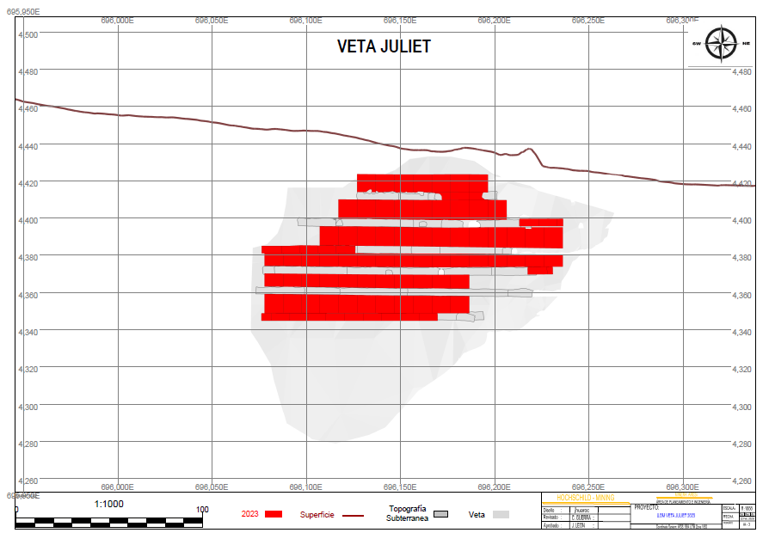

FIGURE 7.2 LONGITUDINAL PROJECTION VIEW OF MIRIAN VEIN

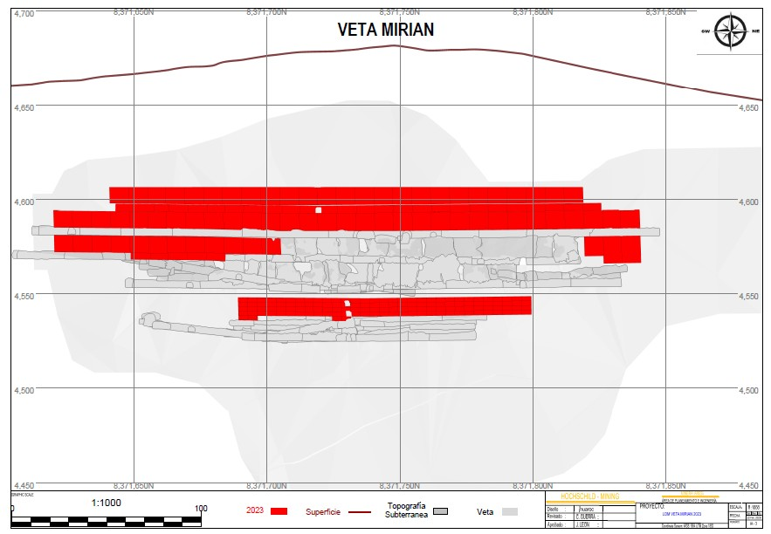

FIGURE 7.3 LONGITUDINAL PROJECTION VIEW OF PABLO VEIN

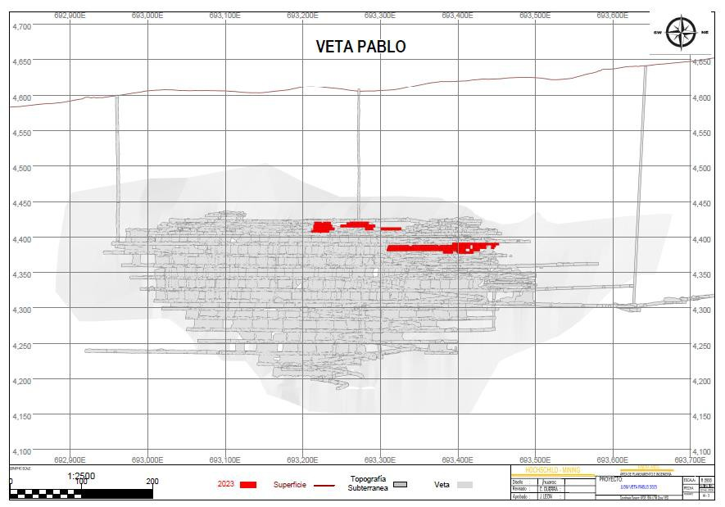

## 7.2 SAN JOSÉ MINE

The San José Property is located in the Province of Santa Cruz, Argentina, lying approximately between latitudes 46° 41‟ S and 46° 47‟ S, and longitudes 70° 17‟ W and 70° 00‟ W. The mine is located 1,750 km by air south-southwest of Buenos Aires and 230 km southwest of the Atlantic port of Comodoro Rivadavia. The nearest town is Perito Moreno, located approximately 50 km west of the Property. The San José operating mine is an epithermal silver-gold vein deposit. Hocschild has a 51% interest in the San José Property. McEwen Mining Inc. has the other 49% interest in the San José Property.

San José is a ramp access underground and open pit mining operation. The San José underground veins are accessed from three main portals: The Tehuelche Portal, the Kospi Portal and the Güer Aike Portal. Initially, two, small, inclined shafts were developed to provide access to the HVS and HVN veins. These shafts are now used to supplement the primary ventilation circuit. Main ramps are generally 4.0 m wide by 4.3 m high at a 12% gradient on the straight sections and

10.5% on the curves. A smaller profile is used in areas where truck access is not required. The main ramps are located about 50 m from the veins, depending upon the dip of the ore. Cross cuts to the ramp are centrally positioned on the vein and usually have an ore pass and a waste backfill pass.

The average mining width across all of the vein systems is approximately 2 m. The dip of the veins varies from 55º to 70º. Mechanized cut and fill mining using load-haul-dump scooptrams (LHDs) and jacklegs (pneumatic hand-held rock drills) or single-boom jumbos are utilized at San José. The majority of production ore is derived from the “uphole retreat” mining technique where a panel of approximately 50 m in length is drilled with upholes and retreated along strike. Horizontal “breasting” is only used on the initial lift in each stope. A “resue” mining technique is employed in narrow high-grade areas. Stoping areas are separated by 3 m high sill pillars. A timber floor mat, for narrow stopes, or cemented backfill, for wider stopes, is placed on the sill pillar (first lift).

The planned production rate is 1,650 tpd, processed, for 328 working da ys per year. A total of 89% of ore mined will be produced by stope mining. The balance of 11% ore mined will be produced from development ore mined. Three mining methods are planned, LOM, as listed below:

1. Mechanized cut and fill using 4 yd3 scooptrams and upper drill jumbos for 2% of total tonnes mined.

2. Longitudinal longhole using 4 yd3 scooptrams and Simba longhole drills for approximately 68% of production.

3. Open pit for 19% of total ore tonnes mined.

The primary ventilation utilizes the negative pressure system that is based on the main (primary) ventilation fan drawing the contaminated air from the mine. Fresh air enters the mine through either the main access declines or a dedicated fresh air raise where it is directed to each of the working areas via a secondary ventilation system.

Development waste rock is usually hauled to a surface stockpile and then rehandled through waste passes when it is required underground as backfill. Supplementary backfill is available from a surface waste dump. Hydraulic backfill is utilized for approximately 60% of the backfill requirements, and waste rock backfill is used for the remaining 40% of the requirements. The hydraulic back fill plant started operating in 2018.

The ground support consists of random rock and cable bolts with occasional mesh and shotcrete. Timber sets are also used in some areas.

Groundwater inflow is estimated to be between 8 and 20 L/s. Floor gradients are constructed to assist the natural flow of water to the sumps. Mine water is pumped to the main underground sumps using small, 7 ph, Flygt submersible pumps. Grindex 50 hp submersible pumps are used to pump the water to the surface settling ponds. Clean water is pumped directly from the settling pond to the processing plant and the main water reservoir or returned to the mine to be used as mine process water, for drilling, washing, etc.

The mining equipment consists of development and production drills, scoop trams, haul trucks, service vehicles and personnel transport vehicles. Scooptrams range in size from 0.75 yd3 to 6.0 yd3. A fleet of 30 t trucks is used to haul the ore to the surface. There are 196 pieces of mobile equipment. A list of company and contractor mobile equipment is presented in Table 7.6.

TABLE 7.6 SAN JOSÉ UNDERGROUND MINE EQUIPMENT FLEET

|  |  |  |
| --- | --- | --- |
| **Description** | **Principle Function** | **Quantity** |
| **Company Equipment** | | |
| Jumbo Drill | Mine Horizontal Development | 5 |
| Jumbo Drill | Production Horizontal Development | 5 |
| Jumbo Troidon Drill Rig | Production Vertical | 3 |
| LHD 0.6 m3 (0.75 yd3) | Production Mucking & Cleaning | 4 |
| LHD 1.2 m3 (1.5 yd3) | Production Mucking & Cleaning | 13 |
| LHD 2.0 m3 (2.5 yd3) | Production Mucking & Cleaning | 4 |
| LHD 3.1 m3 (4.0 yd3) | Production Mucking & Cleaning | 10 |
| LHD 4.8 m3 (6.0 yd3) | Development Mucking | 3 |
| Rock and Cable Bolter | Production Bolting | 7 |
| Rock and Cable Bolter | Development Bolting | 2 |
| Desatador | Scaling / Other | 1 |
| Haulage Truck 30 t | Ore Haulage | 8 |
| Haulage Truck 30 t | Waste (Development) Haulage | 5 |
| Shotcreter | Development Shotcreting | 3 |
| Telescopic lift | Sampling and Installing Services | 14 |
| Mixcrete | Transport Shotcrete | 6 |
| Custer | Transport Personnel | 9 |
| Bobcat | Cleanup Equipment | 1 |

TABLE 7.6 SAN JOSÉ UNDERGROUND MINE EQUIPMENT FLEET

|  |  |  |
| --- | --- | --- |
| **Description** | **Principle Function** | **Quantity** |
| U/G Pickups | Supervision | 59 |
| **Total Company Equipment** | | **162** |
|  | | |
| **Contractor Equipment** | | |
| Jumbo Drills | Mine Horizontal Development | 3 |
| LHD 1.8 m3 (2.2 yd3) | Development Mucking & Cleaning | 1 |
| LHD 3.1 m3 (4.0 yd3) | Development Mucking & Cleaning | 2 |
| Haulage Truck 30 t | Waste/Backfill Haulage | 2 |
| Haulage Truck 48 t | Open Pit | 3 |
| Explosive Truck | Transport Explosives | 3 |
| Rock and Cable Bolter | Rock and Cable Bolting | 3 |
| U/G Pickups | Supervision | 8 |
| Bulldozer | Moving Mineral | 1 |
| Excavator | Loading Mineral | 1 |
| Motor Grader | Road Maintenance | 1 |
| Hyab | Transport Materials | 2 |
| Custer | Transport Personnel | 4 |
| **Contractor Equipment** | | **34** |
| **Total Equipment** | | **196** |

***Note:*** *LHD = load-hual-dump scooptram, U/G = underground.*

There are 1,057 personnel working underground. A summary of company and contractor underground mine personnel is presented in Table 7.7. There are four groups of personnel: two working and two off.

TABLE 7.7 SAN JOSÉ UNDERGROUND MINE PERSONNEL

|  |  |
| --- | --- |
| **Description** | **Quantity** |
| **Company** | |
| Mine Superintendent | 1 |
| Assistant Mine Superintendent | 1 |
| Shift and Section Bosses | 15 |
| Supervisors | 46 |
| Operators and Helpers | 636 |
| **Total Company** | **699** |
|  | |
| **Contractor** | |
| Development Miners | 103 |
| Diamond Drillers | 32 |
| Food Service | 104 |
| Security | 34 |
| Mobile Equipment Mechanics | 54 |
| Service Personnel | 31 |
| **Total Contractor** | **358** |
|  | |
| **Total Mine Personnel** | **1,057** |

There is a total 7,245 m of mine operating development (Table 7.8), that will be expensed, and included in the OPEX, and 6,227 m of mine capital development required (Table 7.9), that will be capitalized, for a total of 13,472 m of development required, LOM.

TABLE 7.8 SAN JOSÉ LOM MINE OPERATING DEVELOPMENT

|  |  |  |
| --- | --- | --- |
| **Heading Size (W x H) (m x m)** | **2023 (m)** | **LOM Total (m)** |
| **Preparation Development** | | |
| 1.5 x 1.5 | 79 | 25 |
| 1.8 x 1.8 | 166 | 34 |
| 2.4 x 2.4 | 44 | 16 |
| 2.5 x 2.0 | 111 | 30 |
| 3.5 x 3.5 | 3,722 | 1,406 |
| 4.3 x 4.0 | 54 | 18 |
| 7.0 x 5.0 | 41 | 16 |

TABLE 7.8 SAN JOSÉ LOM MINE OPERATING DEVELOPMENT

|  |  |  |
| --- | --- | --- |
| Heading Size (W x H) (m x m) | 2023 (m) | LOM Total (m) |
| Total Preparation Develpment | 4,217 | 1,545 |
| 1.50 m Diameter | 920 | 250 |
| 1.80 m Diameter | 313 | 0 |
| Total Raisebore OPEX | 1,233 | 250 |
|  |  |  |
| Total OperatingDevelopment | 5,450 | 1,795 |

*Note: Numbers may not total correctly due to rounding.*

TABLE 7.9 SAN JOSÉ LOM MINE CAPITAL DEVELOPMENT

|  |  |  |  |
| --- | --- | --- | --- |
| **Heading Size (W x H)  (m x m)** | **2023  (m)** | **2024  (m)** | **LOM Total  (m)** |
| **Operational Infrastructure** | | | |
| 2.0 x 1.8 | 69 | 29 | 98 |
| 2.4 x 1.5 | 208 | 65 | 273 |
| 3.5 x 3.5 | 1,472 | 759 | 2,231 |
| 4.3 x 4.0 | 214 | 79 | 293 |
| 6.0 x 5.0 | 10 | 7 | 17 |
| **Total Infrastructure Capital** | **1,973** | **939** | **2,912** |
|  | | | |
| **Preparation Capital** | | | |
| 3.5 x 3.5 | 2,395 | 740 | 3,135 |
| **Total Preparation Capital** | **2,395** | **740** | **3,135** |
|  | | | |
| **Raisebore Capital** | | | |
| 1.80 m Diameter | 180 | 0 | 180 |
| **Total Raisebore Capital** | **180** | **0** | **180** |
|  | | | |
| **Total Mine Development Capital** | **4,548** | **1,679** | **6,227** |

**Note:** Numbers may not total correctly due to rounding.

Production from the San José Mine is estimated to deliver 940,300 tonnes of ore, grading 6.37 g/t Au and 341 g/t Ag, to the mill facility from January 1, 2023 to October 2024 (LOM), which

includes both development and production ore. A summary, and schedule, of remaining LOM

development and production ore is presented in Table 7.10.

TABLE 7.10 SCHEDULE FOR SAN JOSÉ LOM ORE DEVELOPMENT AND PRODUCTION

|  |  |  |  |  |
| --- | --- | --- | --- | --- |
| **Item** | **Units** | **2023** | **2024** | **LOM Total** |
| Development Ore | tonnes | 54,501 | 47,383 | 101,884 |
| Ag (g/t) | 321 | 94 | 215 |
| Au (g/t) | 4.66 | 3.71 | 4.22 |
| Production Ore | tonnes | 513,099 | 325,317 | 838,416 |
| Ag (g/t) | 328 | 401 | 357 |
| Au (g/t) | 5.93 | 7.74 | 6.63 |
| **Total Ore** | **tonnes** | **567,600** | **372,700** | **940,300** |
| **Ag (g/t)** | **328** | **362** | **341** |
| **Au (g/t)** | **5.81** | **7.23** | **6.37** |

The planned production rate is 1,650 tpd, processed, for 328 working days per year. As of December 25, 2022, there is a total 60 veins that will be mined at San José. Three of San José‟s principal veins are Odin, Betania and Escondida. Longitudinal projections views of these three veins are presented in Figures 7.4, 7.5 and 7.6, showing the LOM mine plan areas for 2023 and 2024.

As of December 25, 2022, there were 11,002 tonnes of ore stockpiled grading 336 g/t Ag and

8.00 g/t Au.

FIGURE 7.4 LONGITUDINAL PROJECTION VIEW OF ODIN VEIN

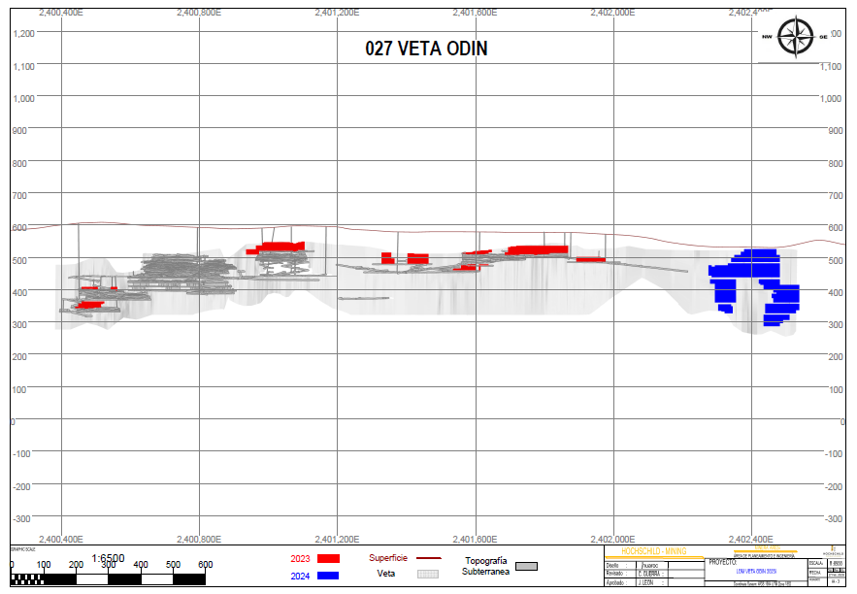

FIGURE 7.5 LONGITUDINAL PROJECTION VIEW OF BETANIA VEIN

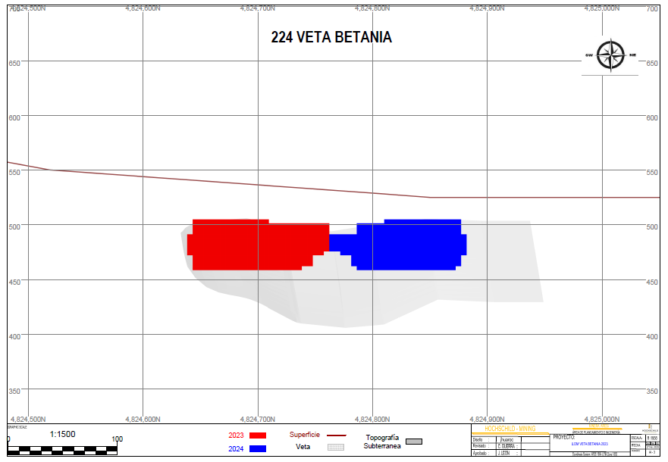

FIGURE 7.6 LONGITUDINAL PROJECTION VIEW OF ESCONDIDA VEIN

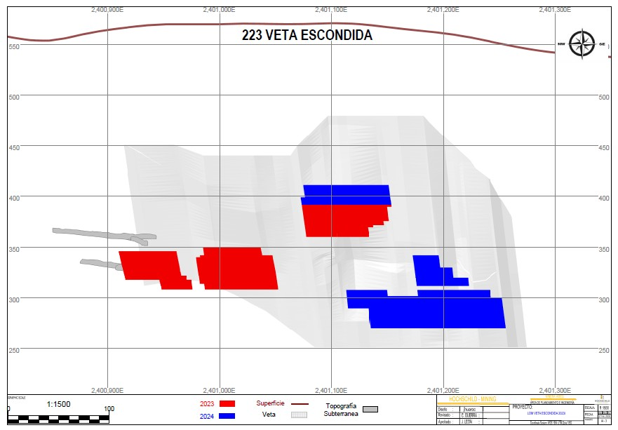

## 7.3 INMACULADA MINE

The Inmaculada Property is located at elevations between 3,900 and 4,800 m asl in the Puquio- Caylloma Belt and is approximately 210 km southwest of the city of Cuzco and 530 km southeast of Lima, the capital of Perú. The Inmaculada Mine has been in operation since 2012. Compañía Minera Ares is the manager and operator of the Mine. In 2013, Hocschild purchased International Minerals Corporation‟s (“IMC”) 40% interest in the Property and subsequently owns 100% of the Inmaculada Mine.

Inmaculada is a ramp access, underground mining operation. The Inmaculada Mine is accessed from three main portals: Boca Mina (Portal) 4500, 4400 and 4300. Ore production at Inmaculada started in June 2015 on the Angela Vein, the main producing vein. Mining of the Barbara Vein commenced in early 2019.

The planned production rate is 3,850 tpd, processed, for 349 working days per year. Eight mining methods are planned, LOM, as listed below:

1. Transverse longhole, Simba drilling and mucking with 6 yd3 scooptrams, planned for

3% of total ore mined.

2. Longitudinal longhole, Simba drilling and mucking with 6 yd3 scooptrams, planned for 13% of total ore mined.

3. Pillar recovery using longholes, Simba drilling and mucking with 6 yd3 scooptrams, planned for 5% of total ore mined.

4. Mechanized cut and fill using jumbo drilling for horizontal holes, and mucking with 4 and 6 yd3 scooptrams, planned for 44% of total ore mined.

5. Semi-mechanized cut and fill using jackleg drills for horizontal holes and mucking with 1.5 yd3 scooptrams, planned for 17% of total ore mined.

6. Semi-mechanized cut and fill using jackleg drills, uppers, and mucking with 1.5 yd3

scooptrams, planned for 1% of total ore mined.

7. Conventional cut and fill using jackleg drills for horizontal holes and mucking with slushers, planned for 2% of total ore mined.

8. Conventional cut and fill using jackleg drills, uppers, and mucking with slushers, planned for 3% of total ore mined.

The balance of production is 13% development ore.

Longhole stopes normally dip at around 60° but are used as low as 50°. Stopes are 19 m high, floor-to-floor. Backfill is either paste backfill, 90%, or cemented rockfill (“CRF”), 10%. CRF is used as sill pillars only. The drill pattern is nominally 2 x 2 m square. Every longhole hole gets a PVC liner. Emulsion explosive loading is done through the liner. Uppers are drilled and blaste d on a retreat basis. Stopes are generally 20 to 25 m along strike. A new slot raise is drilled and blasted with each stope. Mucking is with remote scooptrams.

All development is carried out by contractors. Production is carried out by the company.

The ground support consists of random rock, cable bolts, hydrobolts and split sets, with occasional mesh and shotcrete. Cable bolts are 7, 10 or 15 m long, hydrobolts 7 ft to 10 ft long. Three-foot split sets are also used. Permanent install areas get 7 ft long rebar bolts.

The mining equipment consists of development and production drills, scooptrams, haul trucks, service vehicles and personnel transport vehicles. Scooptrams range in size from 1.5 m 3 to 4.6 m3. A fleet of 30-t trucks is used to haul the ore to the surface. There are 49 pieces of company, and 140 pieces of contractor owned underground mobile equipment, for a total 189 pieces of underground mobile equipment. A list of Company and contractor underground equipment is presented in Table 7.11.

TABLE 7.11 INMACULADA UNDERGROUND MINE EQUIPMENT FLEET

|  |  |  |
| --- | --- | --- |
| **Description** | **Principle Function** | **Quantity** |
| **Company Equipment** | | |
| Jumbo Drill | Production Horizontal | 3 |
| T1D Drill Rig | Production Vertical | 4 |
| LHD 4.6 m3 | Production Mucking & Cleaning | 6 |
| LHD 1.7 m3 | Production Mucking & Cleaning | 3 |
| LHD 1.1 m3 | Production Mucking & Cleaning | 1 |
| LHD 0.6 m3 | Production Mucking & Cleaning | 1 |
| Bolters | Bolters | 1 |
| Scalers | Scalers | 1 |
| U/G Pickups | Supervision | 25 |
| Service Vehicle | Sampling and Installing Services | 2 |
| Other | Cistern, Grua Trucks / Other | 2 |
| **Total Company Equipment** | | **49** |
|  | |  |
| **Contractor Equipment** | | |
| Jumbo Drills | Mine Horizontal Development | 10 |
| LHD 4.6 m3 | Development Mucking & Cleaning | 13 |
| LHD 1.5 m3 | Development Mucking & Cleaning | 1 |
| Haulage Truck 30 t | Production Mineral Haulage | 16 |
| Haulage Truck 30 t | Waste Haulage | 19 |
| Mixer Madrina | Transport Shotcrete | 4 |
| Mixcrete | Transport Shotcrete | 15 |
| Shotcreter | Shotcreting | 8 |

TABLE 7.11 INMACULADA UNDERGROUND MINE EQUIPMENT FLEET

|  |  |  |
| --- | --- | --- |
| **Description** | **Principle Function** | **Quantity** |
| Rock and Cable Bolter | Rock and Cable Bolting | 11 |
| Scaler | Scaling | 8 |
| UG Pickups | Supervision | 18 |
| Personnel Transporter | Transport Personnel | 8 |
| Service Vehicle | Sampling and Installing Services | 3 |
| Other | Cistern, Grua Trucks / Other | 6 |
| **Total Contractor Equipment** | | **140** |
| **Total Equipment** | | **189** |

***Note:*** *LHD = load-hual-dump scooptram, U/G = underground.*

There are 2,236 personnel working underground, 380 company personnel and 1,856 contractor personnel. There are three groups of personnel: two working and one off. A summary of underground mine personnel is presented in Table 7.12.

TABLE 7.12 INMACULADA UNDERGROUND MINE PERSONNEL

|  |  |
| --- | --- |
| **Description** | **Quantity** |
| **Company** | |
| Mine Superintendent | 2 |
| Assistant Mine Superintendent | 2 |
| Shift and Section Bosses | 19 |
| Supervisors | 12 |
| Operators and Helpers | 345 |
| **Total Company** | **380** |
|  | |
| **Contractor** | |
| Development Miners | 905 |
| Shotcreters | 154 |
| Diamond Drillers | 108 |
| Truck Haulage | 123 |
| Food Service | 120 |
| Civil Works and Metal Mechanics Services | 206 |
| Security | 130 |
| Raise Borers | 18 |
| Mobile Equipment Mechanics | 48 |
| Service Personnel | 44 |
| **Total Contractor** | **1,856** |
|  | |
| **Total Mine Personnel** | **2,236** |

There is a total 11,374 m of mine operating development (Table 7.13), that will be expensed, and

38,431 m of mine capital development required (Table 7.14), that will be capitalized, for a total of 49,805 m of development required, LOM.

TABLE 7.13 INMACULADA MINE OPERATING DEVELOPMENT SUMMARY (METRES)

|  |  |  |  |  |  |
| --- | --- | --- | --- | --- | --- |
| **Heading Size (W x H)  (m)** | **2023  (m)** | **2024  (m)** | **2025  (m)** | **2026  (m)** | **LOM Total (m)** |
| 3.0 x 1.2 | 129 | 1,424 | 1,574 | 120 | 3,247 |
| 3.5 x 3.5 | 2,453 | 1,277 | 576 | 90 | 4,396 |
| 3.5 x 4.0 | 466 | 508 | 236 | 35 | 1,246 |
| 4.0 x 4.0 | 726 | 653 | 1,013 | 93 | 2,486 |
| **Total metres** | **3,774** | **3,862** | **3,399** | **339** | **11,374** |

**Note:** Numbers may not total correctly due to rounding.

TABLE 7.14 INMACULADA MINE CAPITAL DEVELOPMENT SUMMARY (METRES)

|  |  |  |  |  |  |  |
| --- | --- | --- | --- | --- | --- | --- |
| **Phase** | **Heading Size (W x H)  (m)** | **2023  (m)** | **2024  (m)** | **2025  (m)** | **2026  (m)** | **LOM Total (m)** |
| Operational  Infrastructure | 2.0 x 2.0 | 243 | 246 | 130 | 60 | 679 |
| 3.5 x 3.5 | 2,697 | 2,432 | 1,473 | 115 | 6,718 |
| 3.5 x 4.0 | 428 | 356 | 812 | 80 | 1,676 |
| 4.0 x 4.0 | 2,047 | 1,436 | 1,278 | 128 | 4,890 |
| 4.5 x 4.0 | 4,687 | 5,279 | 2,328 | 153 | 12,447 |
| 4.5 x 4.5 | 748 | 143 | 0 | 0 | 892 |
| 6.0 x 4.5 | 32 | 0 | 0 | 0 | 32 |
| **Total Operational** | | **10,882** | **9,893** | **6,022** | **537** | **27,333** |
| **Infrastructure** | |  |  |  |  |  |
|  | | | | | | |
| Preparation | 1.2 x 2.4 | 31 | 134 | 62 | 22 | 249 |
| 2.4 x 2.7 | 1,120 | 1,208 | 738 | 126 | 3,191 |
| 3.5 x 3.5 | 132 | 0 | 112 | 0 | 244 |
| 3.5 x 4.0 | 2,251 | 1,967 | 281 | 23 | 4,522 |

TABLE 7.14 INMACULADA MINE CAPITAL DEVELOPMENT SUMMARY (METRES)

|  |  |  |  |  |  |  |
| --- | --- | --- | --- | --- | --- | --- |
| **Total Preparation** | | **3,534** | **3,308** | **1,193** | **171** | **8,206** |
| Raise Climber | 2.8 x 2.8 | 730 | 1,499 | 662 | 0 | 2,891 |
| **Total Raiseboring** | | **730** | **1,499** | **662** | **0** | **2,891** |
| **Total Mine Capital** | |  |  |  |  |  |
| **Development** | | **15,146** | **14,700** | **7,877** | **707** | **38,431** |

**Note:** Numbers may not total correctly due to rounding.

Production from the Inmaculada Mine is estimated to deliver 5,211,400 tonnes of ore, grading

3.63 g/t Au and 155 g/t Ag, to the mill facility from January 1, 2023 to December 2026 (LOM), which includes both development and production ore. A summary and schedule of remaining LOM development and production ore is presented in Table 7.15.

TABLE 7.15 INMACULADA MINE ORE EXTRACTION SCHEDULE

|  |  |  |  |  |  |  |
| --- | --- | --- | --- | --- | --- | --- |
| **Item** | **Units** | **2023** | **2024** | **2025** | **2026** | **LOM Total** |
| Development Ore | tonnes | 181,679 | 251,214 | 229,773 | 10,162 | 672,828 |
| Ag (g/t) | 205 | 98 | 89 | 79 | 123 |
| Au (g/t) | 4.68 | 2.72 | 2.68 | 2.44 | 3.23 |
| Production Ore | tonnes | 1,161,321 | 1,091,911 | 1,115,053 | 1,170,286 | 4,538,571 |
| Ag (g/t) | 161 | 213 | 158 | 111 | 160 |
| Au (g/t) | 3.84 | 4.73 | 3.39 | 2.87 | 3.69 |
| **Total Ore** | **tonnes** | **1,343,000** | **1,343,125** | **1,344,826** | **1,180,449** | **5,211,400** |
| **Ag (g/t)** | **167** | **191** | **146** | **111** | **155** |
| **Au (g/t)** | **3.96** | **4.35** | **3.27** | **2.87** | **3.63** |

***Note:*** *Numbers may not total correctly due to rounding.*

There are a total of 25 veins that will be mined at Inmaculada, LOM. Two of Inmaculada‟s principal veins are Angela and Millet. A longitudinal projection and plan views of these veins are presented in Figures 7.7, 7.8 and 7.9, showing the LOM mine plan areas from 2019 to 2022.

As of December 25, 2022, there were 2,400 tonnes of ore stockpiled on surface, grading 143 g/t Ag and 3.13 g/t Au.

FIGURE 7.7 LONGITUDINAL PROJECTION AND PLAN VIEW OF MILLET VEIN

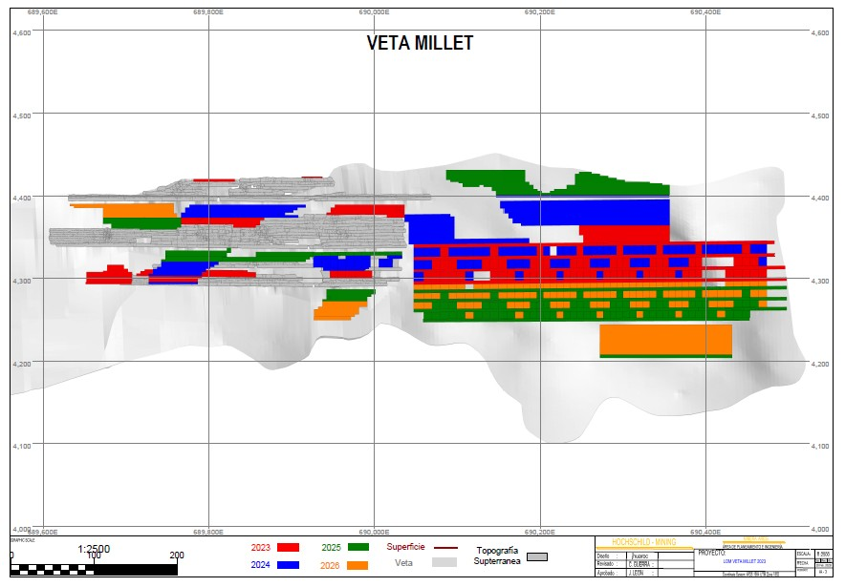

FIGURE 7.8 LONGITUDINAL PROJECTION AND PLAN VIEW OF ANGELA VEIN

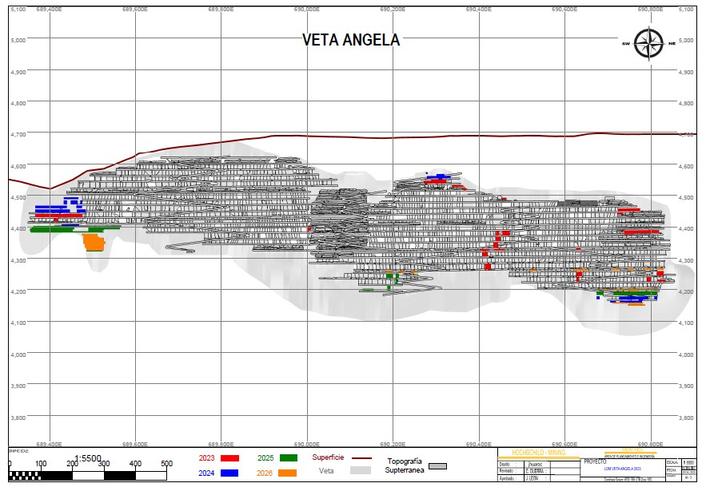

FIGURE 7.9 LONGITUDINAL PROJECTION VIEW OF ANGELA NE VEIN

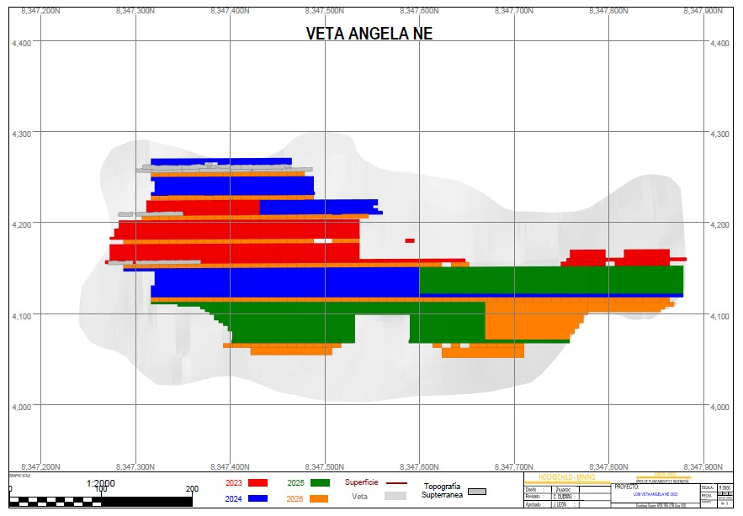

# MINERAL PROCESSING

## 8.1 SELENE/PALLANCATA PROCESS PLANT

The Pallancata mine complex is the source of ore that is hauled 22 km to the Selene plant. The plant normally processes up to 2,800 tpd; the Selene nameplate capacity is 3,000 tpd. The Selene plant is shown in Figure 8.1; the orange-coloured fine ore bins are on the left, the main plant (white) is in the centre and the multi-windowed assay laboratory is on the right. The Selene Plant was not visited by P&E in early 2023. Instead, detailed information on 2022 processing at the Selene plant was kindly forwarded by senior staff at the Hochschild office in Lima.

FIGURE 8.1 SELENE PLANT, PHOTOGRAPH BY P&E, JANUARY 2022

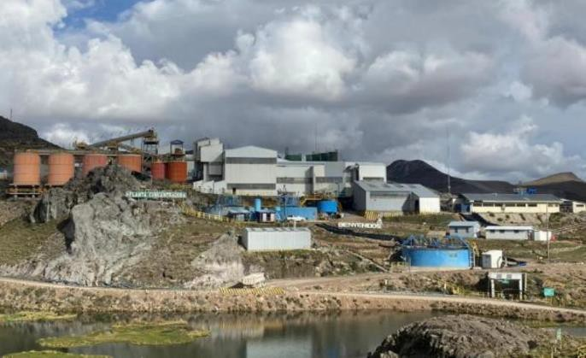

The Selene ore processing facility consists of conventional crushing, grinding, silver -gold- sulphide flotation, concentrate filtering packaging shipping components. The Selene plant has an ore washing facility that permits efficient handling of wet, clay-rich, sticky feed. The processing rate has varied over the last 10 years with the nominal capacity of 2800 t per operating day reached in the last four years.

In 2021, the Selene Process Plant had operated a total of 197 days, slightly over half (53.9%) of available time. In 2022, this pattern was followed with the plant being operated a total of 201 days – 55% of the available time. The principal downtime was again related to accumulation of feed from the mines (40% of available time). The average operating rate was 2,782 tpd during 2022. During operations, the ore washing circuit, both grinding circuits and all three flotation circuits were fully utilized. Due to the skills of the operating staff, the Selene plant has continued to perform efficiently during this on-off operation strategy.

The Selene plant produces a silver-gold flotation concentrate which is pressure filtered and “Big Bagged” in a semi-moist condition for shipment to a Glencore smelter/refinery in Mexico or others as selected by Hochschild. The pressure filters produce a relatively dry concentrate with moisture content ranging between 8.0% and 9.5%.

Ore is delivered to the mill in standard 20-25 t capacity trucks and is placed in specific stockpiles near the crusher feed according to grades determined by underground mine sampling and assaying at the Selene laboratory.

The blending of feed to the mill is normally controlled by the Geology Department; ore is transferred by a loader one bucket at a time from selected stockpiles to a 400 mm grizzly on top of a 180-t surge bin. This bin feeds the Nordberg C100 primary crusher.

Moist, clay-rich ore can result in buildup in hoppers and feeders and this requires dislodging. This dislodging is normally achieved on the first grizzly and in the primary crusher bin by the use of hand tools. ROM (run of mine) ore is sometimes relatively dry but usually contains a significant amount of metal debris, some of which is removed by hand followed by two magnets – the first one on jaw crusher feed, the second magnet on the secondary crusher feed.

The Hochschild-designed clay washing system was installed in the Selene plant in 2013. This system removes clay-rich fines (clay can be ~10% of ore weight) by diverting, with a vibrating grizzly, minus 3.5 inches (88 mm) ore from the primary crusher feed to the wash circuit. The unique wash facility‟s main components are a drum washer, a triple deck vibrating screen, a cyclone and a thickener. A slurry containing the fine solids (< ¼ inch, 6 mm) is delivered to ball mill feed as a dilute slurry; the accounting of this stream‟s tonnage is achieved by flow and slurry density measurement. Moist +¼ inch (6 mm) solids are conveyed to the secondary crusher feed to accompany primary crusher discharge. The operation of the washing system results in a relatively dust-free crushing plant.

The secondary crusher is a Nordberg 300 HP cone crusher set to 2 inches (50 mm) in open circuit with an Osborn double deck screen. The third crushing stage is three Nordberg 200 short head crushers operating in parallel and in closed circuit with 6 ft by 14 ft (1.8 m by 4.3 m) screens. The final screen size in the crushing circuit has 3/8 inches (9 mm) openings.

The crushing plant and washing circuit typically operate 17 h/d at rates up to 165 t/h. The high operation time is partially due to limited fine ore capacity which is nominally 2,200 t (orange - coloured vessels in Figure 8.1) – 70% of the daily mill capacity. The 7 fine ore silos are flat bottomed which undoubtedly limits “live” capacity to significantly below 2,200 t.

The Selene plant has been modified and expanded over the many years of operation. The current plant flowsheet is shown in Figure 8.2. A previously planned expansion of control room-based automation and control had been implemented in 2021.

FIGURE 8.2 2022 SELENE PLANT FLOWSHEET

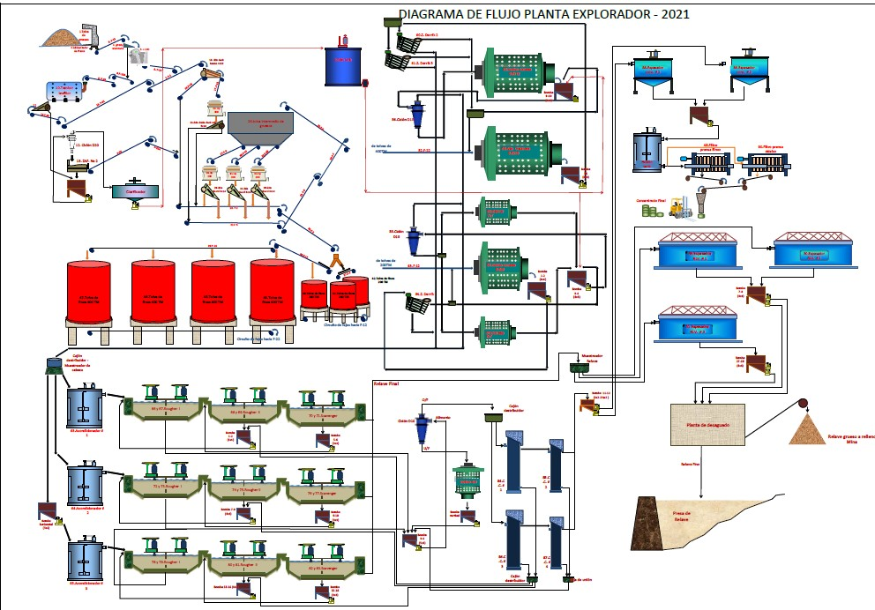

There are two grinding circuits which are composed of a total of five grinding mills that are supplied from the seven small fine ore bins. Number 1 grinding circuit is composed of three small mills and can process 40-50 t/h. Number 2 circuit is composed of two larger mills capable of processing about 60-70 t/h. The ore Work Index, measured during audits of each circuit, ranges from 13.5 to over 18 kWh/t - values that can be considered to be moderately high. The grind size distribution, which is achieved with a combination of cyclones and Derrick screens, is relatively coarse for a flotation process - in October 2022, 23.0% +100 Mesh, 56.3% -200 Mesh.

The fines collected by the washing circuit are distributed equally to the two grinding circuits. The grinding discharges are combined and automatically sampled every 15 minutes by a laboratory technician-secured two-stage sampler. This is the plant feed sample. The grinding discharge is subsequently split three ways to feed the three separate rougher-scavenger flotation circuits. The rougher flotation concentrates are combined and split to feed two cleaner/recleaner column cell circuits, the product of which is combined for concentrate sampling, thickening and filtration.

Each of the three rougher-scavenger flotation circuits is composed of six 250 ft3 (7.1 m3), two cells each for first and second roughers and for the scavenger. Interference of flotation cell froth movement caused by plastic debris had been eliminated years earlier by a dedicated Derrick screen on flotation feed. Rougher concentrate had been observed by P&E in 2022 being reground by the 4 ft by 4 ft mill in a closed circuit with a cyclone. Cyclone overflow feeds the cleaner circuit which is composed of two 5 ft (1.5 m) by 9 m high first stage column cell cleaners and two 3 ft (0.9 m) by 9 m high Goldex second stage column flotation cells. These cleaner cells have been observed during P&E plant visits to be operating very well with good wash distribution (Figure 8.3). The column air injection systems had recently been upgraded to a cavitation system that creates micro-sized bubbles. The new system also circulates the pulp within the column.

FIGURE 8.3 TOP OF COLUMN CLEANER CELL AND FROTH WASHING

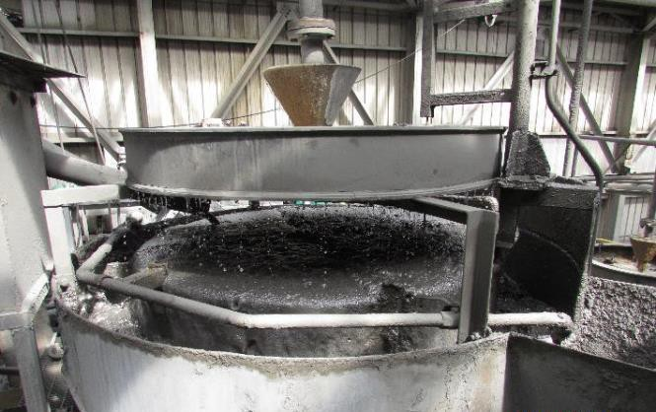

The concentrate is thickened, sampled every 8 minutes, and dewatered by pressure filtration using two automated presses. One filter press is a 19-frame Cidelco unit (Figure 8.4) and the second filter press is a 25-frame Eimco unit. This product is “Big Bagged” in 1,000 kg lots and each bag is sampled in advance of truck transport in 30-33 bag lots to a port for shipment to a smelter (Figure 8.5).

FIGURE 8.4 CONCENTRATE PRESSURE FILTER

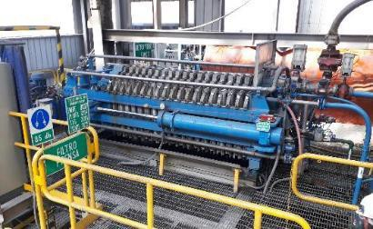

During 2022, 599,799 dry tonnes of Pallancata ore grading 0.69 g/t Au and 152 g/t Ag were processed at the Selene facility. The total tonnage milled was slightly higher than planned -109%, grades of gold and silver were also less than planned (second budget plan)– 0.74 g/t (93% of planned) and 165 g/t (92%) respectively. Recoveries were also lower than planned – 88.7 % vs 89.5% for gold, 87.2% vs. 88.2% for silver.

FIGURE 8.5 CONCENTRATE ASSEMBLED FOR SHIPMENT, JANUARY 2022

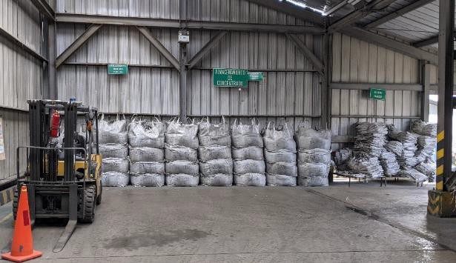

A total of 7,838 tonnes of concentrate containing 43.58 g/t Au and 9,395 g/t Ag were produced in 2022. The “effective” recoveries of gold and silver were 88.7% and 87.2% respectively. These results can be considered to represent good performance of the Selene plant.

### 8.1.1 Recent Selene Plant Performance

A summary of Selene ore processing and metallurgical performance for the last decade is shown below in Table 8.1. Recovery of silver remained reasonable high in 2021 in spite of the lowest feed grade in 10 years.

Geo-metallurgical grinding and flotation tests continued to be conducted in 2022.

To verify performance that meets process objectives, there is an active metallurgical testing and process audit program at the Selene plant. The 2022 internal metallurgical audits include:

* Grinding (monthly plan for each of two circuits) audit reports for 7 of 12 months were available in 2022, and
* Flotation (monthly plan – 7 of 12 months in 2022).

Records of audits for crushing, dewatering and water balances were not available for 2022.

The 2022 audits revealed good grinding performance and consistent, balanced operation of the three rougher and two cleaner flotation circuits.

Routine process controls are size analyses analysis of fines (weekly), pH control (continuous), and flotation testing.

Example key operating statics at the Selene plant are shown in Table 8.2. The plant performance, as indicated by all parameters, remains stable with consistent energy consumption and lower reagent consumption. A summary of available cost data is presented in Table 8.3.

TABLE 8.1 SELENE METALLURGICAL PERFORMANCE 2012-2022

|  |  |  |  |  |  |  |  |  |  |  |  |
| --- | --- | --- | --- | --- | --- | --- | --- | --- | --- | --- | --- |
| **Year /Description** | **2012** | **2013** | **2014** | **2015** | **2016** | **2017** | **2018** | **2019** | **2020** | **2021** | **2022** |
| Dry ore |  |  |  |  |  |  |  |  |  |  |  |
| processed, t | 1,094,250 | 1,088,712 | 1,051,068 | 522,430 | 244,765 | 470,903 | 717,652 | 915,877 | 519,611 | 538,684 | 559,799 |
| Ag g/t | 256.04 | 264.12 | 237.62 | 317.23 | 381.03 | 441.8 | 362 | 277.7 | 246.6 | 224 | 150.8 |
| Au g/t | 1.09 | 1.127 | 1.03 | 1.275 | 1.864 | 1.781 | 1.298 | 1.01 | 0.872 | 0.92 | 0.688 |
| Conc. dry t | 8,036.99 | 8,257.86 | 8,891.93 | 5,220.16 | 3,273.43 | 7,061.94 | 10,856 | 14,221 | 7,010 | 7,227 | 7,838 |
| Conc. Ag g/t | 28,795.44 | 28,730.88 | 22,831.17 | 21,419.83 | 24,770 | 26,174 | 21,343 | 15,874 | 16,872 | 14,031 | 9,395 |
| Conc. Au g/t | 101.51 | 104.83 | 85.16 | 96.85 | 116.26 | 102.8 | 75.63 | 56.1 | 57.34 | 56.13 | 43.58 |
| Conc Ag  content, oz | 7,368,699 | 7,627,943 | 6,527,019 | 3,632,541 | 2,998,477 | 6,689,067 | 7,449,414 | 7,258,825 | 3,678,273 | 3,260,576 | 2,367,522 |
| Conc Au  content, oz | 25,996 | 27,832 | 24,344.93 | 16,254.23 | 14,670.31 | 23,340.71 | 26,399 | 25,952 | 12,925 | 13,045 | 10,977 |
| Moisture content % |  | 16.5 | 17.23 | 11.58 |  | 8.16 | 8.37 | 8.4 | 8.73 | 9 (est.) |  |
| Concentration ratio |  | 132 | 118 | 99.6 | 75 | 66.7 | 66.1 | 64.4 | 74.1 | 74.5 | 72.49 |
| Met rec‟y Ag, % | 82.6 | 82.51 | 81.28 | 84.37 | 83.41 | 86.54 | 87.57 | 87.38 |  |  | 87.63 |
| Met rec‟y Au % | 68.55 | 70.54 | 69.96 | 76.65 | 86.94 | 88.84 | 88.89 | 88.55 |  |  | 86.12 |
| Ag, tails g/t | 46.93 | 48.95 | 46.92 | 42.7 | 50.43 | 50.04 | 40.86 | 32.29 |  |  |  |
| Au, tails g/t | 0.393 | 0.34 | 0.32 | 0.311 | 0.314 | 0.24 | 0.164 | 0.129 |  |  |  |
| Eff rec‟y Ag, % | 81.8 | 81.61 | 80.42 | 83.64 | 84.35 | 87.02 | 88.18 | 88.76 | 88.75 | 90.97 | 88.67 |
| Eff rec‟y Au, % | 67.94 | 69.97 | 69.28 | 75.88 | 87.38 | 89.04 | 89.15 | 87.34 | 89.29 | 90.23 | 87.24 |
| Gain/loss\* Ag oz | 71,904 |  | 69,515 | 0.9% of conc | 34,270 | 73,254 | -283,000\*\* |  |  |  |  |
| Gain/loss\* Au, oz | 233.92 |  | 238.58 | 0.9% of conc | 78.4 | 1,461 | -1,138\*\* |  |  |  |  |

**Note:** \* metallurgical recovery versus effective recovery; \*\*actual vs. budget.

TABLE 8.2 SELENE PLANT OPERATING STATISTICS 2014-2022

|  |  |  |  |  |  |  |  |  |
| --- | --- | --- | --- | --- | --- | --- | --- | --- |
| **Component** | **Units** | **2014** | **2015** | **2016** | **2017** | **2018** | **2019** | **2020** |
| Operating | Days | 351 | 252 | 120 | 269 | 305 | 341.5 | 186.3 |
| Throughput per operating day | tpd | 2,994 | 2070 | 2034 | 1750 | 2350 | 2683 | 2,790 |
| Energy | kwh/t | 30.51 | 34.15 | 35.29 | 37.5 | 36.06 | 34.91 | 34.31 |
| Grinding balls | kg/t | 1.12 | 1.13 | 1.28 | 0.88 | 1.18 | 1.1 | 1.1 |
| Xanthate | kg/t | 0.045 | 0.06 | 0.05 | 0.05 | 0.036 | 0.046 | 0.042 |
| Danafloat 771 | kg/t | 0.01 | 0.014 | 0.013 | 0.014 | 0.013 | 0.014 | 0.015 |
| Aerofloat | kg/t |  |  | 0.021 | 0.021 |  |  | 0.016 |
| Frother MIBC | kg/t | 0.021 | 0.04 | 0.035 | 0.037 | 0.032 | 0.031 |  |
| Flocculent | kg/t | 0.007 | 0.01 | 0.008 | 0.018 | 0.004 | 0.016 | 0.004 |

TABLE 8.3 SELENE PLANT OPERATING COSTS 2013-2022

|  |  |  |  |  |  |  |  |  |  |  |
| --- | --- | --- | --- | --- | --- | --- | --- | --- | --- | --- |
| **Weighted Average Operating Costs $US/t Milled** | | | | | | | | | | |
| **Cost Component** | **2013** | **2014** | **2015** | **2016** | **2017** | **2018** | **2019** | **2020\*\*** | **2021** | **2022\*\*\*** |
| Crushing | 3.75 | 3.55 | 4.14 | 1.35 | 1.58 | 4.13 | 3.57 |  | 4.42 |  |
| Grinding | 6.32 | 6.27 | 6.83 | 2.25 | 2.44 | 6.49 | 6.31 |  | 6.7 |  |
| Flotation | 1.3 | 1.37 | 1.67 | 0.77 | 0.58 | 1.5 | 1.39 |  | 1.55 |  |
| Concentrate handling | 0.86 | 0.81 | 1.02 | 0.56 | 0.46 | 0.95 | 0.84 |  | 0.98 |  |
| Tailings | 0.81 | 0.86 | 0.83 | 0.47 | 0.54 | 0.81 | 0.79 |  | 0.88 |  |
| General services |  |  |  | 5.18 | 2.76 | 1.53  (other) | 1.88 |  | 2.11 |  |
| Laboratory |  |  |  | 0.48 |  |  |  |  |
| Energy |  |  |  | 3.43 |  |  |  |  |
| Maintenance |  |  |  | 1.27 | 2.35 |  |  |  |
| **Total** | **13.04** | **12.85** | **14.49** | **15.76** | **10.71\*** | **15.41** | **14.78** | **15.2** | **16.65** | **12.04** |
| % change from previous year | 11.3 | -1.5 | 11.3 | 8.8 | -15\* |  | -4.1 |  | 9.5 |  |

**Notes: \*** Energy costs excluded, \*\* January to September 2020; \*\*\* energy, maintenance, general services not available.

### 8.1.2 Sampling, Measurement and Accountability

Sampling and key plant measurements (ore tonnage and moisture) as well as analytical methods, procedures and quality assurance are the responsibility of the Selene Laboratory. The procedures for the measurement of ore tonnage and moisture have been independently reviewed in recent years and found to be acceptable. While the tonnage of slurry splitting from the grinding circuit to each of the three rougher flotation circuits feed may be imprecise, no significant discrepancy was revealed in the regular flotation audits. The two-stage sampling equipment for combined heads (flotation feed) and for tails as well as thorough and rigorous concentrate sampling produce reliable data for accurate determination of metallurgical performance.

### 8.1.3 Selene Laboratory

Selene laboratory facilities, equipment, and procedures are consistent with high standards found at all Hochschild laboratories. These standards have been validated by extensive training, standards integration and rigorous auditing by external and internal experts.

The Selene laboratory is responsible for all mill sampling. The laboratory prepares and assays samples of ground ore, tailings, concentrates, and samples from metallurgical tests and process audits as well as a large number of samples from mine geology. The laboratory, under the direction of manager Sr. Maximo Mendoza, has a staff of 19 people.

The laboratory processes over 200 samples a day from the plant, metallurgical testing, geology and exploration, and environment. The laboratory also processes a portion of the exploration samples for the Pallancata Mine with other exploration samples sent to a commercial facility in Lima.

The laboratory has a functional LIMS (Laboratory Information Management System). The geology samples are processed in a separate building with a separate dust management capability. The laboratory had been subject to extensive external auditing procedures in the past but now audits are conducted internally. Two audits were conduct in 2022 – the first 2-3 June and the second 23-26 December. These very rigorous audits identified several non-conformities. None of the non-conformities appear to have represented a significant compromise to the precision and accuracy of analytical results. The Selene laboratory participated in two “round robin” exchanges in 2022 (April and September). The Selene gold, lead, silver and zinc results were “satisfactory” for each exchange when compared to certified standards, (“satisfactory” is actually an understatement – the performance criteria are very strict). Copper was also “satisfactory” in the April tests. Proficiency Certificates were received from the Standards Council of Canada.

Laboratory equipment have been observed by P&E in earlier visits to be in clean, orderly and safe condition. Example facilities, the neat and clean conditions, are shown in Figure 8.6.

FIGURE 8.6 SELENE SAMPLE PREPARATION AND ASSAY LABORATORY

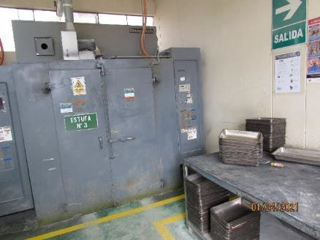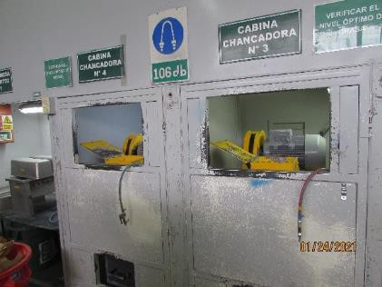

Temperature Controlled Dryers Sample Crushers

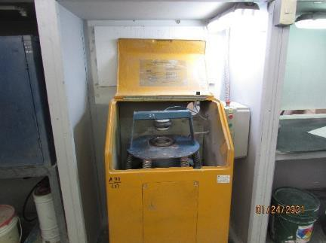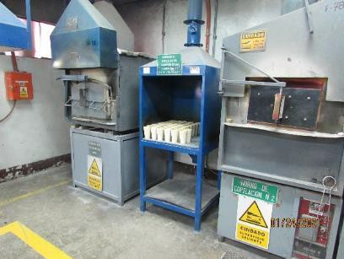

Pulverizer Foundry Furnace

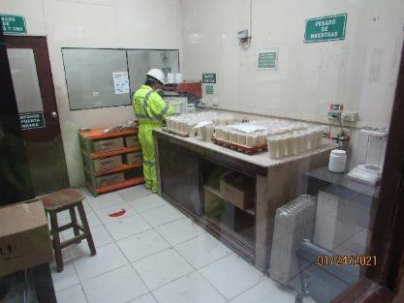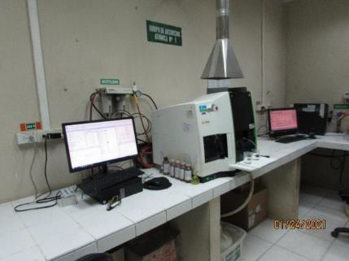

Atomic Absorption Equipment Sample Prep and Weighing

In January 2022, P&E had received and reviewed copies of the Selene procedures for fire assay – gold and silver, and for atomic absorption – silver. A 70-sample fire assay batch contains 6 controls – 1 blank, 1 sterile (quartz), 2 standards as well as fine and coarse duplicates. The assay procedures are judged by P&E to be precise and thorough.

Moisture samples of ball mill feed are taken every 30 minutes by laboratory staff from plant conveyor belt numbers 12 and 22. Each “big bag” of concentrate is pipe-sampled in a strict process to determine metal as well as moisture content.

The laboratory is also responsible for managing and collecting samples from secure automatic in-process samplers – flotation heads and tails (the two-stage Vezin samplers cut samples every 15 minutes of heads and tails) and concentrate (every 8 minutes).

The Selene laboratory has implemented protocols for sample collection, drying and assaying – these protocols are listed in Table 8.4. Sample drying temperatures have been investigated and the selected temperatures are 100°C +/- 10°C for process samples and 130°C +/- 10°C for Geology and Exploration samples. Tests had shown that there was no significant difference in assay results of most samples following drying at either temperature.

TABLE 8.4 SELENE LABORATORY PROTOCOLS

|  |  |
| --- | --- |
| **Code** | **Protocol name** |
| SGC-INS-OPE-01 | Tailings, head and other sampling |
| SGC-INS-OPE-02 | Sampling of feed conveyor belt |
| SGC-INS-OPE-03 | Metallurgical concentrate sampling |
| SGC-INS-OPE-06 | Beneficiation plant sample drying |
| SGC-INS-OPE-10 | Drying geological samples |
| SGC-PRO-OPE-04 | Geology sample preparation |
| SGC-PRO-OPE-05 | Determination of silver and gold by Fire Assay |
| SGC-PRO-OPE-06 | Determination of silver by atomic absorption |

### 8.1.4 Tailings

Flotation tailings are thickened in three 50 ft (16 m) thickeners to a density of 1,400 g/L and pumped to a dewatering plant where up to 40 to 45% of the solids had been removed for transport to the Pallancata mine for backfill. Paste tailings technology is no longer employed at the Pallancata Mines – hydraulic fill and cemented rock fill has been 2used in the narrow stopes. Instead, about 850 tpd of sand is separated (from the fresh tailings, and a proportion is stockpiled for the closure of tailings facilities No. 1 and No. 2. The residual tailings (fines) are pumped directly to the No. 3 failings facility.

The No. 3 tailings facility (Figure 8.7) is 5.5 km from the Selene plant. This facility had been commissioned in 2012. Multi-stage high pressure centrifugal pumps had been initially used to pump tailings to the facility. For reliability reasons, the centrifugal pumps have been held in standby status and tailings pumping is performed by a 3-stage Geho piston pump. As is, No. 3 tailings facility has the capacity to contain tailings produced by Selene through to mid 2022. A lift of the tailings liner and main embankment was undertaken in May 2022.

FIGURE 8.7 SELENE NO. 3 TAILINGS FACILITY, JANUARY 2022

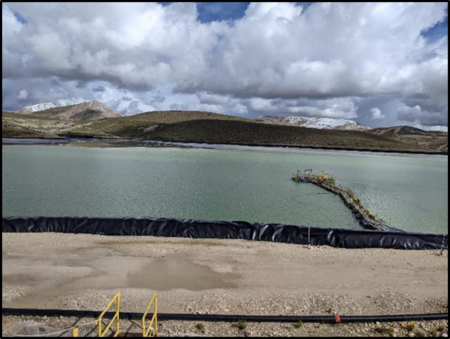(Reclaim Barge Right Centre)

### 8.1.5 Selene/Pallancata Environmental, Permitting and Social

Environmental, permitting and social initiatives are not audited by P&E. The following is a brief review of readily available information.

The environmental aspects of the Selene and Pallancata facilities are extensively monitored by company technicians and results are reviewed by Compania Minera Ares management. Reports are prepared and submitted to government agencies on a quarterly basis on water and effluent quality and on a semi-annual basis on groundwater and biological aspects. A solid waste report is prepared and submitted annually. The site performance on all of these aspects has met pre -set objectives.

Environmental permitting is facilitated by regular updates of site EIA‟s (Environmental Impact Assessments). These are prepared and reviewed by SENACE (Servicio National de Certification Ambiental) agency an agency of the Ministerio del Ambiente. The updated Pallancata EIA was approved in 2017 and currently remains in effect. The Selene EIA update had been approved in

2012 and the relevant baseline assessment has been under review.

In 2015, Hochschild implemented what is termed - the Environmental Corporate Objective (ECO) – an initiative that is applicable at all sites and facilities. The ECO score is intended to encourage all employees to comply with a common environmental mission, and assists in making everyone accountable for their actions. Components of the ECO program includes: discharge limit compliance, minimal environmental incidents, reduction in water use and waste generation as well as limited regulator observations. The average ECO Score for all Hochschild operations and developing sites was 5.29 out of 6 in 2022.

## 8.2 SAN JOSÉ PROCESS PLANT

### 8.2.1 Mineral Processing at San José

The 1,650 tpd San José processing plant in the Santa Cruz Province of Argentina (Figure 8.8) is a relatively complex 16-year-old facility which includes conventional crushing, grinding, and production by flotation of a silver-gold-sulphide concentrate. The flotation concentrate tonnage is normally split between (i) leaching with on-site doré metal production, and (ii) filtering, bagging and the shipment of moist concentrate to a smelter/refinery in Korea for processing. On-site doré metal production facilities are composed of the intensive cyanide extraction of silver and gold from the flotation concentrate followed by electrowinning (EW) of gold and silver from “pregnant” leach solution (PLS). A conventional foundry produces silver-gold doré bars. A small Merrill Crowe (MC) facility was formerly dedicated to recovering gold and silver from cyanide leach tailings pond water but has recently also been used to process the overflow of the third countercurrent decant (CCD) unit.

The most recent visit by P&E occurred in January 2022. However, at that time the whole mine site was shut down due to a Covid-19 outbreak, so the availability of on-site information was limited. The updates shown in this section of the Processing report originate from inform ation kindly provided by Hochschild PLC as well as derived from public information sources.

FIGURE 8.8 SAN JOSÉ PROCESS PLANT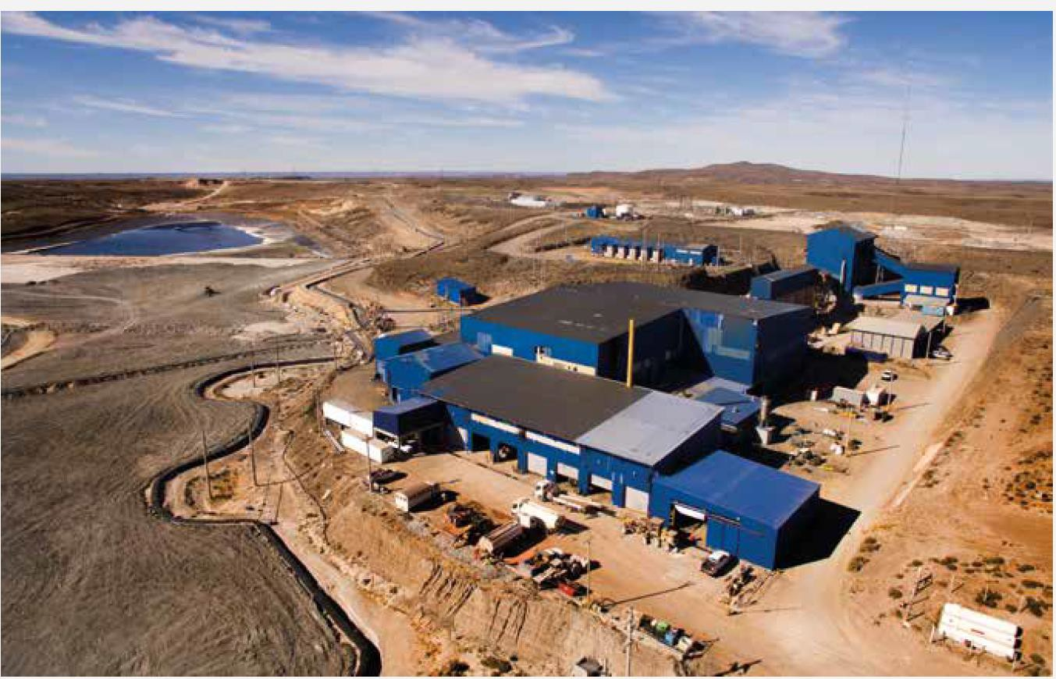

The San Jose plant had been annually visited for 10 years by P&E for audit purposes – the most recent visit with the plant in operation was in January 2021. The plant was then observed to be in a good functioning condition – with crushing, grinding, flotation and product filtering operating smoothly. Also, the intensive leaching reactor (ILR) leaching, counter current decantation (CCD) and clarification circuits were observed to be operating smoothly.

Housekeeping and attention to worker safety continued to be plant management priorities. In

2021, two on-going health and safety challenges were receiving special attention – ambient dust levels in the crusher plant and infrequent elevated gaseous cyanide levels in the intensive leaching/CCD area.

During the most recent year‟s operation, from December 26, 2021 to December 25, 2022, operations were interrupted, by Covid-19 restrictions in January as well as a fire on January 22 in the crusher facility1. Operating time of grinding and flotation was about 337 days during 2022 – the leaching circuit, somewhat less. The significant interruptions are listed in Table 8.5.

TABLE 8.5 SAN JOSÉ PLANT INTERRUPTIONS 2022, % OPERATING TIME, DAYS

|  |  |  |  |
| --- | --- | --- | --- |
| **Month** | **Main Issue** | **Grinding, Flotation, % of Time Scheduled** | **Leaching Circuit %** |
| January | Covid -19 January 9; Fire in crusher plant January 22. Equipment rented to continue crushing | 64 | 62 |
| February | Mill restart Feb 14 with rented crusher equipment @ 50% capacity | 50 | 50 |
| March | None reported | 100 | 74 |
| April | None reported | 97 | 92 |
| May | None reported | 97 | 90 |
| June | None reported | 90 | 89 |
| July | None reported | 97 | 93 |
| August | None reported | 98 | 93 |
| September | None reported | 98 | 90 |
| October | None reported | 99 | 96 |
| November | None reported | 98 | 92 |
| December | None reported | 99 | 93 |
| **Approximate Available Operating days** | | **331** | **314** |

Ore supply is delivered to the plant by mine-accessible trucks, and is piled and blended in grade specific ranges by a loader as shown in Figure 8.9.

1 P&E Has requested information on equipment affected and strategy to bypass and replace the damaged equipment.

FIGURE 8.9 ORE STOCKPILES AND BLENDING AT SAN JOSÉ (JANUARY 2020 AND 2022)

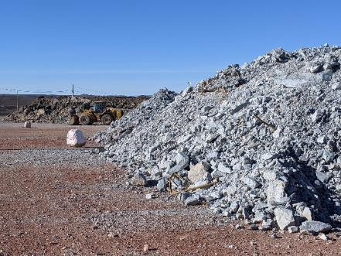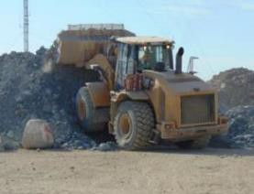

The San José ROM ore is generally dry but clay rich seams can result in some hang-ups on the grizzly feeding the jaw crusher as shown in Figure 8.10. These blockages are manually liberated.

FIGURE 8.10 ORE FEED GRIZZLY, SAN JOSÉ PLANT

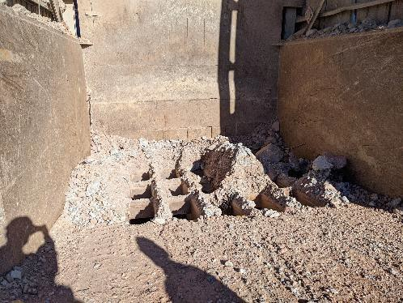

Dust suppression has been observed to be a challenge in the San José crushing facility. During crusher and screen operation, ambient dust levels were observed (January 2020 and 2021) to be high in spite of two installed engineered systems dedicated to dust suppression and dust collection. These two systems of dust control are (1) an integrated dust collection system with a bag house, supplemented (2) by the use of high-pressure fine water sprays (“nebulizers”) placed at critical locations such as conveyor transfer points.

However, based on a January 2022 inspection of the idle crusher facility, dust accumulation appeared to be significant (Figure 8.11).

FIGURE 8.11 CRUSHER FACILITY, DUST ACCUMULATION, JANUARY 2022

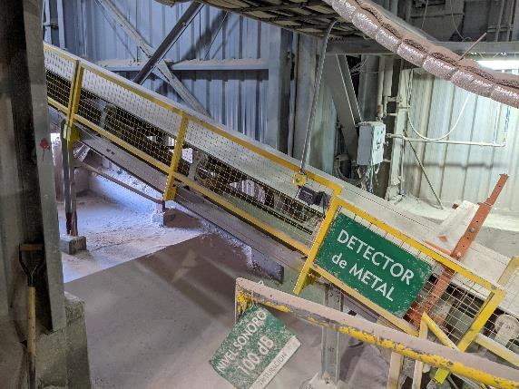

The amount of scrap metal and plastic debris in the ore arriving at the plant from mining has been significant. Two stationary magnets augment the manual removal of ferrous metal. A portion of the plastic debris is also manually removed from the crusher plant screens. Plastic debris fragments can have having deleterious impacts on automatic slurry sample cutting, flotation cell froth overflow and control valve operation.

The San José plant has been continuously improved or modified since operations began in June

2007. In recent years, major modifications have been introduced to the intensive cyanide leaching circuit, CCD, EW, foundry, peroxide supply, and leach circuit ventilation. In 2019, two new 4 m3 diameter CCDs had been installed, a column flotation cell was tested, and a centrifuge- based facility (PRA) to dewater fine flotation tailings was commissioned.

Plans had been considered several years earlier to modify the leaching circuit to increase the capacity of the cyanide leaching, CCD, EW and detox circuits to eventually process up to 100% of the flotation concentrate. The consideration for this change had been driven by higher financial returns on producing doré versus marketing flotation concentrate. None of these modifications/improvements had been made. Instead, the proportion that could be leached is remains restricted by the capacity of the existing ILR-CCD-EW facilities to about 50% of flotation concentrate production.

The San Jose plant has the capability to produce only flotation concentrate from operating the grinding circuits at the nominal 1,650 tpd capacity.

San José plant flowsheets are shown in Figure 8.12 and 8.13. These Figures, with some minor exceptions, correctly identify the unit processe

FIGURE 8.12 SAN JOSE CRUSHING, GRINDING, FLOTATION, CONCENTRATE FILTRATION AND TAILINGS

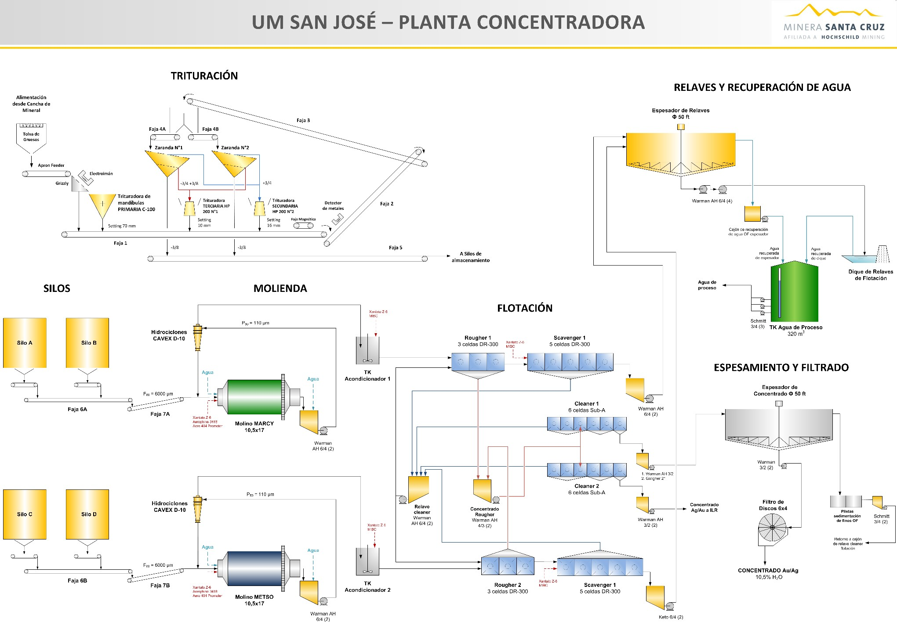

FIGURE 8.13 SAN JOSÉ ILR LEACHING, CCD, EW-FOUNDRY, DETOX AND MC CIRCUITS\*

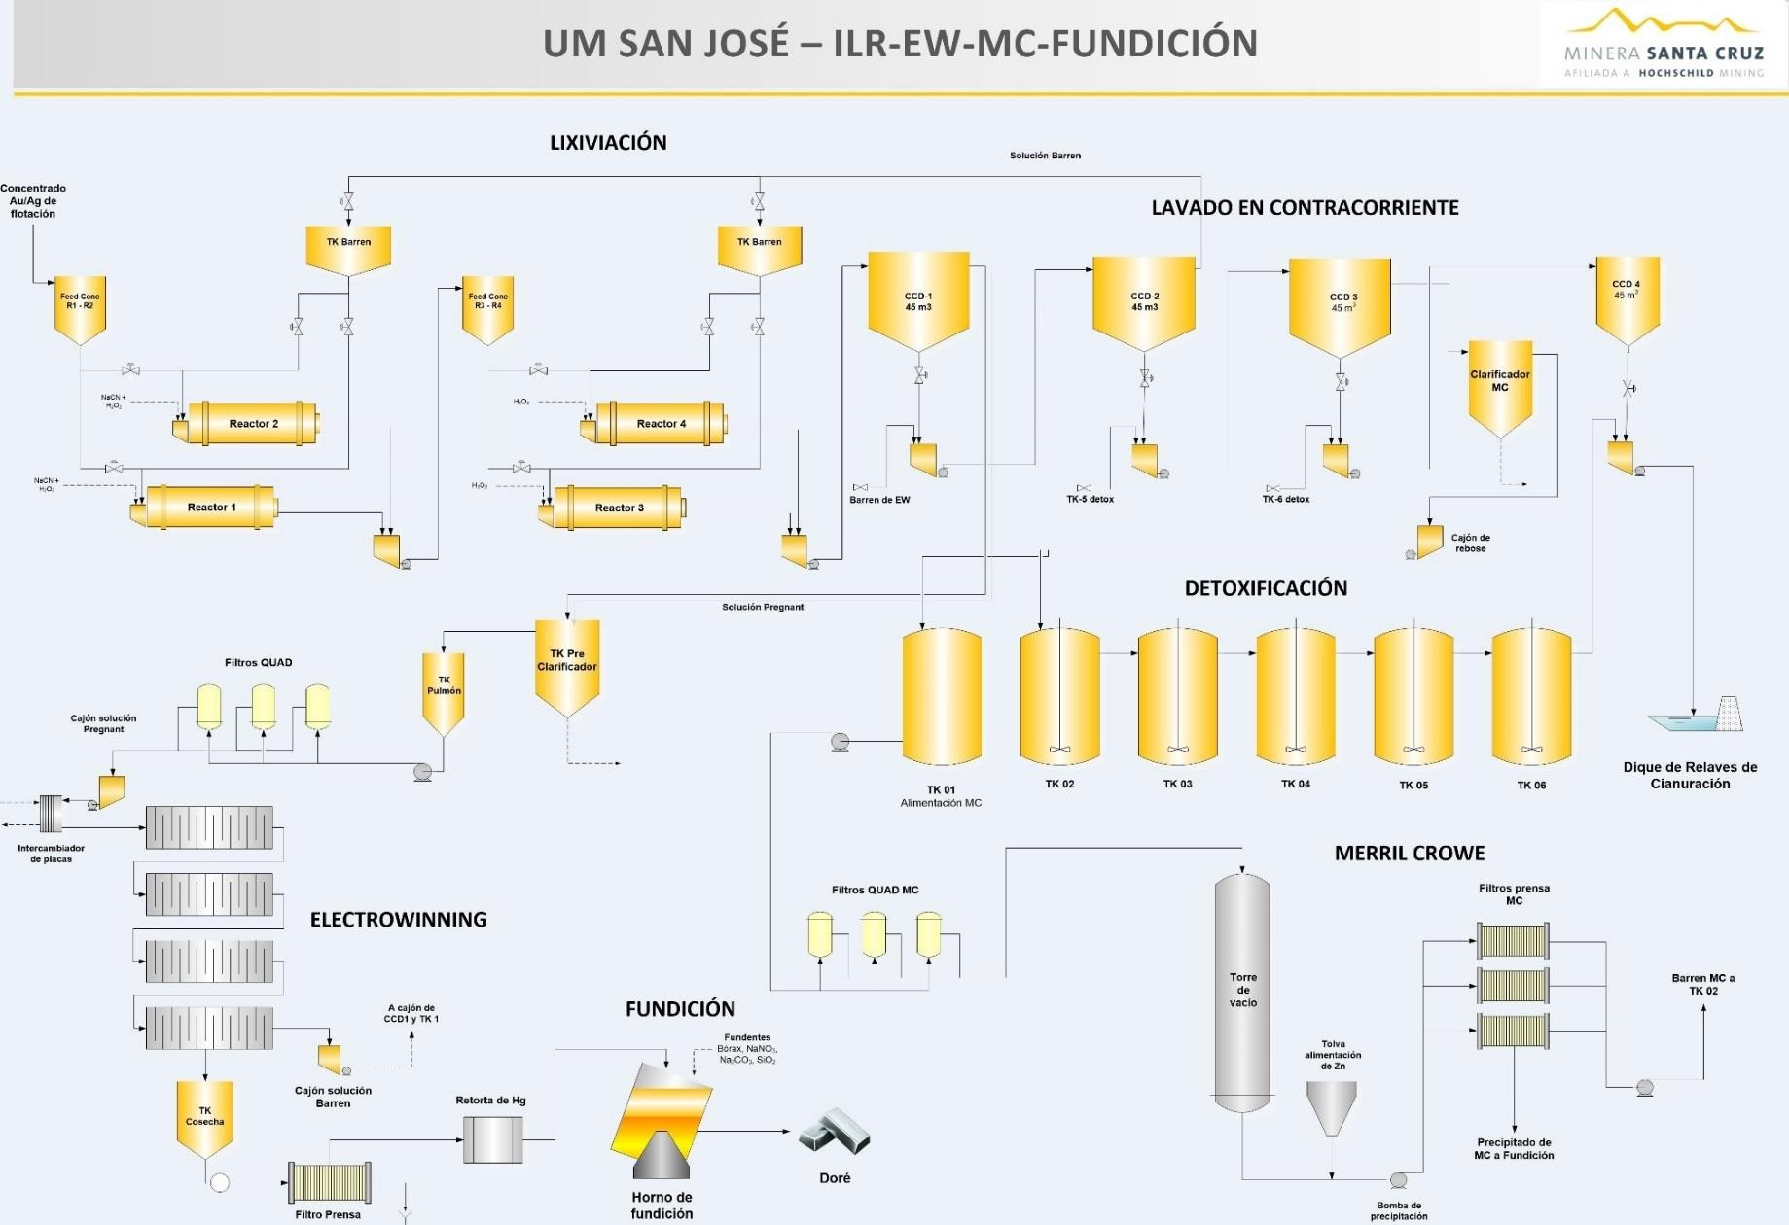

\* *ILR-Intense Reactor Leaching, CCD- counter current decantation, EW- electrowinning, MC-Merrill Crowe*

The San José ore crushing capacity exceeds 2,500 tpd. The three-stage crushing plant normally operates 14-16 hours per day to produce a ball mill feed of 93% - 3/8 inches (9.5 mm). The primary crusher is a Metso C100; the secondary is a Metso HP200 standard, and the tertiary is a Metso HP200 short-head, with the secondary and tertiary operating in closed circuit with Metso 6 by 16 ft (1.8 m by 4.9 m) double deck screens with 3/4-inch (19 mm) and 3/8-inch (9.5 mm) openings. Maximum crushed ore capacity is four silos of nominally 500 t capacity each. Due to crushed ore hang-up, live ore capacity is significantly less than 500 t in each silo.

A total of 1,650 dry tpd, 825 tpd to each of two 10.5 inches by 17 ft (3.2 m by 5.2 m) rubber- lined ball mills is recorded by belt weightometers which are calibrated weekly by the plant instrument technicians. Grab samples are obtained every two hours from the parallel feed conveyors to assess moisture content. Grinding performance is consistently 64-68% -200 Mesh. This indicates very steady crushing and grinding performance. The ball mills are powered with 750 kw drives, rotate at 74.6% of critical speed with a 40% ball charge of 2.5, 3 and 3.5-inch

(64, 76 and 89 mm) steel balls; steel consumption 1.42 kg/t.

The flotation circuit is composed of two parallel circuits of eight Denver DR-300 roughers and scavengers, and six DR-24 Sub-A cleaners. Flotation equipment operates reliably with no inconsistences recently reported. Z6 xanthate and Aerophine 3481A supplemented by a MIBC frother are the principal flotation agents added to grinding and to the flotation feed conditioner. Details of the flotation circuit are shown in Figure 8.14.

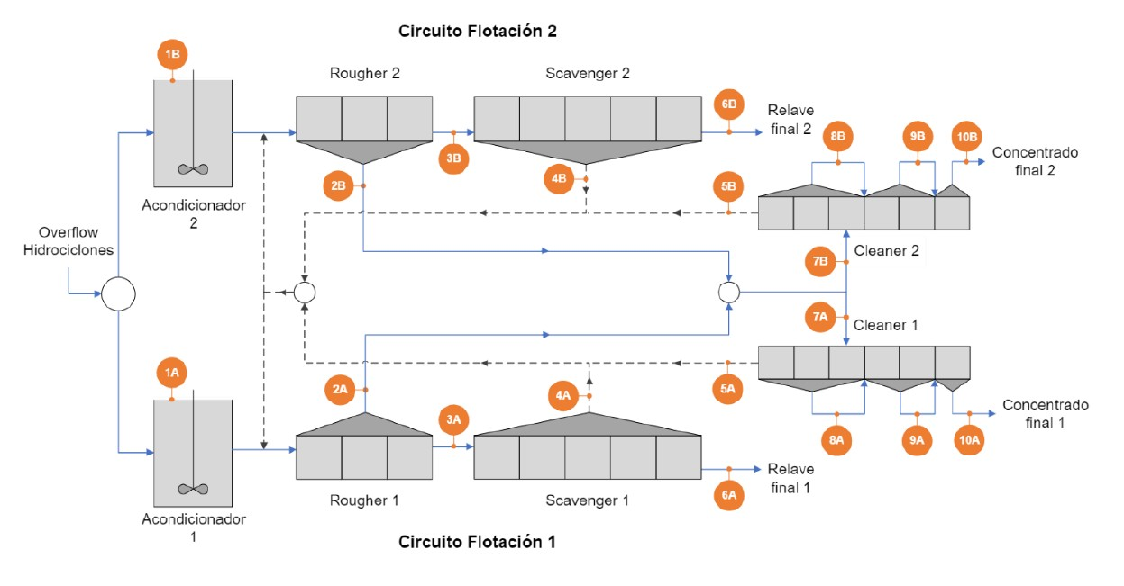

FIGURE 8.14 SAN JOSÉ FLOTATION CIRCUIT

**Figure Source**: San Jose plant audit, November 2022 (audit sample locations in orange).

While there are two parallel grinding and the flotation circuits in the San José plant, grinding slurries and flotation concentrates are combined and roughly split 50:50 downstream. This includes the feed of cleaner concentrate to the ILR leaching and filtration circuits. Inaccurate splitting of slurries is of low importance in terms of operation efficiencies and metallurgical accountability in grinding and flotation. The allocation of the flotation concentrate between filtration and cyanide leaching is more important. The measurement of the concentrate flow to leaching is performed by flow and density measuring instruments installed on a conventional (SRL) pump discharge, which pumps the high specific gravity mineral froth on a horizontal line.

The ILR (Intense Leaching Reactor) circuit is composed of four Gekko model ILR 5000 reactors operating in a 2 by 2 configuration. Leaching is performed at moderate % solids (25-35%) and high concentration of cyanide – 20,000 to 30,000 mg/L. Gold and silver extraction is indicated to be completed in CCD (counter current decantation) units which suggests that the ILR circuit operates at near capacity. However, overall leaching extractions are normally high, approximately 97% (recoveries are slightly lower). The ILR leaching and CCD circuits have been installed in limited space which provides some challenge for routine operator and maintenance personnel access. Pipeline arrangements for barren, slurry and reagents are rudimentary but have appeared to have operated satisfactorily. The ILR-CCD circuit is shown in Figure 8.15.

FIGURE 8.15 SAN JOSE INTENSE LEACHING AND CCD CIRCUITS

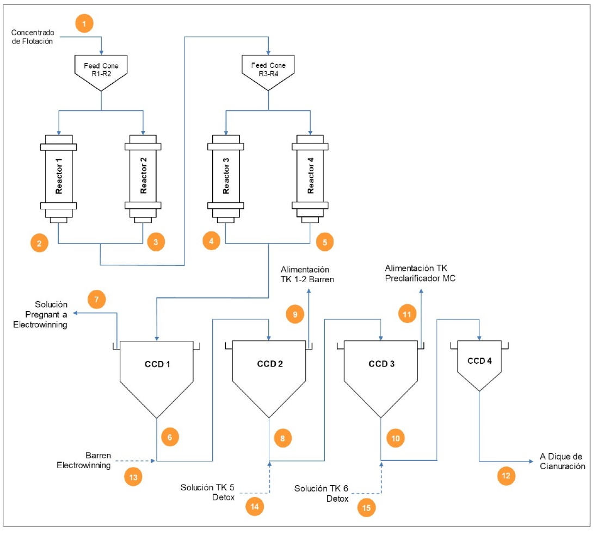

In 2019, an upgraded CCD configuration had been introduced with three larger (4 m diameter) units, replacing the one large and three smaller (2 m) units. Normally a reduction in number of CCD units would increase soluble loss of gold and silver to tailings, but compared to the low capacity of the small units, limited plant space and recycling and MC (Merrill Crowe) treatment of No. 3 CCD overflow as well as leach tailings pond water, the number of CCD stages has proven satisfactory for over three years.

### 8.2.2 San José Plant Metallurgy and Performance

The previous 10-year‟s recoveries have ranged between 87.16% and 89.45% for gold and 85.73% and 89.12% for silver. In 2022, the effective overall recovery was 88.1% for gold and 87.6% for silver. Normally, 50% of the flotation concentrate is bagged and shipped to a smelter, while 50% is processed by leaching and refining on site to doré metal. However, in 2021 only 42% of the flotation concentrate was leached.

A summary of San José‟s 2012 to 2022 plant process statistics is presented in Table 8.6.

In spite of early year restrictions caused a Covid-19 outbreak at the mine site and the crusher house fire, plant operations and metallurgical performance were very steady in 2022.

Plant costs for 2016- 2022 are summarized in Table 8.7 below. Cost details for 2022 were not available but consumptions are similar to previous years.

The usage rates and associated costs for grinding media and flotation chemicals are reasonable, but the usage rates and associated unit costs for cyanide and peroxide used for leaching and cyanide destruction continued to be high, representing a large proportion of the cost for each tonne of concentrate treated.

A discrepancy between metallurgical (“teorico”) and effective metal (“efectivo”) recoveries had been significant at times at San Jose. This difference was relatively small in 2022 and at year end effective recoveries slightly exceeded 2022 budget expectations. (Figure 8.16).

TABLE 8.6 SAN JOSÉ METALLURGICAL PERFORMANCE 2012- 2022

|  |  |  |  |  |  |  |  |  |  |  |  |  |
| --- | --- | --- | --- | --- | --- | --- | --- | --- | --- | --- | --- | --- |
| **Description / Year** | **Units** | **2012** | **2013** | **2014** | **2015** | **2016** | **2017** | **2018** | **2019** | **2020** | **2021** | **2022** |
| Plant capacity | tpd | 1,468 | 1,650+ | 1,650 | 1,650 | 1,650 | 1,650 | 1,650 | 1,650 | 1,650 | 1,650 | 1,650 |
| Plant Operating Days | d | 347 | 356 |  | 327 |  |  | 355 | 348 | 243 | 339 |  |
| Tonnage Treated | t | 509,850 | 536,937 | 571,017 | 532,488 | 536,024 | 532,676 | 556,185 | 544,165 | 401,202 | 539,229 | 507,189 |
| Ore Grade Au | g/t | 5.79 | 6.41 | 5.79 | 6.36 | 6.28 | 6.71 | 6.2 | 6.81 | 5.63 | 5.47 | 5.55 |
| Ore Grade Ag | g/t | 417.3 | 424.45 | 419.09 | 447.55 | 444.26 | 436.17 | 397.14 | 443.33 | 357.39 | 344.11 | 368.94 |
| Flotation recoveries Au | % | 89.7 | 89.3 | 88.8 | 89.5 | 88.7 | 88.95 | 89.18 | 88.55 | 89.7 | 91.1 | 88.3 |
| Flotation recoveries Ag | % | 90 | 89.2 | 88.4 | 89 | 88.3 | 88.64 | 90 | 86.26 | 89.4 | 90.9 | 89.8 |
| Flotation Concentrate | Dry t | 34,101 | 31,585 | 38,203 | 33,741 | 34,415 | 31,433 | 34,681 | 34,884 | 22,230 | 31,170 | 27,186 |
| Au | g/t | 91.6 | 100.8 | 77.55 | 103.78 | 87.12 | 102.57 | 90.63 | 98.04 | 89.96 | 86.26 | 90.41 |
| Ag | g/t | 6,450 | 6,559 | 5,414.17 | 6,687 | 6,255 | 6,687 | 5,914 | 6,417 | 5,563 | 5,413.50 | 6,347 |
| Product, as filtered  concentrate (%) | t | 17,679 | 19,403  (61%) | 22,582  (59%) | 17,957 | 17,435 | 15,414 | 17,312 | 19,604 | 17,722 | 18,201 | 15,035 |
| Tonnes leached to produce  doré (% of total) | t | 16,422  (48%) | 12,182  (39%) | 15,621  (41%) | 15,784  (47%) | 16,980  (49.3%) | 15,948  (51%) | 17,369  (50.0) | 15,280  (44) | 4,508  (20) | 12,969  (42) | 12,151  (45) |
| Leaching recoveries Au | % |  | 96.59 | 96.6 | 96.13 | 96.4 | 96.9 | 97 | 97.1 | 97.1 | 95.8\* |  |
| Leaching recoveries Ag | % |  | 96.6 | 96.4 | 95.08 | 96 | 96.3 | 96.5 | 96.1 | 96.1 | 96.2 |  |
| CCD/EW recoveries Au | % |  | 97.77 | 98.9 | 98.18 | 97.7 | 98.4 | 98.1 | 98.1 |  |  |  |
| CCD/EW recoveries Ag | % |  | 98.19 | 99 | 98.63 | 98.7 | 98.7 | 98.7 | 97.7 |  |  |  |
| Effective recovery Au | % | 88.57 | 88.82 | 87.73 | 87.91 | 87.3 | 87.41 | 87.16 | 88.55 | 89.45 | 88.1 | 87 |
| Effective recovery Ag | % | 85.73 | 86.47 | 86.62 | 86.91 | 86.92 | 86.32 | 86.81 | 88.26 | 89.12 | 87.6 | 88 |
| Theoretical recovery Au | % |  |  | 86.99 | 87.52 | 87.38 | 86.88 | 87.29 | 88.54 | 89.02 | 88.02 | 87 |
| Theoretical recovery Ag | % |  |  | 87.13 | 87.37 | 87.98 | 86.6 | 87.26 | 88.33 | 88.66 | 87.6 | 87.5 |
| Concentration ratio |  |  | 17 | 14.9 | 15.78 | 15.91 | 16.9 | 16 | 16 | 18 | 17.3 | 18.7 |
| Concentrate moisture | % |  | 10 | 10.8 | 10.61 | 10 | 10.2 | 10.2 | 10.8 | 10 | 10.2 | 9.5 |
| **Total Production koz  AgEq** |  |  |  |  |  |  | **13,883** | **13,312** | **15,390** | **9,697** | **12,440** | **10,966** |

*\* total solid and liquid Au losses, leaching +CCD = 4.21%, of which solution is 1.44%*

TABLE 8.7 RECENT CONSUMPTIONS AND COSTS, SAN JOSE PLANT

|  |  |  |  |  |  |  |  |  |  |  |  |  |  |
| --- | --- | --- | --- | --- | --- | --- | --- | --- | --- | --- | --- | --- | --- |
| **Material** | **2016** | | **2017** | | **2018** | | **2019** | | **2020\*\*** | | **2021** | | **2022\*\*\*** |
| **kg/t Ore (/t leach conc)** | **$/t Ore** | **kg/t Ore (kg/t leach conc)** | **$/t Ore Jan. – Sep.** | **kg/t Ore (kg/t leach conc)** | **$/t Ore** | **($/t leach conc)** | **$/t Ore** | **($/t leach conc)** | **$/t Ore** | **($/t leach conc)** | **$/t of Ore** | **$/t of Ore** |
| General services | 17.1756 |  | 2.2655 |  |  |  |  |  |  |  |  |  |  |
| Crushing | 14.5104 |  | 1.852 |  |  |  |  |  |  |  |  |  |  |
| Grinding | 11.8452 |  | 1.4385 |  |  |  |  |  |  |  |  |  |  |
| Concentrate handling | 9.18 |  | 1.025 |  |  |  |  |  |  |  |  |  |  |
| Tailings | 6.5148 |  | 0.6115 |  |  |  |  |  |  |  |  |  |  |
| General services | 3.8496 |  | 0.198 |  |  |  |  |  |  |  |  |  |  |
| Crushing | 1.35 |  | 1.58 |  | 4.13 |  | 3.57 |  |  |  | 4.42 |  |  |
| Grinding | 2.25 |  | 2.44 |  | 6.49 |  | 6.31 |  |  |  | 6.7 |  |  |
| Concentrate handling | -9.424 |  | -4.542 |  |  |  |  |  |  |  |  |  |  |
| Tailings | -8.11 |  | -3.88 |  |  |  |  |  |  |  |  |  |  |
| General services | -6.796 |  | -3.218 |  |  |  |  |  |  |  |  |  |  |
| Flotation | -5.482 |  | -2.556 |  |  |  |  |  |  |  |  |  |  |
| Concentrate handling | -4.168 |  | -1.894 |  |  |  |  |  |  |  |  |  |  |
| Tailings | -2.854 |  | -1.232 |  |  |  |  |  |  |  |  |  |  |
| General services | -1.54 |  | -0.57 |  |  |  |  |  |  |  |  |  |  |
| Flotation | 0.77 |  | 0.58 |  | 1.5 |  | 1.39 |  |  |  | 1.55 |  |  |
| Concentrate handling | 0.56 |  | 0.46 |  | 0.95 |  | 0.84 |  |  |  | 0.98 |  |  |
| Tailings | 0.47 |  | 0.54 |  | 0.81 |  | 0.79 |  |  |  | 0.88 |  |  |
| General services | 5.18 |  | 2.76 |  | 1.53  (other) |  | 1.88 |  |  |  | 2.11 |  |  |
| Laboratory | 0.48 |  | 2.76 |  |  |  |  |  |  |  |  |  |  |

TABLE 8.7 RECENT CONSUMPTIONS AND COSTS, SAN JOSE PLANT

|  |  |  |  |  |  |  |  |  |  |  |  |  |  |
| --- | --- | --- | --- | --- | --- | --- | --- | --- | --- | --- | --- | --- | --- |
| **Material** | **2016** | | **2017** | | **2018** | | **2019** | | **2020\*\*** | | **2021** | | **2022\*\*\*** |
| **kg/t Ore (/t leach conc)** | **$/t Ore** | **kg/t Ore (kg/t leach conc)** | **$/t Ore Jan. – Sep.** | **kg/t Ore (kg/t leach conc)** | **$/t Ore** | **($/t leach conc)** | **$/t Ore** | **($/t leach conc)** | **$/t Ore** | **($/t leach conc)** | **$/t of Ore** | **$/t of Ore** |
| Energy | 3.43 |  | 2.76 |  |  |  |  |  |  |  |  |  |  |
| Maintenance | 1.27 |  | 2.76 |  |  |  |  |  |  |  |  |  |  |
| **Total Costs (\*without details)** | **15.76** |  | **10.71\*** |  | **15.41** |  | **14.78** |  | **15.2** |  | **16.65** |  | **12.04** |

FIGURE 8.16 ACTUAL (EFECTIVO) AND BUDGETED (PPTO) PERCENT RECOVERIES, SAN JOSÉ, 2022

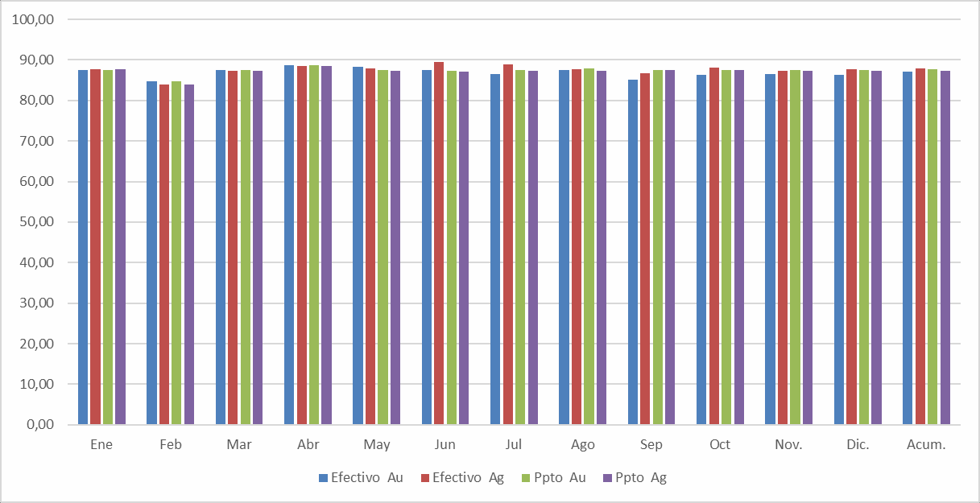

### 8.2.3 Sampling and Analyses

The San José Laboratory is responsible for plant sampling and sample analyses as well and key plant measurements. This includes head sample moisture determination, sand calibration of weightometers on ball mill feed conveyors. Sampling of flotation feed and flotation tailings protocols using secure, two-stage automatic samplers continue to be: primary cut every five minutes; secondary samples are accumulated for 4- and 12-hour composites.

The San José analytical and metallurgical laboratories have 34 persons with two daily shifts. The analytical laboratory manager is Sr. Luis Saire.

The San José laboratory is outfitted with a complete set of modern AAS (Atomic Adsorption Spectrometry) and fire assay equipment including a relatively new, Microwave Plasma – Atomic Emission Spectroscopy (MP-AES) machine that operates on inexpensive nitrogen gas. The extensive facilities are maintained in a spotlessly clean and neat condition. Plant samples are dried at 105°+/- 10°C, which is satisfactory for sulphide-containing samples. Geology samples are dried at 130°C +/- 10°C. These temperatures had been confirmed acceptable in 2021 tests for both gold and silver analyses.

The laboratory is certified under ISO 17025 and a LIMS system is in place. One internal, Hochschild audit of the laboratory was performed June 14-15 2022. P&E has reviewed the audit findings and has concluded that no major issues, affecting assay accuracy were reported.

Interlaboratory exchange analyses were performed during 2022 year with a certified Canadian laboratory and the San José results were classified as satisfactory for all of copper, gold, lead, silver and zinc.

San José plant sampling and measurement procedures, sample preparation, analytical procedures, QC/QA, and reporting can be considered to completely meet acceptable standards.

### 8.2.4 Routine Metallurgical Testing and Process Audits

The San José plant normally has an active metallurgical test program with includes flotation testing of various mineralized zones and types, bottle-roll leach testing, and in-plant audits and investigations. Geology samples are normally subject to flotation testing. No data was available for 2022 tests. Tests were conducted on the leaching efficiency of gold and silver from flotation concentrates with the principal variability being cyanide -ranging from 2.5% to 3.5%. It was determined that gold extraction was roughly independent of cyanide strength, while silver extraction ranged from 91.2% to 96.1%. It was concluded that while silver extraction was improved that increasing the cyanide concentration to 3.5% would significantly increase the cost of detoxification.

As reported to P&E, thirteen process audits were performed in the plant in 2022 – one of crushing, eight of grinding, seven of flotation and four of ILR leaching/CCD. The grinding audits confirmed steady, quality grinding and classification performance for both the Metso a nd Marcy ball mill circuits. The flotation circuit audits indicated reasonable performance and confirmed that the main silver and gold losses to tailings were in the coarse (+60 Mesh) and fine (-400 Mesh) fractions. A significant variation in recoveries were reported – 81% to 90% at different times. However, the audit results reasonably matched plant records at the time of auditing.

The four ILR- three CCD audits indicated a variable performance of the combined circuits. Extraction of silver and gold ranged from 85% to 95% in the ILR reactors. Normally, the leaching of silver and gold continued in the CCD units, with a general maximum extraction of 97% for both silver and gold. These phenomena tend to suggest that the capacity of the 4 -unit ILR leaching system is insufficient to maximize extraction. However, the special configuration of the CCD circuit (Figure 8.18), the strategic introduction of EW barren, detoxed solutions, the recycling of tailings water as well as the use of the small Merrill Crowe circ uit to treat low grade solution (overflow of No. 3 CCD unit), renders the combined circuits reasonably efficient.

### 8.2.5 Tailings Management

Two types of tailings are produced – flotation tailings and cyanide leach tailings. Until 2015, the flotation tailings and leach tailings had been stored close to the plant in the No. 1 tailings facility, which is separated from the nearby No. 2 leached tailings facility by a lined berm.

Leached tailings are disposed in the No. 2 tailings facility which is a fenced, the double-lined facility which had, at the end of 2022, 2.3 years of capacity at recent tailings production rates. A high proportion of residual cyanide in the leach tailings is destroyed by hydrogen peroxide treatment before discharge. The leached tailings facility has a permitted WAD cyanide level of 50 mg/L in the pond water. This limit is consistent with the International Cyanide Code for no-discharge tailings facilities. The average WAD cyanide concentration was 30 mg/L in 2021,

with the 50 mg/L limit exceeded only in 1 month. The No. 2 tailings facility was observed by P&E in January 2022 to be at a low water level, drawn down as a result a general water shortage in the area. Also, a significant amount of tailings from the No. 1 tailings facility has been excavated over the last two years for use as backfill.

A new flotation tailings facility, No. 3, had been commissioned in early 2015, in a dry natural depression 1.6 km east of the plant. This unlined facility includes a small, low profile containment embankment. Attempts to recycle pond water have been frustrated by the lack of ponding (Figure 8.17). Regional persistently high wind velocities, a high evaporation rate and extended periods of low precipitation (both rain and snow) had created this challenge. No water was recovered from No. 3 tailings facility in 2022.

FIGURE 8.17 DRY FLOTATION TAILINGS FACILITY NO. 3, JANUARY 2019

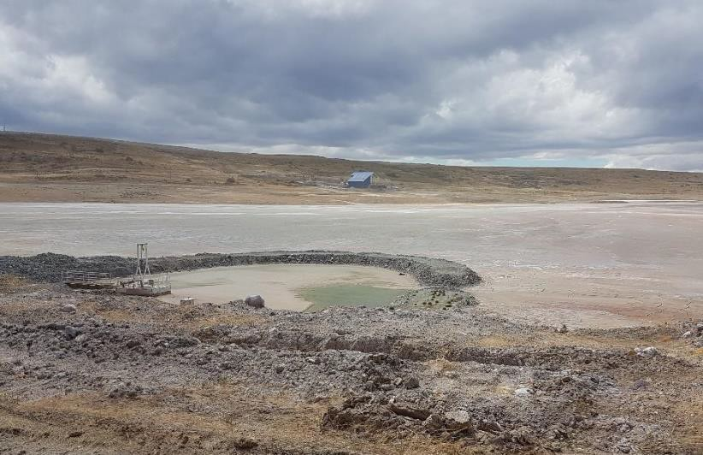

A partial solution had been found to site water shortage with the implementation of “dry” tailings disposal in combination with a mine backfill plant. A new plant was constructed at the edge of No. 3 tailings to recover the maximum of tailings water. Up to 20,000 m3 was recovered monthly by the “PRA” centrifuge plant. As indicated in Figure 8.18, an earlier tailings water balance, much of the recovered water is used in a mine backfill plant with the balance of the water returned to the process plant. In 2022 surveys were completed and the water inventory in Laguna 4 was steady at 150,000 m3.

FIGURE 8.18 SAN JOSE TAILINGS WATER BALANCE, 2020

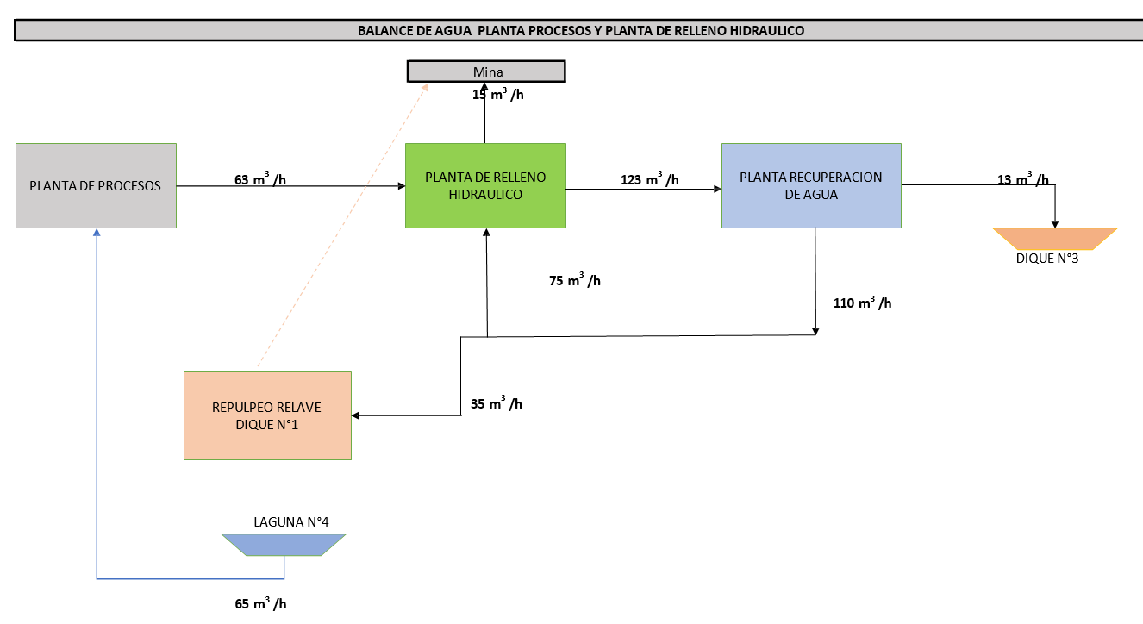

The principal tailings dewatering technology at the PRA facility is the u se of centrifuges. Conventional dry tailings production (aka “dry stack”) typically involves the use of pressure filters, but the clay content of the San José ores, and the removal of the coarse tailings in the backfill plant made this option less attractive. The tailings dewatering plant located on the north bank of No. 3 tailings is shown in Figure 8.19, and the internal workings, the centrifuges, are shown in Figure 8.20.

The centrifuge bowls had been observed in 2020 by P&E to be operating at 1,100 rpm, 65% of capacity. The “dewatered” cake is transferred by conveyor to transports outside the plant. The cake was observed to be very wet and readily fluidized in the truck dump box.

The dewatering process includes the use of significant quantities of flocculant, as much as 0.13 kg/t.

FIGURE 8.19 TAILINGS CENTRIFUGE DEWATERING PLANT 2022

(“Planta Recuperacion de Aqua”, PRA)

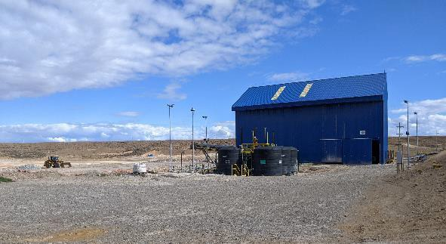

PRA operating reports for 2022 indicate some PRA operational interruptions (about 10% of time) associated with process plant shutdowns. Data on the volume of water recovered from tailings in 2022 was not available.

FIGURE 8.20 PRA TAILINGS DEWATERING CENTRIFUGES

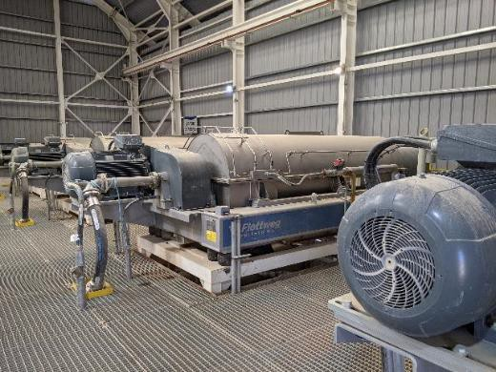

### 8.2.6 Permitting, Environmental and Social

Environmental, permitting and social initiatives are not audited by P&E. The following is a brief review of readily available information.

During normal operation, San José conducts diligent monitoring of environment performance and aspects of the operations and reporting results to local and corporate management as well as to Provincial Authorities. San Jose also normally conducts extensive community consultations and support. Community support and activities were increased in 2022.

In 2015, Hochschild implemented what is termed - the Environmental Corporate Objective (ECO) – a unique initiative that is applicable at all company sites and facilities. The ECO score is intended to encourage all employees to comply with a common environmental mission, and assists in making everyone accountable for their actions. The company-wide performance was

5.27 out of 6.

A conceptual site closure plan was prepared before operations were started at San José. Cost estimates for this closure plan indicated a total cost of $28.7M (million USD) including taxes over three years, 2025-2027.

## 8.3 INMACULADA PROCESS PLANT

### 8.3.1 Process Description

The Inmaculada process plant is a conventional whole ore cyanide leaching facility which produces doré gold-silver metal bars. The Inmaculada plant, laboratory and tailings facilities were visited by P&E for audit purposes on January 11, 2022. All the process plant facilities were in operation during the visit and were observed to be in a clean and a safe operating condition. The operating staff was 28 for each shift of three at the time of the visit. Eight persons operate in the Merrill Crowe facility for each shift.

The Inmaculada processing plant is a modern, efficient and highly reliable facility that is managed by skilled management and staff.

The original 2015 plant capacity of 3,500 tpd was increased to 3,850 tpd (maximum 4,000 tpd) in the second year of operations. During the January 2022 visit the plant was operating at 3850 tpd with one day per month of scheduled shutdown allocated for maintenance. Operating availability for 2022 was high at 96.2%, with 333 hours downtime, 298 of which was for scheduled maintenance.

Ore is crushed to minus 3.25 inches (83 mm) and is conveyed up a significant slope to the plant where it is accumulated in a “live” stockpile for plant feed. The ore is drawn from beneath the stockpile and finely ground in a semi-autogenous (SAG)-ball mill combination to a nominal P80 of 53 µm (270 Mesh). No gravity concentrate of gold and silver is obtained. The whole ore is leached in eight tanks with a strong cyanide solution, with a four-tank counter current decantation (CCD) separation of a pregnant leach solution (PLS) from leached solids. Merrill Crowe technology recovers gold and silver by zinc precipitation from a clarified, de-aerated solution. A doré (silver-gold) product is produced in the on-site foundry.

Early in the Inmaculada development, consideration had been given to the production of a flotation concentrate with either sale of this concentrate or leaching of the concentrate on site to produce a doré product. A whole ore leaching strategy was selected, and the final plant engineering drawings were approved in January 2014. The completed mine and plant facilities

started operations in June 2015 and except for some early grinding mill drive foundation issues, the process plant has operated well and continuously for seven and a half years.

A general outline of the Inmaculada process flowsheet is shown in Figure 8.21. The process was altered slightly in October 2021 with the addition of the eighth leach vessel.

Ore is delivered to a crusher by mine-accessible trucks at a location situated at an elevation considerably lower than the plant (Figure 8.22). Oversize is taken aside and broken with a mobile rock breaker. Ore is blended under Geology‟s control and fed to the crusher through 800 mm square grizzly and a 100 t surge bin. There have been three stockpiles at the crusher location: AAA - >500 g/t AgEq, A-200-500 g/t and B/C – 110-200 g/t. Ore is crushed to minus

3.25 inches (83 mm) and transported 1.5 km by conveyor (Figure 8.22) to a mill feed stockpile

(Figure 8.23) which has a capacity of 1,900 t – about 12 hours of plant processing capacity.

FIGURE 8.21 INMACULADA GENERAL FLOWSHEET (2020 -MID 2021)

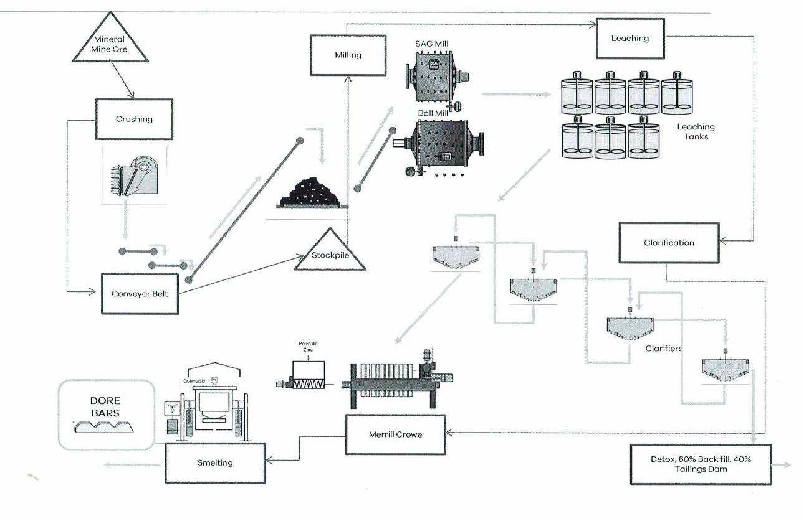

FIGURE 8.22 INMACULADA ORE RECEIPT, CONVEYOR FROM CRUSHER TO PLANT

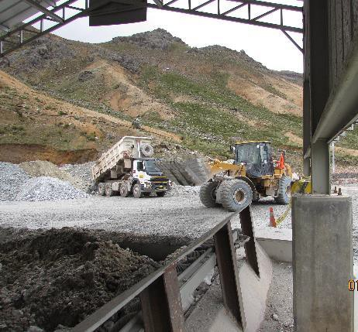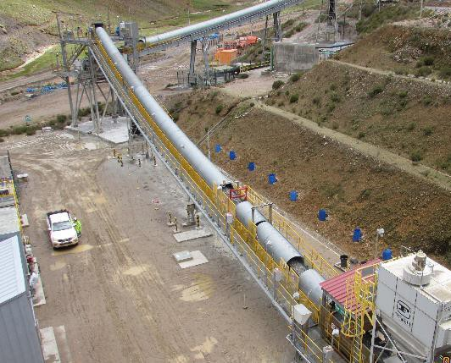

The single drop point feed stockpile configuration had proven, following start-up, to be somewhat problematic because coarse ore fragments run to the pile edge, segregating feed size to the SAG mill. To achieve steady SAG operation, consistently-sized feed is required. A solution to this challenge has been the use of a wheeled loader to continuously blend the crushed ore pile as shown in Figure 8:23.

The stockpile reclaim conveyor weightometer is daily calibrated by plant staff. Samples are hand cut every two hours by laboratory staff from this conveyor to determine moisture content and to estimate process plant feed grade.

FIGURE 8.23 BLENDING THE MILL FEED STOCKPILE

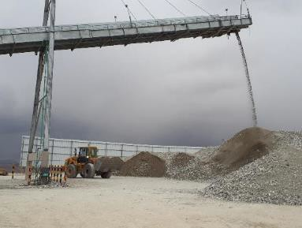

Grinding is performed using a SAG mill-ball mill combination shown in Figure 8.24.

FIGURE 8.24 INMACULADA GRINDING MILLS

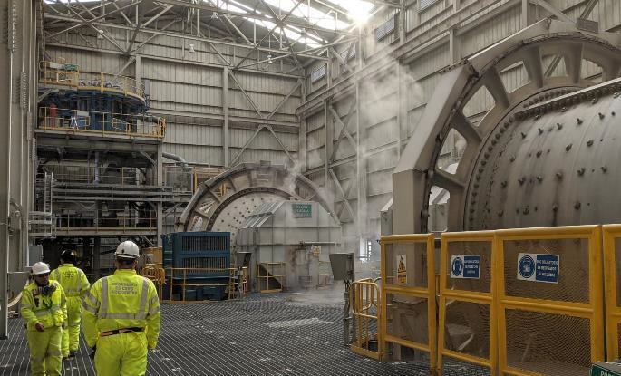

The 18 ft diameter x 14.5 ft (~5.5 m x ~4.4 m) SAG mill is equipped with a pebble circuit where pebbles are recycled to the SAG mill feed. Pebble return is typically low – at about 3% of feed tonnage in 2022. At this low rate, although a pebble crusher installation had been considered in the original design, such a pebble crusher can not be justified. The 18 ft x 27.5 ft (~5.5 m x ~8.4 m) ball mill operates in closed circuit with two banks of seven cyclones - one bank is designed to be operating with one on standby. Cyclone overflow is screened for plastics and metal trash before the slurry flows to the pre-leach thickener. The amount of trash to extracted has been reported to be small. Grinding ball consumption in the SAG was 0.40 kg/t of 5-inch (~12.7 cm) balls and also 0.45 kg/t 4-inch (~10.2 cm) balls in 2022. The 2022 ball mill consumption was a total of 1.85 kg/t of 1.5 and 2 inches (~3.8 and ~5 cm) balls. The nominal grind is 80% - 270 Mesh (53 µm). The average grind in 2022 was 82.5% -270 Mesh, a fine grind. Grinding data obtained in plant surveys has indicated that the grinding energy consumption to be as high as 35 kWh/t – half of the average total processing energy use of 66.5 kwh/t reported in 2021.

The leaching circuit is now composed of 8 tanks in series of 3,335 m3 volume each. The eighth tank came on-line in October 2021. The leaching component of the facility (Figure 8.25) was originally designed to provide 96 hours of retention time leaching in these stirred tanks. However, monthly leaching circuit audits in 2022 indicated an average 87.3 hours of mean retention time in leaching. Leaching conditions were on average 41.5% solids, 1.6 g/L cyanide at pH raised to 11.5 with lime from a lime slaking circuit. Oxidation is provided by 11 tpd to 14 tpd oxygen injection into the first five leach tanks – about 80% of the oxygen is distributed to the first three tanks. Dissolved oxygen in the first three tanks is typically low at 1 ppm. An increase in retention time, important for silver recovery, could be realized if an increase in slurry density could be achieved.

FIGURE 8.25 FOUR TANKS OF THE EIGHT-TANK AGITATED LEACH FACILITY

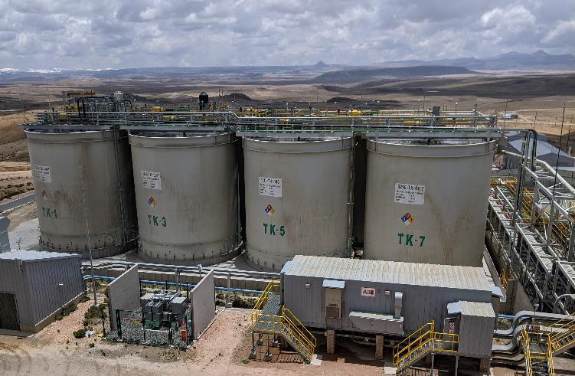

Nine monthly metallurgical audits of leaching performance at Inmaculada were reported in 2022. Example results for June are illustrated in Figures 8.26(a) and for September in Figure 8.26(b) and CCD for September in Figure 8.27. From the data represented by these example internal audit reports, it is apparent that a significant percentage of the gold and of the silver is leached before reaching the leaching circuit, i.e., in the grinding and thickening unit operations. Significant leaching of gold and silver in the grinding circuit of whole ore leaching plants is a common phenomenon. Also, as expected, the kinetic rate of gold leaching is faster than that of silver.

FIGURE 8.26 (A) LEACHING PERFORMANCE, JUNE 2022

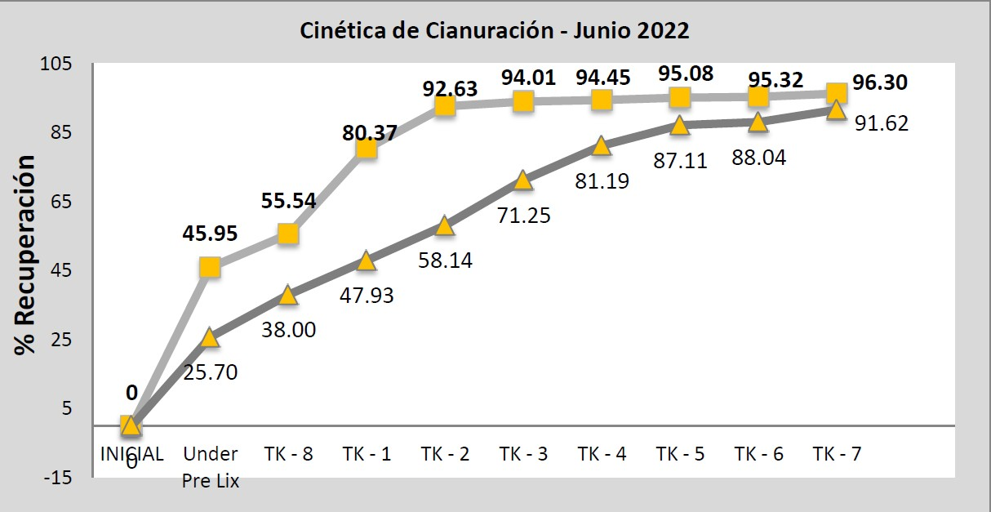

**FIGURE** 8.26 (B) **LEACHING PERFORMANCE, NOVEMBER 2021**

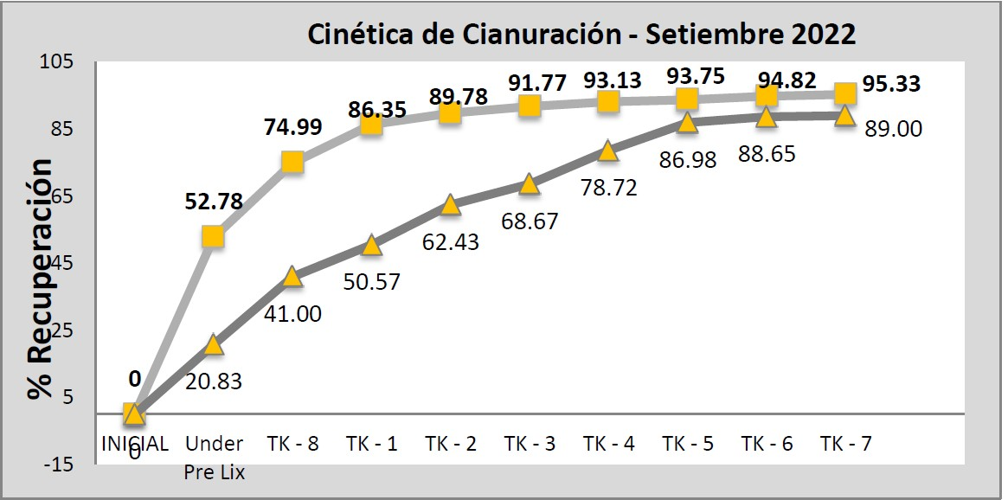

Improvements had been made in the washing efficiency of the CCD circuit, with solubl e loss of gold and silver to tailings previously exceeding 2%, now having been reduced, and as shown in the September 2022 example, to 1.3% for gold and 1.6% for silver. This represents good performance for a four-unit CCD.

FIGURE 8.27 CCD PERFORMANCE, SEPTEMBER 2022

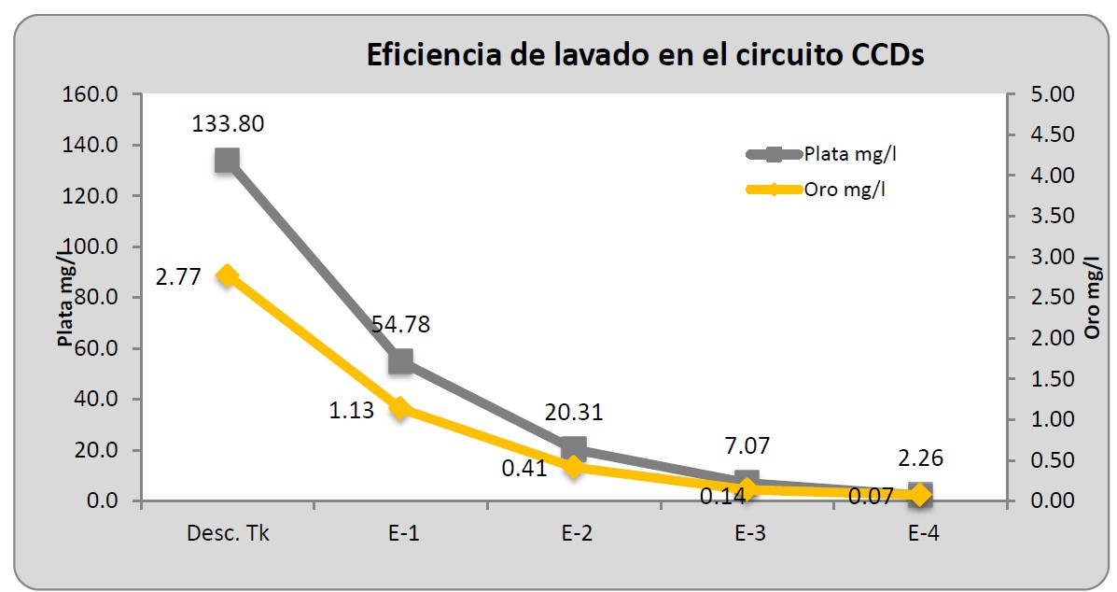

### 8.3.2 Merrill Crowe PLant

Silver and gold are recovered from a clarified, de-aerated pregnant leach solution (PLS) in a traditional Merrill Crowe process by precipitation gold with powdered zinc metal. The precipitate is filtered out, dewatered and refined in an electric furnace to produce Doré bars containing 3-4% gold with the remaining % essentially silver. The zinc-gold-silver precipitate filtration unit is shown in Figure 8.28.

FIGURE 8.28 MERRIL CROWE - PLS CLARIFIERS AND ZINC PRECIPITATION UNIT

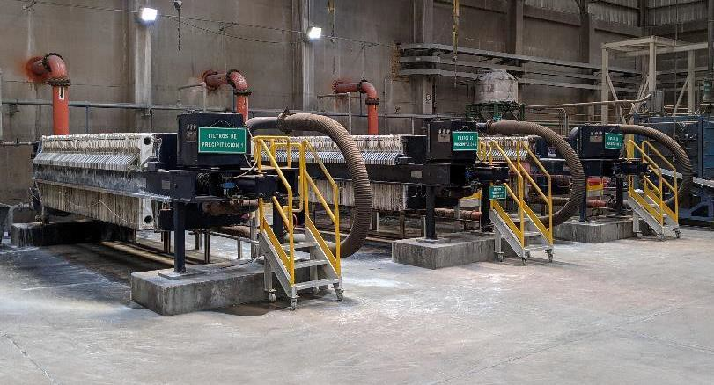

### 8.3.3 Plant Automation

The Inmaculada plant is highly automated and instrumented and a control room display is shown in Figure 8.29. Two technicians staff the control room during normal operations.

FIGURE 8.29 PLANT CONTROL PANELS

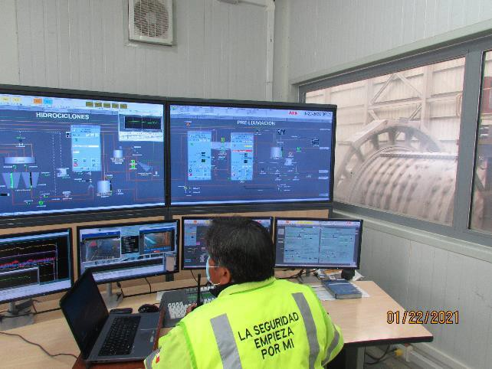

### 8.3.4 Plant Metallurgical and Cost Performance

The official recoveries in 2022 were recorded as 95.1% for gold and 89.1% for silver. A comparison of plant metallurgical performance from start-up in 2015 to the end of 2022 is shown in Table 8.8. Recoveries have recently increased in spite of the processing of lower grade ore.

The Metallurgical Laboratory continued to carry out tests with samples from different veins, pits, and geological exploration samples. The test conditions simulated plant conditions – e.g., grind, slurry density and leach chemistry. No reports of metallurgical test results were received by P&E on samples of feed to grinding, leaching or CCD.

Plant operating costs for 2015-2022 are summarized in Table 8.9 below. The cost for 2022 was

$40.11/t, which was slightly higher than experienced in previous years. P&E suggests that this is a modest cost, given the complexity of the Inmaculada processes. Grinding and detox continue to be major components of processing cost.

TABLE 8.8 INMACULADA METALLURGICAL PERFORMANCE 2015 -2022

|  |  |  |  |  |  |  |  |  |
| --- | --- | --- | --- | --- | --- | --- | --- | --- |
| **Year /Description** | **June – Dec. 2015** | **2016** | **2017** | **2018** | **2019** | **2020** | **2021** | **2022** |
| Plant Feed, t | 659,737 | 1,306,606 | 1,295,701 | 1,323,525 | 1,338,569 | 948.937 | 1,349,892 | 1,329,177 |
| Au g/t | 522,430 | 244,765 | 470,903 | 717,652 | 915,877 | 519,611 | 538,684 | 559,799 |
| Ag g/t | 317.23 | 381.03 | 441.8 | 362 | 277.7 | 246.6 | 224 | 150.8 |
| Doré, kg | 1.275 | 1.864 | 1.781 | 1.298 | 1.01 | 0.872 | 0.92 | 0.688 |
| Au, oz | 5,220.16 | 3,273.43 | 7,061.94 | 10,856 | 14,221 | 7,010 | 7,227 | 7,838 |
| Ag, oz | 21,419.83 | 24,770 | 26,174 | 21,343 | 15,874 | 16,872 | 14,031 | 9,395 |
| Recovery % | 96.85 | 116.26 | 102.8 | 75.63 | 56.1 | 57.34 | 56.13 | 43.58 |
| Au | 3,632,541 | 2,998,477 | 6,689,067 | 7,449,414 | 93.34\*\*\* | 93.81\*\*\* | 3,260,576 | 2,367,522 |
| Ag | 16,254.23 | 14,670.31 | 23,340.71 | 26,399 | 25,952 | 12,925 | 13,045 | 10,977 |
| Tailings solids, % of feed | 11.58 |  | 8.16 | 8.37 | 8.4 | 8.73 | 9 (est.) |  |
| Au | 84.37 | 83.41 | 86.54 | 87.57 | 87.38 |  |  | 87.63 |
| Ag | 76.65 | 86.94 | 88.84 | 88.89 | 88.55 |  |  | 86.12 |
| Tailings Solution, % of heads | 42.7 | 50.43 | 50.04 | 40.86 | 32.29 |  |  |  |
| Au | 75.88 | 87.38 | 89.04 | 2.48\* | \*\*1.21 | 89.29 | 90.23 | 87.24 |
| Ag | 0.9% of conc | 34,270 | 73,254 | 2.02\* | \*\*0.99 |  |  |  |

**\*** Estimated by difference (heads – (conc +tls)). \*\* Measured average soluble loss -\*\*\* “official” recovery.

TABLE 8.9 INMACULADA PLANT COSTS 2015-2022, $/T PROCESSED

|  |  |  |  |  |  |  |  |  |
| --- | --- | --- | --- | --- | --- | --- | --- | --- |
| **Item** | **2015** | **2016** | **2017** | **2018** | **2019** | **2020** | **2021** | **2022** |
| Crushing | 1.59 |  | 0.63 | 1.75 | 1.12 |  | 1.1 | 1.04 |
| Ore transport | 0.12 |  | 0.1 | 0.08 | 0.42 |  | 0.5 | 1.05 |
| Stockpile blending | 1.18 |  | 0.08 | 0.76 | 1 |  | 1.2 | 1.25 |
| Grinding | 11.01 |  | 5.69 | 10.16 | 9.84 |  | 10.96 | 12.46 |
| Leaching, CCD,  clarification | 5.27 |  | 5.65 | 6.92 | 7.34 |  | 7.42 | 8.77 |
| Merrill Crowe,  doré, | 3.74 |  | 1.65 | 2.83 | 2.99 |  | 3.22 | 3.35 |
| Refinery | 1.33 |  |  | -1.22 |  |  |  |  |
| Thickening, detox, tailings | 1.41 |  | 7.28 | 9.76 | 11.35 |  | 9.72 | 10.78 |
| Miscellaneous Reagents | 2.63 |  | 0.16 | 0.32 | 0.25 |  | 0.28 | 0.26 |
| Lime plant | 0.17 |  | 0.01 | 0.15 | 0.15 |  | 0.14 | 0.15 |
| Product Transport |  |  |  | 0.44 | 0.85 |  | 0.92 | 1 |
| **Subtotal** | **$28.45** | **$25.16** | **21.16** |  |  |  | **35.45** | **40.11** |
| General services |  |  | 0.19 |  |  |  |  |  |
| Management |  |  | 0.89 |  |  |  |  |  |
| **Total** |  |  | **22.24\*** | **33.19** | **35.32** | **35.2** | **35.45** | **40.11** |

### 8.3.5 Laboratory Operations and Plant Sampling

The ISO 17025-certified Inmaculada laboratory has 39 staff and technicians, including a quality control manager, operating under the direction the laboratory manager, Sr. Angel Ramos. Daily sample volume is significant (up to 500 per day), and is approximately composed of the following: sample types:

* + 120; process and Merrill Crowe facilities and metallurgical tests.
  + 250; geology.
  + 100; exploration.
  + Incidental environmental.

Duplication exploration samples are processed off site at a commercial facility.

Laboratory facilities and procedures have been patterned after and upgraded compared to those successfully used at other Hochschild laboratories in Peru and Argentina. The laboratory facilities can be described as comprehensive, equipped with state-of-art devices, following detailed and precise procedures and maintained in a very clean and orderly condition (Figure

8.30). Two internal (corporate) audits of laboratory conditions and procedures were believed to have been completed in 2022, but audit reports were not available to P&E. The Inmaculada laboratory successfully completed two proficiency tests for cobalt, gold, silver, copper, lead, nickel and zinc analyses under a protocol arranged by the Standards Council of Canada. The success is labelled by the Standards Council as “Satisfactory” which is actually an understatement for the precise results required.

In sample preparation, the Inmaculada laboratory is drying mine and geology samples for assay at 130°C, and plant samples at 100°C. The appropriateness of drying temperatures above the industrial standard of 105° C had been questioned by P&E, but comprehensive testing confirmed the appropriateness 130°C for mine and geology samples.

For each 30-sample batch for fire assay, the following are included:

* 1 blank.
* 1 sterile (quartz).
* 1 coarse duplicate.
* 1 fine duplicate.
* 1 internal reference material (Material de Reference Interno).

Samples for silver assay containing > 750 g/t are processed by fire assay; those less than 750 g/t by AA (Atomic Absorption).

Inmaculada has acquired and operates an ICP-OES (Inductively Coupled Plasma – Optical

Emission Spectroscopy) instrument, the first for a Hochschild laboratory. The ICP can measure

38 elements, at low concentrations, while an AA can do only about 6. This ICP determines and quantifies the various metallic elements than could affect the leaching process as well as enable the development of a Geometallurgy Program that will support the Mineral Resource Block Model and Mining Plan.

FIGURE 8.30 EXAMPLE INMACULADA LABORATORY COMPONENTS

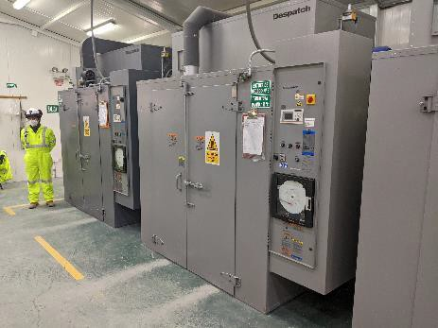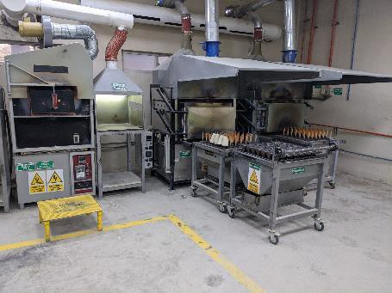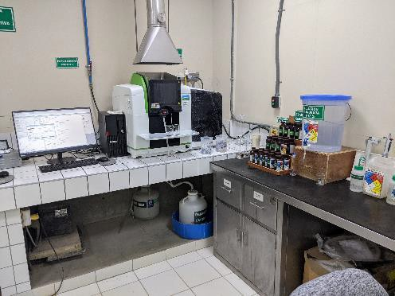

Similar to the successful practice at other Hochschild operations, the Inmaculada laboratory is responsible for plant sampling and sample management. The laboratory procedures for laboratory processing solid, slurry and liquid samples have been reviewed by auditors and were found to be appropriate. Laboratory staff performs the sampling required for the determination of the monthly gold and silver inventory. The staff are involved in the process of continuous improvement, to reduce the Gains/Losses in the Monthly Metallurgical Balance (Effective vs Metallurgical), with the objective being in the range of +/- 5% of total Oz AgEq.

The overflow from ball mill discharge cyclones is sampled automatically to determine the Au and Ag grades in both solid and liquid, for control and evaluation of the underflow sample from the pre-leaching thickener. While this sampling location is very practical, the grinding solution contains significant concentrations of free cyanide from barren solution as well as a minor amount from tailings pond water. A fraction of the gold and a smaller fraction of silver dissolves in the grinding and thickening. Recent data indicated that up to 50% of the gold and 30 % of the silver dissolves during grinding and leach feed preparation (i.e., in the thickener).

Plant management was reported in early 2022 to be in the process of implementing a Metallurgical Balance Improvement Program that will likely select the cyclone overflow as the sampling point as the Feed to the Process. A fine wire sampler, a simple but reliable technology, may be used to sample solution.

The feed to leaching (thickener underflow) is manually sampled every four hours by laboratory personnel or liquid and solid analyses of Au and Ag. These data provide input to the daily metallurgical balance.

Another critical sampling location and strategy is that for tailings. Tailings had earlier been sampled by opening and closing a valve by hand at regular intervals from the No. 4 CCD thickener underflow piping. This was replaced over three years ago with an automatic two-stage Vezin tailings sampling arrangement is shown in Figure 8.31. A tailings sample is obtained every half hour with a 12-hour composite accumulated for analyses.

FIGURE 8.31 TAILINGS (“RELAVE”) AUTOMATIC SAMPLING

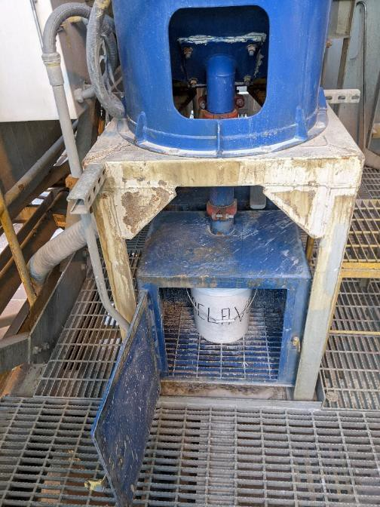

For the metallurgical balance, the head grade is calculated from samples of the pre-leaching thickener underflow, and making a calculation of the metal content in the solids and in solution. An inventory of the metal content of leaching tanks, CCD and Merrill Crowe is performed monthly. At the Merrill Crowe facility, an inventory of the barren and rich solution tanks is carried out for gold and silver. Theoretical extraction is calculated with head, tailings solid and solution grades. Recoveries are calculated based on the number of doré bars obtained, their Au and Ag content and a measurement of inventory in the Merrill Crowe circuit as well as contained in leaching and CCD.

8.3.6 Tailings and Water Management

Tailings are used to make paste backfill for the mine. Approximately 30% of the tailings solids are used in this way. The paste composition is typically 68% tailings, 12% cement and 20% water. Cement addition ranged from 67 to 78 kg per cubic metre of paste in 2022. No fines are removed to construct the paste. CCD No. 4 underflow is washed in a thickener with a sodium hypochlorite and peroxide treated solution to reduce cyanide concentrations. The tailings thickener underflow is further treated with Caro‟s Acid which is a combination of hydrogen peroxide and sulphuric acid. The treated slurry is distributed between being pumped to the paste backfill plant for thickening, or sent directly to tailings. The total cyanide (TCN) specification for paste backfill feed is <1 ppm, while the discharge to tailings TCN specification is <50 ppm. Tailings pond water is typically well below this level.

A 2021 plant water balance is shown in Figure 8.32. Fresh water consumption is 36.5 m3/h while 130 m3/h is recovered from the tailings pond and added to the barren solution tank. In 2022, 78% of water usage was recycled water, a slight increase from 2021.

FIGURE 8.32 INMACULADA PLANT WATER BALANCE

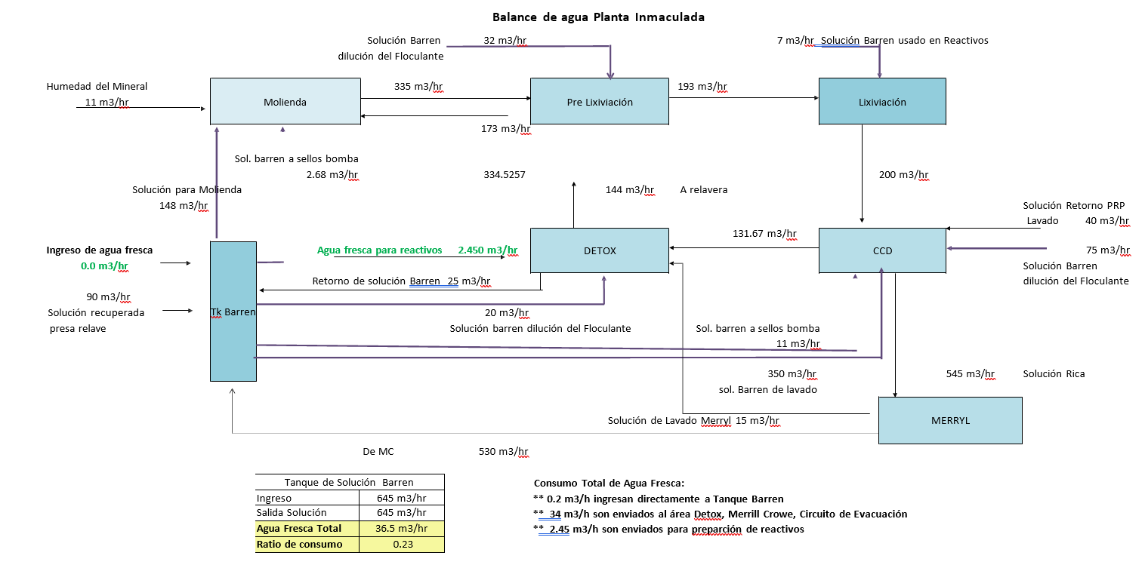

Because the overall Inmaculada facility has a net positive water balance, a treatment plant is in place to treat and discharge excess tailings pond water. Treatment to meet discharge water quality objectives includes the application of sodium metabisulphite, lime, caustic soda, coagulants and a flocculent.

For tailings management, thickened tailings are deposited into a lined facility down gradient from the plant in a local valley (Figure 8.33). Tailings decant water is recycled to the plant along with a small amount of dissolved gold and silver reported in 2020 to be 0.10 mg/L and 4 mg/L respectively. A summary of the 2021 return tailings water other analyses is shown in Table 8.10.

FIGURE 8.33 INMACULADA TAILINGS FACILITY (JANUARY 2021)

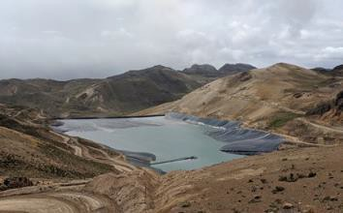

TABLE 8.10 INMACULADA RETURNING TAILINGS WATER ANALYSES 2021 (MG/L)

|  |  |  |  |  |  |  |
| --- | --- | --- | --- | --- | --- | --- |
| **CN total** | **CN WAD** | **CN free** | **Cu** | **Fe** | **Pb** | **Zn** |
| 19 | 16.9 | 0 | 21.5 | 0.26 | 0.12 | 0.06 |

Tailings are mainly discharged from the embankment allowing a beach to be formed and holding pond water away from the embankment. The facility had three years of capacity remaining at the end of 2021. An expansion was undertaken in 2020 with a 10 m lift of the embankment as well as the facility liner.

Two bird deterrent noise devices are used at the tailings facility and it is fenced to keep domestic and wild animals out. No metal recovery is directly attempted from the tailings pond water, e.g. carbon adsorption of gold. However, since about 120 m3/h of pond water is recycled to the plant, a minor amount of Au and Ag is recovered.

### 8.3.7 Environmental and Social

The Inmaculada facilities are located in the district of Oyolo in the provinces of Parinacochas and Paucar del Sara Paccar in the department of Ayacucho, in the Southern Sierra of Peru. The project area is located 210 km south-west of the city of Cusco. There is significant geographical relief in the area with elevation ranging from 3,900 m to 4,800 m. The climate of this puna grassland (ichu and pajonal (feathergrass)) region includes a moderately wet season between December and March and a dry season the remaining part of the year. Annual precipitation of snow and rain exceeds 800 mm and winds are generally light.

#### 8.3.7.1 Wastes

Mine waste rock is classified as “uncertain” with respect to acid rock drainage. Drainage is being monitored and reported to the regulatory authorities. No remedial action has been indicated. There is no mobile crusher plant at Inmaculada to produce aggregate from the mine waste rock for surface road and mine haulage ways. Instead, a scalping plant has been established on a hillside near the tailings facility to recover this road-building material.

Scrap metal is sorted by weight and is disposed in accordance with current regulations. Plastic material that has been extracted from the process is held in temporary storage for industrial waste, and then disposed of as general or hazardous waste by specialized contractors.

#### 8.3.7.2 Reporting, Permitting and Social

Environmental, permitting and social initiatives relevant to Inmaculada are not audited by P&E. The Hochschild Annual Report 2022 indicates a high level of advanced social and environmental initiatives and of due diligence.

No regulatory issues affecting operations have been reported to P&E in 2022. A diverse, professional environmental team is place at Inmaculada. Rigorous audits are routinely performed.

Polarized political sentiments led to physical disturbances, by citizens from local villages, at non critical Inmaculada infrastructure in October 2022. These short-term disturbances did not significantly affect operations. These events emphasised to need to continue discussions with local communities, to understand the needs and to address the expectations of both the communities and government political and agency representatives.

The environmental aspects of the Inmaculada facilities are extensively monitored by company technicians and the results are reviewed by Compania Minera Ares management A range of environmental reports are submitted to government agencies, including:

* + - * + Quarterly.

Surface runoff and effluent water quality monitoring.

Eleven water monitoring points with 2,000 analyses annually - complete compliance.

Air quality monitoring – dust, NOx/SOx climate.

* + - * + Semi-annually.

Electromagnetism monitoring.

Groundwater quality.

Biological and hydrobiological monitoring.

* + - * + Annually.

Solid waste management.

A site closure plan was drafted in 2014 and would have cost $15.4M to implement. It is understood (by P&E) that the current plan prepared by Klohn Crippen Berger was approved five years ago. The closure plan provision was $18,639,300.

Environmental permitting is facilitated by regular updates of site - a MEIA (Modified Environmental Impact Assessment). These are prepared and reviewed by SENACE (Servicio National de Certification Ambiental) agency an agency of the Ministerio del Ambiente.

In 2015, Hochschild implemented what is termed - the Environmental Corporate Objective (ECO) – an initiative that is applicable at all sites and facilities. The ECO score is intended to encourage all employees to comply with a common environmental mission, and assists in making everyone accountable for their actions. Components of the ECO program include: discharge limit compliance, minimal environmental incidents, reduction in water use and waste generation as well as limited regulator observations. The average ECO Score for all Hochschild operations and developing sites was 5.29 out of 6 in 2022. The actual ECO performance at Inmaculada was not available but was 6.0 in 2021- this indicates a strong commitment to environmental due diligence.

In addition to open and regular contact with community representatives, recently there had been initiatives for social support, scholarship and Medico de Cabecera (Health). In collaboration with the Peruvian Health Ministry, a programme entitled “Siempre Sanos” (Always Healthy) had been implemented. Other initiatives in Peru included “Aprender Para Triunfar” (Learn to Succeed) and “Becas Futuro Mujer” (Women of Future Scholarship) as well as assistance in economic development were provided.

# INTERPRETATIONS AND CONCLUSIONS

**P&E offers the following conclusions:**

1. P&E believes the Mineral Resources and Mineral Reserves reported by Hochschild for Pallancata, Inmaculada and San José mining properties are in conformity with the requirements of the Australasian Code for Reporting of Exploration Results, Mineral Resources and Mineral Reserves (“JORC”), as well as generally accepted CIM “Estimation of Mineral Resource and Mineral Reserves Best Practices” guidelines (2019), as required by National Instrument (NI) 43-101 Item 19, Standards of Disclosure for Mineral Projects.
2. The Mineral Resource and Mineral Reserve tables provided in this Technical Report have not been adjusted to reflect the proportion attributable to Hochschild on the basis of their joint ventures participation.
3. The P&E Mineral Resource audit strategy was based on review and validation checks of the deposits associated with the Pallancata, San José and Inmaculada properties. The Mineral Resource Estimates were audited in terms of compliance with generally accepted industry standards and guidelines, the methodology used for estimation, the classification criteria used and the actual implementation of the methodology in terms of Mineral Resource estimation and reporting. Mineral Resource Estimates were also checked by running parallel grade, volume and tonnage comparisons from the supplied block models, as well as comparing the statistical distribution of input and output model data. Grade capping, variography and grade estimation parameters were reviewed in detail and their appropriateness was determined. As a final check, composite grades, estimated block grades and Nearest Neighbour block grades, at zero cut-off, were compared.
4. All Mineral Resource and Mineral Reserve audit data were provided by Hochschild in the form of Excel spreadsheets, text files and AutoCAD format dxf files. P&E cannot absolutely verify the authenticity or accuracy of the original source data. The P&E Mineral Resource Estimate audit strategy was based on review and validation checks of the deposits associated with thePallancata, San José and Inmaculada properties, and on check modeling of the largest vein systems.
5. The P&E Mineral Reserve audit strategy was based on a review and check for reasonableness of the dollar value per tonne cut-off utilized at Pallancata, San José and Inmaculada. Subsequently the internal dilution, geotechnical dilution, mining dilution and mine extraction (mining recovery) was thoroughly scrutinized to ensure they fell within acceptable limits for Mineral Reserve reporting. In addition, the remaining Mineral Resource Estimate not converted to a Mineral Reserve was reviewed to ensure the numbers balanced with the mine extraction data.
6. P&E has undertaken detailed reviews on selected major vein system data at the Pallancata, San José and Inmaculada properties for all stages of the Mineral Resource Estimate and Mineral Reserve Estimate process.
7. The Hocschild December 25, 2022, Mineral Resource Estimates for Pallancata, Inmaculada and San José are based on a Gold (Au) price of US$1,800/oz and a Silver (Ag) price of US$24/oz. The Hocschild Dec 25, 2022, Mineral Reserve Estimates for Inmaculada and San José are based on a Gold (Au) price of US$1,650/oz and a Silver (Ag) price of US$22/oz. The Hocschild Dec 25, 2022, Mineral Reserve Estimate for Pallancata is based on a Gold (Au) price of US$1,650/oz and a Silver (Ag) price of US$25/oz (hedged). P&E determined that these metal prices are suitable to be utilized for Mineral Resource and Mineral Reserve estimation since they are based on recognized consensus forecast metal prices.
8. Mineral Reserves are estimated to a minimum 0.8 m mining thickness. Within the boundaries of this 0.8 m minimum thickness, there is some material that contains combined silver and gold grade values below the marginal cut-off value that must be mined. This material is referred to as planned internal dilution.
9. Planned external dilution is estimated, based on the mine plan and design, and equipment used. This planned external dilution is estimated based on historical reconciliation data gathered, including excavation surveys, and includes slough and blasted waste rock from both the hanging and the footwalls, mined backfill and blasted waste sent to the process plant.
10. For the 2022 Mineral Reserve estimate, inaccessible Mineral Resources that contained insufficient tonnages to permit the development of local infrastructure, Mineral Resources in mined out or isolated areas, Mineral Resources located in sill and rib pillars, uneconomic Mineral Resources that did not pass the Mineral Reserve requirements and operationally lost Mineral Resources, were not included in the Mineral Reserve Estimate. P&E has relied on Hochschild for the determination of which Mineral Resources to exclude, and has directly reviewed these Mineral Resources.
11. At Pallancata there is an average 8% Mineral Reserve internal dilution on Mineral Resources that are converted to Mineral Reserves, an average 15% mine recovery extraction factor is applied to internally diluted Mineral Resources and a 52% external dilution is added to these Minera Resources, at zero grade. These dilution percentages are reasonable. The Mineral Resource losses are excessive.
12. At Inmaculada there is an average 2% Mineral Reserve internal dilution on Mineral Resources, an average 89% mine extraction factor applied to internally diluted Mineral Resources and a 44% external dilution was added to these Mineral Resources, at zero grade. These dilution and extraction percentages are reasonable.
13. At San José there is an average 6% Mineral Reserve internal dilution on Mineral Resources that are converted to Mineral Reserves. Of the internally diluted Mineral Resources, 29% are recovered extractable, and a 51% external dilution was added to these Mineral Resources, at zero grade. These dilution percentages are reasonable. The Mineral Resource recovery is low.
14. The Mineral Reserve Estimate overall dilution and mine extraction percentile average is as follows: Internal Dilution = 3%, Mining and Geotechnical Dilution (External Dilution) = 45% and Mine Extraction = 58%.
15. The Hochschild databases provided to P&E for the Pallancata, San José and
16. Inmaculada mines are situable for Mineral Resource estimation.
17. Based on the supplied database, P&E considers the capping strategy implemented by
18. Hochschild to meet industry standards for linear estimation.
19. A review of the metallurgical components of all three mines‟ process plants was undertaken to assess the reasonableness of the metallurgical accountability, process recoveries, sampling and assaying precision and accuracy, processing costs and concentrate and doré product measurement and handling. In general, sampling and assaying for metallurgical accounting is conducted to a high standard as a result of precise sampling and excellent laboratory performance. Improvements in the sampling of feed and tailings, inventory measurements, metallurgical accounting have been implemented at Inmaculada. Long outstanding improvements in crusher plant dust control and more precision in the concentrate distribution to leaching and filtration is needed at San José. The two-year old “PRA” water-from-tailings recovery plant has proven to be a success at San José. The process plants at all three mines experienced steady and reliable operations in 2021. The stop-start strategy at Selene did not negatively affect performance – the plant successfully operated at full capacity during operating days The 2021 results confim the robust nature of the processes, the facilities, and the responsible, resourceful management.

# RECOMMENDATIONS (OLD 2021 REPORT)

P&E offers the following recommendations:

1. P&E considers the classification scheme as implemented by Hochschild for San José to be suitable for Mineral Resource estimation but recommends that the use of a larger number of samples for estimation be considered for Mineral Resource estimation, especially for poorly informed blocks.
2. P&E recommends that a mine-to-process plant Mineral Resource reconciliation study be implemented.
3. Mineral Reserve cut-off estimations should be calculated for each type of mining method. There should be separate operating cost estimations for each type of mining method at the Pallancata, Inmaculada and San José underground mining operations.
4. As noted in Section 9, item 10, outstanding improvements in crusher plant dust control and more precision in the concentrate distribution to leaching and filtration is needed at San José.

# GLOSSARY OF TERMS

Terminology used throughout this Technical Report is listed in Table 11.1.

TABLE 11.1 TERMS AND ABBREVIATIONS

|  |  |
| --- | --- |
| **Abbreviation** | **Description** |
| / | per |
| ~ | approximately |
| % | percent |
| $ | dollars (United States) |
| $/g | dollars per gram (United States) |
| $/oz | dollars per ounce (United States) |
| $/t | dollars per tonne (United States) |
| AA | atomic adsorption |
| AAS | atomic adsorption spectrometry |
| Ag | silver |
| AgEq | silver equivalent |
| Au | gold |
| CAPEX | capital expenditure |
| CCD | counter current decantation |
| CIM | Canadian Institute of Mining, Metallurgy and Petroleum |
| COV | cut-off value |
| CRF | cemented rockfill |
| csv | coma-separated-value |
| d | day |
| DDH | diamond drill hole |
| dxf | AutoCAD file format |
| ECO | Environmental Corporate Objective |
| ECOV | economic cut-off value |
| EIA | Environmental Impact Assessments |
| EW | electrowinning |
| g | gram |
| g/t | grams per tonne |
| g/t Ag | grams of silver per tonne |
| g/t Au | grams of gold per tonne |
| Hochschild | Hochschild Mining PLC |
| hp | horse power |
| H:V | horizontal:vertical ratio |
| HVC | Huevos Verdes Central |
| HVN | Huevos Verdes Norte (North) |

TABLE 11.1 TERMS AND ABBREVIATIONS

|  |  |
| --- | --- |
| **Abbreviation** | **Description** |
| HVN | Huevos Verdes North East |
| ICP-OES | inductively coupled plasma – optical emission spectroscopy |
| ID | indentity |
| ILR | intensive leaching reactor |
| IMC | International Minerals Corporation‟s |
| ISO/IEC | International Organization for Standardization / International  Electrotechnical Commission |
| JORC Code | Australasian Code for Reporting Mineral Resources and Ore Reserves  (2004) published by the Joint Ore Reserves Committee (“JORC”) |
| k | thousand(s) |
| KCB | Klohn Crippen Berger |
| kg | kilogram |
| kg/t | kilograms per tonne |
| koz | thousands of ounces |
| ktpa | thousand tonnes per annum |
| LHD | load-haul-dump truck |
| LIMS | laboratory information management system |
| LOM | life of mine |
| L/s | litres per second |
| M | million |
| m | metre |
| m3 | cubic metre |
| MC | Merrill Crowe |
| MCOV | marginal cut-off value |
| Moz | millions of ounces |
| MP-AES | Microwave Plasma-Atomic Emission Spectroscopy |
| N | north |
| NE | northeast |
| NI 43-101 | National Instrument 43-101 (Canada) |
| NN | Nearest Neighbour |
| no. | number |
| NSR | Net Smelter Return |
| NW | northwest |
| OK | Ordinary Kriging |
| OPEX | operating cost |
| oz | ounces |
| P&E | P&E Mining Consultants Inc. |
| PLS | pregnant leach solution |

TABLE 11.1 TERMS AND ABBREVIATIONS

|  |  |
| --- | --- |
| **Abbreviation** | **Description** |
| PRA | Planta Recuperacion de Aqua |
| ROM | run of mine |
| S | south |
| SAG | semi-autogenous |
| SE | southeast |
| SENACE | Servicio National de Certification Ambiental |
| SG&A | selling, general and administrative (expenses) |
| SRL | soft rubber lined |
| sondajes | chip channel samples |
| SW | southwest |
| t | tonnes (metric measurement) |
| TCN | total cyanide |
| tpd | tonnes per day |
| W | west |

APPENDIX A PALLANCATA MINE JORC CODE COMMENTS

Note: Figures and Tables, numbered A-, referred to in the following tables are located in later appendices.

**PALLANCATA MINE SECTION 1 SAMPLING TECHNIQUES AND DATA**

|  |  |  |
| --- | --- | --- |
| **Criteria** | **JORC Code Explanation** | **Commentary – Pallancata Mine** |
| ***Sampling techniques*** | * *Nature and quality of sampling (e.g. cut channels, random chips, or specific specialized industry standard measurement tools appropriate to the minerals under investigation, such as down hole gamma sondes, or handheld XRF instruments, etc.). These examples should not be taken as limiting the broad meaning of sampling.* * *Include reference to measures taken to ensure sample representivity and the appropriate calibration of any measurement tools or systems used.* * *Aspects of the determination of mineralisation that are Material to the Public Report.* * *In cases where „industry standard‟ work has been done this would be relatively simple (e.g. „reverse circulation drilling was used to obtain 1 m samples from which 3 kg was pulverised to produce a 30 g charge for fire assay‟). In other cases more explanation may be required, such as where there is coarse gold that has inherent sampling problems. Unusual commodities or mineralisation types (e.g. submarine nodules)*   *may warrant disclosure of detailed information.* | * HQ and NQ sized diamond drill core standard-tube (3 m), wire line equipment used. * Core samples are collected in visually mineralized intervals. Samples are between 0.30 m and 1.00 m in length. Unmineralized core is not sampled. * Channel sample areas are marked with paint. Lines are drawn perpendicular to the vein across the entire working from footwall to hanging wall. * Samples cut in chunks 2 cm deep, by 10 cm wide by 10 cm long across the length of the channel. * Samples are chiseled out using a pneumatic hammer and the sample is collected on a mat laid out below. Once the entire channel sample has been collected it is transferred to a plastic sample bag. * The mat is washed in between samples. * 1.00 kg sample core is pulverized up to 95% passing 140 mesh. * 30 g charge fire assay for gold and silver. |
| ***Drilling techniques*** | * *Drill type (e.g. core, reverse circulation, open- hole hammer, rotary air blast, auger, Bangka,*   *sonic, etc) and details (eg core diameter, triple or* | * HQ and NQ sized diamond drill core. Standard tube wire line equipment. Core is not oriented. |
| **Criteria** | **JORC Code Explanation** | **Commentary – Pallancata Mine** |
|  | *standard tube, depth of diamond tails, face-*  *sampling bit or other type, whether core is oriented and if so, by what method, etc).* |  |
| ***Drill sample recovery*** | * *Method of recording and assessing core and chip sample recoveries and results assessed.* * *Measures taken to maximise sample recovery and ensure representative nature of the samples.* * *Whether a relationship exists between sample recovery and grade and whether sample bias may have occurred due to preferential loss/gain of*   *fine/coarse material.* | * Recovery is recorded as a percentage calculated from measured core versus drilled intervals. * Pallancata achieved >90% recovery. * There is no known relationship between sample recovery and grade. |
| ***Logging*** | * *Whether core and chip samples have been geologically and geotechnically logged to a level of detail to support appropriate Mineral Resource estimation, mining studies and metallurgical studies.* * *Whether logging is qualitative or quantitative in nature. Core (or costean, channel, etc.) photography.* * *The total length and percentage of the relevant intersections logged.* | * Surface and underground core logging is carried out by company geologists, who delineate intervals on geological, structural, alteration and/or mineralogical boundaries, to industry standard. * Logging is qualitative and all core is photographed. Visual estimates are logged of sulphide, oxides, clays, quartz, alteration, as percentages.100% of the drill core is logged. * **Figure 1** in the appendices shows the Pallancata logging facility. |
| ***Sub-sampling techniques and sample preparation*** | * *If core, whether cut or sawn and whether quarter, half or all core taken.* * *If non-core, whether riffled, tube sampled, rotary split, etc. and whether sampled wet or dry.* * *For all sample types, the nature, quality and appropriateness of the sample preparation technique.* * *Quality control procedures adopted for all sub- sampling stages to maximise representivity of*   *samples.* | * Continuous half-core is sampled from 0.30 m to 1.00 m intervals as a general rule in visually mineralized or weakly mineralized intervals. * Care is taken to ensure that wall rock is not sampled with vein material. * Splitting the core is done with a diamond saw. * External laboratory sample preparation is deemed adequate. All samples are oven-dried overnight (max 90°C), jaw crushed to <2 mm, and split to <250 g in a   static riffle splitter, pulverized up to >95% passing 106 |

|  |  |  |
| --- | --- | --- |
| **Criteria** | **JORC Code Explanation** | **Commentary – Pallancata Mine** |
|  | * *Measures taken to ensure that the sampling is representative of the in situ material collected, including for instance results for field duplicate/second-half sampling.* * *Whether sample sizes are appropriate to the grain size of the material being sampled.* | μm (Tyler 140 mesh) and bagged. The analytical sample is further reduced to a 30 g charge weight using a spatula, and the pulp packet is stored awaiting collection.   * All samples are dried prior to analysis. * Sample size is considered to be appropriate. * Assay repeatability for gold and silver metals is poor due to variability in wall rock in adjacent area in channel samples. |
| ***Quality of assay data and laboratory tests*** | * *The nature, quality and appropriateness of the assaying and laboratory procedures used and whether the technique is considered partial or total.* * *For geophysical tools, spectrometers, handheld XRF instruments, etc., the parameters used in determining the analysis including instrument make and model, reading times, calibrations factors applied and their derivation, etc.* * *Nature of quality control procedures adopted (e.g. standards, blanks, duplicates, external laboratory checks) and whether acceptable levels of accuracy (i.e. lack of bias) and precision have been established.* | * Since COVID-19 all Pallancata samples are analyzed at an internal laboratory located at the Selene processing plant site. * Gold and silver are determined by Fire Assay with an Atomic Absorption or Gravimetric finish. * Quality control procedures include the insertion of prepared certified reference materials and site sourced coarse blanks. Each batch of 27 samples includes 1 field duplicate, 1 coarse blank sourced from barren mine material, 1 certified fine blank, 1 coarse duplicate,   1 pulp duplicate, 1 standard (alternating high/medium/low standards) into the regular sample number sequence.   * If any blank or standard is out of spec, re-assay is requested of the laboratory. Blanks and Standards data are assessed when they are imported to the database and reported monthly and yearly. * For mine samples: * QA/QC duplicates have been routinely assayed. Protocols used include using a second laboratory to analyze 5% of all drill and mine sample pulps. * For Infill drilling samples: * Some standards used for Pallancata QA/QC purposes in 2022 showed bias. Standards IN-13 showed a slight |
| **Criteria** | **JORC Code Explanation** | **Commentary – Pallancata Mine** |
|  |  | low bias for gold and silver in some months. All standards were within 2 Standard deviations and no action was taken. Overall, results have improved over past years for performance of standards. New certified standards are being used in 2023.   * Precision in the field duplicates for gold was low in past years due to the low values of gold and silver in the duplicates. A cut-off of 0.3 g/t Au and 5 g/t Ag was used and this helped to remove the failures. * For exploration drilling samples: * Standard Standard IN-13 showed a slight low bias for gold and silver. * New standards will be used in 2023. * QA/QC results for exploration diamond drilling were acceptable. |
| ***Verification of sampling and assaying*** | * *The verification of significant intersections by either independent or alternative company personnel.* * *The use of twinned holes.* * *Documentation of primary data, data entry procedures, data verification, data storage (physical and electronic) protocols.* * *Discuss any adjustment to assay data.* | * Calculations of significant intersections are carried out by a company Competent Person. * Twinned holes are generally not used or considered to be required. * Electronic data from external laboratories is stored and reported under the control of a geological database specialist. * Hard copies of external laboratories core assays and surveys are kept on site. * Visual checks are part of daily use of the data in MineSight. * No adjustments to assay data are carried out. |
| ***Location of data points*** | * *Accuracy and quality of surveys used to locate drill holes (collar and down-hole surveys), trenches, mine workings and other locations used in Mineral Resource estimation.* * *Specification of the grid system used.* | * All Pallancata coordinates are quoted in WGS 84 UTM Zona 18 Sur. * Pallancata survey accuracy and quality are industry standard, drill hole collar positions are picked up by   company surveyors using a total station. The drill hole |
| **Criteria** | **JORC Code Explanation** | **Commentary – Pallancata Mine** |
|  | * *Quality and adequacy of topographic control.* | surveying is done by using Flexit Multismart Multishot Drill hole equipment. (**Figures 5 through 7** in the appendices).   * Topographic control is excellent with no problems detected. |
| ***Data spacing and distribution*** | * *Data spacing for reporting of Exploration Results.* * *Whether the data spacing and distribution is sufficient to establish the degree of geological and grade continuity appropriate for the Mineral Resource and Ore Reserve estimation procedure(s) and classifications applied.* * *Whether sample compositing has been applied.* | * Data spacing (drill hole spacing) is appropriate to the geology. In general, a drill hole spacing of 80 meters is used for inferred resources (100% variogram range) and infill drilling is often used to confirm interpretations every 40 m (66 % variogram range) for indicated resources and measured resources (33% variogram range) with 2 m underground sampling. * Sample compositing is not used in reporting exploration results. |
| ***Orientation of data in***  ***relation to geological structure*** | * *Whether the orientation of sampling achieves unbiased sampling of possible structures and the extent to which this is known, considering the deposit type.* * *If the relationship between the drilling orientation and the orientation of key mineralised structures is considered to have introduced a sampling bias, this should be assessed and reported if material.* | * Quartz-Rodonite Vein, Quartz Vein, Quartz Carbonate and Quartz-sulphide Vein style mineralization are regular in general, and drilling is oriented to intersect the mineralization as perpendicular as possible, with moderate to high angles between 60° to 90° in underground drilling. * No material sampling bias has been introduced by the drilling direction. |
| ***Sample security*** | * *The measures taken to ensure sample security.* | * Pallancata exploration samples are selected, cut and bagged in tied numbered plastic bags and then grouped in larger tied plastic bags with a sample submission sheet. * All sample submissions are documented and all assays are returned via email. * Pallancata sample coarse rejects are returned by truck and stored in a box on site and pulp splits are stored at a company depot in Lima. * This is considered to be a secure and reasonable procedure and no instances of tampering with samples |

|  |  |  |
| --- | --- | --- |
| **Criteria** | **JORC Code Explanation** | **Commentary – Pallancata Mine** |
|  |  | have occurred since drilling commenced in 2004. |
| ***Audits or reviews*** | * *The results of any audits or reviews of sampling techniques and data.* | * Audits of sampling procedure have been completed in 2022 by P&E Mining Consultants. No material issues were raised. |

PALLANCATA MINE SECTION 2 REPORTING OF EXPLORATION RESULTS

|  |  |  |
| --- | --- | --- |
| **Criteria** | **JORC Code Explanation** | **Commentary – Pallancata Mine** |
| ***Mineral tenement and land tenure status*** | * *Type, reference name/number, location and ownership including agreements or material issues with third parties such as joint ventures, partnerships, overriding royalties, native title interests, historical sites, wilderness or national park and environmental settings.* * *The security of the tenure held at the time of reporting along with any known impediments to*   *obtaining a licence to operate in the area.* | * Pallancata´s (100% Hochschild Mining) tenure on Coronel Castañeda District, Parinacochas Province, Ayacucho Department, Peru, totalling 3,569.62 ha of mining properties for Suyamarca Mining SAC, also PALLANCATA has surface rights agreements over the entire property. |
| ***Exploration done by other parties*** | * *Acknowledgment and appraisal of exploration by other parties.* | * No work was done by other parties in 2022 on, Pallancata. * Drilling done on Pallancata between 2003-2005 done by International Minerals Corp was used for the initial   resource. |
| ***Geology*** | * *Deposit type, geological setting and style of mineralization.* | * Pallancata is a high-grade quartz epithermal silver and gold deposit, hosted by volcanic and volcaniclastic   sequences. |
| ***Drill hole Information*** | * *A summary of all information material to the understanding of the exploration results including a tabulation of the following information for all Material drill holes:* * *easting and northing of the drill hole collar* | * Pallancata had 8,926 m of drilling in 110 DDH in 2022 for infill purposes and 23,614 m of drilling in 72 DDH in 2022 for exploration purposes. * Collar locations for the infill drill holes can be found on **Table 1** and Exploration drill hole collars can be found |
| **Criteria** | **JORC Code Explanation** | **Commentary – Pallancata Mine** |
|  | * *elevation or RL (Reduced Level – elevation above sea level in metres) of the drill hole collar* * *dip and azimuth of the hole* * *down hole length and interception depth* * *hole length.* * *If the exclusion of this information is justified on the basis that the information is not Material and this exclusion does not detract from the understanding of the report, the Competent Person*   *should clearly explain why this is the case.* | on **Table 2** in the appendices.   * Borehole location diagrams can be found in **Figures 19 and 20** in the appendices. * Significant Intersections are presented on **Table 7.** |
| ***Data aggregation methods*** | * *In reporting Exploration Results, weighting averaging techniques, maximum and/or minimum grade truncations (e.g. cutting of high grades) and cut-off grades are usually Material and should be stated.* * *Where aggregate intercepts incorporate short lengths of high grade results and longer lengths of low grade results, the procedure used for such aggregation should be stated and some typical examples of such aggregations should be shown in detail.* * *The assumptions used for any reporting of metal equivalent values should be clearly stated.* | * Grade capping is implemented in the resource model to limit the inclusion of isolated, anomalous high-grade values of Ag and Au. * The determination of capping thresholds for Ag and Au grades is based on an analysis of population distributions using histograms and variogram plots, while considering that affected values are randomly distributed and ensuring high grade zones are not formed by visual verification in MineSight. * The capping threshold is applied to the assay samples in the following manner: * Capped grade = Original sample value if the original assay value is less than or equal to the capping grade * Capped grade = Capped grade value if the original assay value is greater than the capping grade * The formula for calculating the silver equivalent grade (AgEq) is as follows:   AgEq= Ag + (Au x 75) |
| ***Relationship between mineralizati on widths*** | * *These relationships are particularly important in the reporting of Exploration Results.* * *If the geometry of the mineralization with respect to the drill hole angle is known, its nature should* | * Due to the complex mineralization geometry and varying intercept angles, true thickness is estimated on a hole by hole basis. |

|  |  |  |
| --- | --- | --- |
| **Criteria** | **JORC Code Explanation** | **Commentary – Pallancata Mine** |
| ***and intercept lengths*** | *be reported.*   * *If it is not known and only the down hole lengths are reported, there should be a clear statement to this effect (eg „down hole length, true width not*   *known‟).* |  |
| ***Diagrams*** | * *Appropriate maps and sections (with scales) and tabulations of intercepts should be included for any significant discovery being reported. These should include, but not be limited to a plan view of drill hole collar locations and appropriate*   *sectional views.* | * A cross section view is presented in **Figure 16** in the appendices. * Borehole location diagrams can be found in **Figures 19 and 20** in the appendices. |
| ***Balanced reporting*** | * *Where comprehensive reporting of all Exploration Results is not practicable, representative reporting of both low and high grades and/or widths should be practiced to avoid misleading reporting of*   *Exploration Results.* | * All intersections within the mineralized wireframe, both high and low grade, are tabulated in this report. |
| ***Other substantive exploration data*** | * *Other exploration data, if meaningful and material, should be reported including (but not limited to): geological observations; geophysical survey results; geochemical survey results; bulk samples – size and method of treatment; metallurgical test results; bulk density, groundwater, geotechnical and rock characteristics; potential deleterious or*   *contaminating substances.* | * Not applicable to this report. |
| ***Further work*** | * *The nature and scale of planned further work (eg tests for lateral extensions or depth extensions or large-scale step-out drilling).* * *Diagrams clearly highlighting the areas of possible extensions, including the main geological interpretations and future drilling areas, provided*   *this information is not commercially sensitive.* | * Pallancata: Potential development in Marco, Pablo W, and Lucas. See **Figure 27** in the appendices. |

**PALLANCATA MINE SECTION 3 ESTIMATION AND REPORTING OF MINERAL RESOURCES**

|  |  |  |
| --- | --- | --- |
| **Criteria** | **JORC Code Explanation** | **Commentary – Pallancata Mine** |
| ***Database integrity*** | * *Measures taken to ensure that data has not been corrupted by, for example, transcription or keying errors, between its initial collection and its use for Mineral Resource estimation purposes.* * *Data validation procedures used.* | * All information is stored in the GEMMs database that was designed, developed and implemented by Hochschild. This system consists of a SQL database and a Net interface developed to accept information from different workstations. The GEMM system is installed on a Windows OS server. * The geological descriptions are entered in the geological database via input screens while the topographical information and laboratory data are entered into the system using predetermined electronic formats. * The data are comprised of vertical and horizontal channels and surface drill holes and drill holes from the interior of the mine. * The original logging sheets are filed and used to validate the electronic database. |
| ***Site visits*** | * *Comment on any site visits undertaken by the Competent Person and the outcome of those visits.* * *If no site visits have been undertaken indicate why this is the case.* | * A mine visit to Pallancata was conducted by Mr. David Burga, P.Geo. and Greg Robinson, P.Eng. on January 12 and 13, 2022. They visited various workings and witnessed the various sampling, mining and fill techniques used. * Work was conducted to industry standards. |
| ***Geological interpretatio n*** | * *Confidence in (or conversely, the uncertainty of ) the geological interpretation of the mineral deposit.* * *Nature of the data used and of any assumptions made.* * *The effect, if any, of alternative interpretations on Mineral Resource estimation.* * *The use of geology in guiding and controlling Mineral Resource estimation.* | * Geological interpretation is based on extensive mining history which provides a high level of confidence in the interpretation of geological and grade continuity. * Mineral Resource estimation is based on identification and modelling of distinct geological structures, with separate block models being maintained for each identified deposit. * Grade and geological continuity are a function of local   structures, which are incorporated into the estimation process. |
| **Criteria** | **JORC Code Explanation** | **Commentary – Pallancata Mine** |
|  | * *The factors affecting continuity both of grade and geology.* |  |
| ***Dimensions*** | * *The extent and variability of the Mineral Resource expressed as length (along strike or otherwise), plan width, and depth below surface to the upper and lower limits of the Mineral Resource.* | * At Pallancata, 94 individual structures relevant to the Mineral Resource have been identified to date. 94 structures have been used in the 2022 Mineral Resource * Strike length of the deposits at Pallancata ranges from 60 m to 1,680 m with an average strike length of 394 m. Model depths range from 40 m to 500 m, with an average depth of 208 m. Plan widths range from 20 m to 460 m, with an average plan width of 86 m. |
| ***Estimation and modelling techniques*** | * *The nature and appropriateness of the estimation technique(s) applied and key assumptions, including treatment of extreme grade values, domaining, interpolation parameters and maximum distance of extrapolation from data points. If a computer assisted estimation method was chosen include a description of computer software and parameters used.* * *The availability of check estimates, previous estimates and/or mine production records and whether the Mineral Resource estimate takes appropriate account of such data.* * *The assumptions made regarding recovery of by- products.* * *Estimation of deleterious elements or other non- grade variables of economic significance (eg sulphur for acid mine drainage characterisation).* * *In the case of block model interpolation, the block size in relation to the average sample spacing and the search employed.* * *Any assumptions behind modelling of selective mining units.* | * Where there is sufficient information available to construct a variogram, Ordinary Kriging (“OK”) is used for estimation. Where insufficient information is available to establish a variogram, Inverse Distance estimation is used, applying similar search criteria as that used for OK. * Resource block model size and orientation are based on the general size and geometry of the deposit. Block models are based on a 5 m x 5 m x 5 m or a 10 m x 10 m x 10 m block size. Pallancata Este uses a block size of 10 m x 10 m x 5 m and Virgen del Carmen uses a block size of 5 m x 10 m x 5 m. Selected deposits have also been divided where appropriate into low and high-grade sub- domains for estimation. Areas of low-geological confidence have been excluded from the Mineral Resource. * The Mineral Resource models consist of separate block models by deposit for Au and Ag estimated grades, diluted Au and Ag estimated grades, average interpolation distance, number of samples used for estimation, ore codes, percentage remaining ore, dilution factors, vein thickness, estimation variance, classification and geological confidence. |
| **Criteria** | **JORC Code Explanation** | **Commentary – Pallancata Mine** |
|  | * *Any assumptions about correlation between variables.* * *Description of how the geological interpretation was used to control the resource estimates.* * *Discussion of basis for using or not using grade cutting or capping.* * *The process of validation, the checking process used, the comparison of model data to drill hole data, and use of reconciliation data if available.* | * Mineral resource estimates assume no correlation between Ag and Au grades. * The influence of high-grade outliers has been restricted by capping composite grades above a threshold value prior to estimation. High-grade thresholds are determined for individually for each structure through statistical analysis and examination of probability data. * Nearest Neighbour models are maintained and used as a comparison against block model grade estimates. Examination of Nearest Neighbour and block model estimates suggests that the Mineral Resource estimates may be slightly conservative in nature. |
| ***Moisture*** | * *Whether the tonnages are estimated on a dry basis or with natural moisture, and the method of determination of the moisture content.* | * Tonnages are estimated on a dry basis. Process tonnages on measured on a dry basis also |
| ***Cut-off parameters*** | * *The basis of the adopted cut-off grade(s) or quality parameters applied.* | * Mineral resources at Pallancata have been accumulated relative to a NSR value, the “Valor de Punto”. Based on a price of US$24.00 per ounce Ag and US$1,800 per ounce Au, the cut-off used for the 2022 Mineral Resources at Pallancata is US$80.60 per tonne. |
| ***Mining factors or assumptions*** | * *Assumptions made regarding possible mining methods, minimum mining dimensions and internal (or, if applicable, external) mining dilution. It is always necessary as part of the process of determining reasonable prospects for eventual economic extraction to consider potential mining methods, but the assumptions made regarding mining methods and parameters when estimating Mineral Resources may not always be rigorous. Where this is the case, this should be reported with an explanation of the basis of the mining assumptions made.* | * The resources are diluted utilizing a minimum underground mining width of 0.8 meters and diluted with zero grade material. This is applied after the processing of the blocks. |
| ***Metallurgic*** | * *The basis for assumptions or predictions* | * The Pallancata resources are modelled using a “cut-off” |
| **Criteria** | **JORC Code Explanation** | **Commentary – Pallancata Mine** |
| ***al factors or assumptions*** | *regarding metallurgical amenability. It is always necessary as part of the process of determining reasonable prospects for eventual economic extraction to consider potential metallurgical methods, but the assumptions regarding metallurgical treatment processes and parameters made when reporting Mineral Resources may not always be rigorous. Where this is the case, this should be reported with an explanation of the*  *basis of the metallurgical assumptions made.* | value of is US$80.60 per tonne. The Valor de Punto “NSR value” is calculated using the metalurgical balance using real plant data. |
| ***Environmen tal factors or assumptions*** | * *Assumptions made regarding possible waste and process residue disposal options. It is always necessary as part of the process of determining reasonable prospects for eventual economic extraction to consider the potential environmental impacts of the mining and processing operation. While at this stage the determination of potential environmental impacts, particularly for a greenfields project, may not always be well advanced, the status of early consideration of these potential environmental impacts should be reported. Where these aspects have not been considered this should be reported with an explanation of the environmental assumptions made.* | * The Pallancata Mine facility has been in operation for several years. Waste characterisation and management are well advanced. |
| ***Bulk density*** | * *Whether assumed or determined. If assumed, the basis for the assumptions. If determined, the method used, whether wet or dry, the frequency of the measurements, the nature, size and representativeness of the samples.* * *The bulk density for bulk material must have been measured by methods that adequately account for void spaces (vugs, porosity, etc), moisture and* | * A global bulk density value per deposit has been applied for volumetrics calculations, based on the median measured bulk density. Bulk density values are determined by water immersion of drill hole core. |

|  |  |  |
| --- | --- | --- |
| **Criteria** | **JORC Code Explanation** | **Commentary – Pallancata Mine** |
|  | *differences between rock and alteration zones within the deposit.*   * *Discuss assumptions for bulk density estimates used in the evaluation process of the different materials.* |  |
| ***Classificatio n*** | * *The basis for the classification of the Mineral Resources into varying confidence categories.* * *Whether appropriate account has been taken of all relevant factors (ie relative confidence in tonnage/grade estimations, reliability of input data, confidence in continuity of geology and metal values, quality, quantity and distribution of the data).* * *Whether the result appropriately reflects the Competent Person‟s view of the deposit.* | * Mineral Resources have been classified based on geological and grade continuity, and areas of low geological confidence have been appropriately down- graded or excluded from the estimates. * Classification is based primarily on the uncapped composite experimental semi-variogram ranges. Between three and eight composites within 1/3 of the defined search range (generally 30 metres) are required for Measured resources. For Indicated resources between two and eight composites within 2/3 of the defined search range (generally 60 metres) are required, and for Inferred resources between one and eight composites within the defined search range are required (generally 90 metres). * All relevant factors regarding tonnage and grade estimates, the quality and distribution of data and confidence in local geological structures has been taken into account. * Estimation methodology is based on detailed knowledge of the local geological structures. |
| ***Audits or reviews*** | * *The results of any audits or reviews of Mineral Resource estimates.* | * P&E has audited the Mineral Resources and believes that the methodology used for Pallancata represents a generally prudent and moderately conservative approach to the Mineral Resource estimates and that the Mineral Resources reported are in conformity with the requirements of the Australasian Code for Reporting of Exploration Results, Mineral Resources and Ore Reserves (“JORC”). |
| ***Discussion*** | * *Where appropriate a statement of the relative* | * Confidence levels for the Mineral Resource estimate have |
| **Criteria** | **JORC Code Explanation** | **Commentary – Pallancata Mine** |
| ***of relative accuracy/ confidence*** | *accuracy and confidence level in the Mineral Resource estimate using an approach or procedure deemed appropriate by the Competent Person. For example, the application of statistical or geostatistical procedures to quantify the relative accuracy of the resource within stated confidence limits, or, if such an approach is not deemed appropriate, a qualitative discussion of the factors that could affect the relative accuracy and confidence of the estimate.*   * *The statement should specify whether it relates to global or local estimates, and, if local, state the relevant tonnages, which should be relevant to technical and economic evaluation. Documentation should include assumptions made and the procedures used.* * *These statements of relative accuracy and confidence of the estimate should be compared with production data, where available.* | not been determined. |

**PALLANCATA MINE SECTION 4 ESTIMATION AND REPORTING OF MINERAL RESERVES**

|  |  |  |
| --- | --- | --- |
| **Criteria** | **JORC Code Explanation** | **Commentary – Pallancata Mine** |
| ***Mineral Resource estimate for conversion to Ore Reserves*** | * *Description of the Mineral Resource estimate used as a basis for the conversion to an Ore Reserve.* * *Clear statement as to whether the Mineral Resources are reported additional to, or*   *inclusive of, the Ore Reserves.* | * Block model. * Remaining Mineral Resources are reported additional to Mineral Reserves. Please refer to Tables 1.3, 6.2 and   6.17 in the report text. |

|  |  |  |
| --- | --- | --- |
| **Criteria** | **JORC Code Explanation** | **Commentary – Pallancata Mine** |
| ***Site visits*** | * *Comment on any site visits undertaken by the Competent Person and the outcome of those visits.* * *If no site visits have been undertaken indicate why this is the case.* | * P&E Qualified Persons have visited all Hochschild operating mines and processing plants since 2009, except for the 2020 Mineral Resource and Reserve Audits due to Covid-19 assess restrictions. The last P&E Qualified Persons site visits were in January 2022. |
| ***Study status*** | * *The type and level of study undertaken to enable Mineral Resources to be converted to Ore Reserves.* * *The Code requires that a study to at least Pre- Feasibility Study level has been undertaken to convert Mineral Resources to Ore Reserves. Such studies will have been carried out and will have determined a mine plan that is technically achievable and economically viable, and that material Modifying Factors have been considered.* | * Hochschild‟s mines are in production. Historical conversion data was used. * Hochschild has a LOM (life-of-mine) plan for the Pallancata operation. This plan was reviewed by the QUALIFIED PERSON. Hochschild‟s mine plan for Pallancata is reasonable. |
| ***Cut-off parameters*** | * *The basis of the cut-off grade(s) or quality parameters applied.* | * Using historic October 2021 to September 2022 operating costs and reasonable metal prices. |
| ***Mining factors or assumptions*** | * *The method and assumptions used as reported in the Pre-Feasibility or Feasibility Study to convert the Mineral Resource to an Ore Reserve (i.e. either by application of appropriate factors by optimisation or by preliminary or detailed design).* * *The choice, nature and appropriateness of the selected mining method(s) and other mining parameters including associated design issues such as pre-strip, access, etc.* * *The assumptions made regarding geotechnical parameters (eg pit slopes, stope sizes, etc), grade control and pre-production drilling.* * *The major assumptions made and Mineral* | * Using actual mine recovery and dilution parameters. * These are producing mining operations as summarized in Section 7 – Mining Operations. * These are producing underground mining operations. Appropriate ground support is installed in these underground operations * N/A |
| **Criteria** | **JORC Code Explanation** | **Commentary – Pallancata Mine** |
|  | *Resource model used for pit and stope optimisation (if appropriate).*   * *The mining dilution factors used.* * *The mining recovery factors used.* * *Any minimum mining widths used.* * *The manner in which Inferred Mineral Resources are utilised in mining studies and the sensitivity of the outcome to their inclusion.* * *The infrastructure requirements of the selected mining methods.* | * Pallancata‟s Mineral Reserve internal dilution is 8%. The average mining and geotechnical dilution (external dilution) is 52%, at zero grade. * The average mine extraction (mine recovery) is 15%. * The minimum mining width used is 0.8 m. * Inferred Mineral Resources are not considered nor converted to Mineral Reserves. * All surface and underground infrastructure required for the selected mining methods exist and are in place. |
| ***Metallurg-ical factors or assumptions*** | * *The metallurgical process proposed and the appropriateness of that process to the style of mineralisation.* * *Whether the metallurgical process is well-tested technology or novel in nature.* * *The nature, amount and representativeness of metallurgical test work undertaken, the nature of the metallurgical domaining applied and the corresponding metallurgical recovery factors applied.* * *Any assumptions or allowances made for deleterious elements.* * *The existence of any bulk sample or pilot scale test work and the degree to which such samples are considered representative of the orebody as a whole.* * *For minerals that are defined by a specification, has the ore reserve estimation been based on the*   *appropriate mineralogy to meet the* | * The metallurgical processes selected at the Pallancata operation are appropriate for the mineralization. * Flotation recovery of gold/silver concentrates has been well tested. * Flotation testing on all mineralized zones is a routine practice. The results of these tests are used to adjust in advance process conditions. Metallurgical recoveries are applied to Mineral Resources by slightly discounting actual plant performance. This has proven to be a conservative practice. * No significant amounts of deleterious elements are present and need to be considered. * N/A * N/A |
| **Criteria** | **JORC Code Explanation** | **Commentary – Pallancata Mine** |
|  | *specifications?* |  |
| ***Environmental*** | * *The status of studies of potential environmental impacts of the mining and processing operation. Details of waste rock characterisation and the consideration of potential sites, status of design options considered and, where applicable, the status of approvals for process residue storage and waste dumps should be reported.* | * Environmental impacts of mining and processing activities are continuously being assessed by a dedicated team. This operation is compliant with ISO 14001 principles of environmental management. Wastes have been characterised for acid generation and metal leaching potential. Where acid generation is observed, and where justified by climatic conditions, measures are in place to prevent and/or treat the acidic drainage. * Pallancata has permitted waste rock and tailings management facilities. |
| ***Infrastructure*** | * *The existence of appropriate infrastructure: availability of land for plant development, power, water, transportation (particularly for bulk commodities), labour, accommodation; or the ease with which the infrastructure can be provided, or accessed.* | * This is a producing operation. All required infrastructure is in place. |
| ***Costs*** | * *The derivation of, or assumptions made, regarding projected capital costs in the study.* * *The methodology used to estimate operating costs.* * *Allowances made for the content of deleterious elements.* * *The derivation of assumptions made of metal or commodity price(s), for the principal minerals and co- products.* * *The source of exchange rates used in the study.* * *Derivation of transportation charges.* * *The basis for forecasting or source of treatment and refining charges, penalties for failure to* | * Capital cost estimates to purchase and install equipment and infrastrucuture required for the LOM‟s (life-of- mine‟s) were completed. * Using historic October 2021 to September 2022 operating costs. * There are no deleterious elements in the underground ore. * P&E determined that metal prices used are suitable to be utilized for Mineral Resource and Mineral Reserve estimation since they are based on recognized consensus metal price projections. * All costs are in US$. * 2022 transportation charges were used. * 2022 treatment and refining charges were used. |
| **Criteria** | **JORC Code Explanation** | **Commentary – Pallancata Mine** |
|  | *meet specification, etc.*   * *The allowances made for royalties payable, both Government and private.* | * Actual 2022 allowances for royalties were made. |
| ***Revenue factors*** | * *The derivation of, or assumptions made regarding revenue factors including head grade, metal or commodity price(s) exchange rates, transportation and treatment charges, penalties, net smelter returns, etc.* * *The derivation of assumptions made of metal or commodity price(s), for the principal metals, minerals and co-products.* | * Used current and 2022 parameters. * P&E determined that metal prices used are suitable to be utilized for Mineral Resource and Mineral Reserve estimation since they are based on recognized consensus metal price projections. |
| ***Market assessment*** | * *The demand, supply and stock situation for the particular commodity, consumption trends and factors likely to affect supply and demand into the future.* * *A customer and competitor analysis along with the identification of likely market windows for the product.* * *Price and volume forecasts and the basis for these forecasts* * *For industrial minerals the customer specification, testing and acceptance requirements prior to a supply contract.* | * Gold and silver are freely traded on world markets. * P&E determined that metal prices used are suitable to be utilized for Mineral Resource and Mineral Reserve estimation since they are based on recognized consensus metal price projections. * P&E determined that metal prices used are suitable to be utilized for Mineral Resource and Mineral Reserve estimation since they are based on recognized consensus metal price projections. * N/A |
| ***Economic*** | * *The inputs to the economic analysis to produce the net present value (NPV) in the study, the source and confidence of these economic inputs including estimated inflation, discount rate, etc.* * *NPV ranges and sensitivity to variations in the* | * Estimated revenues, production costs, SG&A expenses, EBITDA (excluding exploration expenses), mining royalties, SMT, capex and mine closure costs * The after-tax cash flow is positive in 2023, its final year |
| **Criteria** | **JORC Code Explanation** | **Commentary – Pallancata Mine** |
|  | *significant assumptions and inputs.* | of production, and to the completion of closure. The after-tax NPV is positive beyond a 0% discount rate. The Pallancata operation is most sensitive to Ag metal price followed by Ag head grade, Ag metallurgical recoveries, OPEX, CAPEX and the Au metal price. |
| ***Social*** | * *The status of agreements with key stakeholders and matters leading to social licence to operate.* | * All agreements with key stakeholders are in place. There are no foreseeable material social issues that may jeopardize the ability to continue to operate. |
| ***Other*** | * *To the extent relevant, the impact of the following on the project and/or on the estimation and classification of the Ore Reserves:* * *Any identified material naturally occurring risks.* * *The status of material legal agreements and marketing arrangements.* * *The status of governmental agreements and approvals critical to the viability of the project, such as mineral tenement status, and government and statutory approvals. There must be reasonable grounds to expect that all necessary Government approvals will be received within the timeframes anticipated in the Pre-Feasibility or Feasibility study. Highlight and discuss the materiality of any unresolved matter that is dependent on a third party on which extraction of the reserve is contingent.* | * There are no known material, naturally occurring risks at the Hochschild‟s Pallancata operating mine. * The necessary agreements are in place that allow the mine to continue to operate. * The necessary agreements are in place that allow the mine to continue to operate. |
| ***Classification*** | * *The basis for the classification of the Ore Reserves into varying confidence categories.* * *Whether the result appropriately reflects the Competent Person‟s view of the deposit.* | * Only Measured Mineral Resources are converted to Proven Mineral Reserves. Only Indicated Mineral Resources are converted to Probable Mineral Reserves. * The results appropriately reflect P&E‟s QUALIFIED PERSON view of the deposit. |
| **Criteria** | **JORC Code Explanation** | **Commentary – Pallancata Mine** |
|  | * *The proportion of Probable Ore Reserves that have been derived from Measured Mineral Resources (if any).* | * Only Indicated Mineral Resources are converted to Probable Mineral Reserves. No Measured Mineral Resources are converted to Probable Mineral Reserves. |
| ***Audits or reviews*** | * *The results of any audits or reviews of Ore Reserve estimates.* | * Hochschild‟s Mineral Reserve Estimates have been reported in accordance with the requirements of JORC (Code 2012), NI 43-101 (2014) and CIM Best Practices Guidelines (2019). |
| ***Discussion of relative accuracy/ confidence*** | * *Where appropriate a statement of the relative accuracy and confidence level in the Ore Reserve estimate using an approach or procedure deemed appropriate by the Competent Person. For example, the application of statistical or geostatistical procedures to quantify the relative accuracy of the reserve within stated confidence limits, or, if such an approach is not deemed appropriate, a qualitative discussion of the factors which could affect the relative accuracy and confidence of the estimate.* * *The statement should specify whether it relates to global or local estimates, and, if local, state the relevant tonnages, which should be relevant to technical and economic evaluation. Documentation should include assumptions made and the procedures used.* * *Accuracy and confidence discussions should extend to specific discussions of any applied Modifying Factors that may have a material impact on Ore Reserve viability, or for which there are remaining areas of uncertainty at the current study stage.* * *It is recognised that this may not be possible or appropriate in all circumstances. These* | * The Pallancata Dec 25, 2022, Mineral Reserve Estimates are based on a gold (Au) price of US$1,650/oz and a Silver (Ag) price of US$25/oz (hedged). P&E determined that these metal prices are suitable to be utilized for Mineral Resource and Mineral Reserve estimation since they are based on recognized consensus metal price projections. The Pallancata operation is most sensitive to Ag metal price followed by Ag head grade, Ag metallurgical recoveries, OPEX, CAPEX and the Au metal price. * The Ag and Au metal price estimates are based on global estimates. Opex costs are based on historical operating costs from Hochschild‟s operations. * No „Modifying Factors‟ were used to estimate Mineral Reserves. These are operating mines that use historical operating costs to estimate future OPEX. Future CAPEX costs are estimated using both internal and external studies. * Hochschild uses historical Hochschild operation costs to estimate OPEX costs. |
| **Criteria** | **JORC Code Explanation** | **Commentary – Pallancata Mine** |
|  | *statements of relative accuracy and confidence of the estimate should be compared with production data, where available.* |  |

APPENDIX SAN JOSÉ MINE JORC CODE COMMENTS

Note: Figures and Tables, numbered A-, referred to in the following tables are located in later appendices.

SAN JOSÉ MINE SECTION 1 SAMPLING TECHNIQUES AND DATA

|  |  |  |
| --- | --- | --- |
| **Criteria** | **JORC Code Explanation** | **Commentary – San José Mine** |
| ***Sampling techniques*** | * *Nature and quality of sampling (e.g. cut channels, random chips, or specific specialized industry standard measurement tools appropriate to the minerals under investigation, such as down hole gamma sondes, or handheld XRF instruments, etc.). These examples should not be taken as limiting the broad meaning of sampling.* * *Include reference to measures taken to ensure sample representivity and the appropriate calibration of any measurement tools or systems used.* * *Aspects of the determination of mineralisation that are Material to the Public Report.* * *In cases where „industry standard‟ work has been done this would be relatively simple (e.g. „reverse circulation drilling was used to obtain 1 m samples from which 3 kg was pulverised to produce a 30 g charge for fire assay‟). In other cases more explanation may be required, such as where there is coarse gold that has inherent sampling problems. Unusual commodities or mineralisation types (eg submarine nodules) may warrant disclosure of detailed information.* | * HQ and NQ sized diamond drill core standard-tube (3 metre), wire line equipment used. * Core samples are collected in visually mineralized intervals. Samples are between 0.30 m and 1.00 m in length. Unmineralized core is not sampled. * Channel sample areas are marked with paint. Lines are drawn perpendicular to the vein across the entire working from footwall to hanging wall. * Samples cut in chunks 2 cm deep, by 10 cm wide by 10 cm long across the length of the channel. * Samples are chiseled out using a pneumatic hammer and the sample is collected on a mat laid out below. Once the entire channel sample has been collected it is transferred to a plastic sample bag. * 1.00 kg sample core is pulverized up to 95% passing 140 mesh. * 30 g charge fire assay for gold and silver. |
| ***Drilling techniques*** | * *Drill type (eg core, reverse circulation, open-hole hammer, rotary air blast, auger, Bangka, sonic, etc) and details (eg core diameter, triple or* | * HQ and NQ sized diamond drill core. Standard tube wire line equipment. Core is not oriented. |

|  |  |  |
| --- | --- | --- |
| **Criteria** | **JORC Code Explanation** | **Commentary – San José Mine** |
|  | *standard tube, depth of diamond tails, face-*  *sampling bit or other type, whether core is oriented and if so, by what method, etc).* |  |
| ***Drill sample recovery*** | * *Method of recording and assessing core and chip sample recoveries and results assessed.* * *Measures taken to maximise sample recovery and ensure representative nature of the samples.* * *Whether a relationship exists between sample recovery and grade and whether sample bias may have occurred due to preferential loss/gain of fine/coarse material.* | * Recovery is recorded as a percentage calculated from measured core versus drilled intervals. * San José achieved >96% recover. * There is no known relationship between sample recovery and grade. |
| ***Logging*** | * *Whether core and chip samples have been geologically and geotechnically logged to a level of detail to support appropriate Mineral Resource estimation, mining studies and metallurgical studies.* * *Whether logging is qualitative or quantitative in nature. Core (or costean, channel, etc) photography.* * *The total length and percentage of the relevant intersections logged.* | * Surface and underground core logging is carried out by company geologists, who delineate intervals on geological, structural, alteration and/or mineralogical boundaries, to industry standard. * Logging is qualitative and all core is photographed. Visual estimates are logged of sulphide, oxides, clays, quartz, alteration, as percentages.100% of the drill core is logged.   **Figure 2** in the appendices shows the San José logging facility. |
| ***Sub- sampling techniques and sample preparatio n*** | * *If core, whether cut or sawn and whether quarter, half or all core taken.* * *If non-core, whether riffled, tube sampled, rotary split, etc and whether sampled wet or dry.* * *For all sample types, the nature, quality and appropriateness of the sample preparation technique.* * *Quality control procedures adopted for all sub- sampling stages to maximise representivity of samples.* | * Continuous half-core is sampled from 0.30 m to 1.00 m intervals as a general rule in visually mineralized or weakly mineralized intervals. * Care is taken to ensure that wall rock is not sampled with vein material. * Splitting the core is done with a diamond saw. * External laboratory sample preparation is deemed adequate. All samples are oven-dried overnight (max 90°C), jaw crushed to <2 mm, and split to <250 g in a static riffle splitter, pulverized up to >95% passing 106 |

|  |  |  |
| --- | --- | --- |
| **Criteria** | **JORC Code Explanation** | **Commentary – San José Mine** |
|  | * *Measures taken to ensure that the sampling is representative of the in situ material collected, including for instance results for field duplicate/second-half sampling.* * *Whether sample sizes are appropriate to the grain size of the material being sampled.* | μm (Tyler 140 mesh) and bagged. The analytical sample is further reduced to a 30 g charge weight using a spatula, and the pulp packet is stored awaiting collection.   * All samples are dried prior to analysis. * Sample size is considered to be appropriate. * Assay repeatability for gold and silver metals is poor due to variability in wall rock in adjacent area in channel   samples. |
| ***Quality of assay data and laboratory tests*** | * *The nature, quality and appropriateness of the assaying and laboratory procedures used and whether the technique is considered partial or total.* * *For geophysical tools, spectrometers, handheld XRF instruments, etc, the parameters used in determining the analysis including instrument make and model, reading times, calibrations factors applied and their derivation, etc.* * *Nature of quality control procedures adopted (eg standards, blanks, duplicates, external laboratory checks) and whether acceptable levels of accuracy (ie lack of bias) and precision have been established.* | * Samples were analyzed by Alex Stewart and the internal laboratory. * Gold and silver are determined by Fire Assay with an Atomic Absorption or Gravimetric finish. * Quality control procedures include the insertion of prepared certified reference materials and site sourced coarse blanks. Each batch of 37 samples includes 1 field duplicate, 1 coarse blank sourced from barren mine material, 1 certified fine blank, 1 coarse duplicate, 1 pulp duplicate, 1 standard (alternating high/medium/low standards) into the regular sample number sequence. * If any blank or standard is out of spec, re-assay is requested of the laboratory. Blanks and Standards data are assessed when they are imported to the database and reported monthly and yearly. * For mine samples: * QA/QC duplicates have been routinely assayed. Protocols used include using a second laboratory to analyze 5% of all drill and mine sample pulps. * All standards were within 2 Standard deviations and no action was taken. New certified standards are being used in 2023. * Some standards used for San José QA/QC purposes in 2023 showed bias. Standard CDN-ME-1903 showed a slight high bias for silver. |
| **Criteria** | **JORC Code Explanation** | **Commentary – San José Mine** |
|  |  | Precision in the field duplicates, coarse duplicates and pulp duplicates was acceptable in 2023 at San José.  For exploration samples:  All standards were within 2 Standard deviations and no action was taken. New certified standards are being used in 2023.  Standard CDN-ME-1903 showed a high bias for silver.   * QA/QC results for exploration diamond drilling were acceptable. |
| ***Verificatio n of***  ***sampling and assaying*** | * *The verification of significant intersections by either independent or alternative company personnel.* * *The use of twinned holes.* * *Documentation of primary data, data entry procedures, data verification, data storage (physical and electronic) protocols.* * *Discuss any adjustment to assay data.* | * Calculations of significant intersections are carried out by a company Competent Person. * Twinned holes are generally not used or considered to be required. * Electronic data from external laboratories is stored and reported under the control of a geological database specialist. * Hard copies of external laboratories core assays and surveys are kept on site. * Visual checks are part of daily use of the data in MineSight. * No adjustments to assay data are carried out. |
| ***Location of data points*** | * *Accuracy and quality of surveys used to locate drill holes (collar and down-hole surveys), trenches, mine workings and other locations used in Mineral Resource estimation.* * *Specification of the grid system used.* * *Quality and adequacy of topographic control.* | * All San José coordinates are quoted in Gauss Kruger Argentina Zone 2. * Topographic control is excellent with no problems detected. * (**Figures 8 through 10** in the appendices) |
| **Criteria** | **JORC Code Explanation** | **Commentary – San José Mine** |
| ***Data spacing and distributio n*** | * *Data spacing for reporting of Exploration Results.* * *Whether the data spacing and distribution is sufficient to establish the degree of geological and grade continuity appropriate for the Mineral Resource and Ore Reserve estimation procedure(s) and classifications applied.* * *Whether sample compositing has been applied.* | * Data spacing (drill hole spacing) is appropriate to the geology. In general, a drill hole spacing of 80 meters is used for inferred resources (100% variogram range) and infill drilling is often used to confirm interpretations every 40 m (66 % variogram range) for indicated resources and measured resources (33% variogram range) with 2 m underground sampling. * Sample compositing is not used in reporting exploration results. |
| ***Orientatio n of data in relation to geological structure*** | * *Whether the orientation of sampling achieves unbiased sampling of possible structures and the extent to which this is known, considering the deposit type.* * *If the relationship between the drilling orientation and the orientation of key mineralised structures is considered to have introduced a sampling bias, this should be assessed and reported if material.* | * Quartz-Rodonite Vein, Quartz Vein, Quartz Carbonate and Quartz-sulphide Vein style mineralization are regular in general, and drilling is oriented to intersect the mineralization as perpendicular as possible, with moderate to high angles between 60° to 90° in underground drilling. * No material sampling bias has been introduced by the drilling direction. |
| ***Sample security*** | * *The measures taken to ensure sample security.* | * All San José samples are selected, cut and bagged in tied numbered plastic bags, grouped in larger tied plastic bags with a sample submission sheet. The bags are transported via ALEX STEWART Laboratories who are ISO9001 accredited. * All sample submissions are documented, and all assays are returned via email. * San José sample coarse rejects and pulp splits are returned to San José by truck and stored in a box on site * This is considered to be a secure and reasonable procedure and no instances of tampering with samples have occurred since drilling commenced in 2001 (San José). |
| ***Audits or reviews*** | * *The results of any audits or reviews of sampling techniques and data.* | * Audits of sampling procedure have been completed in 2022 by P&E Mining Consultants. No material issues were raised |

**SAN JOSÉ MINE SECTION 2 REPORTING OF EXPLORATION RESULTS**

|  |  |  |
| --- | --- | --- |
| **Criteria** | **JORC Code Explanation** | **Commentary – San José Mine** |
| ***Mineral tenement and land tenure status*** | * *Type, reference name/number, location and ownership including agreements or material issues with third parties such as joint ventures, partnerships, overriding royalties, native title interests, historical sites, wilderness or national park and environmental settings.* * *The security of the tenure held at the time of reporting along with any known impediments to obtaining a licence to operate in the area.* | * San José: MSC´s (51% hochschild Mining and 49 % Mc Ewen mining) tenure on Lago Buenos Aires Department, Argentine controls 40,498.69 ha. |
| ***Exploratio n done by***  ***other parties*** | * *Acknowledgment and appraisal of exploration by other parties.* | * No work was done by other parties in 2022 on José. |
| ***Geology*** | * *Deposit type, geological setting and style of mineralization.* | * San José is a high-grade quartz epithermal silver and gold deposit, hosted by volcanic and volcaniclastic sequence. |
| ***Drill hole Informatio n*** | * *A summary of all information material to the understanding of the exploration results including a tabulation of the following information for all Material drill holes:* * *easting and northing of the drill hole collar* * *elevation or RL (Reduced Level – elevation above sea level in metres) of the drill hole collar* * *dip and azimuth of the hole* * *down hole length and interception depth* * *hole length.* | * San José had 134 DDH totaling 20,746.40 m for infill drilling and 45 DDH totaling 12,944 m for exploration drilling. * Collar location tables can be found in **Tables 3 and 4** and significant intersections on **Table 8** in the appendices. |
| **Criteria** | **JORC Code Explanation** | **Commentary – San José Mine** |
|  | * *If the exclusion of this information is justified on the basis that the information is not Material and this exclusion does not detract from the understanding of the report, the Competent Person should clearly explain why this is the case.* |  |
| ***Data aggregatio n methods*** | * *In reporting Exploration Results, weighting averaging techniques, maximum and/or minimum grade truncations (e.g. cutting of high grades) and cut-off grades are usually Material and should be stated.* * *Where aggregate intercepts incorporate short lengths of high grade results and longer lengths of low grade results, the procedure used for such aggregation should be stated and some typical examples of such aggregations should be shown in detail.* * *The assumptions used for any reporting of metal equivalent values should be clearly stated.* | * Grade capping is implemented in the resource model to limit the inclusion of isolated, anomalous high-grade values of Ag and Au. * The determination of capping thresholds for Ag and Au grades is based on an analysis of population distributions using histograms and variogram plots, while considering that affected values are randomly distributed and ensuring high grade zones are not formed by visual verification in MineSight. * The capping threshold is applied to the assay samples in the following manner: * Capped grade = Original sample value if the original assay value is less than or equal to the capping grade * Capped grade = Capped grade value if the original assay value is greater than the capping grade * The formula for calculating the silver equivalent grade (AgEq) is as follows:   AgEq= Ag + (Au x 72) |
| ***Relationshi p between mineralizat ion widths and intercept lengths*** | * *These relationships are particularly important in the reporting of Exploration Results.* * *If the geometry of the mineralization with respect to the drill hole angle is known, its nature should be reported.* * *If it is not known and only the down hole lengths are reported, there should be a clear statement to this effect (eg „down hole length, true width not known‟).* | * Due to the complex mineralization geometry and varying intercept angles, true thickness is estimated on a hole by hole basis. |
| **Criteria** | **JORC Code Explanation** | **Commentary – San José Mine** |
| ***Diagrams*** | * *Appropriate maps and sections (with scales) and tabulations of intercepts should be included for any significant discovery being reported. These should include, but not be limited to a plan view of drill hole collar locations and appropriate sectional views.* | * A sectional view is presented on **Figure 17** and a plan views is presented on **Figures 21 to 24** in the appendices. |
| ***Balanced reporting*** | * *Where comprehensive reporting of all Exploration Results is not practicable, representative reporting of both low and high grades and/or widths should be practiced to avoid misleading reporting of Exploration Results.* | * All intersections within the mineralized wireframe, both high and low grade, are tabulated in this report. |
| ***Other substantive exploration data*** | * *Other exploration data, if meaningful and material, should be reported including (but not limited to): geological observations; geophysical survey results; geochemical survey results; bulk samples – size and method of treatment; metallurgical test results; bulk density, groundwater, geotechnical and rock characteristics; potential deleterious or contaminating substances.* | * Not applicable to this report. |
| ***Further work*** | * *The nature and scale of planned further work (eg tests for lateral extensions or depth extensions or large-scale step-out drilling).* * *Diagrams clearly highlighting the areas of possible extensions, including the main geological interpretations and future drilling areas, provided this information is not commercially sensitive.* | * Drilling will focus on the Maura West Vein, Zona 2, Kospi Sur, Suspiro NW and Saavedra. * San José: **Figure 28** in the appendices shows the 2023 drilling plan. |

**SAN JOSÉ MINE SECTION 3 ESTIMATION AND REPORTING OF MINERAL RESOURCES**

|  |  |  |
| --- | --- | --- |
| **Criteria** | **JORC Code Explanation** | **Commentary – San José Mine** |
| ***Database integrity*** | * *Measures taken to ensure that data has not been corrupted by, for example, transcription or keying errors, between its initial collection and its use for Mineral Resource estimation purposes.* * *Data validation procedures used.* | * All information is stored in the GEMMs database that was designed, developed and implemented by Hochschild. This system consists of a SQL database and a Net interface developed to accept information from different workstations. The GEMM system is installed on a Windows OS server. * The geological descriptions are entered in the geological database via input screens while the topographical information and laboratory data are entered into the system using predetermined electronic formats. * The data are comprised of vertical and horizontal channels and surface drill holes and drill holes from the interior of the mine. * The original logging sheets are filed and used to validate the electronic database. |
| ***Site visits*** | * *Comment on any site visits undertaken by the Competent Person and the outcome of those visits.* * *If no site visits have been undertaken indicate why this is the case.* | * A mine visit to San Jose was conducted by Mr. David Burga, P.Geo. and Greg Robinson, P.Eng. on January 17 and 18, 2022. They visited various workings and witnessed the various sampling, mining and fill techniques used. * Work was conducted to industry standards. |
| ***Geological interpretatio n*** | * *Confidence in (or conversely, the uncertainty of ) the geological interpretation of the mineral deposit.* * *Nature of the data used and of any assumptions made.* * *The effect, if any, of alternative interpretations on Mineral Resource estimation.* * *The use of geology in guiding and controlling Mineral Resource estimation.* | * Geological interpretation is based on extensive mining history which provides a high level of confidence in the interpretation of geological and grade continuity. * Mineral Resource estimation is based on identification and modelling of distinct geological structures, with separate block models being maintained for each identified deposit. * Grade and geological continuity are a function of local structures, which are incorporated into the estimation process. |
| **Criteria** | **JORC Code Explanation** | **Commentary – San José Mine** |
|  | * *The factors affecting continuity both of grade and geology.* |  |
| ***Dimensions*** | * *The extent and variability of the Mineral Resource expressed as length (along strike or otherwise), plan width, and depth below surface to the upper and lower limits of the Mineral Resource.* | * At San José, 154 individual structures relevant to the Mineral Resource have been identified to date. * Strike length of the deposits at San José ranges from 48 m to 2,250 m with an average strike length of 348 m. Model depths range from 50 m to 400 m, with an average depth of 182 m. Plan widths range from 15 m to 310 m, with an average plan width of 91 m. |
| ***Estimation and modelling techniques*** | * *The nature and appropriateness of the estimation technique(s) applied and key assumptions, including treatment of extreme grade values, domaining, interpolation parameters and maximum distance of extrapolation from data points. If a computer assisted estimation method was chosen include a description of computer software and parameters used.* * *The availability of check estimates, previous estimates and/or mine production records and whether the Mineral Resource estimate takes appropriate account of such data.* * *The assumptions made regarding recovery of by- products.* * *Estimation of deleterious elements or other non- grade variables of economic significance (eg sulphur for acid mine drainage characterisation).* * *In the case of block model interpolation, the block size in relation to the average sample spacing and the search employed.* * *Any assumptions behind modelling of selective mining units.* * *Any assumptions about correlation between* | * Where there is sufficient information available to construct a variogram, Ordinary Kriging (“OK”) is used for estimation. Where insufficient information is available to establish a variogram, Inverse Distance estimation is used, applying similar search criteria as that used for OK. * Resource block model size and orientation are based on the general size and geometry of the deposit. Block models are based on a 5 m x 5 m x 5 m block size. Selected deposits have also been divided where appropriate into low and high-grade sub-domains for estimation. Areas of low-geological confidence have been excluded from the Mineral Resource. * The Mineral Resource models consist of separate block models by deposit for Au and Ag estimated grades, diluted Au and Ag estimated grades, average interpolation distance, number of samples used for estimation, ore codes, percentage remaining ore, dilution factors, vein thickness, estimation variance, classification and geological confidence. * Mineral resource estimates assume no correlation between Ag and Au grades. |
| **Criteria** | **JORC Code Explanation** | **Commentary – San José Mine** |
|  | *variables.*   * *Description of how the geological interpretation was used to control the resource estimates.* * *Discussion of basis for using or not using grade cutting or capping.* * *The process of validation, the checking process used, the comparison of model data to drill hole data, and use of reconciliation data if available.* | * The influence of high-grade outliers has been restricted by capping composite grades above a threshold value prior to estimation. High-grade thresholds are determined for individually for each structure through statistical analysis and examination of probability data. * Nearest Neighbor models are maintained and used as a comparison against block model grade estimates. Examination of Nearest Neighbor and block model estimates suggests that the Mineral Resource estimates may be slightly conservative in nature. |
| ***Moisture*** | * *Whether the tonnages are estimated on a dry basis or with natural moisture, and the method of*   *determination of the moisture content.* | * Tonnages are estimated on a dry basis. Process tonnages on measured on a dry basis also |
| ***Cut-off parameters*** | * *The basis of the adopted cut-off grade(s) or quality parameters applied.* | * Mineral resources at San José have been accumulated relative to a NSR value, the “Valor de Punto”. Based on a price of US$**24.00** per ounce Ag and US$**1,800** per ounce Au, the cut-off used for the 2023 Mineral Resources at   San José is US$148.3 per tonne. |
| ***Mining factors or assumptions*** | * *Assumptions made regarding possible mining methods, minimum mining dimensions and internal (or, if applicable, external) mining dilution. It is always necessary as part of the process of determining reasonable prospects for eventual economic extraction to consider potential mining methods, but the assumptions made regarding mining methods and parameters when estimating Mineral Resources may not always be rigorous. Where this is the case, this should be reported with an explanation of the basis of the mining assumptions made.* | * The resources are diluted utilizing a minimum underground mining width of 0.8 meters and diluted with zero grade material. This is applied after the processing of the blocks. |
| ***Metallurgic al factors or assumptions*** | * *The basis for assumptions or predictions regarding metallurgical amenability. It is always necessary as part of the process of determining* | * The San José resources are modelled using a “cut-off” value of US$148.3 per tonne. The Valor de Punto “NSR value” is calculated using the metallurgical balance |
| **Criteria** | **JORC Code Explanation** | **Commentary – San José Mine** |
|  | *reasonable prospects for eventual economic extraction to consider potential metallurgical methods, but the assumptions regarding metallurgical treatment processes and parameters made when reporting Mineral Resources may not always be rigorous. Where this is the case, this should be reported with an explanation of the basis of the metallurgical assumptions made.* | utilizing real plant data. |
| ***Environmen tal factors or assumptions*** | * *Assumptions made regarding possible waste and process residue disposal options. It is always necessary as part of the process of determining reasonable prospects for eventual economic extraction to consider the potential environmental impacts of the mining and processing operation. While at this stage the determination of potential environmental impacts, particularly for a greenfields project, may not always be well advanced, the status of early consideration of these potential environmental impacts should be reported. Where these aspects have not been considered this should be reported with an explanation of the environmental assumptions made.* | * The San José Mine facility has been in operation for several years. Waste characterisation and management are well advanced. |
| ***Bulk density*** | * *Whether assumed or determined. If assumed, the basis for the assumptions. If determined, the method used, whether wet or dry, the frequency of the measurements, the nature, size and representativeness of the samples.* * *The bulk density for bulk material must have been measured by methods that adequately account for void spaces (vugs, porosity, etc), moisture and differences between rock and alteration zones within the deposit.* | * A global bulk density value per deposit has been applied for volumetrics calculations, based on the median measured bulk density. Bulk density values are determined by water immersion of drill hole core. |
| **Criteria** | **JORC Code Explanation** | **Commentary – San José Mine** |
|  | * *Discuss assumptions for bulk density estimates used in the evaluation process of the different materials.* |  |
| ***Classificatio n*** | * *The basis for the classification of the Mineral Resources into varying confidence categories.* * *Whether appropriate account has been taken of all relevant factors (ie relative confidence in tonnage/grade estimations, reliability of input data, confidence in continuity of geology and metal values, quality, quantity and distribution of the data).* * *Whether the result appropriately reflects the Competent Person‟s view of the deposit.* | * Mineral Resources have been classified based on geological and grade continuity, and areas of low geological confidence have been appropriately down graded or excluded from the estimates. * Classification is based primarily on the uncapped composite experimental semi-variogram ranges. Between three and eight composites within 1/3 of the defined search range (generally 30 metres) are required for Measured resources. For Indicated resources between two and eight composites within 2/3 of the defined search range (generally 60 metres) are required, and for Inferred resources between one and eight composites within the defined search range are required (generally 90 metres). * All relevant factors regarding tonnage and grade estimates, the quality and distribution of data and confidence in local geological structures has been taken into account. * Estimation methodology is based on detailed knowledge of the local geological structures. |
| ***Audits or reviews*** | * *The results of any audits or reviews of Mineral Resource estimates.* | * P&E has audited the Mineral Resources and believes that the methodology used for San José represents a generally prudent and moderately conservative approach to the Mineral Resource estimates and that the Mineral Resources reported are in conformity with the requirements of the Australasian Code for Reporting of Exploration Results, Mineral Resources and Ore Reserves (“JORC”). |
| ***Discussion of relative accuracy/*** | * *Where appropriate a statement of the relative accuracy and confidence level in the Mineral*   *Resource estimate using an approach or* | * Confidence levels for the Mineral Resource Estimate have not been determined. |

|  |  |  |
| --- | --- | --- |
| **Criteria** | **JORC Code Explanation** | **Commentary – San José Mine** |
| ***confidence*** | *procedure deemed appropriate by the Competent Person. For example, the application of statistical or geostatistical procedures to quantify the relative accuracy of the resource within stated confidence limits, or, if such an approach is not deemed appropriate, a qualitative discussion of the factors that could affect the relative accuracy and confidence of the estimate.*   * *The statement should specify whether it relates to global or local estimates, and, if local, state the relevant tonnages, which should be relevant to technical and economic evaluation. Documentation should include assumptions made and the procedures used.* * *These statements of relative accuracy and*   *confidence of the estimate should be compared with production data, where available.* |  |

SAN JOSÉ MINE SECTION 4 ESTIMATION AND REPORTING OF MINERAL RESERVES

|  |  |  |
| --- | --- | --- |
| **Criteria** | **JORC Code Explanation** | **Commentary – San José Mine** |
| ***Mineral Resource estimate for conversion to Ore Reserves*** | * *Description of the Mineral Resource estimate used as a basis for the conversion to an Ore Reserve.* * *Clear statement as to whether the Mineral Resources are reported additional to, or inclusive*   *of, the Ore Reserves.* | * Block model. * Remaining Mineral Resources are reported additional to Mineral Reserves. Please refer to **Tables 1.3, 6.19 and 6.34** in the report text. |
| ***Site visits*** | * *Comment on any site visits undertaken by the Competent Person and the outcome of those*   *visits.* | * P&E Qualified Persons have visited all Hochschild operating mines and processing plants since 2009,   except for the 2020 Mineral Resource and Reserve |

|  |  |  |
| --- | --- | --- |
| **Criteria** | **JORC Code Explanation** | **Commentary – San José Mine** |
|  | * *If no site visits have been undertaken indicate why this is the case.* | Audits due to Covid-19 assess restrictions. The last P&E Qualified Persons site visits were in January 2022. |
| ***Study status*** | * *The type and level of study undertaken to enable Mineral Resources to be converted to Ore Reserves.* * *The Code requires that a study to at least Pre- Feasibility Study level has been undertaken to convert Mineral Resources to Ore Reserves. Such studies will have been carried out and will have determined a mine plan that is technically achievable and economically viable, and that material Modifying Factors have been considered.* | * San José Mine is an operating mine. Historical conversion data was used. * Hochschild has a LOM (life-of-mine) plan for the San José operation. This plan was reviewed by the QUALIFIED PERSON. San José Mine plan is reasonable. |
| ***Cut-off parameters*** | * *The basis of the cut-off grade(s) or quality parameters applied.* | * Using historic October 2021 to September 2022 operating costs and reasonable metal prices. |
| ***Mining factors or assumptions*** | * *The method and assumptions used as reported in the Pre-Feasibility or Feasibility Study to convert the Mineral Resource to an Ore Reserve (i.e. either by application of appropriate factors by optimisation or by preliminary or detailed design).* * *The choice, nature and appropriateness of the selected mining method(s) and other mining parameters including associated design issues such as pre-strip, access, etc.* * *The assumptions made regarding geotechnical parameters (eg pit slopes, stope sizes, etc), grade control and pre-production drilling.* * *The major assumptions made and Mineral Resource model used for pit and stope optimisation (if appropriate).* * *The mining dilution factors used.* | * Using actual mine recovery and dilution parameters. * These are producing mining operations as summarized in Section 7 – Mining Operations. * These are producing underground mining operations. Appropriate ground support is installed in these underground operations. * N/A * San José‟s Mineral Reserve internal dilution is 6%. The |
| **Criteria** | **JORC Code Explanation** | **Commentary – San José Mine** |
|  | * *The mining recovery factors used.* * *Any minimum mining widths used.* * *The manner in which Inferred Mineral Resources are utilised in mining studies and the sensitivity of the outcome to their inclusion.* * *The infrastructure requirements of the selected mining methods.* | average mining and geotechnical dilution (external dilution) is 51%, at zero grade.   * The average mine extraction (mine recovery) is 29%. * The minimum mining width used is 0.8 m. * Inferred Mineral Resources are not considered nor converted to Mineral Reserves. * All surface and underground infrastructure required for the selected mining methods exist and are in place. |
| ***Metallurgical factors or assumptions*** | * *The metallurgical process proposed and the appropriateness of that process to the style of mineralisation.* * *Whether the metallurgical process is well-tested technology or novel in nature.* * *The nature, amount and representativeness of metallurgical test work undertaken, the nature of the metallurgical domaining applied and the corresponding metallurgical recovery factors applied.* * *Any assumptions or allowances made for deleterious elements.* * *The existence of any bulk sample or pilot scale test work and the degree to which such samples are considered representative of the orebody as a whole.* * *For minerals that are defined by a specification, has the ore reserve estimation been based on the appropriate mineralogy to meet the specifications?* | * The metallurgical processes selected are appropriate for the mineralization. * Flotation recovery of gold silver concentrates has been well tested. The use of intensive leaching and cyanide destruction or recovery at San José may not have been well tested before implementation. * Flotation testing on all mineralized zones is a routine practice. The results of these tests are used to adjust in advance process conditions. Metallurgical recoveries are applied to Mineral Resources by slightly discounting actual plant performance. This has proven to be a conservative practice. * No significant amounts of deleterious elements are present and need to be considered. * Recent (2006-7) pilot testing was completed on representive San José ores before operations commenced in 2007. * N/A |
| **Criteria** | **JORC Code Explanation** | **Commentary – San José Mine** |
| ***Environ- mental*** | * *The status of studies of potential environmental impacts of the mining and processing operation. Details of waste rock characterisation and the consideration of potential sites, status of design options considered and, where applicable, the status of approvals for process residue storage and waste dumps should be reported.* | * Environmental impacts of mining and processing activities are continuously being assessed by dedicated team. This operation is compliant with ISO 14001 principles of environmental management. Wastes have been characterised for acid generation and metal leaching potential. Where acid generation is observed, and where justified by climatic conditions, measures are in place to prevent and/or treat the acidic drainage. * San José has permitted waste rock and tailings management facilities. At San José, the current flotation tailings facility is approaching full. A new facility has been constructed and permits for its use have been received. |
| ***Infrastructure*** | * *The existence of appropriate infrastructure: availability of land for plant development, power, water, transportation (particularly for bulk commodities), labour, accommodation; or the ease with which the infrastructure can be provided, or accessed.* | * This is a producing operation. All required infrastructure is in place. |
| ***Costs*** | * *The derivation of, or assumptions made, regarding projected capital costs in the study.* * *The methodology used to estimate operating costs.* * *Allowances made for the content of deleterious elements.* * *The derivation of assumptions made of metal or commodity price(s), for the principal minerals and co- products.* * *The source of exchange rates used in the study.* | * Capital cost estimates to purchase and install equipment and infrastrucuture required for the LOM‟s (life-of- mine‟s) were completed. * Using historic October 2021 to September 2022 operating costs. * There are no deleterious elements in the underground ore. * P&E determined that metal prices used are suitable to be utilized for Mineral Resource and Mineral Reserve estimation since they are based on recognized consensus metal price projections. |
| **Criteria** | **JORC Code Explanation** | **Commentary – San José Mine** |
|  | * *Derivation of transportation charges.* * *The basis for forecasting or source of treatment and refining charges, penalties for failure to meet specification, etc.* * *The allowances made for royalties payable, both Government and private.* | * All costs are in US$. * 2022 transportation charges were used. * 2022 treatment and refining charges were used. * Actual 2022 allowances for royalties were made. |
| ***Revenue factors*** | * *The derivation of, or assumptions made regarding revenue factors including head grade, metal or commodity price(s) exchange rates, transportation and treatment charges, penalties, net smelter returns, etc.* * *The derivation of assumptions made of metal or commodity price(s), for the principal metals, minerals and co-products.* | * Used current and 2022 parameters. * P&E determined that metal prices used are suitable to be utilized for Mineral Resource and Mineral Reserve estimation since they are based on recognized consensus metal price projections. |
| ***Market assessment*** | * *The demand, supply and stock situation for the particular commodity, consumption trends and factors likely to affect supply and demand into the future.* * *A customer and competitor analysis along with the identification of likely market windows for the product.* * *Price and volume forecasts and the basis for these forecasts* * *For industrial minerals the customer specification, testing and acceptance requirements prior to a supply contract.* | * Gold and silver are freely traded on world markets. * P&E determined that metal prices used are suitable to be utilized for Mineral Resource and Mineral Reserve estimation since they are based on recognized consensus metal price projections. * P&E determined that metal prices used are suitable to be utilized for Mineral Resource and Mineral Reserve estimation since they are based on recognized consensus metal price projections. * N/A |
| ***Economic*** | * *The inputs to the economic analysis to produce the net present value (NPV) in the study, the* | * Estimated revenues, production costs, SG&A expenses, EBITDA (excluding exploration expenses), mining |

|  |  |  |
| --- | --- | --- |
| **Criteria** | **JORC Code Explanation** | **Commentary – San José Mine** |
|  | *source and confidence of these economic inputs including estimated inflation, discount rate, etc.*   * *NPV ranges and sensitivity to variations in the significant assumptions and inputs.* | royalties, SMT, capex and mine closure costs.   * The NPV is positive at discount rates well above 100%. The San José operation is most sensitive to Opex followed by Au metal price, Au head grade, Au metallurgical recoveries, Ag metal price and CAPEX. |
| ***Social*** | * *The status of agreements with key stakeholders and matters leading to social licence to operate.* | * All agreements with key stakeholders are in place. There are no foreseeable material social issues that may jeopardize the ability to continue to operate. |
| ***Other*** | * *To the extent relevant, the impact of the following on the project and/or on the estimation and classification of the Ore Reserves:* * *Any identified material naturally occurring risks.* * *The status of material legal agreements and marketing arrangements.* * *The status of governmental agreements and approvals critical to the viability of the project, such as mineral tenement status, and government and statutory approvals. There must be reasonable grounds to expect that all necessary Government approvals will be received within the timeframes anticipated in the Pre-Feasibility or Feasibility study. Highlight and discuss the materiality of any unresolved matter that is dependent on a third party on which extraction of the reserve is contingent.* | * There are no known material, naturally occurring risks at the Hochschild‟s San José operating mine. * The necessary agreements are in place that allow the mine to continue to operate. * The necessary agreements are in place that allow the mine to continue to operate. |
| ***Classification*** | * *The basis for the classification of the Ore Reserves into varying confidence categories.* * *Whether the result appropriately reflects the Competent Person‟s view of the deposit.* | * Only Measured Mineral Resources are converted to Proven Mineral Reserves. Only Indicated Mineral Resources are converted to Probable Mineral Reserves. * The results appropriately reflect P&E‟s QUALIFIED PERSON view of the deposit. |
| **Criteria** | **JORC Code Explanation** | **Commentary – San José Mine** |
|  | * *The proportion of Probable Ore Reserves that have been derived from Measured Mineral Resources (if any).* | * Only Indicated Mineral Resources are converted to Probable Mineral Reserves. No Measured Mineral Resources are converted to Probable Mineral Reserves. |
| ***Audits or reviews*** | * *The results of any audits or reviews of Ore Reserve estimates.* | * San José‟s Mineral Reserve Estimates have been reported in accordance with the requirements of JORC (Code 2012), NI 43-101 (2014) and CIM Best Practices Guidelines (2019). |
| ***Discussion of relative accuracy/ confidence*** | * *Where appropriate a statement of the relative accuracy and confidence level in the Ore Reserve estimate using an approach or procedure deemed appropriate by the Competent Person. For example, the application of statistical or geostatistical procedures to quantify the relative accuracy of the reserve within stated confidence limits, or, if such an approach is not deemed appropriate, a qualitative discussion of the factors which could affect the relative accuracy and confidence of the estimate.* * *The statement should specify whether it relates to global or local estimates, and, if local, state the relevant tonnages, which should be relevant to technical and economic evaluation. Documentation should include assumptions made and the procedures used.* * *Accuracy and confidence discussions should extend to specific discussions of any applied Modifying Factors that may have a material impact on Ore Reserve viability, or for which there are remaining areas of uncertainty at the current study stage.* * *It is recognised that this may not be possible or appropriate in all circumstances. These* | * The San José Dec 25, 2022, Mineral Reserve Estimates are based on a gold (Au) price of US$1,650/oz and a Silver (Ag) price of US$22.00/oz. P&E determined that these metal prices are suitable to be utilized for Mineral Resource and Mineral Reserve estimation since they are based on recognized consensus metal price projections. The San José operation is most sensitive to Opex followed by Au metal price, Au head grade, Au metallurgical recoveries, Ag metal price and CAPEX. * The Ag and Au metal price estimates are based on global estimates. Opex costs are based on historical operating costs from Hochschild‟s operations. * No „Modifying Factors‟ were used to estimate Mineral Reserves. These are operating mines that use historical operating costs to estimate future OPEX. Future CAPEX costs are estimated using both internal and external studies. * Hochschild uses historical Hochschild operation costs to estimate OPEX costs. |
| **Criteria** | **JORC Code Explanation** | **Commentary – San José Mine** |
|  | *statements of relative accuracy and confidence of the estimate should be compared with production*  *data, where available.* |  |

APPENDIX C INMACULADA MINE JORC CODE COMMENTS

Note: Figures and Tables, numbered A-, referred to in the following tables are located in later appendices.

**INMACULADA MINE SECTION 1 SAMPLING TECHNIQUES AND DATA**

|  |  |  |
| --- | --- | --- |
| **Criteria** | **JORC Code Explanation** | **Commentary – Inmaculada Mine** |
| ***Sampling techniques*** | * *Nature and quality of sampling (e.g. cut channels, random chips, or specific specialized industry standard measurement tools appropriate to the minerals under investigation, such as down hole gamma sondes, or handheld XRF instruments, etc). These examples should not be taken as limiting the broad meaning of sampling.* * *Include reference to measures taken to ensure sample representivity and the appropriate calibration of any measurement tools or systems used.* * *Aspects of the determination of mineralisation that are Material to the Public Report.* * *In cases where „industry standard‟ work has been done this would be relatively simple (eg „reverse circulation drilling was used to obtain 1 m samples from which 3 kg was pulverised to produce a 30 g charge for fire assay‟). In other cases more explanation may be required, such as where there is coarse gold that has inherent sampling problems. Unusual commodities or mineralisation types (e.g. submarine nodules) may warrant disclosure of detailed information.* | * HQ and NQ sized diamond drill core standard-tube (3 metre), wire line equipment used. * Core samples are collected in visually mineralized intervals. Samples are between 0.30 m and 1.00 m in length. Unmineralized core is not sampled. * Channel sample areas are marked with paint. Lines are drawn perpendicular to the vein across the entire working from footwall to hanging wall. * Samples cut in chunks 2 cm deep, by 10 cm wide by 10 cm long across the length of the channel. * Samples are chiseled out using a pneumatic hammer and the sample is collected on a mat laid out below. Once the entire channel sample has been collected it is transferred to a plastic sample bag.   •   * 1.00 kg sample core is pulverized up to 95% passing 140 mesh.   •   * 30 g charge fire assay for gold and silver. |
| ***Drilling techniques*** | * *Drill type (e.g. core, reverse circulation, open-hole hammer, rotary air blast, auger, Bangka, sonic, etc.) and details (e.g. core diameter, triple or* | * HQ and NQ sized diamond drill core. Standard tube wire line equipment. Core is not oriented. |
| **Criteria** | **JORC Code Explanation** | **Commentary – Inmaculada Mine** |
|  | *standard tube, depth of diamond tails, face-*  *sampling bit or other type, whether core is oriented and if so, by what method, etc.).* |  |
| ***Drill sample recovery*** | * *Method of recording and assessing core and chip sample recoveries and results assessed.* * *Measures taken to maximise sample recovery and ensure representative nature of the samples.* * *Whether a relationship exists between sample recovery and grade and whether sample bias may have occurred due to preferential loss/gain of fine/coarse material.* | * Recovery is recorded as a percentage calculated from measured core versus drilled intervals. * Inmaculada achieved >96% recover. * There is no known relationship between sample recovery and grade. |
| ***Logging*** | * *Whether core and chip samples have been geologically and geotechnically logged to a level of detail to support appropriate Mineral Resource estimation, mining studies and metallurgical studies.* * *Whether logging is qualitative or quantitative in nature. Core (or costean, channel, etc) photography.* * *The total length and percentage of the relevant intersections logged.* | * Surface and underground core logging is carried out by company geologists, who delineate intervals on geological, structural, alteration and/or mineralogical boundaries, to industry standard. * Logging is qualitative and all core is photographed. Visual estimates are logged of sulphide, oxides, clays, quartz, alteration, as percentages. 100% of the drill core is logged. * **Figure 4** in the appendices shows the Inmaculada logging facility. |
| ***Sub- sampling techniques and sample preparatio n*** | * *If core, whether cut or sawn and whether quarter, half or all core taken.* * *If non-core, whether riffled, tube sampled, rotary split, etc and whether sampled wet or dry.* * *For all sample types, the nature, quality and appropriateness of the sample preparation technique.* * *Quality control procedures adopted for all sub- sampling stages to maximise representivity of samples.* * *Measures taken to ensure that the sampling is* | * Continuous half-core is sampled from 0.30 m to 1.00 m intervals as a general rule in visually mineralized or weakly mineralized intervals. * Care is taken to ensure that wall rock is not sampled with vein material. * Splitting the core is done with a diamond saw. * External laboratory sample preparation is deemed adequate. All samples are oven-dried overnight (max 90°C), jaw crushed to <2 mm, and split to <250 g in a static riffle splitter, pulverized up to >95% passing 106 μm (Tyler 140 mesh) and bagged. The analytical sample |
| **Criteria** | **JORC Code Explanation** | **Commentary – Inmaculada Mine** |
|  | *representative of the in situ material collected, including for instance results for field duplicate/second-half sampling.*   * *Whether sample sizes are appropriate to the grain size of the material being sampled.* | is further reduced to a 30 g charge weight using a spatula, and the pulp packet is stored awaiting collection.   * All samples are dried prior to analysis. * Sample size is considered to be appropriate. * Assay repeatability for gold and silver metals is poor due to variability in wall rock in adjacent area in channel samples. |
| ***Quality of assay data and laboratory tests*** | * *The nature, quality and appropriateness of the assaying and laboratory procedures used and whether the technique is considered partial or total.* * *For geophysical tools, spectrometers, handheld XRF instruments, etc, the parameters used in determining the analysis including instrument make and model, reading times, calibrations factors applied and their derivation, etc.* * *Nature of quality control procedures adopted (eg standards, blanks, duplicates, external laboratory checks) and whether acceptable levels of accuracy (ie lack of bias) and precision have been established.* | * Inmaculada samples are analyzed at an internal laboratory located at the Inmaculada Mine site. * Gold and silver are determined by Fire Assay with an Atomic Absorption or Gravimetric finish. * Quality control procedures include the insertion of prepared certified reference materials and site sourced coarse blanks. Each batch of 27 samples includes 1 field duplicate, 1 coarse blank sourced from barren mine material, 1 certified fine blank, 1 coarse duplicate, 1 pulp duplicate, 1 standard (alternating high/medium/low standards) into the regular sample number sequence. * If any blank or standard is out of spec, re-assay is requested of the laboratory. Blanks and Standards data are assessed when they are imported to the database and reported monthly and yearly. * QA/QC duplicates have been routinely assayed. Protocols used include using a second laboratory to analyze 5% of all drill and mine sample pulps. * For mine samples: * There were no failures for gold and silver. * Some standards used for Inmaculada QA/QC purposes in 2022 showed bias. Standards IN-13 showed a slight low for Au and IN-15 showed a slight high for Au. * Precision in the field duplicates for gold was low in past years due to the low values of gold and silver in the |
| **Criteria** | **JORC Code Explanation** | **Commentary – Inmaculada Mine** |
|  |  | duplicates. A cut-off of 0.3 g/t Au and 5 g/t Ag was used and this helped to remove the failures.   * Within the mine, precision in the coarse duplicates and pulp duplicates was good in 2022 at Inmaculada. Pulp duplicate precision was good. * For exploration drilling samples: * There were no failures for gold and silver and no significant bias in the standards. * New standards will be used in 2023. * QA/QC results for exploration diamond drilling were acceptable. |
| ***Verificatio n of***  ***sampling and assaying*** | * *The verification of significant intersections by either independent or alternative company personnel.* * *The use of twinned holes.* * *Documentation of primary data, data entry procedures, data verification, data storage (physical and electronic) protocols.* * *Discuss any adjustment to assay data.* | * Calculations of significant intersections are carried out by a company Competent Person. * Twinned holes are generally not used or considered to be required. * Electronic data from external laboratories is stored and reported under the control of a geological database specialist. * Hard copies of external laboratories core assays and surveys are kept on site. * Visual checks are part of daily use of the data in MineSight. * No adjustments to assay data are carried out. |
| ***Location of data points*** | * *Accuracy and quality of surveys used to locate drill holes (collar and down-hole surveys), trenches, mine workings and other locations used in Mineral Resource estimation.* * *Specification of the grid system used.* * *Quality and adequacy of topographic control.* | * All Inmaculada coordinates are quoted in PSAD 56 Zone 18 Sur. * Inmaculada survey accuracy and quality are industry standard, drill hole collar positions are picked up by company surveyors using a total station. The drill hole surveying is done by using Flexit Multismart Multishot Drill hole equipment. (**Figures 11 through 15** in the appendices). * Topographic control is excellent with no problems |
| **Criteria** | **JORC Code Explanation** | **Commentary – Inmaculada Mine** |
|  |  | detected. |
| ***Data spacing and distributio n*** | * *Data spacing for reporting of Exploration Results.* * *Whether the data spacing and distribution is sufficient to establish the degree of geological and grade continuity appropriate for the Mineral Resource and Ore Reserve estimation procedure(s) and classifications applied.* * *Whether sample compositing has been applied.* | * Data spacing (drill hole spacing) is appropriate to the geology. In general, a drill hole spacing of 80 meters is used for inferred resources (100% variogram range) and infill drilling is often used to confirm interpretations every 40 m (66 % variogram range) for indicated resources and measured resources (33% variogram range) with 2 m underground sampling. * Sample compositing is not used in reporting exploration results. |
| ***Orientatio n of data in relation to geological structure*** | * *Whether the orientation of sampling achieves unbiased sampling of possible structures and the extent to which this is known, considering the deposit type.* * *If the relationship between the drilling orientation and the orientation of key mineralised structures is considered to have introduced a sampling bias, this should be assessed and reported if material.* | * Quartz-Rodonite Vein, Quartz Vein, Quartz Carbonate and Quartz-sulphide Vein style mineralization are regular in general, and drilling is oriented to intersect the mineralization as perpendicular as possible, with moderate to high angles between 60° to 90° in underground drilling. * No material sampling bias has been introduced by the drilling direction. |
| ***Sample security*** | * *The measures taken to ensure sample security.* | * Inmaculada exploration samples are selected, cut and bagged in tied numbered plastic bags and then grouped in larger tied plastic bags with a sample submission sheet. The bags are transported by SGS Laboratories who are ISO9001 accredited. * All sample submissions are documented and all assays are returned via email. * Inmaculada sample coarse rejects are returned by truck and stored in a box on site and pulp splits are stored at a company depot in Lima. * This is considered to be a secure and reasonable procedure and no instances of tampering with samples have occurred since drilling commenced in 2007 (Inmaculada). |
| **Criteria** | **JORC Code Explanation** | **Commentary – Inmaculada Mine** |
| ***Audits or reviews*** | * *The results of any audits or reviews of sampling techniques and data.* | * Audits of sampling procedure have been completed in 2022 by P&E Mining Consultants. No material issues   were raised. |

**INMACULADA MINE SECTION 2 REPORTING OF EXPLORATION RESULTS**

|  |  |  |
| --- | --- | --- |
| **Criteria** | **JORC Code explanation** | **Commentary – Inmaculada Mine** |
| ***Mineral tenement and land tenure status*** | * *Type, reference name/number, location and ownership including agreements or material issues with third parties such as joint ventures, partnerships, overriding royalties, native title interests, historical sites, wilderness or national park and environmental settings.* * *The security of the tenure held at the time of reporting along with any known impediments to obtaining a licence to operate in the area.* | * Inmaculada – (100% Hochschild Mining) tenure on Oyolo, San Javier de Alpabamba, San Francisco de Ravacayco, Pacapausa and Coronel Catañeda Districts, Ayacucho Department, Peru totalling 3,719.92 ha of land as well as surface rights agreements. |
| ***Exploratio n done by other***  ***parties*** | * *Acknowledgment and appraisal of exploration by other parties.* | * No work was done by other parties in 2023 on Inmaculada. * Inmaculada – prior work done by Oro Vega |
| ***Geology*** | * *Deposit type, geological setting and style of mineralization.* | * Inmaculada is characterized by low and high sulphidation epithermal mineralized systems, hosted by veins, breccias * and disseminations within tertiary volcanics. |
| ***Drill hole Informatio n*** | * *A summary of all information material to the understanding of the exploration results including a tabulation of the following information for all Material drill holes:* * *easting and northing of the drill hole collar* * *elevation or RL (Reduced Level – elevation above sea level in metres) of the drill hole collar* | * Inmaculada drilled 101 infill boreholes totalling 18,514 m and 2 exploration boreholes totalling 1,558 m in 2023. * Collar location tables can be found in **Tables 5 and 6**, significant intersections can be found on **Table 9** in the appendices. * Borehole location diagrams can be found on **Figures 25 and** 26 in the appendices. |
| **Criteria** | **JORC Code explanation** | **Commentary – Inmaculada Mine** |
|  | * *dip and azimuth of the hole* * *down hole length and interception depth* * *hole length.* * *If the exclusion of this information is justified on the basis that the information is not Material and this exclusion does not detract from the understanding of the report, the Competent Person should clearly explain why this is the case.* |  |
| ***Data aggregatio n methods*** | * *In reporting Exploration Results, weighting averaging techniques, maximum and/or minimum grade truncations (e.g. cutting of high grades) and cut-off grades are usually Material and should be stated.* * *Where aggregate intercepts incorporate short lengths of high grade results and longer lengths of low grade results, the procedure used for such aggregation should be stated and some typical examples of such aggregations should be shown in detail.* * *The assumptions used for any reporting of metal equivalent values should be clearly stated.* | * Grade capping is implemented in the resource model to limit the inclusion of isolated, anomalous high-grade values of Ag and Au. * The determination of capping thresholds for Ag and Au grades is based on an analysis of population distributions using histograms and variogram plots, while considering that affected values are randomly distributed and ensuring high grade zones are not formed by visual verification in MineSight. * The capping threshold is applied to the assay samples in the following manner: * Capped grade = Original sample value if the original assay value is less than or equal to the capping grade * Capped grade = Capped grade value if the original assay value is greater than the capping grade * The formula for calculating the silver equivalent grade (AgEq) is as follows:   AgEq= Ag + (Au x 75) |
| ***Relationshi p between mineralizat ion widths and intercept*** | * *These relationships are particularly important in the reporting of Exploration Results.* * *If the geometry of the mineralization with respect to the drill hole angle is known, its nature should be reported.* * *If it is not known and only the down hole lengths* | * Due to the complex mineralization geometry and varying intercept angles, true thickness is estimated on a hole-by- hole basis. |
| **Criteria** | **JORC Code explanation** | **Commentary – Inmaculada Mine** |
| ***lengths*** | *are reported, there should be a clear statement to*  *this effect (eg „down hole length, true width not known‟).* |  |
| ***Diagrams*** | * *Appropriate maps and sections (with scales) and tabulations of intercepts should be included for any significant discovery being reported. These should include, but not be limited to a plan view of drill hole collar locations and appropriate sectional views.* | * A sectional view of the mine is presented on **Figure 17** and a plan view is presented on **Figures 25 through 26** in the appendices. |
| ***Balanced reporting*** | * *Where comprehensive reporting of all Exploration Results is not practicable, representative reporting of both low and high grades and/or widths should be practiced to avoid misleading reporting of Exploration Results.* | * All intersections within the mineralized wireframe, both high and low grade, are tabulated in this report. |
| ***Other substantive exploration data*** | * *Other exploration data, if meaningful and material, should be reported including (but not limited to): geological observations; geophysical survey results; geochemical survey results; bulk samples – size and method of treatment; metallurgical test results; bulk density, groundwater, geotechnical and rock characteristics; potential deleterious or contaminating substances.* | * Not applicable to this report. |
| ***Further work*** | * *The nature and scale of planned further work (eg tests for lateral extensions or depth extensions or large-scale step-out drilling).* * *Diagrams clearly highlighting the areas of possible extensions, including the main geological interpretations and future drilling areas, provided this information is not commercially sensitive.* | * Inmaculada: 2023 drill plan is presented on **Figure 29.** |

**INMACULADA MINE SECTION 3 ESTIMATION AND REPORTING OF MINERAL RESOURCES**

|  |  |  |
| --- | --- | --- |
| **Criteria** | **JORC Code Explanation** | **Commentary – Inmaculada Mine** |
| ***Database integrity*** | * *Measures taken to ensure that data has not been corrupted by, for example, transcription or keying errors, between its initial collection and its use for Mineral Resource estimation purposes.* * *Data validation procedures used.* | * All information is stored in the GEMMs database that was designed, developed and implemented by Hochschild. This system consists of a SQL database and a Net interface developed to accept information from different workstations. The GEMM system is installed on a Windows OS server. * The geological descriptions are entered in the geological database via input screens while the topographical information and laboratory data are entered into the system using predetermined electronic formats. * The data are comprised of vertical and horizontal channels and surface drill holes and drill holes from the interior of the mine. * The original logging sheets are filed and used to validate the electronic database. |
| ***Site visits*** | * *Comment on any site visits undertaken by the Competent Person and the outcome of those visits.* * *If no site visits have been undertaken indicate why this is the case.* | * A mine visit to Inmaculada was conducted by Mr. David Burga, P.Geo. and Greg Robinson, P.Eng. on January 10 and 11, 2022. They visited various workings and witnessed the various sampling, mining and fill techniques used. * Work was conducted to industry standards. |
| ***Geological interpretati on*** | * *Confidence in (or conversely, the uncertainty of ) the geological interpretation of the mineral deposit.* * *Nature of the data used and of any assumptions made.* * *The effect, if any, of alternative interpretations on Mineral Resource estimation.* * *The use of geology in guiding and controlling Mineral Resource estimation.* | * Geological interpretation is based on extensive mining history which provides a high level of confidence in the interpretation of geological and grade continuity. * Mineral Resource estimation is based on identification and modelling of distinct geological structures, with separate block models being maintained for each identified deposit. * Grade and geological continuity are a function of local   structures, which are incorporated into the estimation process. |
| **Criteria** | **JORC Code Explanation** | **Commentary – Inmaculada Mine** |
|  | * *The factors affecting continuity both of grade and geology.* |  |
| ***Dimension s*** | * *The extent and variability of the Mineral Resource expressed as length (along strike or otherwise), plan width, and depth below surface to the upper and lower limits of the Mineral Resource.* | * At Inmaculada, 70 individual structures relevant to the Mineral Resource have been identified to date. * Strike length of the deposits at Inmaculada ranges from 60 m to 2,200 m with an average strike length of 613 m. Model depths range from 80 m to 640 m, with an average depth of 268 m. Plan widths range from 40 m to 340 m, with an average plan width of 142 m. |
| ***Estimation and modelling techniques*** | * *The nature and appropriateness of the estimation technique(s) applied and key assumptions, including treatment of extreme grade values, domaining, interpolation parameters and maximum distance of extrapolation from data points. If a computer assisted estimation method was chosen include a description of computer software and parameters used.* * *The availability of check estimates, previous estimates and/or mine production records and whether the Mineral Resource estimate takes appropriate account of such data.* * *The assumptions made regarding recovery of by- products.* * *Estimation of deleterious elements or other non- grade variables of economic significance (eg sulphur for acid mine drainage characterisation).* * *In the case of block model interpolation, the block size in relation to the average sample spacing and the search employed.* * *Any assumptions behind modelling of selective mining units.* * *Any assumptions about correlation between* | * Where there is sufficient information available to construct a variogram, Ordinary Kriging (“OK”) is used for estimation. Where insufficient information is available to establish a variogram, Inverse Distance estimation is used, applying similar search criteria as that used for OK. * Resource block model size and orientation are based on the general size and geometry of the deposit. Block models are based on a 5 m x 5 m x 5 m block size. Selected deposits have also been divided where appropriate into low and high-grade sub-domains for estimation. Areas of low-geological confidence have been excluded from the Mineral Resource. * The Mineral Resource models consist of separate block models by deposit for Au and Ag estimated grades, diluted Au and Ag estimated grades, average interpolation distance, number of samples used for estimation, ore codes, percentage remaining ore, dilution factors, vein thickness, estimation variance, classification and geological confidence. * Mineral resource estimates assume no correlation between Ag and Au grades. * The influence of high-grade outliers has been restricted by capping composite grades above a threshold value |
| **Criteria** | **JORC Code Explanation** | **Commentary – Inmaculada Mine** |
|  | *variables.*   * *Description of how the geological interpretation was used to control the resource estimates.* * *Discussion of basis for using or not using grade cutting or capping.* * *The process of validation, the checking process used, the comparison of model data to drill hole data, and use of reconciliation data if available.* | prior to estimation. High-grade thresholds are determined for individually for each structure through statistical analysis and examination of probability data.   * Nearest Neighbor models are maintained and used as a comparison against block model grade estimates. Examination of Nearest Neighbor and block model estimates suggests that the Mineral Resource estimates may be slightly conservative in nature. |
| ***Moisture*** | * *Whether the tonnages are estimated on a dry basis or with natural moisture, and the method of determination of the moisture content.* | * Tonnages are estimated on a dry basis. Process tonnages on measured on a dry basis also. |
| ***Cut-off parameters*** | * *The basis of the adopted cut-off grade(s) or quality parameters applied.* | * Mineral resources at Inmaculada have been accumulated relative to a NSR value, the “Valor de Punto”. Based on a price of US$24.00 per ounce Ag and US$1,800 per ounce Au, the cut-off used for the 2022 Mineral Resources at Inmaculada is US$73.40 per tonne. |
| ***Mining factors or assumption s*** | * *Assumptions made regarding possible mining methods, minimum mining dimensions and internal (or, if applicable, external) mining dilution. It is always necessary as part of the process of determining reasonable prospects for eventual economic extraction to consider potential mining methods, but the assumptions made regarding mining methods and parameters when estimating Mineral Resources may not always be rigorous. Where this is the case, this should be reported with an explanation of the basis of the mining assumptions made.* | * The resources are diluted utilizing a minimum underground mining width of 0.8 meters and diluted with zero grade material. This is applied after the processing of the blocks. |
| ***Metallurgi cal factors or assumption s*** | * *The basis for assumptions or predictions regarding metallurgical amenability. It is always necessary as part of the process of determining reasonable prospects for eventual economic extraction to consider potential metallurgical* | * The Inmaculada resources are modelled using a “cut-off” value of US$73.40 per tonne. The Valor de Punto “NSR value” is calculated using the metalurgical balance using real plant data. |

|  |  |  |
| --- | --- | --- |
| **Criteria** | **JORC Code Explanation** | **Commentary – Inmaculada Mine** |
|  | *methods, but the assumptions regarding metallurgical treatment processes and parameters made when reporting Mineral Resources may not always be rigorous. Where this is the case, this should be reported with an explanation of the basis of the metallurgical assumptions made.* |  |
| ***Environme ntal factors or assumption s*** | * *Assumptions made regarding possible waste and process residue disposal options. It is always necessary as part of the process of determining reasonable prospects for eventual economic extraction to consider the potential environmental impacts of the mining and processing operation. While at this stage the determination of potential environmental impacts, particularly for a greenfields project, may not always be well advanced, the status of early consideration of these potential environmental impacts should be reported. Where these aspects have not been considered this should be reported with an explanation of the environmental assumptions made.* | * Waste characterization and management for Inmaculada follow the procedures outlined in two approved environmental impact studies under Directoral Resolutions No. 319-2012-MEM/AAM and No. 322- 2015-MEM/AAM. Inmaculada began operation in 2015. |
| ***Bulk density*** | * *Whether assumed or determined. If assumed, the basis for the assumptions. If determined, the method used, whether wet or dry, the frequency of the measurements, the nature, size and representativeness of the samples.* * *The bulk density for bulk material must have been measured by methods that adequately account for void spaces (vugs, porosity, etc), moisture and differences between rock and alteration zones within the deposit.* * *Discuss assumptions for bulk density estimates used in the evaluation process of the different* | * A global bulk density value per deposit has been applied for volumetrics calculations, based on the median measured bulk density. Bulk density values are determined by water immersion of drill hole core. |
| **Criteria** | **JORC Code Explanation** | **Commentary – Inmaculada Mine** |
|  | *materials.* |  |
| ***Classificati on*** | * *The basis for the classification of the Mineral Resources into varying confidence categories.* * *Whether appropriate account has been taken of all relevant factors (ie relative confidence in tonnage/grade estimations, reliability of input data, confidence in continuity of geology and metal values, quality, quantity and distribution of the data).* * *Whether the result appropriately reflects the Competent Person‟s view of the deposit.* | * Mineral Resources have been classified based on geological and grade continuity, and areas of low geological confidence have been appropriately down- graded or excluded from the estimates. * Classification is based primarily on the uncapped composite experimental semi-variogram ranges. Between three and eight composites within 1/3 of the defined search range (generally 30 metres) are required for Measured resources. For Indicated resources between two and eight composites within 2/3 of the defined search range (generally 60 metres) are required, and for Inferred resources between one and eight composites within the defined search range are required (generally 90 metres). * All relevant factors regarding tonnage and grade estimates, the quality and distribution of data and confidence in local geological structures has been taken into account. * Estimation methodology is based on detailed knowledge of the local geological structures. |
| ***Audits or reviews*** | * *The results of any audits or reviews of Mineral Resource estimates.* | * P&E has audited the Mineral Resources and believes that the methodology used for Inmaculada represents a generally prudent and moderately conservative approach to the Mineral Resource estimates and that the Mineral Resources reported are in conformity with the requirements of the Australasian Code for Reporting of Exploration Results, Mineral Resources and Ore Reserves (“JORC”). |
| ***Discussion of relative accuracy/ confidence*** | * *Where appropriate a statement of the relative accuracy and confidence level in the Mineral Resource estimate using an approach or procedure deemed appropriate by the Competent Person. For example, the application of statistical* | * Confidence levels for the Mineral Resource estimate have not been determined. |
| **Criteria** | **JORC Code Explanation** | **Commentary – Inmaculada Mine** |
|  | *or geostatistical procedures to quantify the relative accuracy of the resource within stated confidence limits, or, if such an approach is not deemed appropriate, a qualitative discussion of the factors that could affect the relative accuracy and confidence of the estimate.*   * *The statement should specify whether it relates to global or local estimates, and, if local, state the relevant tonnages, which should be relevant to technical and economic evaluation. Documentation should include assumptions made and the procedures used.* * *These statements of relative accuracy and confidence of the estimate should be compared with production data, where available.* |  |

**INMACULADA MINE SECTION 4 ESTIMATION AND REPORTING OF MINERAL RESERVES**

|  |  |  |
| --- | --- | --- |
| **Criteria** | **JORC Code Explanation** | **Commentary – Inmaculada Mine** |
| ***Mineral Resource Estimate for conversion to Ore Reserves*** | * *Description of the Mineral Resource estimate used as a basis for the conversion to an Ore Reserve.* * *Clear statement as to whether the Mineral Resources are reported additional to, or inclusive of, the Ore Reserves.* | * Block model. * Remaining Mineral Resources are reported additional to Mineral Reserves. Please refer to **Tables 1.3, 6.36 and 6.53** in the report text. |
| ***Site visits*** | * *Comment on any site visits undertaken by the Competent Person and the outcome of those visits.* * *If no site visits have been undertaken indicate why this is the case.* | * P&E Qualified Persons have visited all Hochschild operating mines and processing plants since 2009, except for the 2020 Mineral Resource and Reserve Audits due to Covid-19 assess restrictions. The last P&E Qualified Persons site visits were in January 2022. |
| **Criteria** | **JORC Code Explanation** | **Commentary – Inmaculada Mine** |
| ***Study status*** | * *The type and level of study undertaken to enable Mineral Resources to be converted to Ore Reserves.* * *The Code requires that a study to at least Pre- Feasibility Study level has been undertaken to convert Mineral Resources to Ore Reserves. Such studies will have been carried out and will have determined a mine plan that is technically achievable and economically viable, and that material Modifying Factors have been considered.* | * The Inmaculada Mine is in production. Historical conversion data was used. * Hochschild has a LOM (life-of-mine) plan for each of their operations. These plans were reviewed by the QUALIFIED PERSON. Hochschild‟s mine plans, for all of their operations, are reasonable. |
| ***Cut-off parameters*** | * *The basis of the cut-off grade(s) or quality parameters applied.* | * Using historic October 2021 to September 2022 operating costs and reasonable metal prices. |
| ***Mining factors or assumptions*** | * *The method and assumptions used as reported in the Pre-Feasibility or Feasibility Study to convert the Mineral Resource to an Ore Reserve (i.e. either by application of appropriate factors by optimisation or by preliminary or detailed design).* * *The choice, nature and appropriateness of the selected mining method(s) and other mining parameters including associated design issues such as pre-strip, access, etc.* * *The assumptions made regarding geotechnical parameters (eg pit slopes, stope sizes, etc), grade control and pre-production drilling.* * *The major assumptions made and Mineral Resource model used for pit and stope optimisation (if appropriate).* * *The mining dilution factors used.* | * Using actual mine recovery and dilution parameters. * These are producing mining operations as summarized in Section 7 – Mining Operations. * These are producing underground mining operations. Appropriate ground support is installed in these underground operations. * N/A * Inmaculada‟s Mineral Reserve internal dilution is 2%. The average mining and geotechnical dilution (external dilution) is 44%. |
| **Criteria** | **JORC Code Explanation** | **Commentary – Inmaculada Mine** |
|  | * *The mining recovery factors used.* * *Any minimum mining widths used.* * *The manner in which Inferred Mineral Resources are utilised in mining studies and the sensitivity of the outcome to their inclusion.* * *The infrastructure requirements of the selected mining methods.* | * The average mine extraction (mine recovery) used is 89%. * The minimum mining width used is 0.8 m. * Inferred Mineral Resources are not considered nor converted to Mineral Reserves. * All surface and underground infrastructure required for the selected mining methods exist and are in place. |
| ***Metallurgical factors or assumptions*** | * *The metallurgical process proposed and the appropriateness of that process to the style of mineralisation.* * *Whether the metallurgical process is well-tested technology or novel in nature.* * *The nature, amount and representativeness of metallurgical test work undertaken, the nature of the metallurgical domaining applied and the corresponding metallurgical recovery factors applied.* * *Any assumptions or allowances made for deleterious elements.* * *The existence of any bulk sample or pilot scale test work and the degree to which such samples are considered representative of the orebody as a whole.* * *For minerals that are defined by a specification, has the ore reserve estimation been based on the appropriate mineralogy to meet the specifications?* | * The metallurgical processes selected are appropriate for the mineralization. * The metallurgical process has been well tested. * Metallurgical testing on all mineralized zones is a routine practice. The results of these tests are used to adjust in advance process conditions. Metallurgical recoveries are applied to Mineral Resources by slightly discounting actual plant performance. This has proven to be a conservative practice. * No significant amounts of deleterious elements are present and need to be considered. * N/A   •  •   * N/A |
| ***Environ- mental*** | * *The status of studies of potential environmental impacts of the mining and processing operation. Details of waste rock characterisation and the* | * Environmental impacts of mining and processing activities are continuously being assessed by a dedicated team. This operation is compliant with ISO |
| **Criteria** | **JORC Code Explanation** | **Commentary – Inmaculada Mine** |
|  | *consideration of potential sites, status of design options considered and, where applicable, the status of approvals for process residue storage and waste dumps should be reported.* | 14001 principles of environmental management. Wastes have been characterised for acid generation and metal leaching potential. Where acid generation is observed, and where justified by climatic conditions, measures are in place to prevent and/or treat the acidic drainage.   * Inmaculada has permitted waste rock and tailings management facilities. |
| ***Infrastructure*** | * *The existence of appropriate infrastructure: availability of land for plant development, power, water, transportation (particularly for bulk commodities), labour, accommodation; or the ease with which the infrastructure can be provided, or accessed.* | * This is a producing operation. All required infrastructure is in place. |
| ***Costs*** | * *The derivation of, or assumptions made, regarding projected capital costs in the study.* * *The methodology used to estimate operating costs.* * *Allowances made for the content of deleterious elements.* * *The derivation of assumptions made of metal or commodity price(s), for the principal minerals and co- products.* * *The source of exchange rates used in the study.* * *Derivation of transportation charges.* * *The basis for forecasting or source of treatment and refining charges, penalties for failure to meet specification, etc.* * *The allowances made for royalties payable, both Government and private.* | * Capital cost estimates to purchase and install equipment and infrastrucuture required for the LOM‟s (life-of- mine‟s) were completed. * Using historic October 2021 to September 2022 operating costs. * There are no deleterious elements in the underground ore. * P&E determined that metal prices used are suitable to be utilized for Mineral Resource and Mineral Reserve estimation since they are based on recognized consensus metal price projections. * All costs are in US$. * 2022 transportation charges were used. * 2022 treatment and refining charges were used. * Actual 2022 allowances for royalties were made. |
| **Criteria** | **JORC Code Explanation** | **Commentary – Inmaculada Mine** |
| ***Revenue factors*** | * *The derivation of, or assumptions made regarding revenue factors including head grade, metal or commodity price(s) exchange rates, transportation and treatment charges, penalties, net smelter returns, etc.* * *The derivation of assumptions made of metal or commodity price(s), for the principal metals, minerals and co-products.* | * Used current and 2022 parameters. * P&E determined that metal prices used are suitable to be utilized for Mineral Resource and Mineral Reserve estimation since they are based on recognized consensus metal price projections. |
| ***Market assessment*** | * *The demand, supply and stock situation for the particular commodity, consumption trends and factors likely to affect supply and demand into the future.* * *A customer and competitor analysis along with the identification of likely market windows for the product.* * *Price and volume forecasts and the basis for these forecasts* * *For industrial minerals the customer specification, testing and acceptance requirements prior to a supply contract.* | * Gold and silver are freely traded on world markets. * Gold and silver are freely traded on world markets. * P&E determined that metal prices used are suitable to be utilized for Mineral Resource and Mineral Reserve estimation since they are based on recognized consensus metal price projections. * N/A |
| ***Economic*** | * *The inputs to the economic analysis to produce the net present value (NPV) in the study, the source and confidence of these economic inputs including estimated inflation, discount rate, etc.* * *NPV ranges and sensitivity to variations in the significant assumptions and inputs.* | * Estimated revenues, production costs, SG&A expenses, EBITDA (excluding exploration expenses), mining royalties, SMT, capex and mine closure costs * The NPV is positive at discount rates well above 100%. The Inmaculada operation is most sensitive to Au metal price followed by Au head grade,OPEX, Ag metal price, Au metallurgical recoveries and CAPEX. |
| **Criteria** | **JORC Code Explanation** | **Commentary – Inmaculada Mine** |
| ***Social*** | * *The status of agreements with key stakeholders and matters leading to social licence to operate.* | * All agreements with key stakeholders are in place. There are no foreseeable material social issues that may jeopardize the ability to continue to operate. |
| ***Other*** | * *To the extent relevant, the impact of the following on the project and/or on the estimation and classification of the Ore Reserves:* * *Any identified material naturally occurring risks.* * *The status of material legal agreements and marketing arrangements.* * *The status of governmental agreements and approvals critical to the viability of the project, such as mineral tenement status, and government and statutory approvals. There must be reasonable grounds to expect that all necessary Government approvals will be received within the timeframes anticipated in the Pre-Feasibility or Feasibility study. Highlight and discuss the materiality of any unresolved matter that is dependent on a third party on which extraction of the reserve is contingent.* | * There are no known material, naturally occurring risks at the Hochschild‟s Inmaculada operating mine. * The necessary agreements are in place that allow the mine to continue to operate. * The necessary agreements are in place that allow the mine to continue to operate. |
| ***Classification*** | * *The basis for the classification of the Ore Reserves into varying confidence categories.* * *Whether the result appropriately reflects the Competent Person‟s view of the deposit.* * *The proportion of Probable Ore Reserves that have been derived from Measured Mineral Resources (if any).* | * Only Measured Mineral Resources are converted to Proven Mineral Reserves. Only Indicated Mineral Resources are converted to Probable Mineral Reserves. * The results appropriately reflect P&E‟s QUALIFIED PERSON view of the deposit. * Only Indicated Mineral Resources are converted to Probable Mineral Reserves. No Measured Mineral Resources are converted to Probable Mineral Reserves. |
| ***Audits or reviews*** | * *The results of any audits or reviews of Ore Reserve estimates.* | * Inmaculada‟s Mineral Reserve Estimates have been reported in accordance with the requirements of JORC (Code 2012), NI 43-101 (2014) and CIM Best Practices |
| **Criteria** | **JORC Code Explanation** | **Commentary – Inmaculada Mine** |
|  |  | Guidelines (2019). |
| ***Discussion of relative accuracy/ confidence*** | * *Where appropriate a statement of the relative accuracy and confidence level in the Ore Reserve estimate using an approach or procedure deemed appropriate by the Competent Person. For example, the application of statistical or geostatistical procedures to quantify the relative accuracy of the reserve within stated confidence limits, or, if such an approach is not deemed appropriate, a qualitative discussion of the factors which could affect the relative accuracy and confidence of the estimate.* * *The statement should specify whether it relates to global or local estimates, and, if local, state the relevant tonnages, which should be relevant to technical and economic evaluation. Documentation should include assumptions made and the procedures used.* * *Accuracy and confidence discussions should extend to specific discussions of any applied Modifying Factors that may have a material impact on Ore Reserve viability, or for which there are remaining areas of uncertainty at the current study stage.* * *It is recognised that this may not be possible or appropriate in all circumstances. These statements of relative accuracy and confidence of the estimate should be compared with production data, where available.* | * The Inmaculada Dec 25, 2022, Mineral Reserve Estimates are based on a gold (Au) price of US$1,650/oz and a Silver (Ag) price of US$22/oz. P&E determined that these metal prices are suitable to be utilized for Mineral Resource and Mineral Reserve estimation since they are based on recognized consensus metal price projections. The Inmaculada operation is most sensitive to Au metal price followed by Au head grade, OPEX, Ag metal price, Au metallurgical recoveries and CAPEX. * The Ag and Au metal price estimates are based on global estimates. Opex costs are based on historical operating costs from Hochschild‟s operations. * No „Modifying Factors‟ were used to estimate Mineral Reserves. These are operating mines that use historical operating costs to estimate future OPEX. Future CAPEX costs are estimated using both internal and external studies. * Hochschild uses historical Hochschild operation costs to estimate OPEX costs. |

APPENDIX D CORE SAMPLE PHOTOGRAPHS

FIGURE 1 PALLANCATA LOGGING FACILITY

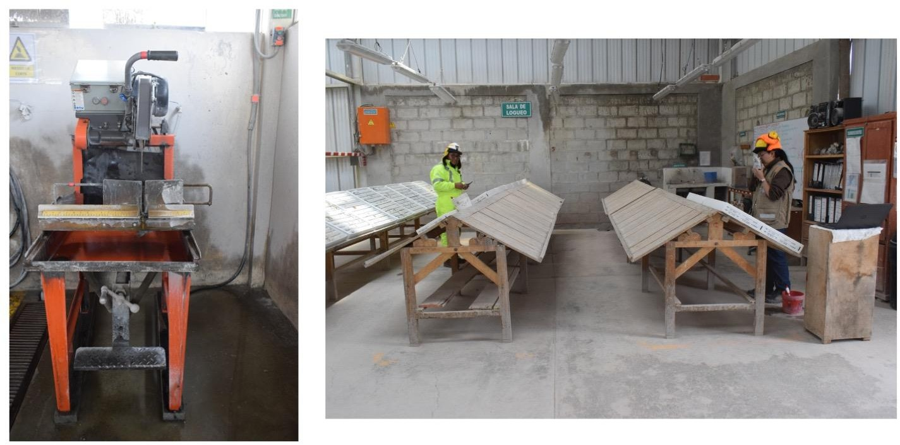

FIGURE 2 SAN JOSÉ LOGGING FACILITY

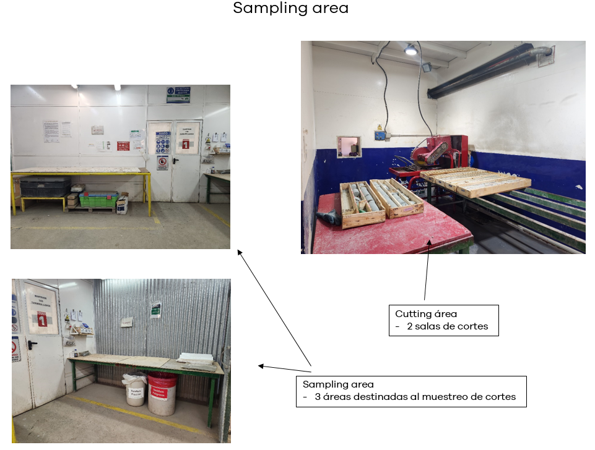

FIGURE 3 SAN JOSÉ LOGGING FACILITY

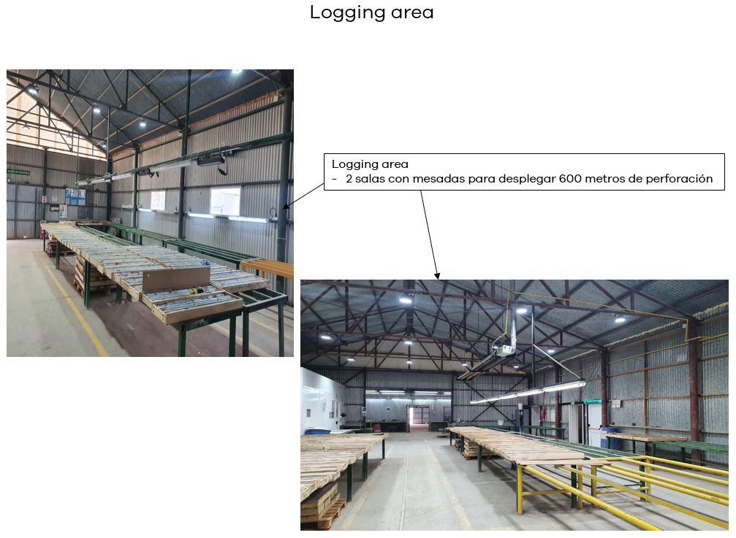

FIGURE 4 INMACULADA LOGGING FACILITY

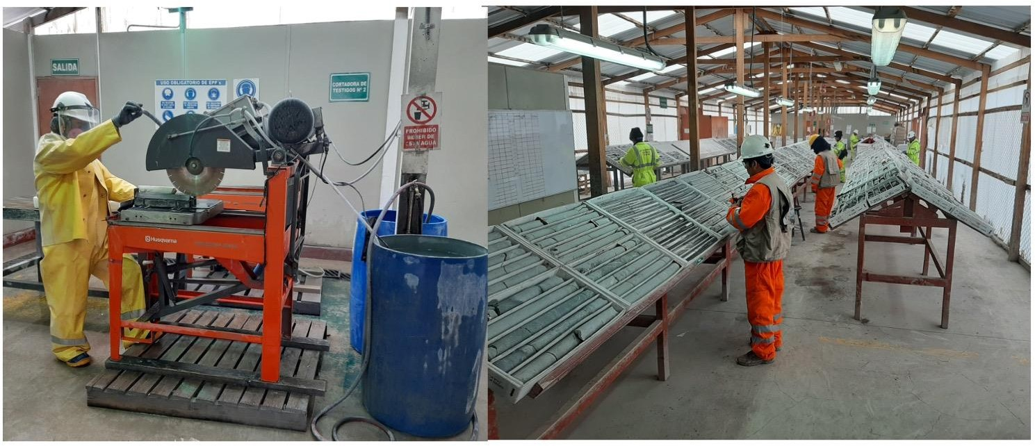

APPENDIX E MISCELLANEOUS DATA AND DRAWINGS

FIGURE 5 PALLANCATA SAMPLE SURVEY DETAILS AND DATA

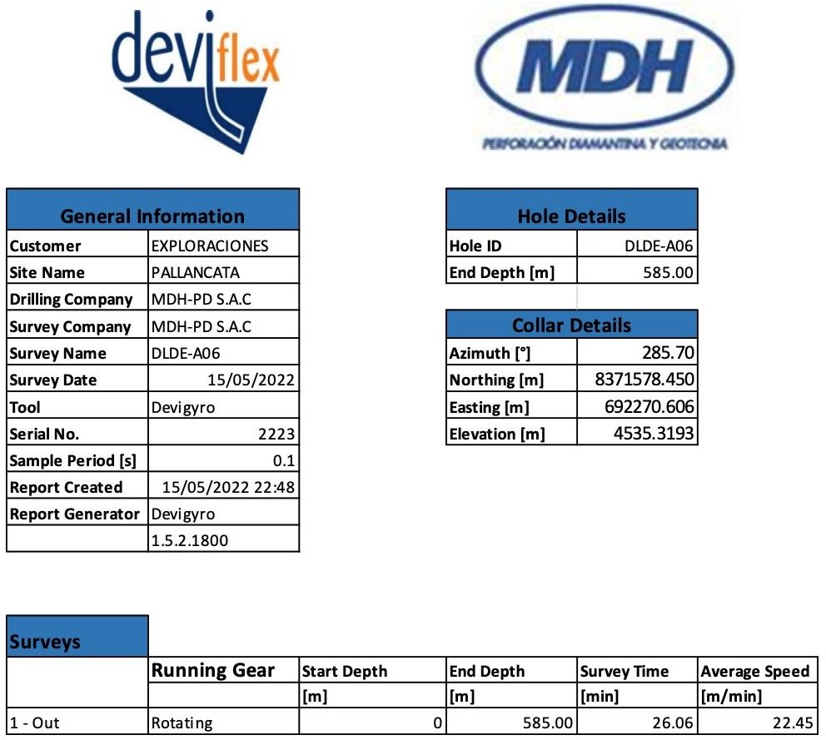

FIGURE 6 PALLANCATA SAMPLE SURVEY GYRO INFORMATION

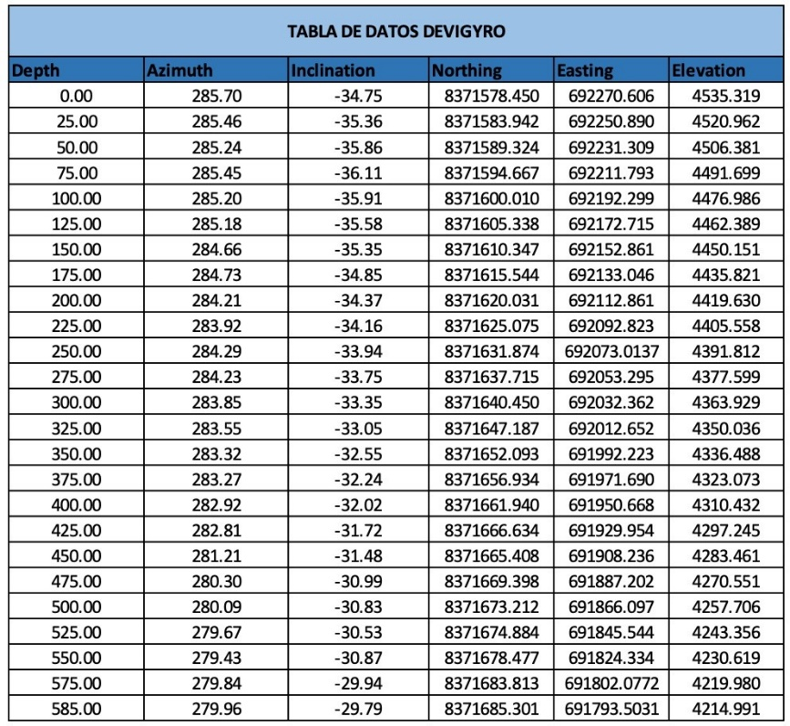

**FIGURE 7 PALLANCATA SAMPLE SURVEY SECTION**

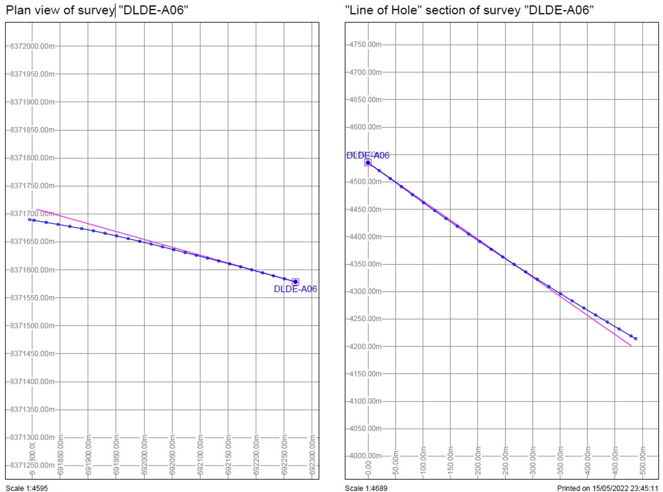

**FIGURE 8 SAN JOSÉ SAMPLE SURVEY DATA SHEET**

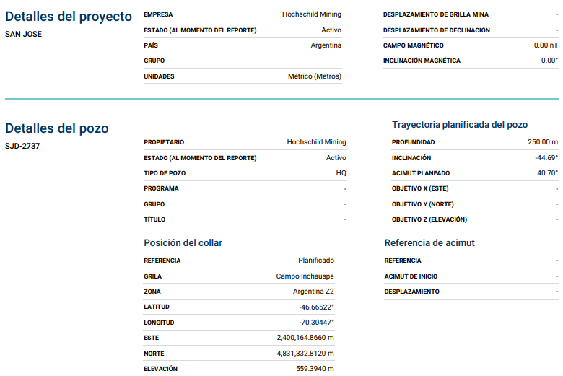

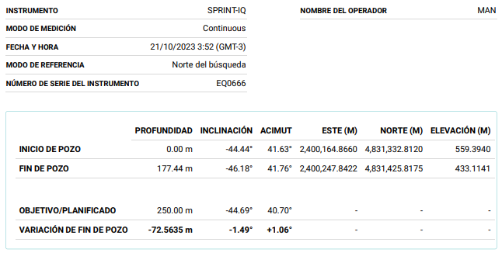

**FIGURE 9 SAN JOSÉ SAMPLE SURVEY DATA**

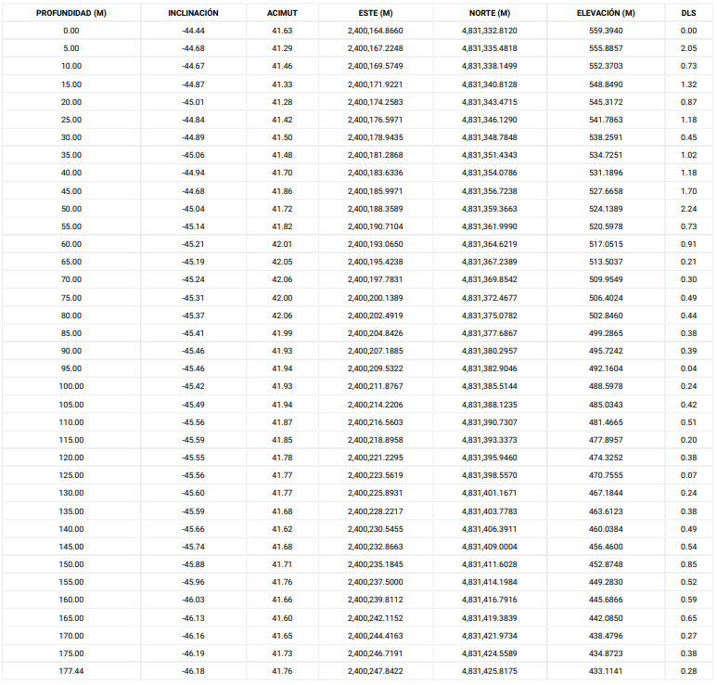

**FIGURE 10 SAN JOSÉ SAMPLE SURVEY SECTION**

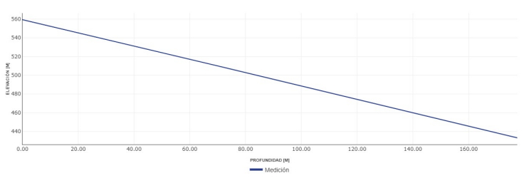

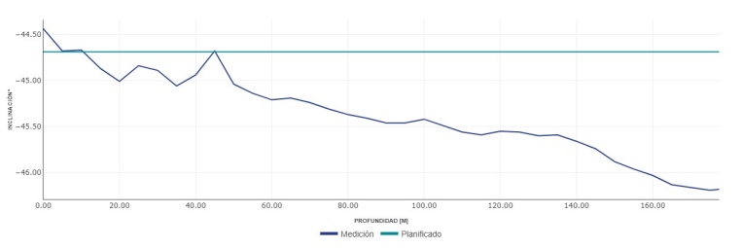

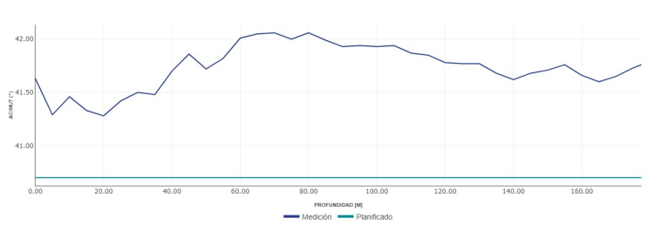

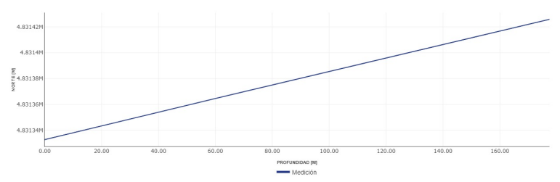

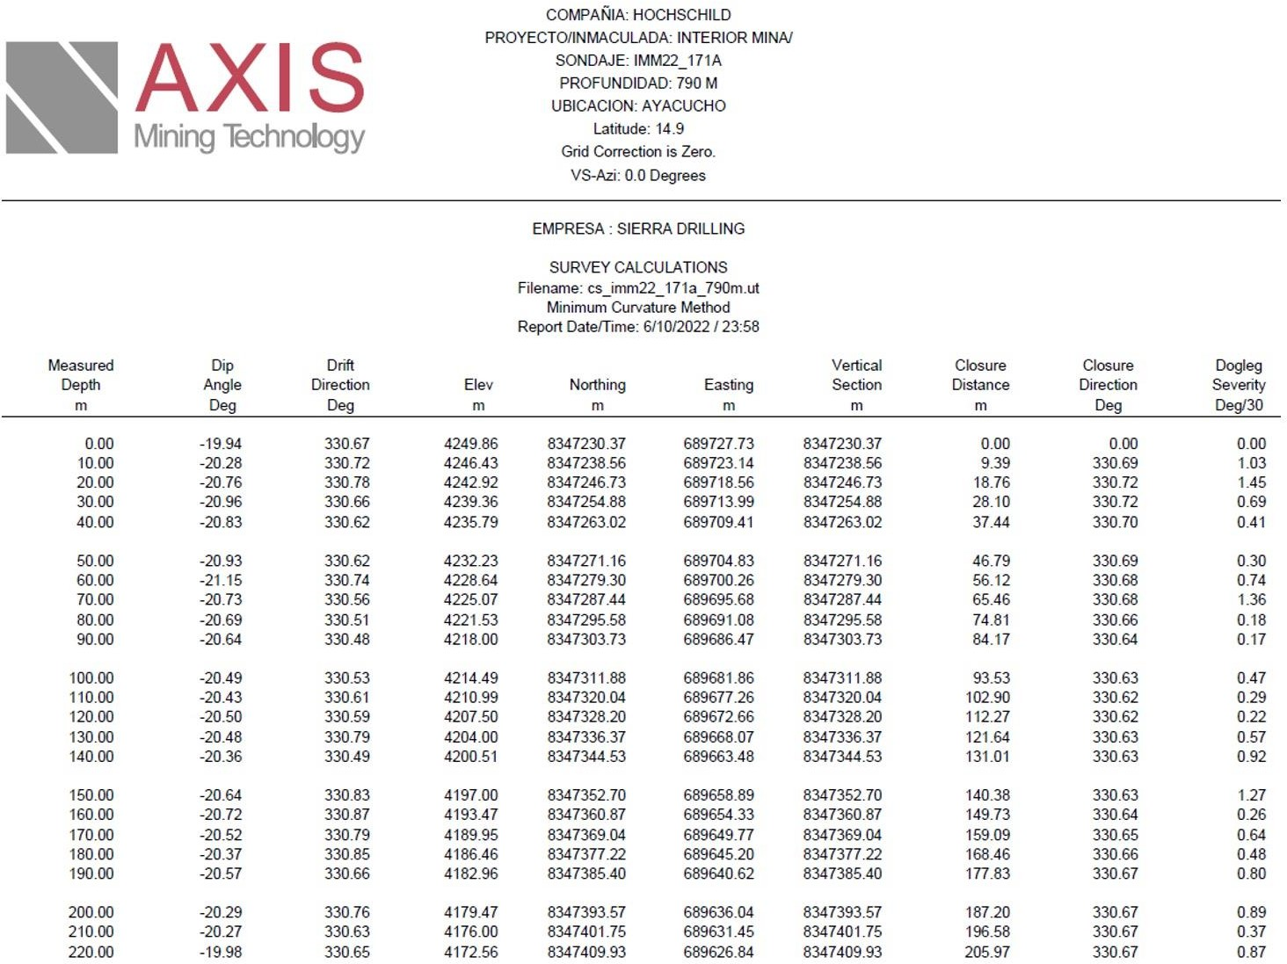**FIGURE 11 INMACULADA SAMPLE SURVEY DETAILS**

**FIGURE 12 INMACULADA SAMPLE SURVEY DATA**

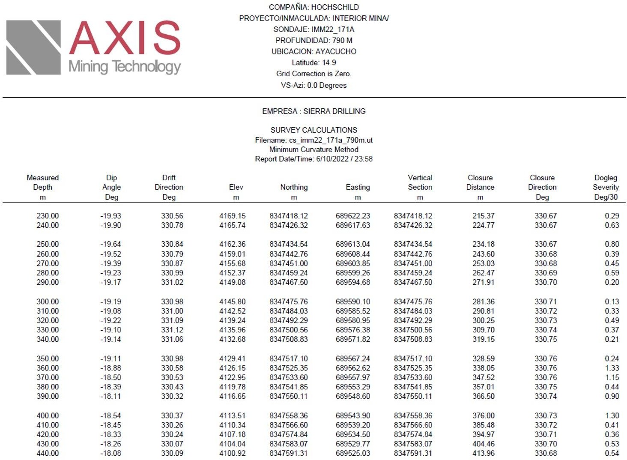

**FIGURE 13 INMACULADA SAMPLE SURVEY DATA**

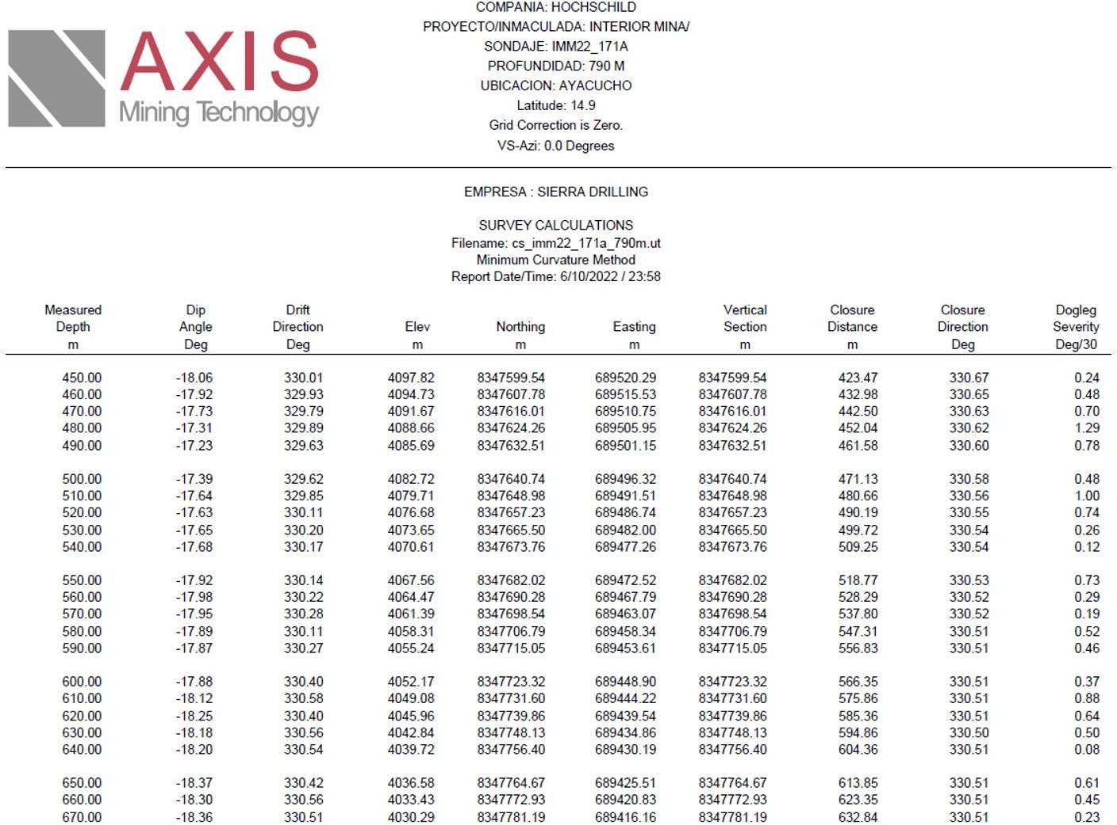

**FIGURE 14 INMACULADA SAMPLE SURVEY DATA**

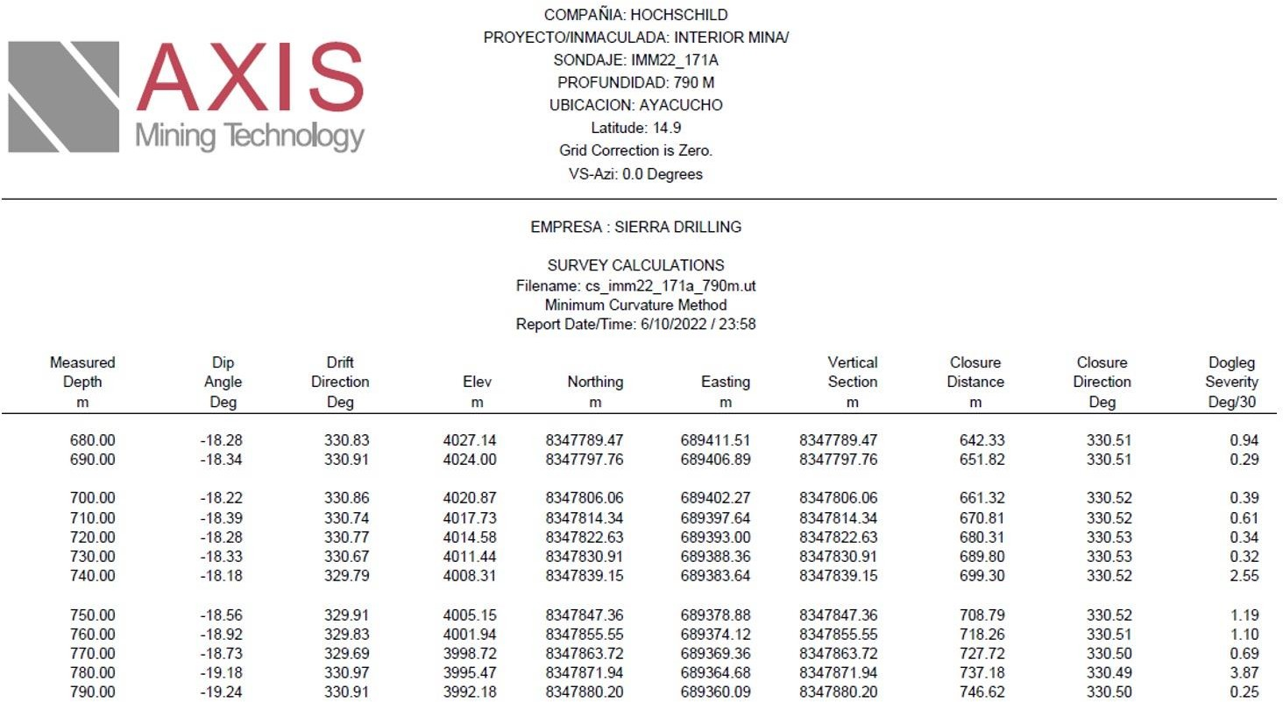

**FIGURE 15 INMACULADA SAMPLE SURVEY DATA**

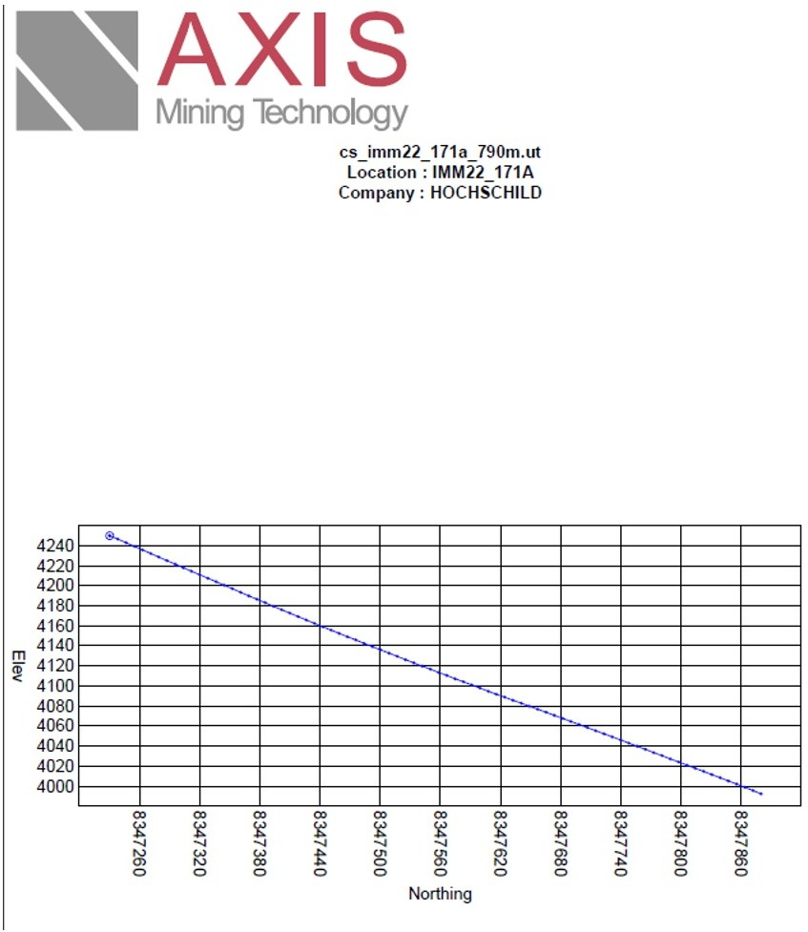

**FIGURE 16 PALLANCATA MINE DRILLING CROSS SECTION**

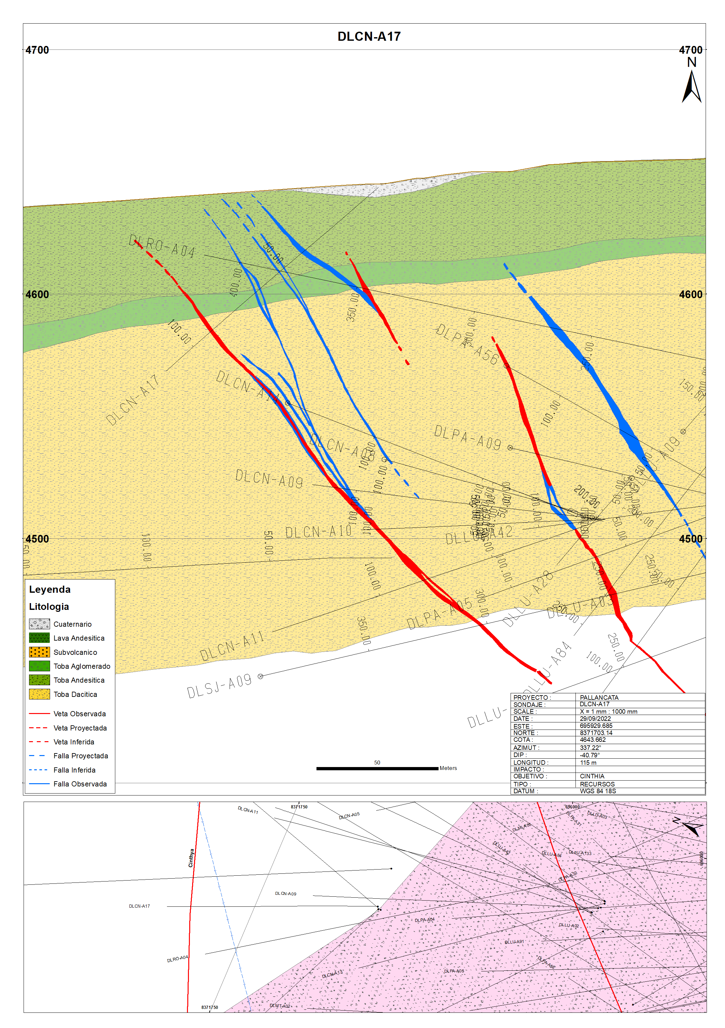

**FIGURE 17 SAN JOSÉ MINING CROSS SECTION**

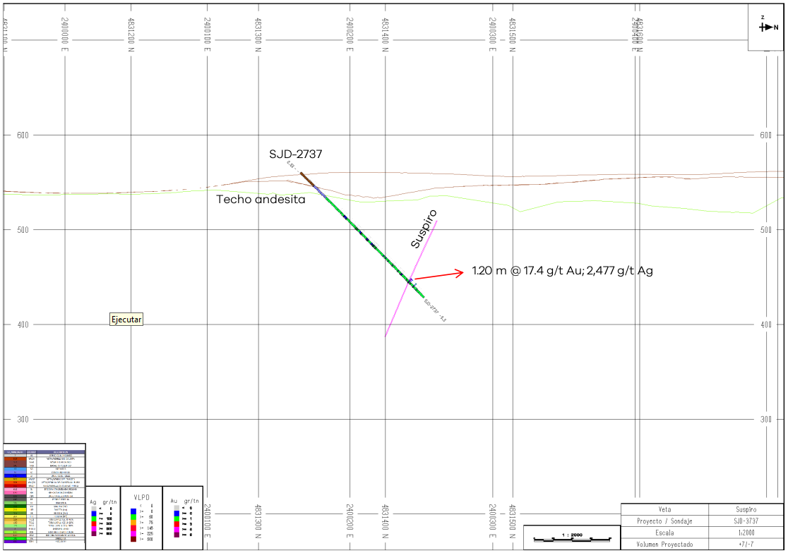

**FIGURE 18 INMACULADA MINE DRILLING CROSS SECTION**

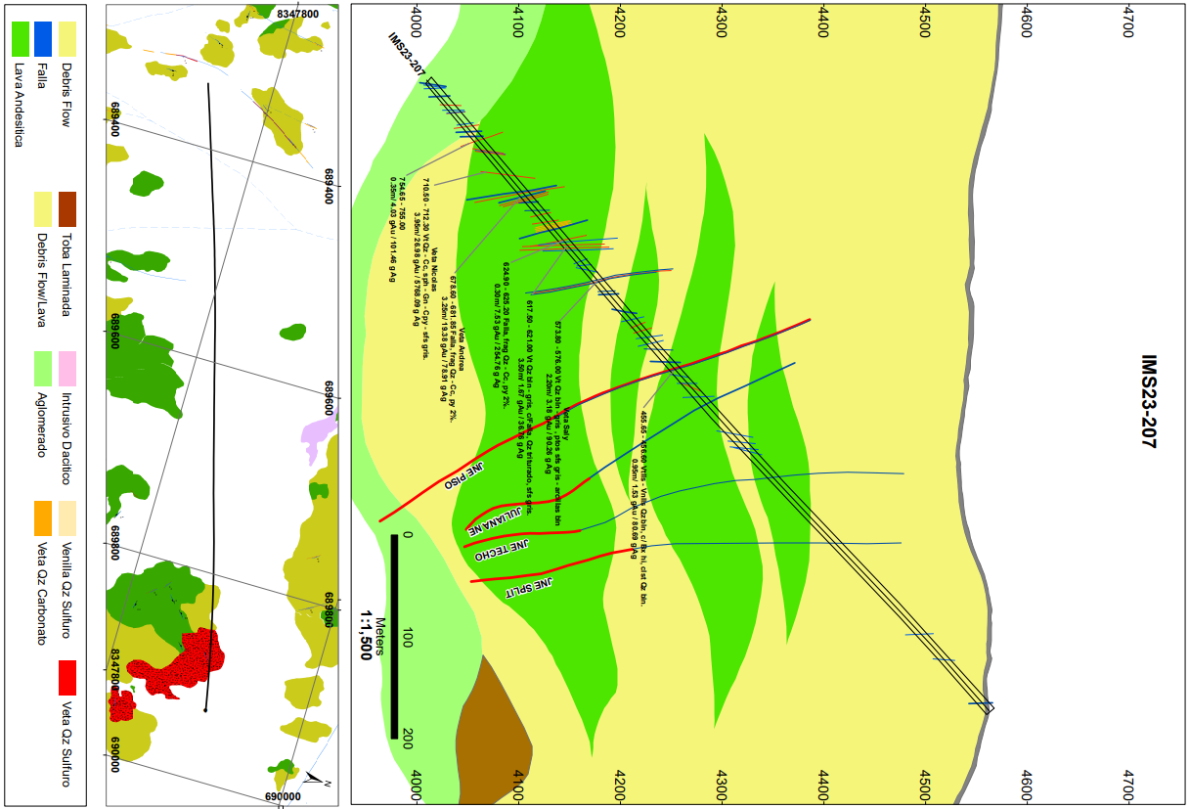

APPENDIX COLLAR LOCATION TABLES

PALLANCATA INFILL DRILLING

TABLE 1 PALLANCATA INFILL DRILLING

|  |  |  |  |  |  |  |  |  |
| --- | --- | --- | --- | --- | --- | --- | --- | --- |
| **Drill Hole ID** | **Easting** | **Northing** | **Elevation  (m)** | **Length  (m)** | **Azimuth  (°)** | **Dip  (°)** | **% Recovery** | **Target** |
| DLANS-A01 | 695624 | 8368931 | 4194 | 65 | 219 | -18 | 93 | Anais |
| DLCA-A06 | 695548 | 8370931 | 4362 | 120 | 116 | -2 | 96 | Carmen |
| DLCH-A04 | 695424 | 8370932 | 4391 | 57 | 160 | -18 | 96 | Charo |
| DLCH-A05 | 695419 | 8370935 | 4391 | 53 | 192 | -20 | 96 | Charo |
| DLCH-A06 | 695510 | 8370975 | 4384 | 120 | 215 | -12 | 97 | Charo |
| DLCM-A04 | 695829 | 8368871 | 4124 | 48 | 45 | -16 | 96 | Cimoide |
| DLCM-A05 | 695645 | 8368911 | 4128 | 110 | 16 | -8 | 96 | Cimoide |
| DLCM-A06 | 695645 | 8368911 | 4128 | 115 | 351 | -6 | 99 | Cimoide |
| DLDI-A01 | 696363 | 8368631 | 4216 | 11 | 201 | 2 | 95 | Diana |
| DLDI-A02 | 696379 | 8368632 | 4217 | 12 | 199 | 2 | 97 | Diana |
| DLDI-A03 | 696326 | 8368663 | 4294 | 18 | 249 | 0 | 92 | Diana |
| DLDI-A04 | 696333 | 8368661 | 4296 | 13 | 180 | 45 | 93 | Diana |
| DLJT-A08 | 696151 | 8370732 | 4400 | 70 | 245 | -18 | 97 | Juliet |
| DLJT-A09 | 696151 | 8370732 | 4400 | 52 | 236 | -26 | 96 | Juliet |
| DLLU-A217 | 695508 | 8371413 | 4382 | 32 | 2 | -25 | 96 | Luisa |
| DLLU-A218 | 695482 | 8371404 | 4382 | 27 | 344 | -27 | 97 | Luisa |
| DLMS-A10 | 695231 | 8371302 | 4386 | 56 | 308 | 31 | 91 | Mishell |
| DLPL-A987 | 695933 | 8368829 | 4437 | 51 | 188 | 30 | 92 | Pallancata |
| DLRI-A206 | 695884 | 8370872 | 4290 | 90 | 226 | 18 | 97 | Rina |
| DLRI-A207 | 696463 | 8370693 | 4369 | 50 | 68 | 30 | 96 | Rina |
| DLRI-A208 | 696443 | 8370685 | 4365 | 50 | 48 | 34 | 95 | Rina |
| DLRI-A209 | 696245 | 8370740 | 4360 | 15 | 33 | 19 | 96 | Rina |
| DLRI-A210 | 696233 | 8370739 | 4360 | 19 | 12 | 15 | 97 | Rina |

**TABLE 1 PALLANCATA INFILL DRILLING**

|  |  |  |  |  |  |  |  |  |
| --- | --- | --- | --- | --- | --- | --- | --- | --- |
| **Drill Hole ID** | **Easting** | **Northing** | **Elevation  (m)** | **Length  (m)** | **Azimuth  (°)** | **Dip  (°)** | **% Recovery** | **Target** |
| DLRI-A211 | 696227 | 8370760 | 4314 | 65 | 177 | -24 | 93 | Rina |
| DLRI-A212 | 696228 | 8370761 | 4315 | 74 | 156 | -20 | 96 | Rina |
| DLRI-A213 | 696286 | 8370771 | 4306 | 87 | 198 | -14 | 97 | Rina |
| DLRRT-A02 | 696326 | 8368651 | 4145 | 68 | 271 | 16 | 93 | Ramal Ruth |
| DLRUB-A07 | 696327 | 8368651 | 4145 | 95 | 232 | 20 | 91 | Rubi |
| DLRUB-A08 | 696327 | 8368649 | 4145 | 80 | 221 | 16 | 90 | Rubi |
| DLSJ-A48 | 695541 | 8370901 | 4374 | 47 | 108 | -18 | 96 | San Javier |
| DLSJ-A49 | 695539 | 8370899 | 4375 | 39 | 171 | -5 | 97 | San Javier |
| DLSJ-A50 | 695964 | 8371410 | 4527 | 111 | 120 | -26 | 97 | San Javier |
| DLSJ-A51 | 696022 | 8371352 | 4477 | 8 | 140 | 0 | 95 | San Javier |
| DLSJ-A52 | 696006 | 8371339 | 4477 | 8 | 139 | 1 | 96 | San Javier |
| DLYN-A10 | 694560 | 8371612 | 4435 | 50 | 203 | 2 | 96 | Yanely |
| DLRY-A15 | 692271 | 8371578 | 4535 | 496 | 292 | -37 | 98 | Marco W |
| DLRY-A16 | 692374 | 8371487 | 4547 | 22 | 295 | -25 | 96 | Marco W |

TABLE 2 PALLANCATA EXPLORATION DRILLING

|  |  |  |  |  |  |  |  |  |
| --- | --- | --- | --- | --- | --- | --- | --- | --- |
| **Drill Hole ID** | **Easting** | **Northing** | **Elevation  (m)** | **Length  (m)** | **Azimuth  (°)** | **Dip  (°)** | **% Recovery** | **Target** |
| DLCN-A17 | 695930 | 8371703 | 4644 | 115 | 337 | -41 | 100 | Cinthia |
| DLCN-A18 | 695929 | 8371703 | 4643 | 124 | 295 | -43 | 99 | Cinthia |
| DLCN-A19 | 695928 | 8371702 | 4644 | 122 | 18 | -29 | 100 | Cinthia |
| DLCN-A20 | 696080 | 8371783 | 4644 | 118 | 287 | -28 | 100 | Cinthia |
| DLCN-A21 | 696080 | 8371782 | 4644 | 110 | 36 | -31 | 99 | Cinthia |
| DLEP-A76 | 692865 | 8371386 | 4590 | 398 | 340 | -58 | 98 | Explorador Pablo |
| DLES-A03 | 694572 | 8371620 | 4435 | 469 | 319 | 16 | 94 | Escarpa |
| DLLUC-A01 | 692857 | 8371614 | 4238 | 256 | 193 | -38 | 99 | Lucas |
| DLMA-A28 | 695545 | 8369008 | 4197 | 538 | 52 | 17 | 98 | Maria S |
| DLMARC-A35 | 692858 | 8371619 | 4238 | 148 | 336 | -37 | 100 | Marco |
| DLMT-A08 | 693011 | 8371558 | 4309 | 126 | 256 | -16 | 96 | Mateo |
| DLPI2-A01 | 696427 | 8368644 | 4232 | 550 | 355 | 10 | 99 | Esperanza |
| DLPI2-A02 | 696426 | 696426 | 4153 | 292 | 24 | 11 | 99 | Esperanza |
| DLPI2-A03 | 696429 | 8368666 | 4152 | 336 | 38 | -10 | 99 | Esperanza |
| DLPL-A988 | 695586 | 8369000 | 4197 | 486 | 145 | -53 | 98 | Pallancata W |
| DLPL-A989 | 695988 | 8368746 | 4167 | 250 | 69 | -26 | 98 | Rossy |
| DLPNE-A01 | 693973 | 8371525 | 4330 | 272 | 334 | 13 | 97 | Pablo NE |
| DLTYP-A03 | 693044 | 8371570 | 4236 | 136 | 215 | -18 | 100 | Tencional Yurica Piso |
| DLTYP-A04 | 693045 | 8371570 | 4237 | 240 | 179 | -27 | 96 | Tencional Yurica Piso |
| DLYP-A18 | 693397 | 8371544 | 4635 | 411 | 358 | -34 | 98 | Yurica Piso |

SAN JOSÉ DRILLING

TABLE 3 SAN JOSE INFILL DRILLING

|  |  |  |  |  |  |  |  |  |
| --- | --- | --- | --- | --- | --- | --- | --- | --- |
| **Drill Hole ID** | **Easting** | **Northing** | **Elevation  (m)** | **Length  (m)** | **Azimuth (°)** | **Dip  (°)** | **% Recovery** | **Target** |
|
| SJD-2588 | 2399658.05 | 4831676.66 | 557.27 | 175 | 31 | -46.5 | 94.66 | RHVN |
| SJD-2589 | 2400807.36 | 4831969.94 | 575.49 | 289 | 207 | -51.8 | 96.88 | Escondida |
| SJD-2592 | 2402526.50 | 4824507.21 | 574.40 | 70 | 12 | -45.53 | 94.2 | Saavedra |
| SJD-2594 | 2402481.55 | 4824536.42 | 567.12 | 62 | 41 | -45.2 | 97.66 | Saavedra |
| SJD-2595 | 2400786.94 | 4831621.82 | 570.24 | 161 | 204 | -46.95 | 98.56 | Norte |
| SJD-2597 | 2399873.75 | 4831677.11 | 551.59 | 192 | 20 | -45.16 | 92.34 | R861\_V |
| SJD-2599 | 2401579.37 | 4832599.14 | 577.78 | 112 | 58 | -54.42 | 96.85 | Odin |
| SJD-2600 | 2402505.43 | 4832533.96 | 565.64 | 144 | 10 | -55.36 | 94.01 | Ayelen SE |
| SJD-2601 | 2399836.01 | 4831825.46 | 550.07 | 71 | 204 | -46.2 | 92.48 | Majo |
| SJD-2611 | 2399929.76 | 4831876.58 | 559.78 | 161 | 200 | -51.2 | 90.45 | RML 861V |
| SJD-2612 | 2399854.22 | 4831986.06 | 551.78 | 194 | 184 | -57.5 | 94.3 | Majo |
| SJD-2613 | 2401710.72 | 4832144.46 | 574.15 | 200 | 21 | -49.97 | 98.18 | Emilia |
| SJD-2614 | 2401003.47 | 4831785.01 | 574.39 | 200 | 209 | -56.46 | 99.08 | Escondida |
| SJD-2615 | 2401238.26 | 4832225.42 | 585.31 | 120 | 232 | -45.1434 | 96.26 | Abril |
| SJD-2616 | 2401232.63 | 4832218.23 | 585.66 | 120 | 254 | -45.1539 | 98.25 | Abril |
| SJD-2618 | 2401990.33 | 4832148.73 | 575.32 | 302 | 236 | -45.0927 | 93.77 | 290 |
| SJD-2619 | 2401642.30 | 4832133.81 | 571.85 | 200 | 202 | -58.2829 | 95.51 | RML Frea |
| SJD-2621 | 2401270.21 | 4832129.64 | 588.46 | 85 | 189 | -59 | 94.86 | Abril |
| SJD-2622 | 2401251.74 | 4832040.91 | 585.34 | 88 | 51 | -52.53 | 93 | Abril |
| SJD-2623 | 2399710.65 | 4832008.96 | 548.93 | 150 | 38 | -44.38 | 94.25 | RML 861G |
| SJD-2624 | 2401643.81 | 4832296.11 | 563.93 | 152 | 235 | -45.54 | 96.99 | Shanne |
| SJD-2625 | 2399878.58 | 4832109.77 | 552.13 | 169 | 224 | -50.36 | 96.38 | RML 861M |
| SJD-2626 | 2401684.50 | 4832260.83 | 564.75 | 153 | 219 | -46.1735 | 98.26 | Ester |

**TABLE 3 SAN JOSE INFILL DRILLING**

|  |  |  |  |  |  |  |  |  |
| --- | --- | --- | --- | --- | --- | --- | --- | --- |
| **Drill Hole ID** | **Easting** | **Northing** | **Elevation  (m)** | **Length  (m)** | **Azimuth (°)** | **Dip  (°)** | **% Recovery** | **Target** |
|
| SJD-2627 | 2399736.40 | 4832021.01 | 549.86 | 114 | 37 | -48.41 | 95.15 | RML 861M |
| SJD-2628 | 2401665.52 | 4832292.86 | 564.65 | 212 | 203 | -51.34 | 98.52 | Ester |
| SJD-2629 | 2399758.00 | 4831972.74 | 549.95 | 145 | 28 | -46.47 | 98.48 | RML 861G |
| SJD-2630 | 2401699.33 | 4832164.85 | 572.20 | 90 | 265 | -45.33 | 97.27 | Shanne |
| SJD-2631 | 2399927.69 | 4832128.15 | 553.74 | 86 | 12 | -48.47 | 96.85 | RML Sanson |
| SJD-2632 | 2401711.84 | 4832175.80 | 574.84 | 156 | 227 | -63.34 | 98.16 | Shanne |
| SJD-2633 | 2399957.22 | 4832112.55 | 554.75 | 98 | 11 | -45.77 | 97.18 | RML Sanson |
| SJD-2634 | 2401666.06 | 4832086.73 | 574.92 | 128 | 62 | -51.5723 | 97.9 | Sig Julia |
| SJD-2635 | 2399691.67 | 4831984.81 | 548.95 | 180 | 32 | -46.26 | 96.51 | RML 861G |
| SJD-2636 | 2401648.44 | 4832130.16 | 571.43 | 125 | 61 | -49.3806 | 97.81 | Sig Julia |
| SJD-2637 | 2400035.05 | 4831741.07 | 563.32 | 220 | 186 | -45.4038 | 92.59 | Amelia |
| SJD-2638 | 2401696.64 | 4832410.69 | 572.66 | 150 | 243 | -45.2201 | 92.6 | Sig Julia |
| SJD-2639 | 2400909.91 | 4831958.16 | 578.38 | 317.5 | 217 | -53.4323 | 91.49 | Escondida |
| SJD-2640 | 2402483.85 | 4832225.85 | 528.49 | 117 | 38 | -51.53 | 93.37 | Odin |
| SJD-2641 | 2402662.07 | 4832161.01 | 525.37 | 117 | 9 | -60.8086 | 92.74 | Odin |
| SJD-2642 | 2402653.77 | 4832174.79 | 526.26 | 102 | 1 | -51.39 | 91.76 | Odin |
| SJD-2643 | 2400672.01 | 4832834.18 | 600.52 | 212 | 7 | -64.1335 | 91.37 | Odin |
| SJD-2644 | 2400966.55 | 4831844.01 | 576.40 | 353 | 257 | -62.36 | 97.79 | Celina |
| SJD-2645 | 2400620.72 | 4832871.51 | 598.11 | 98 | 46 | -60.43 | 98.11 | Odin |
| SJD-2645B | 2400671.50 | 4832834.49 | 600.40 | 185 | 5 | -56.2 | 97.47 | Odin |
| SJD-2646 | 2401993.72 | 4832648.74 | 573.60 | 120 | 0 | -50.01 | 90.15 | Ayelen |
| SJD-2647 | 2401447.29 | 4832161.28 | 574.46 | 239 | 47 | -48.4 | 98.31 | Shanne |
| SJD-2648 | 2401447.66 | 4832161.33 | 575.41 | 263 | 63 | -48.45 | 95.67 | Shanne |
| SJD-2649 | 2401614.69 | 4832072.33 | 571.91 | 220 | 25 | -55.1734 | 91.91 | Shanne |

**TABLE 3 SAN JOSE INFILL DRILLING**

|  |  |  |  |  |  |  |  |  |
| --- | --- | --- | --- | --- | --- | --- | --- | --- |
| **Drill Hole ID** | **Easting** | **Northing** | **Elevation  (m)** | **Length  (m)** | **Azimuth (°)** | **Dip  (°)** | **% Recovery** | **Target** |
|
| SJD-2650 | 2401899.75 | 4832682.13 | 573.61 | 116 | 38 | -52.2858 | 92.51 | Ayelen |
| SJD-2651 | 2399871.69 | 4832101.50 | 552.06 | 138 | 217 | -46.18 | 90.81 | RML 861G |
| SJD-2652 | 2401639.81 | 4832045.70 | 574.39 | 182 | 22 | -55.3158 | 90.29 | Shanne |
| SJD-2653 | 2399916.86 | 4831915.40 | 555.00 | 142 | 24 | -51.5118 | 95.07 | RML 861G |
| SJD-2654 | 2401586.59 | 4832084.75 | 569.93 | 186 | 52 | -54.03 | 94.59 | Shanne |
| SJD-2655 | 2401590.54 | 4832094.57 | 570.26 | 161 | 37 | -48.48 | 96.13 | Shanne |
| SJD-2656 | 2401635.76 | 4832065.39 | 573.02 | 150 | 28 | -50.71 | 96.79 | Shanne |
| SJD-2657 | 2401587.15 | 4832084.96 | 569.75 | 186 | 75 | -50.09 | 97.65 | Shanne |
| SJD-2658 | 2401564.63 | 4832060.42 | 568.88 | 221 | 65 | -46.44 | 97.09 | Shanne |
| SJD-2659 | 2401511.29 | 4832163.01 | 571.09 | 173 | 59 | -45.08 | 96.84 | Shanne |
| SJD-2660 | 2401495.18 | 4832218.19 | 572.80 | 175 | 61 | -55.34 | 95.12 | Shanne |
| SJD-2661 | 2402519.85 | 4832230.30 | 528.49 | 97 | 19 | -55.05 | 92.8 | Odin |
| SJD-2662 | 2401580.46 | 4832070.06 | 570.09 | 190 | 80 | -45.07 | 97.64 | Shanne |
| SJD-2663 | 2402566.06 | 4832221.13 | 527.16 | 92 | 357 | -61.43 | 94.05 | Odin |
| SJD-2664 | 2401508.62 | 4832228.69 | 572.06 | 147 | 89 | -43.55 | 92.31 | Shanne |
| SJD-2665 | 2401599.51 | 4832095.05 | 571.03 | 169 | 89 | -47.53 | 98.33 | Shanne |
| SJD-2666 | 2402565.96 | 4832220.37 | 527.82 | 85 | 43 | -56.54 | 90.1 | Odin |
| SJD-2667 | 2402562.92 | 4832188.01 | 526.21 | 130 | 40 | -44.29 | 92.1 | Odin |
| SJD-2668 | 2402661.16 | 4832160.93 | 526.44 | 102 | 11 | -51.95 | 93.41 | Odin |
| SJD-2669 | 2402590.70 | 4832182.18 | 525.46 | 110 | 37 | -47 | 92.01 | Odin |
| SJD-2670 | 2402662.61 | 4832163.60 | 525.55 | 97 | 35 | -50.08 | 91.62 | Odin |
| SJD-2671 | 2402591.03 | 4832182.75 | 525.47 | 120 | 53 | -47.21 | 90.5 | Odin |
| SJD-2672 | 2401993.97 | 4832649.16 | 573.65 | 120 | 350 | -54.06 | 93.97 | Ayelen |
| SJD-2673 | 2402674.85 | 4832207.20 | 528.78 | 57 | 32 | -51.42 | 92.18 | Odin |

**TABLE 3 SAN JOSE INFILL DRILLING**

|  |  |  |  |  |  |  |  |  |
| --- | --- | --- | --- | --- | --- | --- | --- | --- |
| **Drill Hole ID** | **Easting** | **Northing** | **Elevation  (m)** | **Length  (m)** | **Azimuth (°)** | **Dip  (°)** | **% Recovery** | **Target** |
|
| SJD-2029 | 2401914.79 | 4832654.56 | 573.39 | 160 | 1 | -58.15 | 92.03 | Ayelen |
| SJD-2674 | 2401653.28 | 4832055.51 | 574.81 | 186 | 53 | -44.57 | 91.34 | Sig Julia |
| SJD-2675 | 2402617.32 | 4832226.00 | 529.71 | 97 | 28 | -45.45 | 81.41 | Odin |
| SJD-2676 | 2401743.53 | 4832471.70 | 578.09 | 146 | 12 | -44.33 | 86.84 | Odin |
| SJD-2677 | 2401817.79 | 4832483.77 | 577.35 | 173 | 12 | -57.42 | 90.19 | Odin |
| SJD-2678 | 2402072.49 | 4831961.64 | 567.25 | 282 | 25 | -57.06 | 96.5 | Emilia |
| SJD-2679 | 2402591.19 | 4832242.92 | 530.80 | 69 | 32 | -45.49 | 75.42 | Odin |
| SJD-2680 | 2402072.13 | 4831918.23 | 566.12 | 305 | 29 | -49.4048 | 97.26 | Emilia |
| SJD-2681 | 2400966.27 | 4831844.17 | 576.51 | 320 | 241 | -53.31 | 95.26 | Escondida |
| SJD-2682 | 2399674.17 | 4831855.55 | 548.40 | 45 | 213 | -53.49 | 95.38 | Majo |
| SJD-2683 | 2399812.03 | 4831858.96 | 550.60 | 80 | 194 | -52.24 | 97.13 | Majo |
| SJD-2684 | 2399865.28 | 4831852.20 | 553.88 | 100 | 204 | -45.4321 | 93.55 | Majo |
| SJD-2685 | 2400911.91 | 4831963.50 | 578.92 | 353.5 | 199 | -47.1712 | 97.65 | Escondida |
| SJD-2686 | 2402642.24 | 4832537.58 | 555.42 | 125 | 29 | -55.0732 | 97.92 | Maia |
| SJD-2687 | 2400991.42 | 4831748.17 | 574.78 | 250 | 213 | -56.2924 | 96.08 | Escondida |
| SJD-2688 | 2402695.14 | 4832503.08 | 548.05 | 135 | 29 | -45.241 | 98.19 | Maia |
| SJD-2689 | 2401118.54 | 4831876.85 | 576.16 | 380 | 214 | -56.24 | 97.15 | Escondida |
| SJD-2690 | 2400056.07 | 4831732.98 | 562.91 | 240 | 185 | -46.33 | 97.58 | Amelia |
| SJD-2691 | 2402623.91 | 4832513.92 | 558.65 | 160 | 37 | -51.39 | 97.6 | Maia |
| SJD-2692 | 2402688.67 | 4832491.04 | 547.63 | 161 | 30 | -49.09 | 97.55 | Maia |
| SJD-2693 | 2402386.52 | 4832547.13 | 569.55 | 160 | 41 | -48.85 | 98.06 | Ayelen SE |
| SJD-2694 | 2402442.74 | 4832570.87 | 566.69 | 114 | 15 | -48 | 95.16 | Ayelen SE |
| SJD-2695 | 2402795.76 | 4832499.32 | 544.51 | 140 | 20 | -50 | 94.01 | Maia |
| SJD-2696 | 2402476.92 | 4832581.94 | 566.18 | 102 | 24 | -51.21 | 94.12 | Ayelen SE |

**TABLE 3 SAN JOSE INFILL DRILLING**

|  |  |  |  |  |  |  |  |  |
| --- | --- | --- | --- | --- | --- | --- | --- | --- |
| **Drill Hole ID** | **Easting** | **Northing** | **Elevation  (m)** | **Length  (m)** | **Azimuth (°)** | **Dip  (°)** | **% Recovery** | **Target** |
|
| SJD-2698 | 2402771.80 | 4832479.20 | 544.02 | 150 | 48 | -49.14 | 95.76 | Maia |
| SJD-2700 | 2402464.14 | 4832530.96 | 566.15 | 155 | 21 | -51.4154 | 95.56 | Ayelen SE |
| SJD-2702 | 2402532.59 | 4832558.24 | 563.35 | 110 | 356 | -46.1534 | 97.1 | Ayelen SE |
| SJD-2704 | 2400226.17 | 4831511.39 | 563.59 | 340 | 191 | -59.42 | 92.27 | RHVNC |
| SJD-2707 | 2402682.52 | 4832454.41 | 546.34 | 194 | 18 | -54.5 | 98.26 | Maia |
| SJD-2711 | 2402724.12 | 4832430.57 | 541.73 | 235 | 9 | -54.41 | 97.74 | Maia |
| SJD-2714 | 2402724.22 | 4832431.87 | 541.32 | 230 | 25 | -45.85 | 96.47 | Maia |
| SJD-2715 | 2402764.23 | 4832426.45 | 540.70 | 225 | 22 | -54.77 | 95.18 | Maia |
| SJD-2716 | 2402764.11 | 4832425.88 | 540.97 | 215 | 34 | -51.31 | 96.51 | Maia |
| SJD-2719 | 2401533.77 | 4832483.51 | 577.32 | 79 | 225 | -45.6 | 97.14 | Julia |
| SJD-2720 | 2401503.56 | 4832496.02 | 578.67 | 179 | 233 | -44.67 | 95.24 | Julia |
| SJD-2721 | 2400195.38 | 4831368.67 | 562.53 | 140 | 239 | -56.11 | 90.79 | HVN |
| SJD-2724 | 2400121.04 | 4831363.47 | 554.57 | 80 | 280 | -50.1 | 87.48 | HVN |
| SJD-2725 | 2400040.59 | 4831392.61 | 547.01 | 69 | 30 | -45.25 | 93.25 | HVN |
| SJD-2726 | 2400019.92 | 4831407.28 | 546.89 | 60 | 37 | -45.26 | 93.68 | HVN |
| SJD-2730 | 2402522.30 | 4832237.22 | 528.50 | 90 | 20 | -46 | 95.96 | Odin |
| SJD-2732 | 2402031.60 | 4832468.72 | 576.25 | 75 | 20 | -45.13 | 96.8 | Odin |
| SJD-2733 | 2401954.42 | 4832491.76 | 575.16 | 71 | 22 | -53,97 | 92.5 | Odin |
| SJD-2734 | 2401382.54 | 4832271.49 | 576.87 | 220 | 66 | -46.55 | 94.84 | Julia |
| SJD-2735 | 2402073.77 | 4832462.35 | 575.58 | 71 | 20 | -45.15 | 91.51 | Odin |
| SJM-614 | 2400745.96 | 4831542.00 | 314.35 | 135 | 199 | -16.3243 | 95.47 | Kospi SE |
| SJM-615 | 2400746.25 | 4831542.02 | 314.23 | 164 | 187 | -21.2006 | 92.44 | Kospi SE |
| SJM-616 | 2400276.27 | 4831768.31 | 312.05 | 102 | 189 | -36.19 | 98.38 | Rml 861W |
| SJM-617 | 2400273.93 | 4831769.60 | 312.00 | 90 | 228 | -38 | 99.4 | Rml 861W |

**TABLE 3 SAN JOSE INFILL DRILLING**

|  |  |  |  |  |  |  |  |  |
| --- | --- | --- | --- | --- | --- | --- | --- | --- |
| **Drill Hole ID** | **Easting** | **Northing** | **Elevation  (m)** | **Length  (m)** | **Azimuth (°)** | **Dip  (°)** | **% Recovery** | **Target** |
|
| SJM-618 | 2400940.06 | 4832557.70 | 414.43 | 174 | 32 | -21.44 | 98.96 | Perla |
| SJM-622 | 2401591.77 | 4832282.82 | 450.43 | 67 | 224 | -6.3349 |  | Shanne |
| SJM-623 | 2401699.41 | 4832266.52 | 442.19 | 137 | 233 | 0.3257 | 95.94 | Shanne |
| SJM-624 | 2401700.54 | 4832267.47 | 442.22 | 66 | 212 | 2.52 | 98.97 | Sig Julia |
| SJM-625 | 2401700.09 | 4832266.51 | 442.24 | 115 | 184 | 0.36 | 98.03 | Sig Julia |
| SJM-626 | 2401698.92 | 4832266.77 | 442.25 | 150 | 172 | 1.23 | 98.52 | Sig Julia |
| SJM-627 | 2400772.37 | 4831834.49 | 317.67 | 140.1 | 35 | 1.5943 | 86.46 | Escondida |
| SJM-628 | 2400761.42 | 4831562.18 | 287.18 | 269.8 | 23 | 6.1854 | 91.43 | Escondida |
| SJM-629 | 2400756.42 | 4831550.45 | 288.24 | 131 | 168 | 31.5612 | 98.12 | Kospi SE01 |
| SJM-630 | 2399906.05 | 4831732.29 | 433.05 | 62 | 53 | 3.3 | 95.15 | RML 861V |
| SJM-631 | 2399891.86 | 4831719.98 | 432.51 | 89.5 | 21 | 4.032 | 94.32 | RML 861V |
| SJM-632 | 2400716.23 | 4831565.04 | 397.22 | 124 | 191 | -26.11 | 94.73 | Kospi SE |
| SJM-633 | 2401589.47 | 4832266.20 | 451.06 | 80 | 210 | 5.7 | 96.3 | Shanne |
| SJM-634 | 2401589.22 | 4832266.87 | 451.19 | 70 | 225 | 9.03 | 98.61 | Shanne |
| SJM-635 | 2400772.89 | 4831831.23 | 318.09 | 75 | 87 | 13.5 | 84.29 | Escondida |

**TABLE 4 SAN JOSE EXPLORATION DRILLING**

|  |  |  |  |  |  |  |  |  |
| --- | --- | --- | --- | --- | --- | --- | --- | --- |
| **Drill Hole ID** | **Easting** | **Northing** | **Elevation  (m)** | **Length  (m)** | **Azimuth  (°)** | **Dip  (°)** | **% Recuperation** | **Target** |
| SJD-2590 | 2402001.8 | 4833584.57 | 559.87 | 95 | 200 | -45 | 97.1 | Maura |
| SJD-2591 | 2402071.6 | 4833627.431 | 557.495 | 180 | 180 | -45 | 97.88 | Maura |
| SJD-2593 | 2401807.6 | 4833463.75 | 569.16 | 185 | 30 | -45 | 98.12 | Maura |
| SJD-2596 | 2401123.6 | 4834011.188 | 579.662 | 240 | 200 | -45 | 95.65 | Maura |
| SJD-2602 | 2400970.9 | 4831629.284 | 572.899 | 402 | 199.5637 | -55.03 | 92.18 | Kospi Sur |
| SJD-2603 | 2401083.7 | 4833908.51 | 582.92 | 245 | 198.57 | -44.19 | 98.63 | Maura |
| SJD-2604 | 2401068.7 | 4833861.936 | 582.99 | 265 | 199.28 | -45.17 | 98.15 | Maura |
| SJD-2605 | 2401042.9 | 4833784.14 | 587.91 | 280 | 199.34 | -45.4 | 99.11 | Maura |
| SJD-2606 | 2401010.7 | 4833705.399 | 590.585 | 190 | 199.2858 | -45.24 | 94.32 | Maura |
| SJD-2607 | 2401698.7 | 4824843.061 | 525.876 | 280 | 110.412 | -51.4222 | 95.71 | Maura |
| SJD-2608 | 2400988.7 | 4833661.17 | 594.72 | 206 | 198 | -45.5 | 97.4 | Maura |
| SJD-2609 | 2400972.8 | 4833610.24 | 593.27 | 220 | 199 | -45.3641 | 95.3 | Maura |
| SJD-2610 | 2402541.1 | 4823781.188 | 596.926 | 1400.7 | 290 | -11 | 90.39 | Saavedra |
| SJD-2617 | 2404173.3 | 4830291.914 | 548.15 | 340 | 55 | -55.1014 | 97.08 | Buitre |
| SJD-2620 | 2404816 | 4833193.29 | 495.173 | 300 | 90 | -61.0603 | 97.37 | Roadside NS |
| SJD-2697 | 2400618.8 | 4833560.865 | 580.537 | 280 | 31 | -45.39 | 96.38 | Maura Sur |
| SJD-2699 | 2400927.9 | 4831079.72 | 563.85 | 450 | 38 | -53.27 | 97.15 | Kospi Sur |
| SJD-2701 | 2402383.8 | 4832730.3 | 548.679 | 176 | 1 | -59.18 | 95.05 | Maura Sur |
| SJD-2703 | 2402196.7 | 4833628.173 | 556.424 | 200 | 204 | -45.39 | 96.55 | Maura Norte |
| SJD-2705 | 2400927.4 | 4831079.405 | 563.81 | 390 | 40 | -59.3 | 91.83 | Kospi Sur |
| SJD-2706 | 2401495.4 | 4833910.415 | 563.897 | 175 | 220 | -44.96 | 97.06 | Maura Este |
| SJD-2708 | 2401590.1 | 4833724.89 | 562.46 | 160 | 201 | -44.3 | 97.26 | Maura EW |
| SJD-2709 | 2401511.4 | 4830449.69 | 531.21 | 320 | 54 | -45.7 | 98.99 | Kospi Sur |
| SJD-2710 | 2401541 | 4833653.45 | 564.39 | 135 | 185 | -44.64 | 97.42 | Maura EW-1 |
| SJD-2712 | 2401528.3 | 4833562.214 | 567.141 | 155 | 200 | -45.3 | 92.5 | Maura EW-2 |
| SJD-2713 | 2400588.2 | 4831097.122 | 547.99 | 336 | 23 | -45.84 | 92.08 | Suspiro |

TABLE 4 SAN JOSE EXPLORATION DRILLING

|  |  |  |  |  |  |  |  |  |
| --- | --- | --- | --- | --- | --- | --- | --- | --- |
| **Drill Hole ID** | **Easting** | **Northing** | **Elevation  (m)** | **Length  (m)** | **Azimuth  (°)** | **Dip  (°)** | **% Recuperation** | **Target** |
| SJD-2717 | 2401822.4 | 4833619.69 | 560 | 200 | 215 | -50 | 98 | Maura NW |
| SJD-2718 | 2400306.6 | 4831506.398 | 556 | 275 | 195 | -53 | 92 | RHVNC |
| SJD-2722 | 2400306.9 | 4831506.297 | 557 | 360 | 203 | -62 | 95 | RHVNC |
| SJD-2723 | 2400198.2 | 4831454.641 | 561 | 460 | 15 | -51 | 95 | RML 861W |
| SJD-2727 | 2400197.2 | 4831558.61 | 564 | 150 | 246 | -45 | 98 | Suspiro |
| SJD-2728 | 2400198.3 | 4831454.34 | 563 | 470 | 20 | -53 | 98 | RML 861W |
| SJD-2729 | 2400204.3 | 4831381.24 | 561 | 150 | 42 | -47 | 94 | Suspiro |
| SJD-2731 | 2400187.3 | 4831416.17 | 561 | 510 | 24 | -53 | 97 | RML 861W |
| SJM-610 | 2400118.1 | 4832268.621 | 477 | 290 | 352 | -2 | 96 | Olivia |
| SJM-611 | 2400119.5 | 4832268.596 | 477 | 195 | 32 | 8 | 95 | Olivia |
| SJM-612 | 2400118.9 | 4832267.578 | 477 | 231 | 38 | -8 | 94 | Olivia |
| SJM-613 | 2400748.2 | 4831541.403 | 313 | 195 | 187 | -33 | 98 | Marte |
| SJM-619 | 2400931.2 | 4833081.23 | 451 | 473 | 0 | -4 | 98 | Maura-Norte |
| SJM-620 | 2401021.9 | 4833051.918 | 450 | 495 | 4 | 2 | 98 | Maura-Norte |
| SJM-621 | 2401021.2 | 4833051.501 | 450 | 279 | 344 | 0 | 99 | Maura-Norte |
| SJM-636 | 2401219.9 | 4833024.539 | 482 | 225 | 348 | 1 | 97 | Maura |
| SJM-637 | 2400276.5 | 4831768.202 | 312 | 100 | 167 | -37 | 87 | Rml 861W |
| SJM-638 | 2400580.7 | 4831444.468 | 211 | 138 | 194 | -40 | 98 | Kospi |
| SJM-639 | 2400575.9 | 4831445.925 | 212 | 143 | 241 | -30 | 98 | Kospi |

**INMACULADA DRILLING**

TABLE 5 INMACULADA INFILL DRILLING

|  |  |  |  |  |  |  |  |  |
| --- | --- | --- | --- | --- | --- | --- | --- | --- |
| **Drill Hole ID** | **Easting** | **Northing** | **Elevation  (m)** | **Length  (m)** | **Azimuth  (°)** | **Dip  (°)** | **% Recovery** | **Target** |
| IMM22-226 | 689859 | 8347082 | 4245 | 225 | 25 | -25 | 100 | Susana Beatriz |
| IMM22-227 | 689804 | 8347106 | 4336 | 290 | 134 | 6 | 100 | Bety |
| IMM22-229 | 689565 | 8346875 | 4407 | 194 | 140 | 8 | 100 | Sheyla |
| IMM22-232 | 689804 | 8347106 | 4337 | 283 | 135 | 13 | 99 | Bety |
| IMM22-233 | 689554 | 8346894 | 4406 | 120 | 324 | -26 | 100 | Juliana Sur |
| IMM22-234 | 689859 | 8347082 | 4245 | 246 | 27 | -35 | 100 | Susana Beatriz |
| IMM22-235 | 689804 | 8347108 | 4337 | 294 | 112 | 14 | 100 | Bety |
| IMM22-236 | 689553 | 8346894 | 4407 | 110 | 318 | 10 | 100 | Juliana Sur |
| IMM22-237 | 689730 | 8347232 | 4250 | 91 | 0 | -21 | 100 | Shakira W |
| IMM22-238 | 689553 | 8346894 | 4406 | 140 | 340 | -26 | 100 | Juliana Sur |
| IMM22-240 | 689554 | 8346894 | 4407 | 130 | 341 | 10 | 100 | Juliana Sur |
| IMM22-241 | 689726 | 8347230 | 4250 | 100 | 291 | -19 | 100 | Shakira W |
| IMM22-242 | 689564 | 8346905 | 4406 | 131 | 348 | -8 | 100 | Juliana Sur |
| IMM22-243 | 689726 | 8347230 | 4250 | 95 | 278 | -4 | 100 | Shakira W |
| IMM22-246 | 689860 | 8347076 | 4246 | 90 | 127 | -11 | 100 | Pilar |
| IMM22-247 | 689564 | 8346905 | 4406 | 159 | 0 | -11 | 100 | Juliana Sur |
| IMM22-248 | 689857 | 8347076 | 4246 | 83 | 181 | -9 | 100 | Angela |
| IMM23-267 | 689539 | 8346878 | 4407 | 188 | 125 | 11 | 100 | Barbara |
| IMM23-268 | 689327 | 8346237 | 4348 | 150 | 17 | 19 | 100 | Millet |
| IMM23-269 | 689324 | 8346236 | 4348 | 185 | 326 | 6 | 100 | Millet |
| IMM23-270 | 689324 | 8346237 | 4347 | 186 | 320 | -7 | 100 | Millet |
| IMM23-271 | 689783 | 8347394 | 4272 | 75 | 121 | 23 | 100 | Angela NE |
| IMM23-272 | 689324 | 8346237 | 4348 | 189 | 333 | 14 | 100 | Millet |

**TABLE 5 INMACULADA INFILL DRILLING**

|  |  |  |  |  |  |  |  |  |
| --- | --- | --- | --- | --- | --- | --- | --- | --- |
| **Drill Hole ID** | **Easting** | **Northing** | **Elevation  (m)** | **Length  (m)** | **Azimuth  (°)** | **Dip  (°)** | **% Recovery** | **Target** |
| IMM23-273 | 689539 | 8346878 | 4406 | 180 | 162 | 14 | 100 | Barbara |
| IMM23-274 | 689784 | 8347400 | 4271 | 89 | 80 | 18 | 100 | Angela NE |
| IMM23-275 | 689324 | 8346237 | 4346 | 123 | 318 | -37 | 100 | Millet |
| IMM23-276 | 689786 | 8347399 | 4271 | 78 | 52 | 15 | 100 | Angela NE |
| IMM23-277 | 689327 | 8346237 | 4347 | 420 | 15 | -19 | 100 | Barbara |
| IMM23-278 | 689652 | 8346157 | 4304 | 165 | 345 | -4 | 100 | Millet |
| IMM23-279 | 689327 | 8346237 | 4347 | 446 | 20 | -20 | 100 | Barbara |
| IMM23-280 | 689539 | 8346877 | 4407 | 175 | 176 | 15 | 100 | Barbara |
| IMM23-281 | 689652 | 8346158 | 4305 | 185 | 343 | 5 | 100 | Millet |
| IMM23-282 | 689539 | 8346878 | 4407 | 166 | 191 | 19 | 100 | Barbara |
| IMM23-283 | 689652 | 8346158 | 4304 | 161 | 335 | -13 | 100 | Millet |
| IMM23-284 | 689327 | 8346237 | 4347 | 373 | 9 | -19 | 100 | Barbara |
| IMM23-285 | 689652 | 8346158 | 4305 | 226 | 333 | 8 | 100 | Millet |
| IMM23-286 | 689539 | 8346878 | 4406 | 192 | 112 | 9 | 100 | Barbara |
| IMM23-287 | 689652 | 8346158 | 4304 | 117 | 23 | -10 | 100 | Tula |
| IMM23-288 | 689653 | 8346158 | 4303 | 120 | 8 | -38 | 100 | Millet |
| IMM23-289 | 689327 | 8346237 | 4347 | 448 | 27 | -18 | 100 | Barbara |
| IMM23-290 | 690047 | 8346557 | 4338 | 199 | 162 | -3 | 99 | Alexandra |
| IMM23-292A | 689584 | 8346912 | 4304 | 176 | 324 | -51 | 99 | Juliana Sur |
| IMM23-293 | 689327 | 8346237 | 4346 | 120 | 9 | -38 | 100 | Millet |
| IMM23-294 | 690047 | 8346557 | 4338 | 217 | 168 | -13 | 100 | Alexandra |
| IMM23-295 | 690046 | 8346557 | 4338 | 206 | 183 | -10 | 100 | Alexandra |
| IMM23-296 | 689578 | 8346920 | 4306 | 99 | 313 | 1 | 99 | Juliana Sur |
| IMM23-297 | 689327 | 8346237 | 4348 | 186 | 31 | 17 | 100 | Millet |
| IMM23-298 | 689328 | 8346236 | 4347 | 143 | 42 | -15 | 100 | Millet |

**TABLE 5 INMACULADA INFILL DRILLING**

|  |  |  |  |  |  |  |  |  |
| --- | --- | --- | --- | --- | --- | --- | --- | --- |
| **Drill Hole ID** | **Easting** | **Northing** | **Elevation  (m)** | **Length  (m)** | **Azimuth  (°)** | **Dip  (°)** | **% Recovery** | **Target** |
| IMM23-299 | 689577 | 8346919 | 4306 | 100 | 287 | -1 | 100 | Juliana Sur |
| IMM23-300 | 689324 | 8346237 | 4347 | 126 | 325 | -16 | 100 | Millet |
| IMM23-301 | 689579 | 8346921 | 4306 | 123 | 343 | 5 | 99 | Juliana Sur |
| IMM23-302 | 690047 | 8346557 | 4338 | 200 | 156 | -11 | 100 | Alessandra |
| IMM23-303 | 689579 | 8346921 | 4306 | 132 | 1 | 1 | 100 | Juliana Sur |
| IMM23-304 | 689328 | 8346236 | 4347 | 141 | 45 | -30 | 100 | Millet |
| IMM23-305 | 689577 | 8346918 | 4306 | 117 | 265 | -1 | 100 | Juliana Sur |
| IMM23-306 | 689330 | 8346222 | 4348 | 176 | 153 | 26 | 100 | Tula |
| IMM23-307 | 690048 | 8346557 | 4338 | 202 | 145 | -13 | 100 | Alessandra |
| IMM23-308 | 689578 | 8346917 | 4306 | 130 | 250 | -1 | 100 | Juliana Sur |
| IMM23-309 | 689330 | 8346222 | 4349 | 199 | 153 | 35 | 100 | Tula |
| IMM23-310 | 690048 | 8346557 | 4338 | 235 | 130 | -3 | 100 | Alessandra |
| IMM23-311 | 690050 | 8346557 | 4338 | 285 | 117 | -5 | 100 | Alessandra |
| IMM23-312 | 689330 | 8346222 | 4348 | 180 | 152 | 13 | 100 | Tula |
| IMM23-313 | 690049 | 8346557 | 4338 | 215 | 136 | -9 | 100 | Alessandra |
| IMM23-314 | 690015 | 8346547 | 4290 | 214 | 164 | -4 | 100 | Alessandra |
| IMM23-315 | 689330 | 8346221 | 4347 | 191 | 154 | -11 | 100 | Tula |
| IMM23-316 | 689784 | 8347472 | 4256 | 120 | 63 | -7 | 100 | Angela NE |
| IMM23-317 | 690049 | 8346557 | 4338 | 224 | 123 | 1 | 100 | Alessandra |
| IMM23-318 | 689330 | 8346221 | 4347 | 211 | 142 | -11 | 100 | Tula |
| IMM23-319 | 690049 | 8346557 | 4338 | 204 | 134 | 10 | 100 | Alessandra |
| IMM23-320 | 689330 | 8346224 | 4347 | 246 | 130 | -12 | 100 | Tula |
| IMM23-321 | 690049 | 8346557 | 4337 | 300 | 121 | -18 | 100 | Alessandra |
| IMM23-322 | 690015 | 8346547 | 4290 | 200 | 175 | -6 | 100 | Alessandra |
| IMM23-323A | 690049 | 8346558 | 4337 | 266 | 129 | -19 | 100 | Alessandra |

**TABLE 5 INMACULADA INFILL DRILLING**

|  |  |  |  |  |  |  |  |  |
| --- | --- | --- | --- | --- | --- | --- | --- | --- |
| **Drill Hole ID** | **Easting** | **Northing** | **Elevation  (m)** | **Length  (m)** | **Azimuth  (°)** | **Dip  (°)** | **% Recovery** | **Target** |
| IMM23-324 | 690015 | 8346547 | 4290 | 239 | 151 | -5 | 100 | Alessandra |
| IMM23-325 | 690015 | 8346547 | 4290 | 203 | 182 | 6 | 100 | Alessandra |
| IMM23-326 | 689851 | 8347432 | 4154 | 80 | 89 | -13 | 100 | Angela NE |
| IMM23-327 | 689851 | 8347432 | 4154 | 95 | 90 | -27 | 100 | Angela NE |
| IMM23-328 | 689850 | 8347433 | 4154 | 271 | 129 | -52 | 100 | Angela NE |
| IMM23-329 | 689851 | 8347432 | 4155 | 89 | 104 | 9 | 100 | Angela NE |
| IMM23-330 | 689849 | 8347429 | 4155 | 75 | 143 | 14 | 100 | Angela NE |
| IMM23-331A | 690048 | 8346557 | 4337 | 240 | 144 | -25 | 100 | Alessandra |
| IMM23-332 | 689405 | 8346202 | 4401 | 94 | 149 | 5 | 100 | Tula |
| IMM23-333 | 690015 | 8346547 | 4290 | 200 | 160 | -4 | 100 | Alessandra |
| IMM23-334 | 690015 | 8346547 | 4289 | 205 | 159 | -14 | 100 | Alessandra |
| IMM23-335 | 690015 | 8346547 | 4289 | 255 | 170 | -17 | 100 | Alessandra |
| IMM23-336 | 690049 | 8346557 | 4337 | 267 | 148 | -32 | 100 | Alessandra |
| IMM23-337 | 689395 | 8346196 | 4402 | 121 | 180 | 29 | 100 | Tula |
| IMM23-338 | 689455 | 8346223 | 4400 | 65 | 184 | -9 | 100 | Tensional Lourdes |
| IMM23-339 | 690047 | 8346557 | 4337 | 252 | 167 | -33 | 100 | Alessandra |
| IMM23-340 | 689654 | 8346123 | 4304 | 132 | 317 | -36 | 100 | Tula |
| IMM23-341 | 689654 | 8346123 | 4304 | 115 | 293 | -39 | 100 | Tula |
| IMM23-342 | 690049 | 8346557 | 4337 | 261 | 140 | -30 | 100 | Alessandra |
| IMM23-343 | 689653 | 8346123 | 4304 | 144 | 284 | -17 | 100 | Tula |
| IMM23-345 | 689654 | 8346122 | 4304 | 137 | 342 | -47 | 100 | Tula |
| IMM23-346 | 690049 | 8346557 | 4337 | 260 | 135 | -24 | 100 | Alessandra |
| IMM23-348 | 689331 | 8346223 | 4347 | 207 | 138 | -20 | 100 | Tula |
| IMM23-349 | 690049 | 8346558 | 4337 | 284 | 131 | -28 | 99 | Alessandra |
| IMM23-351 | 689654 | 8346123 | 4304 | 182 | 277 | -31 | 100 | Tula |
| IMM23-352 | 689327 | 8346228 | 4346 | 120 | 11 | -58 | 99 | Millet |

**TABLE 5 INMACULADA INFILL DRILLING**

|  |  |  |  |  |  |  |  |  |
| --- | --- | --- | --- | --- | --- | --- | --- | --- |
| **Drill Hole ID** | **Easting** | **Northing** | **Elevation  (m)** | **Length  (m)** | **Azimuth  (°)** | **Dip  (°)** | **% Recovery** | **Target** |
| IMM23-353 | 689327 | 8346228 | 4346 | 122 | 48 | -49 | 100 | Millet |
| IMM23-354 | 690049 | 8346557 | 4337 | 307 | 124 | -27 | 99 | Alessandra |

TABLE 6 INMACULADA EXPLORATION DRILLING

|  |  |  |  |  |  |  |  |  |
| --- | --- | --- | --- | --- | --- | --- | --- | --- |
| **Drill Hole ID** | **Easting** | **Northing** | **Elevation  (m)** | **Length  (m)** | **Azimuth  (°)** | **Dip  (°)** | **% Recovery** | **Target** |
|
| IMS23-206 | 689784 | 8347901 | 4549 | 727 | 264 | -43 | 99 | Nicolas |
| IMS23-207 | 689933 | 8347905 | 4563 | 831 | 260 | -40 | 99 | Nicolas |

APPENDIX SIGNIFICANT INTERSECTIONS

TABLE 7 PALLANCATA SIGNIFICANT INTERSECTIONS

|  |  |  |  |  |  |  |  |  |
| --- | --- | --- | --- | --- | --- | --- | --- | --- |
| **Drill Hole ID** | **Vein** | **From  (m)** | **To  (m)** | **Intercept (m)** | **True Width  (m)** | **Au  (g/t)** | **Ag  (g/t)** | **AgEq  (g/t)** |
| DLCN-A17 | Cinthya | 94.95 | 96.25 | 1.30 | 1.25 | 4.76 | 400.55 | 743.29 |
| Including | 94.95 | 95.35 | 0.40 | 0.38 | 9.97 | 882.93 | 1600.80 |
| Including | 95.85 | 96.25 | 0.40 | 0.38 | 5.41 | 415.74 | 805.01 |
| DLCN-A18 | Cinthya | 93.95 | 94.85 | 0.90 | 0.79 | 1.66 | 47.47 | 167.31 |
| Including | 94.25 | 94.85 | 0.60 | 0.53 | 2.41 | 42.60 | 216.14 |
| DLCN-A19 | Cinthya | 87.55 | 90.80 | 3.25 | 2.20 | 2.79 | 334.10 | 535.26 |
| DLMT-A08 | Mateo | 79.95 | 81.40 | 1.45 | 1.28 | 0.39 | 118.65 | 146.58 |
| Including | 80.80 | 81.40 | 0.60 | 0.53 | 0.44 | 157.41 | 189.27 |
| DLTYP-A03 | Lucas | 49.50 | 50.65 | 1.15 | 0.78 | 0.50 | 187.90 | 223.56 |
| Including | 50.00 | 50.65 | 0.65 | 0.44 | 0.82 | 302.28 | 361.21 |
| DLPI2-A02 | Esperanza | 262.40 | 263.25 | 0.85 | 0.80 | 1.39 | 16.00 | 131.03 |
| Including | 262.40 | 262.80 | 0.40 | 0.38 | 2.68 | 22.92 | 245.52 |
| DLRY-A15 | Demian | 365.80 | 366.75 | 0.95 | 0.44 | 2.69 | 589.60 | 783.05 |
| DLRY-A15 | Royropata | 374.00 | 375.15 | 1.15 | 0.75 | 1.76 | 236.85 | 363.84 |
| Including | 374.00 | 374.60 | 0.60 | 0.39 | 2.43 | 424.59 | 599.73 |
| DLRY-A15 | Marco W | 431.25 | 432.95 | 1.70 | 0.80 | 0.42 | 135.37 | 165.29 |
| Including | 432.60 | 432.95 | 0.35 | 0.16 | 1.17 | 427.51 | 511.50 |
| DLJT-A08 | Juliet | 67.10 | 69.10 | 2.00 | 1.41 | 0.49 | 116.27 | 157.18 |
| Including | 67.10 | 67.50 | 0.40 | 0.28 | 1.08 | 258.04 | 347.65 |
| Including | 68.55 | 69.10 | 0.55 | 0.39 | 0.78 | 210.62 | 275.25 |
| DLLU-A218 | Luisa | 23.50 | 24.20 | 0.70 | 0.70 | 0.69 | 109.95 | 166.86 |
| Including | 23.80 | 24.20 | 0.40 | 0.40 | 0.88 | 143.04 | 215.86 |

**TABLE 7 PALLANCATA SIGNIFICANT INTERSECTIONS**

|  |  |  |  |  |  |  |  |  |
| --- | --- | --- | --- | --- | --- | --- | --- | --- |
| **Drill Hole ID** | **Vein** | **From  (m)** | **To  (m)** | **Intercept (m)** | **True Width  (m)** | **Au  (g/t)** | **Ag  (g/t)** | **AgEq  (g/t)** |
| DLDI-A01 | Diana | 1.60 | 2.60 | 1.00 | 1.00 | 5.40 | 1188.89 | 1637.00 |
| DLRUB-A07 | Rubi | 78.70 | 80.30 | 1.60 | 1.22 | 1.22 | 393.70 | 494.96 |
| Including | 79.70 | 80.00 | 0.30 | 0.23 | 3.03 | 786.29 | 1038.05 |
| DLRUB-A08 | Rubi | 69.25 | 70.10 | 0.85 | 0.54 | 0.96 | 322.23 | 402.13 |
| DLYN-A10 | Yanely | 46.20 | 47.05 | 0.85 | 0.80 | 0.60 | 94.10 | 144.29 |
| Including | 46.20 | 46.60 | 0.40 | 0.38 | 0.83 | 159.63 | 228.18 |
| DLCH-A06 | Charo | 112.30 | 113.20 | 0.90 | 0.80 | 0.87 | 146.40 | 218.69 |
| Including | 112.30 | 112.75 | 0.45 | 0.40 | 1.67 | 282.32 | 420.66 |
| DLCM-A04 | Cimoide | 41.65 | 43.50 | 1.85 | 1.31 | 2.20 | 157.79 | 340.39 |
| Including | 43.05 | 43.50 | 0.45 | 0.32 | 4.02 | 124.35 | 458.21 |
| DLCA-A06 | Carmen | 116.00 | 116.90 | 0.90 | 0.80 | 0.45 | 221.04 | 258.20 |
| Including | 116.55 | 116.90 | 0.35 | 0.31 | 1.03 | 544.46 | 630.22 |
| DLRI-A211 | Rina | 55.00 | 56.20 | 1.20 | 0.85 | 1.07 | 214.15 | 303.26 |
| Including | 55.70 | 56.20 | 0.50 | 0.35 | 2.10 | 449.32 | 623.57 |
| DLRI-A212 | Rina | 60.90 | 62.30 | 1.40 | 0.90 | 0.48 | 187.10 | 226.60 |
| Including | 61.30 | 61.80 | 0.50 | 0.32 | 0.58 | 303.63 | 351.46 |
| DLANS-A01 | Anais | 54.75 | 58.20 | 3.45 | 2.88 | 1.80 | 416.76 | 566.06 |
| Including | 57.60 | 58.20 | 0.60 | 0.50 | 6.39 | 1567.44 | 2098.16 |

TABLE 8 SAN JOSE SIGNIFICANT INTERSECTIONS

|  |  |  |  |  |  |  |  |
| --- | --- | --- | --- | --- | --- | --- | --- |
| **Drill Hole ID** | **From (m)** | **To (m)** | **Intercept (m)** | **Au (g/t)** | **Ag (g/t)** | **Vein** | **Classification** |
| SJD-2422 | 153.95 | 155.35 | 1.40 | 3.25 | 18.32 | ? | POTENCIAL |
| SJD-2422 | 167.70 | 169.65 | 1.95 | 4.51 | 9.32 | Agostina | POTENCIAL |
| SJD-2423 | 95.00 | 95.95 | 0.95 | 5.09 | 20.86 | Bx Jimena | POTENCIAL |
| SJD-2423 | 117.15 | 118.55 | 1.40 | 3.22 | 24.83 | Florencia | POTENCIAL |
| SJD-2425 | 165.85 | 166.95 | 1.10 | 2.95 | 17.49 | Agostina | POTENCIAL |
| SJD-2451 | 298.00 | 299.50 | 1.50 | 5.99 | 235.96 | Celina | POTENCIAL |
| SJD-2453 | 213.30 | 214.50 | 1.20 | 8.31 | 560.51 | Celina | POTENCIAL |
| SJD-2453 | 282.45 | 283.55 | 1.10 | 2.81 | 546.42 | ? | POTENCIAL |
| SJD-2455 | 182.90 | 183.70 | 0.80 | 1.24 | 354.20 | Olivia | POTENCIAL |
| SJD-2460 | 52.65 | 53.60 | 0.95 | 1.99 | 80.19 | Olivia | POTENCIAL |
| SJD-2463 | 141.50 | 146.70 | 5.20 | 1.57 | 47.32 | Bx Jimena | POTENCIAL |
| SJD-2465 | 137.25 | 139.60 | 2.35 | 2.84 | 48.07 | Bx Jimena | POTENCIAL |
| SJD-2468 | 146.80 | 150.90 | 4.10 | 7.46 | 83.86 | Bx Agostina | POTENCIAL |
| SJD-2469 | 137.35 | 142.70 | 5.35 | 3.27 | 29.30 | Bx Agostina | POTENCIAL |
| SJD-2471 | 153.30 | 155.15 | 1.85 | 1.62 | 67.57 | Bx Agostina | POTENCIAL |
| SJD-2492 | 96.90 | 97.70 | 0.80 | 1.97 | 178.01 | Micaela NW | POTENCIAL |
| SJD-2496 | 132.40 | 133.40 | 1.00 | 0.41 | 218.87 | Olivia | POTENCIAL |
| SJD-2498 | 138.10 | 138.90 | 0.80 | 0.78 | 151.76 | Olivia | POTENCIAL |
| SJD-2511 | 276.10 | 277.00 | 0.90 | 0.95 | 205.50 | Celina | POTENCIAL |
| SJD-2522 | 235.35 | 236.25 | 0.90 | 0.85 | 30.15 | Consuelo | POTENCIAL |
| SJM-594 | 299.00 | 300.50 | 1.50 | 6.91 | 647.58 | Ayelen SE | POTENCIAL |
| SJD-2529 | 121.80 | 124.55 | 2.75 | 3.89 | 363.26 | Ayelen SE | POTENCIAL |
| SJD-2531 | 111.45 | 112.25 | 0.80 | 3.63 | 181.14 | ? | POTENCIAL |
| SJD-2531 | 116.95 | 119.90 | 2.95 | 10.00 | 1320.65 | Ayelen SE | POTENCIAL |
| SJD-2543 | 132.40 | 135.75 | 3.35 | 14.49 | 322.82 | ? | POTENCIAL |

TABLE 8 SAN JOSE SIGNIFICANT INTERSECTIONS

|  |  |  |  |  |  |  |  |
| --- | --- | --- | --- | --- | --- | --- | --- |
| **Drill Hole ID** | **From (m)** | **To (m)** | **Intercept (m)** | **Au (g/t)** | **Ag (g/t)** | **Vein** | **Classification** |
| SJD-2546 | 74.00 | 74.80 | 0.80 | 0.06 | 636.38 | Ayelen | POTENCIAL |
| SJD-2547 | 80.20 | 81.20 | 1.00 | 0.03 | 427.28 | ? | POTENCIAL |
| SJD-2547 | 197.40 | 198.90 | 1.50 | 4.83 | 6709.25 | ? | POTENCIAL |
| SJD-2554 | 110.35 | 111.25 | 0.90 | 2.95 | 97.52 | ? | POTENCIAL |
| SJD-2554 | 113.10 | 115.00 | 1.90 | 4.68 | 101.80 | Maura | POTENCIAL |
| SJD-2556 | 150.45 | 151.25 | 0.80 | 2.55 | 142.21 | ? | POTENCIAL |
| SJD-2556 | 154.90 | 155.70 | 0.80 | 5.53 | 102.87 | Maura | POTENCIAL |
| SJD-2563 | 138.40 | 139.90 | 1.50 | 6.29 | 108.70 | Maura | POTENCIAL |
| SJD-2570 | 107.30 | 108.45 | 1.15 | 15.12 | 123.34 | Maura | POTENCIAL |
| SJD-2572 | 118.50 | 121.30 | 2.80 | 3.99 | 216.25 | Maura | POTENCIAL |
| SJD-2572 | 135.55 | 137.15 | 1.60 | 1.94 | 56.48 | Maura Este | POTENCIAL |
| SJD-2590 | 82.90 | 83.80 | 0.90 | 4.85 | 145.48 | Maura | POTENCIAL |
| SJD-2590 | 85.40 | 87.20 | 1.80 | 0.03 | 322.51 | Maura Este | POTENCIAL |
| SJM-609 | 174.20 | 175.25 | 1.05 | 2.96 | 356.65 | Olivia | POTENCIAL |
| SJM-611 | 40.40 | 41.20 | 0.80 | 2.24 | 116.63 | Olivia | POTENCIAL |

TABLE 9 INMACULADA SIGNIFICANT INTERSECTIONS

|  |  |  |  |  |  |  |  |  |  |
| --- | --- | --- | --- | --- | --- | --- | --- | --- | --- |
| **Drill Hole ID** | **Target** | **From  (m)** | **To  (m)** | **Intercept (m)** | **True Width (m)** | **Au  (g/t)** | **Ag  (g/t)** | **AgEq  (g/t)** | **Type** |
| IMM22-226 | Angela Conexión | 202.30 | 204.00 | 1.70 | 1.20 | 0.33 | 15.17 | 38.95 | Infill |
| IMM22-226 | Dora | 76.40 | 77.70 | 1.30 | 1.00 | 0.15 | 11.93 | 22.73 | Infill |
| IMM22-226 | Salvador | 140.30 | 143.30 | 3.00 | 2.00 | 2.21 | 52.99 | 211.92 | Infill |
| IMM22-226 | Susana Beatriz | 165.90 | 166.90 | 1.00 | 0.80 | 0.29 | 7.83 | 28.58 | Infill |
| IMM22-227 | Angela Conexión | 16.20 | 17.20 | 1.00 | 0.80 | 0.15 | 12.30 | 23.10 | Infill |
| IMM22-227 | Bety | 262.90 | 265.00 | 2.10 | 1.70 | 1.59 | 78.20 | 192.40 | Infill |
| IMM22-229 | Barbara | 165.85 | 167.15 | 1.30 | 1.00 | 0.65 | 53.29 | 99.98 | Infill |
| IMM22-229 | Sheyla | 30.60 | 31.50 | 0.90 | 0.80 | 2.73 | 192.92 | 389.19 | Infill |
| IMM22-229 | Splay | 55.60 | 57.60 | 2.00 | 1.40 | 1.94 | 150.84 | 290.35 | Infill |
| IMM22-232 | Bety | 252.00 | 252.80 | 0.80 | 0.80 | 0.84 | 67.62 | 128.18 | Infill |
| IMM22-232 | Keyla | 234.10 | 235.00 | 0.90 | 0.80 | 0.15 | 84.50 | 95.30 | Infill |
| IMM22-233 | Juliana Sur | 90.00 | 93.60 | 3.60 | 2.50 | 3.28 | 369.49 | 605.35 | Infill |
| IMM22-234 | Angela Conexión | 219.00 | 219.90 | 0.90 | 0.80 | 0.55 | 43.12 | 82.69 | Infill |
| IMM22-234 | Dora | 88.70 | 89.70 | 1.00 | 0.80 | 0.15 | 4.64 | 15.44 | Infill |
| IMM22-234 | Salvador | 166.70 | 168.15 | 1.45 | 1.10 | 1.38 | 83.22 | 182.85 | Infill |
| IMM22-234 | Susana Beatriz | 195.00 | 195.90 | 0.90 | 0.80 | 0.49 | 46.27 | 81.86 | Infill |
| IMM22-235 | Angela Conexión | 14.10 | 15.15 | 1.05 | 0.80 | 0.15 | 4.25 | 15.05 | Infill |
| IMM22-235 | Bety | 240.15 | 241.20 | 1.05 | 0.90 | 0.59 | 141.85 | 184.05 | Infill |
| IMM22-236 | Juliana Sur | 87.90 | 88.90 | 1.00 | 0.80 | 2.41 | 94.01 | 267.76 | Infill |
| IMM22-237 | Shakira W | 67.50 | 68.40 | 0.90 | 0.90 | 0.32 | 10.92 | 34.10 | Infill |
| IMM22-238 | Juliana Sur | 101.70 | 107.70 | 6.00 | 4.40 | 9.72 | 1392.57 | 2092.51 | Infill |
| IMM22-240 | Juliana Sur | 106.20 | 107.30 | 1.10 | 0.90 | 0.85 | 125.36 | 186.30 | Infill |
| IMM22-241 | Shakira W | 52.00 | 52.90 | 0.90 | 0.80 | 1.94 | 40.82 | 180.69 | Infill |
| IMM22-242 | Juliana Sur | 108.20 | 110.40 | 2.20 | 1.60 | 1.06 | 121.41 | 197.50 | Infill |
| IMM22-243 | Shakira W | 77.80 | 78.70 | 0.90 | 0.80 | 2.31 | 45.65 | 211.92 | Infill |

**TABLE 9 INMACULADA SIGNIFICANT INTERSECTIONS**

|  |  |  |  |  |  |  |  |  |  |
| --- | --- | --- | --- | --- | --- | --- | --- | --- | --- |
| **Drill Hole ID** | **Target** | **From  (m)** | **To  (m)** | **Intercept (m)** | **True Width (m)** | **Au  (g/t)** | **Ag  (g/t)** | **AgEq  (g/t)** | **Type** |
| IMM22-246 | Pilar | 26.60 | 27.60 | 1.00 | 0.80 | 1.09 | 82.95 | 161.56 | Infill |
| IMM22-247 | Juliana Sur | 132.50 | 133.80 | 1.30 | 1.00 | 12.89 | 462.18 | 1390.50 | Infill |
| IMM22-248 | Angela | 33.10 | 36.20 | 3.10 | 1.90 | 4.35 | 286.15 | 599.65 | Infill |
| IMM22-248 | Pilar | 23.70 | 24.70 | 1.00 | 0.80 | 2.70 | 132.08 | 326.64 | Infill |
| IMM23-267 | Barbara | 178.20 | 179.25 | 1.05 | 0.80 | 1.08 | 42.42 | 123.78 | Infill |
| IMM23-268 | Millet | 124.80 | 127.65 | 2.85 | 1.90 | 1.51 | 152.44 | 266.04 | Infill |
| IMM23-269 | Millet | 165.40 | 166.60 | 1.20 | 0.80 | 6.31 | 691.16 | 1164.25 | Infill |
| IMM23-270 | Millet | 133.80 | 135.10 | 1.30 | 1.00 | 5.69 | 520.13 | 947.09 | Infill |
| IMM23-271 | Angela NE | 49.70 | 51.30 | 1.60 | 1.00 | 0.47 | 133.20 | 168.50 | Infill |
| IMM23-272 | Millet | 165.45 | 166.60 | 1.15 | 0.90 | 0.36 | 96.72 | 123.42 | Infill |
| IMM23-273 | Barbara | 157.40 | 158.75 | 1.35 | 1.00 | 1.98 | 84.48 | 233.27 | Infill |
| IMM23-274 | Angela NE | 59.50 | 60.90 | 1.40 | 1.20 | 0.59 | 103.33 | 147.40 | Infill |
| IMM23-275 | Millet | 93.80 | 95.00 | 1.20 | 0.90 | 2.78 | 236.20 | 445.08 | Infill |
| IMM23-276 | Angela NE | 65.40 | 66.90 | 1.50 | 1.20 | 0.33 | 60.03 | 85.02 | Infill |
| IMM23-277 | Barbara | 369.60 | 371.05 | 1.45 | 1.10 | 3.73 | 236.92 | 516.58 | Infill |
| IMM23-277 | Millet | 79.80 | 81.00 | 1.20 | 1.00 | 0.48 | 17.13 | 53.12 | Infill |
| IMM23-278 | Millet | 139.80 | 141.00 | 1.20 | 1.00 | 0.77 | 125.95 | 183.59 | Infill |
| IMM23-279 | Barbara | 382.80 | 383.80 | 1.00 | 0.80 | 0.30 | 72.26 | 95.12 | Infill |
| IMM23-280 | Barbara | 151.75 | 153.20 | 1.45 | 1.00 | 2.54 | 110.17 | 300.72 | Infill |
| IMM23-281 | Millet | 155.40 | 156.90 | 1.50 | 1.20 | 3.32 | 137.63 | 386.27 | Infill |
| IMM23-282 | Barbara | 144.10 | 145.10 | 1.00 | 0.80 | 1.31 | 30.78 | 128.88 | Infill |
| IMM23-283 | Millet | 125.75 | 126.75 | 1.00 | 0.80 | 0.34 | 227.07 | 252.50 | Infill |
| IMM23-285 | Millet | 192.90 | 194.25 | 1.35 | 1.00 | 2.73 | 149.31 | 354.28 | Infill |
| IMM23-284 | Barbara | 360.95 | 361.95 | 1.00 | 0.80 | 1.09 | 104.09 | 194.81 | Infill |
| IMM23-284 | Millet | 79.80 | 80.90 | 1.10 | 0.80 | 5.77 | 698.74 | 1177.94 | Infill |

**TABLE 9 INMACULADA SIGNIFICANT INTERSECTIONS**

|  |  |  |  |  |  |  |  |  |  |
| --- | --- | --- | --- | --- | --- | --- | --- | --- | --- |
| **Drill Hole ID** | **Target** | **From  (m)** | **To  (m)** | **Intercept (m)** | **True Width (m)** | **Au  (g/t)** | **Ag  (g/t)** | **AgEq  (g/t)** | **Type** |
| IMM23-286 | Splay | 101.30 | 102.70 | 1.40 | 1.00 | 1.93 | 69.84 | 229.81 | Infill |
| IMM23-286 | Barbara | 176.70 | 177.50 | 0.80 | 0.80 | 1.14 | 33.86 | 128.56 | Infill |
| IMM23-286 | Sheyla | 52.80 | 53.60 | 0.80 | 0.80 | 0.43 | 42.38 | 77.65 | Infill |
| IMM23-287 | Tula | 82.80 | 84.00 | 1.20 | 1.00 | 0.38 | 5.85 | 36.97 | Infill |
| IMM23-288 | Millet | 113.25 | 114.45 | 1.20 | 1.00 | 0.48 | 44.88 | 84.60 | Infill |
| IMM23-288 | Tula | 61.80 | 63.00 | 1.20 | 1.00 | 0.15 | 31.58 | 44.03 | Infill |
| IMM23-289 | Barbara | 394.80 | 396.10 | 1.30 | 1.10 | 1.40 | 136.64 | 252.75 | Infill |
| IMM23-289 | Millet | 87.00 | 87.95 | 0.95 | 0.80 | 0.68 | 59.92 | 116.45 | Infill |
| IMM23-290 | Thalia | 17.45 | 18.60 | 1.15 | 1.00 | 1.21 | 34.68 | 135.31 | Infill |
| IMM23-290 | Sandra | 112.85 | 114.00 | 1.15 | 1.00 | 0.58 | 12.91 | 60.75 | Infill |
| IMM23-290 | Alexandra | 164.80 | 166.00 | 1.20 | 1.00 | 1.61 | 95.19 | 228.85 | Infill |
| IMM23-290 | Josefa | 197.25 | 198.40 | 1.15 | 1.00 | 3.11 | 10.79 | 269.07 | Infill |
| IMM23-292A | R4 Angela | 29.85 | 30.95 | 1.10 | 0.90 | 0.79 | 25.22 | 90.86 | Infill |
| IMM23-292A | Juliana Sur | 101.80 | 102.95 | 1.15 | 1.00 | 0.65 | 3.99 | 57.94 | Infill |
| IMM23-293 | Millet | 81.00 | 82.50 | 1.50 | 1.00 | 3.20 | 212.61 | 478.22 | Infill |
| IMM23-294 | Sandra | 112.40 | 114.50 | 2.10 | 1.50 | 1.17 | 52.70 | 149.58 | Infill |
| IMM23-294 | Alexandra | 174.40 | 175.55 | 1.15 | 0.90 | 1.00 | 44.60 | 127.39 | Infill |
| IMM23-294 | Josefa | 211.50 | 213.25 | 1.75 | 1.20 | 2.83 | 40.78 | 275.77 | Infill |
| IMM23-295 | Thalia | 21.00 | 23.55 | 2.55 | 1.80 | 1.58 | 44.55 | 175.92 | Infill |
| IMM23-295 | Sandra | 110.20 | 111.70 | 1.50 | 1.20 | 1.32 | 65.44 | 174.77 | Infill |
| IMM23-295 | Alexandra | 187.05 | 188.20 | 1.15 | 1.20 | 3.42 | 177.42 | 460.99 | Infill |
| IMM23-296 | Juliana Sur | 77.60 | 78.60 | 1.00 | 0.90 | 1.18 | 77.68 | 175.44 | Infill |
| IMM23-297 | Millet | 128.70 | 130.50 | 1.80 | 1.10 | 3.59 | 365.97 | 663.81 | Infill |
| IMM23-298 | Millet | 97.50 | 98.55 | 1.05 | 0.90 | 0.32 | 16.36 | 42.64 | Infill |
| IMM23-298 | Piso Millet W | 121.00 | 122.40 | 1.40 | 1.00 | 1.90 | 157.80 | 315.66 | Infill |

**TABLE 9 INMACULADA SIGNIFICANT INTERSECTIONS**

|  |  |  |  |  |  |  |  |  |  |
| --- | --- | --- | --- | --- | --- | --- | --- | --- | --- |
| **Drill Hole ID** | **Target** | **From  (m)** | **To  (m)** | **Intercept (m)** | **True Width (m)** | **Au  (g/t)** | **Ag  (g/t)** | **AgEq  (g/t)** | **Type** |
| IMM23-299 | Juliana Sur | 83.70 | 84.85 | 1.15 | 0.90 | 1.31 | 58.84 | 167.66 | Infill |
| IMM23-300 | Millet | 101.30 | 103.55 | 2.25 | 1.20 | 17.86 | 1865.35 | 3347.67 | Infill |
| IMM23-301 | Juliana Sur | 85.75 | 89.75 | 4.00 | 2.90 | 1.85 | 157.97 | 311.88 | Infill |
| IMM23-302 | Thalia | 18.00 | 19.70 | 1.70 | 1.00 | 1.47 | 21.73 | 143.63 | Infill |
| IMM23-302 | Sandra | 122.00 | 123.25 | 1.25 | 1.00 | 1.28 | 2.50 | 108.46 | Infill |
| IMM23-302 | Alessandra | 174.75 | 175.55 | 0.80 | 0.80 | 2.50 | 153.23 | 360.98 | Infill |
| IMM23-303 | Juliana Sur | 116.40 | 117.70 | 1.30 | 0.80 | 3.51 | 298.29 | 589.29 | Infill |
| IMM23-304 | Millet | 85.30 | 86.45 | 1.15 | 1.00 | 0.15 | 8.99 | 21.44 | Infill |
| IMM23-305 | Juliana Sur | 93.15 | 94.30 | 1.15 | 0.90 | 1.29 | 27.33 | 134.12 | Infill |
| IMM23-306 | Tensional Lourdes | 94.20 | 95.40 | 1.20 | 1.00 | 2.72 | 133.69 | 359.76 | Infill |
| IMM23-306 | Tula | 154.60 | 155.85 | 1.25 | 1.00 | 6.70 | 204.66 | 760.35 | Infill |
| IMM23-307 | Thalia | 17.75 | 18.60 | 0.85 | 0.80 | 0.32 | 7.58 | 33.96 | Infill |
| IMM23-307 | Sandra | 148.20 | 149.60 | 1.40 | 1.00 | 1.25 | 87.90 | 191.37 | Infill |
| IMM23-307 | Alessandra | 187.80 | 188.80 | 1.00 | 0.80 | 1.93 | 68.64 | 229.21 | Infill |
| IMM23-308 | Juliana Sur | 103.20 | 104.00 | 0.80 | 0.80 | 0.70 | 63.29 | 121.63 | Infill |
| IMM23-309 | Tensional Lourdes | 102.85 | 104.00 | 1.15 | 1.00 | 1.48 | 131.66 | 254.75 | Infill |
| IMM23-309 | Tula | 166.70 | 168.70 | 2.00 | 1.40 | 4.09 | 89.12 | 428.63 | Infill |
| IMM23-310 | Thalia | 17.50 | 18.60 | 1.10 | 0.90 | 0.50 | 47.19 | 88.50 | Infill |
| IMM23-310 | Sandra | 172.30 | 175.10 | 2.80 | 1.10 | 1.48 | 108.23 | 231.04 | Infill |
| IMM23-310 | Alessandra | 201.75 | 203.45 | 1.70 | 1.20 | 4.82 | 170.66 | 570.99 | Infill |
| IMM23-311 | Sandra | 218.80 | 224.60 | 5.80 | 4.00 | 1.58 | 71.24 | 202.48 | Infill |
| IMM23-311 | Alessandra | 244.60 | 257.30 | 12.70 | 6.50 | 1.99 | 90.28 | 255.30 | Infill |
| IMM23-312 | Tensional Lourdes | 81.60 | 82.80 | 1.20 | 0.90 | 0.29 | 8.85 | 32.99 | Infill |
| IMM23-312 | Tula | 146.30 | 148.50 | 2.20 | 1.40 | 1.70 | 74.79 | 215.97 | Infill |
| IMM23-313 | Thalia | 16.85 | 18.00 | 1.15 | 0.90 | 0.36 | 53.13 | 83.22 | Infill |

**TABLE 9 INMACULADA SIGNIFICANT INTERSECTIONS**

|  |  |  |  |  |  |  |  |  |  |
| --- | --- | --- | --- | --- | --- | --- | --- | --- | --- |
| **Drill Hole ID** | **Target** | **From  (m)** | **To  (m)** | **Intercept (m)** | **True Width (m)** | **Au  (g/t)** | **Ag  (g/t)** | **AgEq  (g/t)** | **Type** |
| IMM23-313 | Sandra | 156.90 | 158.40 | 1.50 | 1.20 | 1.54 | 103.96 | 232.03 | Infill |
| IMM23-313 | Alessandra | 192.00 | 193.40 | 1.40 | 1.00 | 3.73 | 200.20 | 509.70 | Infill |
| IMM23-314 | Thalia | 29.00 | 30.00 | 1.00 | 0.80 | 1.24 | 36.03 | 138.77 | Infill |
| IMM23-314 | Sandra | 109.20 | 111.20 | 2.00 | 1.20 | 2.21 | 47.83 | 231.42 | Infill |
| IMM23-314 | Alessandra | 169.70 | 170.70 | 1.00 | 0.90 | 0.92 | 50.18 | 126.54 | Infill |
| IMM23-314 | Jose | 205.10 | 206.95 | 1.85 | 1.30 | 2.50 | 104.49 | 311.57 | Infill |
| IMM23-315 | Tensional Lourdes | 81.20 | 82.20 | 1 | 0.9 | 3.06 | 127.87 | 382.08 | Infill |
| IMM23-315 | Tula | 176.65 | 178.20 | 1.55 | 1.2 | 1.70 | 74.46 | 215.58 | Infill |
| IMM23-316 | Angela NE | 80.90 | 81.75 | 0.85 | 0.8 | 0.15 | 2.50 | 14.95 | Infill |
| IMM23-317 | Thalia | 18.75 | 19.65 | 0.9 | 0.8 | 1.49 | 30.81 | 154.75 | Infill |
| IMM23-317 | Sandra | 197.10 | 199.55 | 2.45 | 1.8 | 3.44 | 121.20 | 406.89 | Infill |
| IMM23-317 | Alessandra | 206.90 | 212.20 | 5.3 | 3.2 | 3.52 | 121.58 | 413.33 | Infill |
| IMM23-318 | Tensional Lourdes | 90.70 | 92.05 | 1.35 | 1.1 | 4.62 | 327.23 | 710.84 | Infill |
| IMM23-318 | Tula | 165.55 | 167.65 | 2.1 | 1.5 | 2.50 | 91.17 | 298.81 | Infill |
| IMM23-319 | Millet | 191.40 | 192.90 | 1.5 | 1.2 | 0.64 | 44.11 | 96.93 | Infill |
| IMM23-319 | Thalia | 16.80 | 17.80 | 1 | 0.8 | 0.74 | 28.14 | 89.60 | Infill |
| IMM23-319 | Sandra | 152.05 | 154.50 | 2.45 | 1.6 | 4.53 | 115.31 | 491.03 | Infill |
| IMM23-319 | Alessandra | 168.75 | 169.60 | 0.85 | 0.8 | 0.83 | 44.89 | 113.72 | Infill |
| IMM23-319 | Veronica | 196.10 | 197.40 | 1.3 | 0.9 | 0.15 | 5.22 | 17.67 | Infill |
| IMM23-321 | Thalia | 20.65 | 21.70 | 1.05 | 0.8 | 1.78 | 42.11 | 189.74 | Infill |
| IMM23-321 | Sandra | 250.55 | 251.55 | 1 | 0.8 | 2.66 | 62.12 | 282.58 | Infill |
| IMM23-321 | Alessandra | 257.10 | 261.10 | 4 | 2.2 | 2.86 | 121.35 | 358.89 | Infill |
| IMM23-320 | Tensional Lourdes | 116.60 | 117.60 | 1 | 0.8 | 0.41 | 8.05 | 42.49 | Infill |
| IMM23-320 | Tula | 177.45 | 178.70 | 1.25 | 1 | 0.15 | 3.90 | 16.35 | Infill |
| IMM23-322 | Thalia | 28.20 | 29.10 | 0.9 | 0.8 | 1.23 | 23.83 | 126.20 | Infill |

**TABLE 9 INMACULADA SIGNIFICANT INTERSECTIONS**

|  |  |  |  |  |  |  |  |  |  |
| --- | --- | --- | --- | --- | --- | --- | --- | --- | --- |
| **Drill Hole ID** | **Target** | **From  (m)** | **To  (m)** | **Intercept (m)** | **True Width (m)** | **Au  (g/t)** | **Ag  (g/t)** | **AgEq  (g/t)** | **Type** |
| IMM23-322 | Sandra | 107.80 | 108.90 | 1.1 | 0.9 | 7.00 | 128.73 | 709.36 | Infill |
| IMM23-322 | Alessandra | 179.60 | 180.60 | 1 | 0.8 | 1.02 | 37.00 | 121.92 | Infill |
| IMM23-323 | Thalia | 18.95 | 19.80 | 0.85 | 0.8 | 1.88 | 110.37 | 266.10 | Infill |
| IMM23-323A | Thalia | 19.90 | 21.00 | 1.1 | 0.8 | 0.69 | 30.89 | 88.48 | Infill |
| IMM23-323A | Sandra | 229.55 | 231.60 | 2.05 | 1.5 | 3.34 | 131.26 | 408.85 | Infill |
| IMM23-323A | Alessandra | 245.50 | 246.50 | 1 | 0.8 | 2.04 | 85.82 | 255.11 | Infill |
| IMM23-324 | Thalia | 33.30 | 35.40 | 2.1 | 1.5 | 223.26 | 345.30 | 18875.83 | Infill |
| IMM23-324 | Sandra | 119.20 | 120.30 | 1.1 | 0.8 | 0.75 | 23.92 | 86.31 | Infill |
| IMM23-324 | Alessandra | 173.70 | 174.60 | 0.9 | 0.8 | 1.88 | 85.08 | 240.85 | Infill |
| IMM23-324 | Jose | 223.50 | 224.70 | 1.2 | 0.9 | 1.50 | 168.07 | 292.28 | Infill |
| IMM23-325 | Thalia | 26.40 | 27.40 | 1 | 0.8 | 0.77 | 33.67 | 97.94 | Infill |
| IMM23-325 | Sandra | 103.20 | 104.40 | 1.2 | 0.9 | 1.18 | 82.64 | 180.83 | Infill |
| IMM23-325 | Alessandra | 184.70 | 189.20 | 4.5 | 2.3 | 2.90 | 128.85 | 369.37 | Infill |
| IMM23-326 | Angela NE | 54.40 | 57.00 | 2.6 | 2.3 | 3.06 | 180.11 | 434.07 | Infill |
| IMM23-327 | Angela NE | 58.80 | 69.80 | 11 | 7.5 | 8.78 | 274.53 | 1003.09 | Infill |
| IMM23-328 | Angela NE | 197.40 | 198.45 | 1.05 | 0.8 | 0.77 | 91.53 | 155.51 | Potencial |
| IMM23-329 | Angela NE | 45.30 | 47.70 | 2.4 | 2 | 2.05 | 108.29 | 278.26 | Infill |
| IMM23-330 | Angela NE | 51.00 | 58.00 | 7 | 5.5 | 29.97 | 1054.19 | 3541.46 | Infill |
| IMM23-331A | Thalia | 21.40 | 22.20 | 0.8 | 0.8 | 1.14 | 20.04 | 114.94 | Infill |
| IMM23-331A | Sandra | 170.80 | 173.80 | 3 | 2.5 | 3.56 | 256.12 | 551.63 | Infill |
| IMM23-331A | Alessandra | 212.10 | 213.35 | 1.25 | 0.8 | 2.41 | 140.41 | 340.79 | Infill |
| IMM23-332 | Tensional Lourdes | 40.65 | 41.55 | 0.9 | 0.8 | 3.15 | 161.96 | 423.28 | Infill |
| IMM23-332 | Tula | 72.15 | 73.80 | 1.65 | 1.4 | 1.63 | 106.84 | 242.32 | Infill |
| IMM23-333 | Thalia | 28.40 | 29.80 | 1.4 | 1.2 | 3.39 | 41.35 | 322.42 | Infill |
| IMM23-333 | Sandra | 113.70 | 114.60 | 0.9 | 0.8 | 1.06 | 51.96 | 139.52 | Infill |

**APPENDIX H DRILL HOLE LOCATIONS**

**FIGURE 19 PALLANCATA 2023 EXPLORATION DRILL HOLE LOCATIONS**

**D:\Documentos\Escritorio\NILSON\Reporte Recursos_Nilson\DATOS PARA ACTUALIZAR\Data Auditoria 2023_Pallancata\Perforación exploraciones 2023.tif**

**FIGURE 20 PALLANCATA 2023 INFILL DRILL HOLE LOCATIONS**

D:\Documentos\Escritorio\NILSON\Reporte Recursos_Nilson\DATOS PARA ACTUALIZAR\Data Auditoria 2023_Pallancata\Perforación infill 2023.tif

**FIGURE 21 SAN JOSÉ 2023 EXPLORATION DRILL HOLE LOCATIONS**

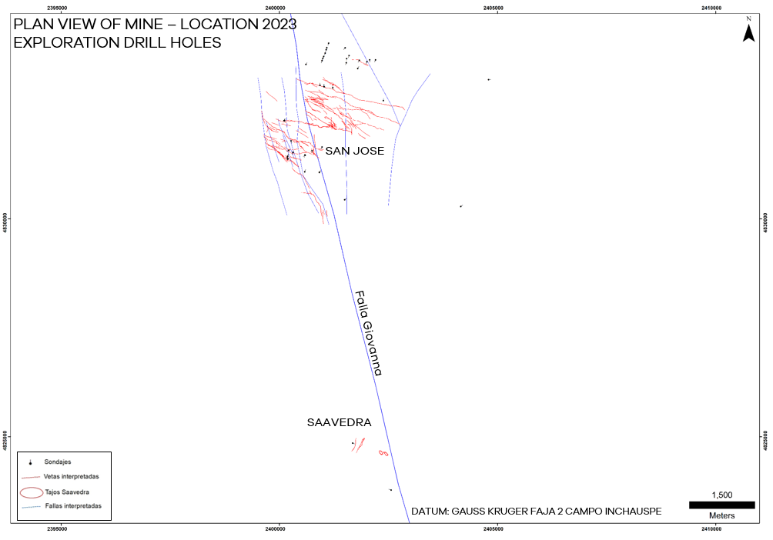

**FIGURE 22 SAN JOSÉ 2023 EXPLORATION DRILL HOLE LOCATIONS (AYELEN – HUEVOS VERDES)**

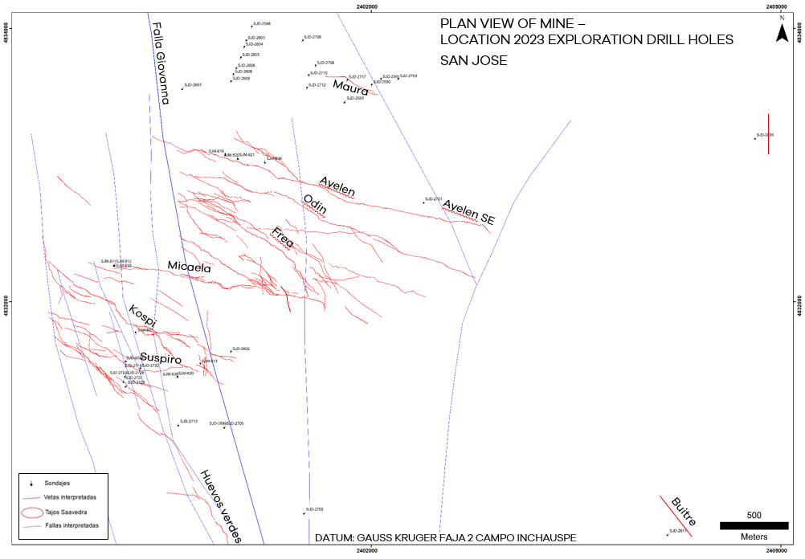

**FIGURE 23 SAN JOSÉ 2023 EXPLORATION DRILL HOLE LOCATIONS (SAAVEDRA)**

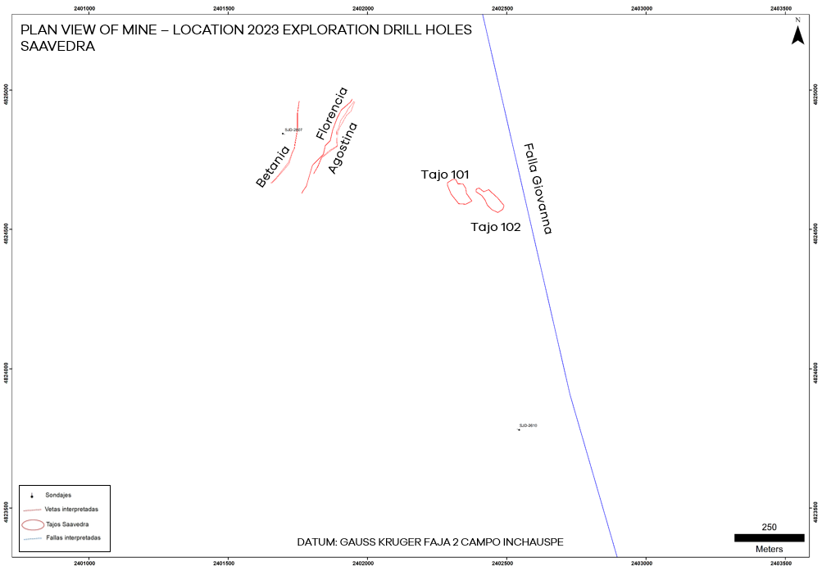

FIGURE 24 SAN JOSÉ 2023 INFILL DRILL HOLE LOCATIONS

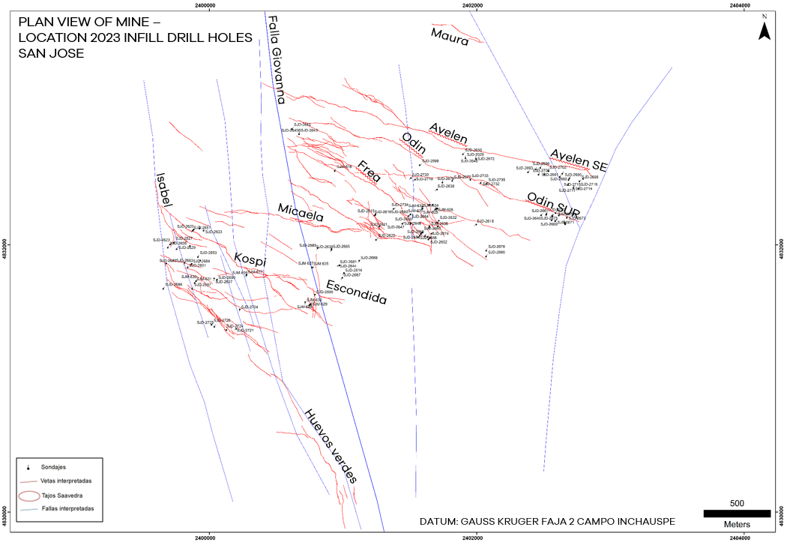

**FIGURE 25 INMACULADA 2023 EXPLORATION DRILL HOLE LOCATIONS**

**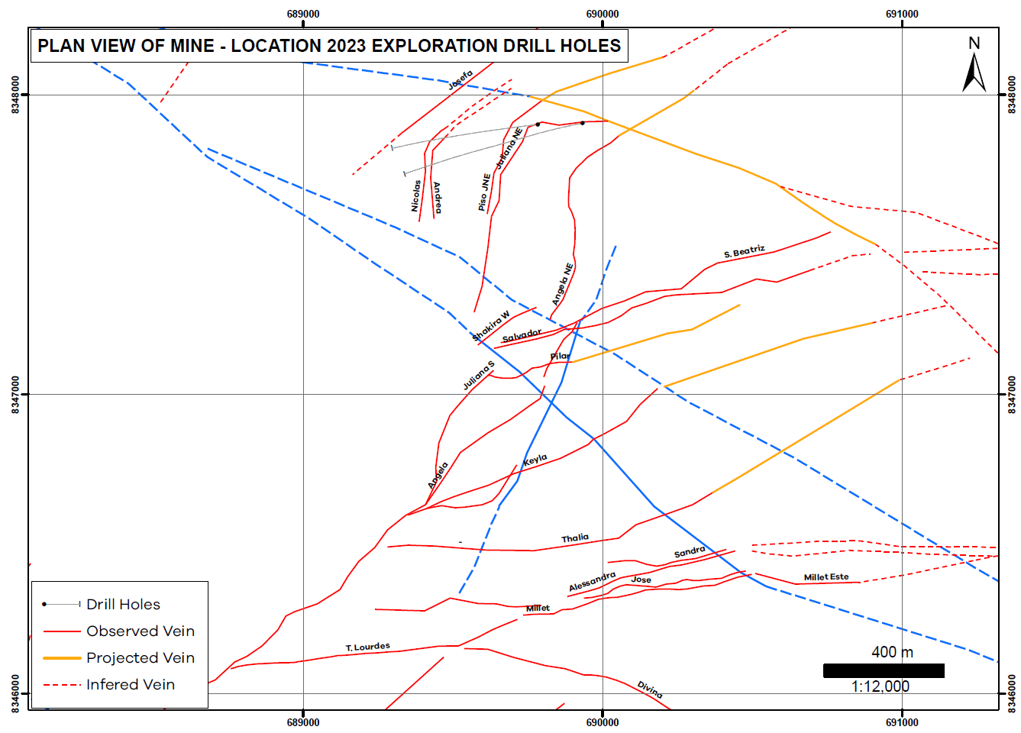**

**FIGURE 26 INMACULADA 2023 INFILL DRILL HOLE LOCATIONS**

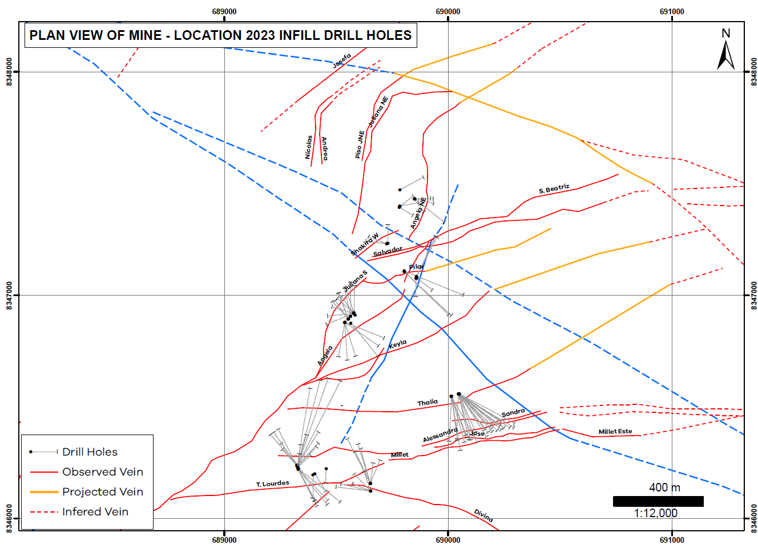

APPENDIX FUTURE EXPLORATION PLAN

FIGURE 27 PALLANCATA EXPLORATION PLAN 2024



FIGURE 28 SAN JOSÉ EXPLORATION PLAN 2024

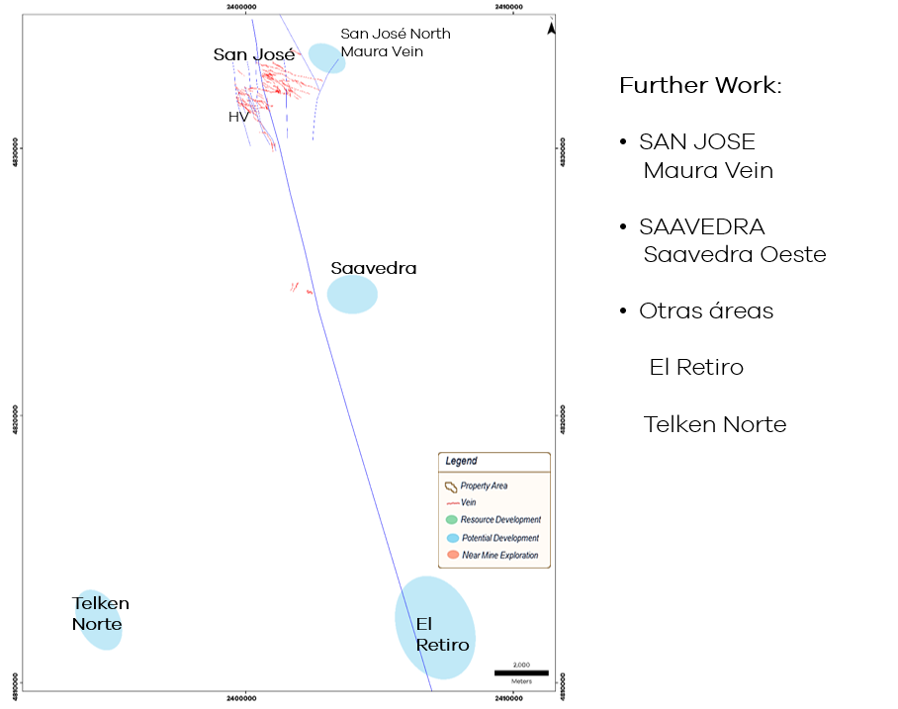

FIGURE 29 INMACULADA EXPLORATION PLAN 2024

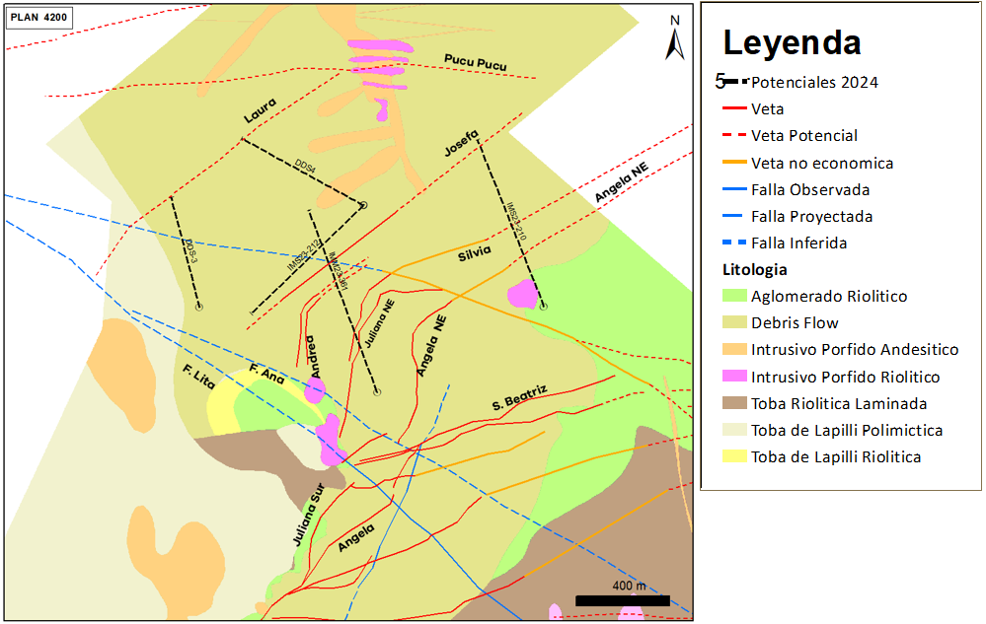

APPENDIX J BLOCK MODEL VALIDATION TREND PLOTS

INAMCULADA TREND PLOTS

Validation Trend Plots for selected deposits within the Inmaculada Mine are shown below.

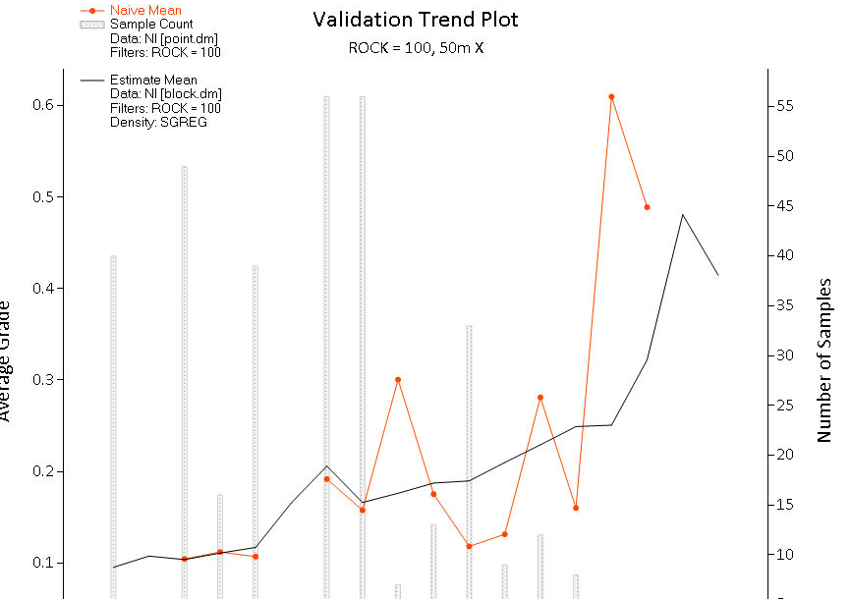

PALLANCATA TREND PLOTS

Validation Trend Plots for selected deposits within the Inmaculada Mine are shown below.

SAN JOSE TREND PLOTS

Validation Trend Plots for selected deposits within the Inmaculada Mine are shown below.

APPENDIX K CONSENT FORM

Competent Persons consent form, JORC Code regulations